Report for June, 2004

for

The University of Tibet Seismic Network (UTB)

Operated by

The Department of Science

Address: Environmental Physics institute. Lhasa. Tibet. PRC

Responsible: Tsoja Wangmo
Email: tsoja2@yahoo.com

The UTB network operates short period stations in and around Lhasa with the purpose of studying the local seismicity. The first station started operating on June 18, 2004. The network is considered experimental and stable operation cannot be expected before more experience is gained. All data is freely available on request.

Stations:

Station name: Code Latitude(N) Longitude(E) Height (m)
Jamag JAMG 29.6879° 91.6694° 4161
Nhimo NIHM 29.4336° 90.1643° 3823

Station Operation time for June Problems

JAMG 22-30 OK
NIHM 17-30 OK

For the month of June a total of 83 events were recorded (Table 2). Of these, 22 were located with 2 stations and 36 with one station (see Figure 1). 2 events were teleseismic. The largest local event had magnitude Ml=3.6. The one station locations must be considered very uncertain due to the uncertainty in azimuth determination.

The crustal model used for location is given in Table 1.

Depth (km) | Vp (km/s) | Vs (km/s)
0-27 | 6.0 | 3.4
27-41 | 6.5 | 3.7
41-61 | 7.0 | 4.0
>61 | 8.0 | 4.6
Table 1. Crustal model of the area around Lhasa

The magnitude scales used are:

Mc = 2.6log(coda) + 0.001dist –3.0
Ml = log (amp) – 1.11 log (dist) – 0.00189 dist – 2.09

Where Mc is coda magnitude, coda is coda length in seconds, dist is hypocentral distance in km, Ml is local magnitude and amp is maximum S-amplitude in nm.

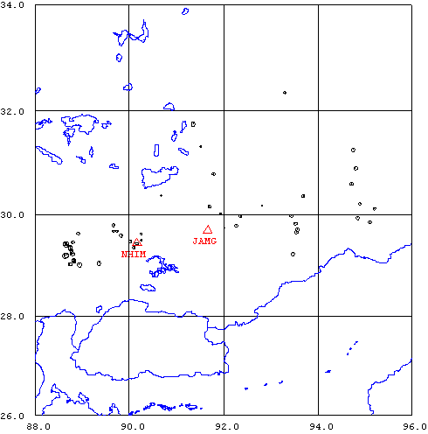
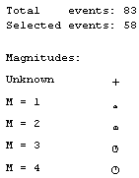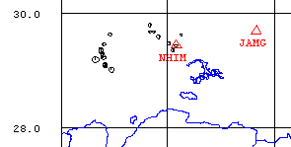
Figure 1. Seismicity of area around Lhasa for June 18-30, 2004. The network recorded 83 events for this time period and 58 could be located within the area shown (top). The bottom figure shows the best located events where 2 stations are used. The two stations used are shown with triangles

Year Date HRMM Sec L Latitud Longitud Depth AGA NST RMS Mc Ml Mb
2004 618 814 42.0 L TBU 1
2004 619 719 57.0 L TBU 1
2004 620 1731 19.0 L TBU 1
2004 621 0005 38.0 L 29.497 90.255 15.0 TBU 1 3.0 1.4
2004 621 0015 55.8 L 29.497 90.256 15.0 TBU 1 3.0 1.3
2004 621 1727 31.9 L 29.417 90.195 15.0 TBU 1 2.8 0.8
2004 622 12 7 16.0 L TBU 1
2004 622 1347 42.9 L 30.151 91.699 15.0 TBU 1 0.2 1.7 0.6
2004 622 1443 20.1 L 29.433 90.159 0.0 TBU 2 2.8 1.5 1.0
2004 622 15 1 43.0 L TBU 1
2004 622 1533 57.5 L 29.496 90.257 15.0 TBU 1 3.0 1.0 1.6
2004 623 126 1.0 D -6.960 124.970 537.1 PDE 1 5.3
2004 623 144 54.0 L TBU 1
2004 623 2329 27.9 L 29.968 93.444 15.0 TBU 1 0.0 2.1
2004 624 0027 53.0 L 29.497 90.256 15.0 TBU 1 3.1 0.3
2004 624 0254 7.1 L 29.703 93.565 15.0 TBU 1 0.0 2.1
2004 624 0320 29.9 L 29.814 93.526 15.0 TBU 1 0.0 2.1
2004 624 0559 37.1 L 29.229 93.470 15.0 TBU 1 0.0 2.1 1.3
2004 624 642 37.0 L TBU 1
2004 624 0841 23.1 L 29.966 92.361 15.0 TBU 1 0.0 1.6 0.9
2004 624 0941 42.8 R 29.249 88.778 0.1 TBU 2 3.3 2.2
2004 624 1003 35.6 L 29.008 88.944 0.0 TBU 2 3.6 2.8
2004 624 10 3 49.0 L TBU 1
2004 624 1046 39.0 L TBU 1
2004 624 1625 8.3 L 29.072 88.839 0.0 TBU 2 3.6 1.9 1.5
2004 624 2011 1.2 L 29.585 89.830 15.0 TBU 2 0.7 2.2 1.6
2004 624 2051 51.0 L TBU 2
2004 625 235 8.0 D -6.710 130.360 70.5 PDE 1 6.0
2004 625 0319 42.9 L 29.649 93.543 15.0 TBU 1 0.0 1.9 1.2
2004 625 1028 1.2 L 30.356 93.690 15.0 TBU 1 0.0 2.1 2.2
2004 625 1709 56.1 L 29.415 88.642 15.0 TBU 1 0.0 2.1 2.9
2004 625 1710 2.7 L 29.449 88.795 0.0 TBU 2 3.5 2.1
2004 625 1728 54.3 L 29.083 88.825 0.0 TBU 2 3.2 2.0
2004 625 1749 59.0 L TBU 1
2004 625 1832 52.4 L 29.016 88.736 15.0 TBU 1 0.0 2.0 2.8
2004 625 1832 57.3 L 29.215 88.790 0.0 TBU 2 3.0 2.3
2004 625 1846 35.3 L 30.117 95.203 15.0 TBU 1 0.0 1.7
2004 625 2347 5.4 L 30.208 94.893 15.0 TBU 1 0.0 1.3
2004 626 0259 25.1 L 29.184 88.641 0.1 TBU 2 2.8 3.3
2004 626 259 44.0 L TBU 1
2004 626 0312 54.8 L 29.040 89.360 15.0 TBU 1 0.0 2.4
2004 626 0312 55.9 L 31.751 91.356 15.0 TBU 1 0.0 2.4
2004 626 0326 31.1 L 32.348 93.306 15.0 TBU 1 0.0 1.7
2004 626 0331 28.3 L 29.104 88.819 0.0 TBU 2 3.2 2.2
2004 626 4 8 45.0 L TBU 1
2004 626 0444 43.8 L 29.843 95.108 15.0 TBU 1 0.0 1.8
2004 626 0600 5.8 L 29.433 88.669 15.0 TBU 1 0.0 2.4 2.9
2004 626 0600 10.0 L 29.330 88.751 0.0 TBU 2 3.4 2.7
2004 626 0641 14.2 L 30.893 94.802 15.0 TBU 1 0.0 1.9
2004 626 1624 9.0 L TBU 1
2004 626 1838 35.2 L 29.203 88.668 15.0 TBU 1 0.0 2.9
2004 626 1838 40.1 L 29.347 88.742 0.0 TBU 2 3.4 2.5
2004 626 1853 58.1 L 29.111 88.817 0.0 TBU 2 2.8 2.0 2.0
2004 626 2049 29.2 L 29.668 89.665 0.1 TBU 2 2.3 1.2
2004 627 1029 55.3 L 31.319 91.510 15.0 TBU 1 0.0 1.3
2004 627 1155 5.0 L TBU 1
2004 627 1227 0.7 L 29.742 92.024 15.0 TBU 1 0.0 0.5
2004 627 1325 12.0 L TBU 1
2004 627 1409 19.2 L 29.351 90.102 0.0 TBU 2 3.2 1.6 1.2
2004 627 1418 28.4 L 31.256 94.753 15.0 TBU 1 0.0 1.8
2004 627 1524 29.0 L TBU 1
2004 627 1943 35.3 L 29.784 92.271 15.0 TBU 1 0.0 1.9 0.9
2004 627 2047 59.2 L 30.140 91.755 15.0 TBU 1 0.2 0.2
2004 628 0211 48.8 L 30.596 94.714 15.0 TBU 1 0.0 2.1
2004 628 0818 29.3 L 34.628 90.541 15.0 TBU 1 0.0 4.2
2004 628 2109 36.0 L 29.475 90.025 15.0 TBU 2 1.8 1.4
2004 628 2154 30.0 L 30.175 92.810 15.0 TBU 1 0.0 0.9
2004 628 2231 52.4 L 29.624 90.249 0.0 TBU 2 2.1 1.4
2004 628 2320 55.1 L 29.628 88.918 0.0 TBU 2 3.4 1.9
2004 628 2337 18.1 L 30.366 90.671 15.0 TBU 1 0.0 0.9
2004 628 2348 22.0 L TBU 1
2004 629 0014 38.7 L 29.789 89.666 0.1 TBU 2 3.0 2.0 1.8
2004 629 812 31.0 L TBU 1
2004 629 2230 57.6 L 30.785 91.794 15.0 TBU 1 0.0 1.8
2004 630 0346 18.3 L 30.015 91.931 15.0 TBU 1 0.0 1.0
2004 630 1324 21.0 L 29.932 94.853 15.0 TBU 1 0.0 2.0
2004 630 1533 3.7 L 29.414 88.664 15.0 TBU 1 0.0 3.5
2004 630 1533 8.9 L 29.293 88.773 0.0 TBU 2 3.3 2.0
2004 630 1711 45.0 L TBU 1
2004 630 2051 23.5 L 29.671 89.742 0.0 TBU 2 1.9 1.4
2004 630 2210 24.0 L TBU 1
2004 630 2248 47.0 L TBU 1
2004 630 2344 39.0 L TBU 1
Table 2 . All events of June 2004 recorded by TBU. Abbreviations are: HRMM: Hour and minute, Sec, Seconds, L: L or D for local or distant event, respectively, AGA: Agency, NST: Number of station used, RMS: Root mean square of location residuals, Mc, Ml and Mb: Coda wave magnitude, local magnitude and body wave magnitude, respectively.

