Report for July, 2004

for

The University of Tibet Seismic Network (UTB)

Operated by

The Department of Science

Address: Environmental Physics institute. Lhasa. Tibet. PRC

Responsible: Tsoja Wangmo
Email: tsoja2@yahoo.com

The UTB network operates short period stations in and around Lhasa with the purpose of studying the local seismicity. The first station started operating on June 18, 2004. The network is considered experimental and stable operation cannot be expected before more experience is gained. All data is freely available on request.

Stations:

Station name: Code Latitude(N) Longitude(E) Height(m)
Jamag JAMG 29.6879° 91.6694° 4161
Nhimo NIHM 29.4336° 90.1643° 3823

Station Operation time for June Problems
JAMG 01-13 there is no data July 14-31due to a
memory problem
NIHM none there is no date, due to a memory
problem, no visits was made during July

For the month of July a total of 21 events were recorded (Table 2). Of these, 21 were located with one station (see Figure 1). The largest local event had magnitude Mw=3.6. The one station locations must be considered very uncertain due to the uncertainty in azimuth determination.

The crustal model used for location is given in Table 1.

Depth (km) | Vp (km/s) | Vs (km/s)
0-27 | 6.0 | 3.4
27-41 | 6.5 | 3.7
41-61 | 7.0 | 4.0
>61 | 8.0 | 4.6
Table 1. Crustal model of the area around Lhasa

The magnitude scales used are:
Mc = 2.6log(coda) + 0.001dist –3.0
Ml = log (amp) – 1.11 log (dist) – 0.00189 dist – 2.09

where Mc is coda magnitude, coda is coda length in seconds, dist is hypocentral distance in km, Ml is local magntude and amp is maximum S-amplitude in nm.

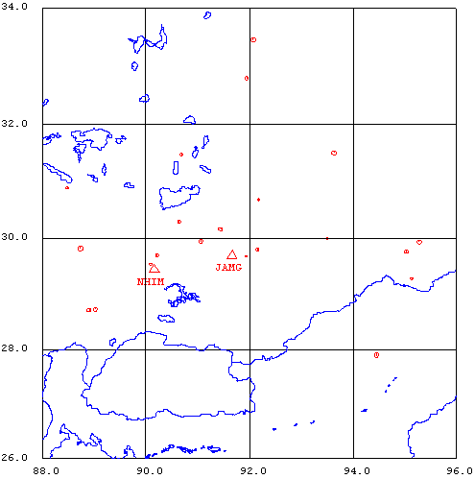
Figure 1. Seismicity of area around Lhasa for July 1-13, 2004. The network recorded 21 events for this time period and all could be located within the area shown.

Year Date HRMM Sec L Latitud Longitud Depth AGA NST RMS Mc Ml
2004 7 1 0040 22.8 L 29.753 95.039 15.0 TBU 1 0.0 1.8
2004 7 1 0357 45.6 L 30.293 90.644 15.0 TBU 1 0.0 1.7 1.2
2004 7 1 0914 10.9 L 29.794 92.155 15.0 TBU 1 0.0 1.4 0.8
2004 7 1 1704 59.9 L 29.990 93.494 15.0 TBU 1 0.0 1.1
2004 7 1 1901 36.5 L 28.708 88.907 15.0 TBU 1 0.0 2.2 2.8
2004 7 1 1901 38.1 L 28.725 89.026 15.0 TBU 1 0.0 2.0 2.5
2004 7 1 1901 38.9 L 27.894 94.454 15.0 TBU 1 0.0 2.7
2004 7 1 1914 41.4 L 29.815 88.736 0.0 TBU 2 4.2 2.7
2004 7 1 1950 1.7 L 29.276 95.133 15.0 TBU 1 0.0 1.5
2004 7 2 0645 24.7 L 30.892 88.479 15.0 TBU 1 0.0 1.6
2004 7 2 1517 1.6 L 29.679 91.934 15.0 TBU 1 0.0 1.0 0.8
2004 7 2 2048 18.6 L 31.478 90.681 15.0 TBU 1 0.0 1.7
2004 7 2 2115 14.7 L 30.682 92.177 15.0 TBU 1 0.0 1.6 1.1
2004 7 3 0211 24.4 L 29.931 95.284 15.0 TBU 1 0.0 2.4
2004 7 3 0406 57.0 L 33.468 92.071 15.0 TBU 1 0.0 2.9
2004 7 3 0710 21.1 L 31.507 93.637 15.0 TBU 1 0.0 2.4
2004 7 3 0920 9.8 L 32.809 91.947 15.0 TBU 1 0.0 1.9
2004 7 3 1411 52.1 L 30.161 91.447 15.0 TBU 1 0.0 2.1 2.1
2004 7 3 1437 12.2 L 29.944 91.065 15.0 TBU 1 0.0 2.1 1.7
2004 712 1439 38.0 L 29.534 90.093 15.0 TBU 1 1.9 1.2 1.8
2004 713 0408 24.8 L 29.698 90.218 15.0 TBU 1 0.1 1.7 1.7
Table 2 . All events of July 2004 recorded by TBU. Abbreviations are: HRMM: Hour and minute, Sec, Seconds, L: L or D for local or distant event, respectively, AGA: Agency, NST: Number of station used, RMS: Root mean square of location residuals, Mc, Ml and Mb: Coda wave magnitude, local magnitude and body wave magnitude, respectively.

