Report for August, 2004

for

The University of Tibet Seismic Network (UTB)

Operated by

The Department of Science

Address: Environmental Physics institute. Lhasa. Tibet. PRC

Responsible: Tsoja Wangmo
Email: tsoja2@yahoo.com

The UTB network operates short period stations in and around Lhasa with the purpose of studying the local seismicity. The first station started operating on June 18, 2004. The network is considered experimental and stable operation cannot be expected before more experience is gained. All data is freely available on request.

Stations:

Station name: Code Latitude(N) Longitude(E) Height(m)
Jamag JAMG 29.6879° 91.6694° 4161
Nhimo NIHM 29.4336° 90.1643° 3823
Palub PALB 29.6534° 91.1130° 3679

Operation of stations in August 2004

Jamag
Station was visited on 25th of Augus
Down Auguet 1 to June 14. The reason was that, due to late visit, the memory was full

Nhimo
Station was visited on First of December
Down August 1-24: due to memory full
Down August 29-31: memory full
Note: Due to a bad road to Nhimo, visits have been difficult

Palub
The station started operation August 31

For the month of August a total of 45 events were recorded (Table 2). Of these, 38 were located with one station (see Figure 1). The largest local event had magnitude ML=5.2. The one station locations must be considered very uncertain due to the uncertainty in azimuth determination.

The crustal model used for location is given in Table 1.

Depth (km) | Vp (km/s) | Vs (km/s)
0-27 | 6.0 | 3.4
27-41 | 6.5 | 3.7
41-61 | 7.0 | 4.0
>61 | 8.0 | 4.6
Table 1. Crustal model of the area around Lhasa

The magnitude scales used are:
Mc = 2.6log(coda) + 0.001dist –3.0
Ml = log (amp) – 1.11 log (dist) – 0.00189 dist – 2.09

where Mc is coda magnitude, coda is coda length in seconds, dist is hypocentral distance in km, Ml is local magntude and amp is maximum S-amplitude in nm.

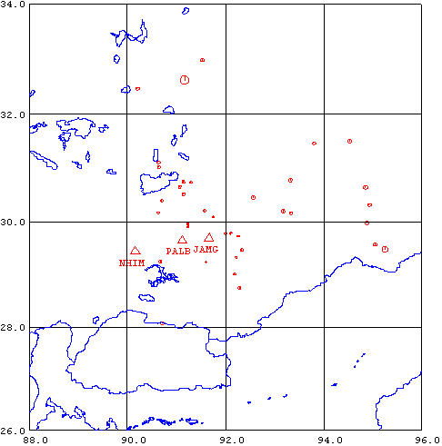
Figure 1. Seismicity of area around Lhasa for August 15-31, 2004. The network recorded 42 events for this time period and 38 could be located within the area shown.

Year Date HRMM Sec L Latitud Longitud Depth AGA NST RMS Mc Ml
2004 815 0621 23.6 L 29.786 92.105 15.0 TBU 1 0.0 1.6 1.0
2004 816 0903 50.3 L 29.008 92.182 15.0 TBU 1 0.0 1.5 1.4
2004 817 0538 39.4 L 31.115 90.634 15.0 TBU 1 0.0 1.8 1.4
2004 817 1115 36.7 L 31.023 90.641 15.0 TBU 1 0.0 1.7 1.5
2004 817 1758 39.5 L 29.792 92.114 15.0 TBU 1 0.0 1.1 0.8
2004 817 2228 46.6 L 30.738 91.293 15.0 TBU 1 0.0 1.4 1.2
2004 818 0514 19.8 L 30.663 91.064 15.0 TBU 1 0.0 1.7 1.6
2004 818 0618 25.7 L 30.449 92.563 15.0 TBU 1 0.0 2.2 3.6
2004 818 0646 40.8 L 30.741 91.139 15.0 TBU 1 0.0 1.8 1.8
2004 818 0903 58.5 L 30.170 90.626 15.0 TBU 1 0.0 1.7 1.6
2004 820 0707 59.0 L 30.092 91.754 15.0 TBU 1 0.0 1.5 1.1
2004 820 1031 49.0 L TBU 0
2004 820 1046 14.9 L 29.568 95.053 15.0 TBU 1 0.0 2.2 2.2
2004 821 0206 36.2 L 30.162 93.336 15.0 TBU 1 0.0 1.9 2.0
2004 821 0907 9.3 L 29.476 95.252 15.0 TBU 1 0.0 3.5
2004 821 1532 6.8 L 29.462 92.335 15.0 TBU 1 0.0 1.7 1.7
2004 821 1906 24.8 L 32.467 90.207 15.0 TBU 1 0.0 2.2 2.0
2004 822 0008 40.1 L 29.333 92.227 15.0 TBU 1 0.0 1.3 1.0
2004 822 0224 56.5 L 29.907 91.233 15.0 TBU 1 0.0 0.9 1.0
2004 822 1358 7.6 L 31.462 93.805 15.0 TBU 1 0.0 1.9 1.7
2004 822 1629 7.7 L 29.241 91.609 15.0 TBU 1 0.0 1.2 1.0
2004 822 1634 45.2 L 30.391 90.698 15.0 TBU 1 0.0 1.6 1.6
2004 823 2304 31.4 L 29.775 92.000 15.0 TBU 1 0.0 1.2 1.0
2004 824 017 54.0 L TBU 1
2004 824 0505 25.5 L 29.792 92.099 15.0 TBU 1 0.0 1.2 0.8
2004 824 1005 34.0 L 32.631 91.164 10.0 TBU 2 2.3 5.2
2004 824 2123 48.3 L 30.642 94.856 15.0 TBU 1 0.0 2.2 1.9
2004 825 0128 58.5 L 32.995 91.532 15.0 TBU 1 0.0 2.3 2.6
2004 825 1257 14.5 L 31.500 94.532 15.0 TBU 1 0.0 2.4 3.1
2004 825 1337 55.9 L 28.743 92.288 15.0 TBU 1 0.0 1.9 1.9
2004 826 0834 16.7 L 29.950 91.230 15.0 TBU 1 0.0 1.2 1.2
2004 826 1716 23.0 L TBU 0
2004 827 0546 27.8 L 30.312 94.933 15.0 TBU 1 0.0 2.1 1.8
2004 827 1423 28.7 L 30.191 93.179 15.0 TBU 1 0.0 2.1 1.9
2004 827 1502 41.3 L 29.731 92.261 15.0 TBU 1 0.0 1.1 0.9
2004 827 1550 22.0 L TBU 0
2004 828 2353 21.5 L 30.519 91.141 15.0 TBU 1 0.0 1.6 1.3
2004 830 0349 53.9 L 29.244 90.672 15.0 TBU 1 0.0 1.9 2.3
2004 830 1437 58.6 L 30.778 93.324 15.0 TBU 1 0.0 2.1 2.6
2004 830 1437 57.8 L 28.070 90.708 15.0 TBU 1 0.0 2.3 2.7
2004 831 0102 39.5 L 30.206 91.573 15.0 TBU 1 0.0 1.4 1.3
2004 831 0927 29.1 L 29.978 94.882 15.0 TBU 1 0.0 2.2 2.1
Table 2 . All events of August 2004 recorded by TBU. Abbreviations are: HRMM: Hour and minute, Sec, Seconds, L: L or D for local or distant event, respectively, AGA: Agency, NST: Number of station used, RMS: Root mean square of location residuals, Mc, Ml and Mb: Coda wave magnitude, local magnitude and body wave magnitude, respectively.

