Report for August, 2005

for

The University of Tibet Seismic Network (UTB)

Operated by

The Department of Science

Address: Environmental Physics institute. Lhasa. Tibet. PRC

Responsible: Tsoja Wangmo
Email: tsoja2@yahoo.com

The UTB network opera TBU short period stations in and around Lhasa with the purpose of studying the local seismicity. The first station started operating on June 18, 2004. All data is freely available on request.

Stations:
Station name | Code | Latitude(N) | Longitude(E) | Height(m)
Jamag | JAMG | 29.6879 | 91.6694° | 4161
Nhimo | NIHM | 29.4336° | 90.1643° | 3823
Chuding | CHUD | 29.6978° | 91.1438° | 3794

Operation of stations in August 2005

Jamag
Down August 1 to June 21. The reason was that, signal cable had been cut.

Nhimo
Station running stable.

Chuding
Down Auguet 1 to June 17. The PC was infected by virus and we had to reinstall the windows system.

For the month of August a total of 62 events were recorded (Table 2). Of these, 58 were located with one station (see Figure 1). 4 were located with two stations.

The crustal model used for location is given in Table 1.

Depth (km) | Vp (km/s) | Vs (km/s)
0-27 | 6.0 | 3.4
27-41 | 6.5 | 3.7
41-61 | 7.0 | 4.0
>61 | 8.0 | 4.6
Table 1. Crustal model of the area around Lhasa
The magnitude scales used are:
Mc = 2.6log(coda) + 0.001dist –3.0
Ml = log (amp) – 1.11 log (dist) – 0.00189 dist – 2.09

where Mc is coda magnitude, coda is coda length in seconds, dist is hypocentral distance in km, Ml is local magntude and amp is maximum S-amplitude in nm.

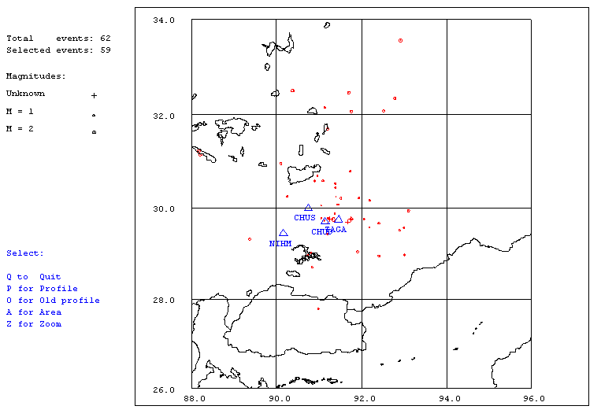
Figure 1. Seismicity of area around Lhasa for August 1-31, 2005. The network recorded 62 events for this time period and 59 could be located within the area shown.

Year Date HRMM Sec Latitud Longitud Depth AGA NST RMS Mc Ml Mb
2005 8 1 0038 29.2 28.960 90.733 15.0 TBU 1 0.0 0.8 2.3
2005 8 4 0750 25.0 30.248 90.251 15.0 TBU 1 0.0 1.2 2.7
2005 816 1655 2.0 TBU 1
2005 819 1259 25.1 29.756 91.241 15.0 TBU 1 1.9 -0.2 0.4
2005 819 2039 26.7 29.757 91.240 15.0 TBU 1 0.3 0.3 0.7
2005 819 2335 33.9 29.012 90.810 15.0 TBU 1 0.0 0.6 1.7
2005 820 0438 1.2 29.658 91.199 15.0 TBU 1 0.7 0.4 0.7
2005 820 1250 49.0 31.223 88.168 54.0 TBU 2 2.4 2.3 3.5 5.1
2005 820 1407 10.1 31.144 88.206 10.0 TBU 2 1.4 2.2 2.9 4.4
2005 820 1839 57.1 29.043 91.910 15.0 TBU 1 0.0 1.6 2.5
2005 820 2318 37.7 29.766 87.006 17.9 TBU 2 3.0 2.2 2.9
2005 820 2328 22.1 29.756 92.061 15.0 TBU 1 0.3 0.8 1.6
2005 824 0000 47.5 30.050 91.054 15.0 TBU 1 0.0 0.6 1.0
2005 824 0333 59.3 30.074 91.441 15.0 TBU 1 0.0 1.0 1.1
2005 824 357 56.0 TBU 1
2005 824 0740 14.1 29.755 91.242 15.0 TBU 1 2.2 0.0 0.7
2005 824 1114 41.7 32.350 92.789 15.0 TBU 1 0.0 1.9 3.7
2005 824 1319 7.7 30.212 91.939 15.0 TBU 1 0.0 0.9 0.9
2005 825 0251 18.3 29.575 92.183 15.0 TBU 1 0.0 0.7 0.8
2005 826 0001 35.2 30.162 92.196 15.0 TBU 1 0.0 0.9 1.5
2005 826 0203 6.9 29.757 91.755 15.0 TBU 1 0.1 0.0 1.6
2005 826 0353 14.0 29.764 91.233 15.0 TBU 1 0.0 0.3 0.9
2005 826 0439 29.5 29.665 92.410 15.0 TBU 1 0.0 1.0 1.6
2005 826 0545 26.6 30.207 91.519 15.0 TBU 1 0.0 1.4 1.9
2005 826 1017 36.8 27.778 90.989 15.0 TBU 1 0.0 1.1 2.0
2005 826 1117 50.8 29.939 93.106 15.0 TBU 1 0.0 1.7 1.8
2005 826 1310 10.8 33.572 92.923 15.0 TBU 1 0.0 2.2 2.4
2005 826 1836 59.4 28.965 93.014 15.0 TBU 2 7.3 1.3 3.0
2005 826 2118 1.3 29.770 91.050 15.0 TBU 1 0.0 0.9 1.6
2005 826 2147 54.1 29.742 91.100 15.0 TBU 1 1.9 0.3 0.3
2005 826 2318 2.4 29.428 91.207 15.0 TBU 1 0.1 0.9 2.5
2005 826 2321 35.6 29.756 91.757 15.0 TBU 1 0.6 1.0 1.1
2005 827 0010 35.6 32.472 91.697 15.0 TBU 1 0.0 1.8 2.0
2005 827 0014 19.9 29.766 91.746 15.0 TBU 1 0.4 0.6 1.5
2005 827 0016 26.1 30.580 90.897 15.0 TBU 1 0.0 1.4 1.2
2005 827 0212 39.9 29.775 91.222 15.0 TBU 2 10.4 1.0 0.9
2005 827 0649 25.7 32.156 91.134 15.0 TBU 1 0.0 1.6 2.2
2005 827 1117 51.0 29.318 89.369 15.0 TBU 1 0.0 1.1 1.6
2005 827 1141 44.4 32.083 92.519 15.0 TBU 1 0.0 1.7 2.2
2005 827 1156 18.3 30.698 90.958 15.0 TBU 1 0.0 0.8 1.7
2005 827 1336 41.9 29.716 91.126 15.0 TBU 1 1.8 0.6 1.1
2005 827 1855 29.1 29.690 91.666 15.0 TBU 1 0.3 -0.2 0.5
2005 827 1927 15.1 29.565 92.997 15.0 TBU 1 0.0 1.0 1.7
2005 828 0010 32.1 29.870 91.369 15.0 TBU 1 0.0 0.5 1.0
2005 828 0714 27.0 29.509 92.893 15.0 TBU 1 0.0 1.1 1.8
2005 828 0720 51.7 29.764 91.233 15.0 TBU 1 1.2 0.6 1.1
2005 829 1239 59.6 29.776 91.220 15.0 TBU 1 0.5 0.3 0.7
2005 829 1335 54.1 30.435 91.378 15.0 TBU 1 0.0 1.1 1.5
2005 829 1648 23.8 29.757 91.240 15.0 TBU 1 0.0 0.5 0.7
2005 829 1819 52.7 32.511 90.386 15.0 TBU 1 0.0 2.1 2.9
2005 830 0046 25.6 28.950 92.417 15.0 TBU 1 0.0 1.3 3.0
2005 830 0549 35.2 30.519 91.382 15.0 TBU 1 0.0 1.0 2.6
2005 830 0628 33.0 28.701 90.837 15.0 TBU 1 0.0 1.1 1.4
2005 830 0637 26.9 29.743 91.338 15.0 TBU 1 0.0 2.0 2.5
2005 830 0713 1.4 30.792 91.735 15.0 TBU 1 0.0 0.9 1.9
2005 830 0757 29.5 32.071 91.757 15.0 TBU 1 0.0 1.7 2.0
2005 830 0840 41.4 29.684 91.124 15.0 TBU 1 0.5 0.3 0.8
2005 830 1101 57.0 30.590 91.092 15.0 TBU 1 0.0 1.1 2.1
2005 830 1207 39.8 30.248 91.399 15.0 TBU 1 0.0 0.7 1.7
2005 830 1212 2.7 31.703 91.205 15.0 TBU 1 0.0 1.6 2.6
2005 831 0926 0.3 30.959 90.109 15.0 TBU 1 0.0 1.3 2.2
2005 831 1646 38.0 29.790 91.759 15.0 TBU 1 0.1 0.7 1.4
Table 2 . All events of August 2005 recorded by TBU. Abbreviations are: HRMM: Hour and minute, Sec, Seconds, L: L or D for local or distant event, respectively, AGA: Agency, NST: Number of station used, RMS: Root mean square of location residuals, Mc, Ml and Mb: Coda wave magnitude, local magnitude and body wave magnitude, respectively.

