Report for September, 2005

for

The University of Tibet Seismic Network (UTB)

Operated by

The Department of Science

Address: Environmental Physics institute. Lhasa. Tibet. PRC

Responsible: Tsoja Wangmo
Email: tsoja2@yahoo.com

The UTB network operates short period stations in and around Lhasa with the purpose of studying the local seismicity. The first station started operating on June 18, 2004. The network is considered experimental and stable operation cannot be expected before more experience is gained. All data is freely available on request.

Stations:
Station name | Code | Latitude(N) | Longitude(E) | Height(m)
Jamag | JAMG | 29.6879° | 91.6694° | 4161
Nhimo | NIHM | 29.4336° | 90.1643° | 3823
Chuding | CHUD | 29.6978° | 91.1438° | 3794
Chusang | CHUS | 29.9970° | 90.7462° | 4113

Operation of stations in September 2005

Jamag
Station running stable

Nhimo
Down September 30-31: due to power failure

Chuding
Down September 21 and 30 ; System could not restart after power failure.

Chusang
Down September 16 and 30 ; Station down due to power shortage.

For the month of September a total of 21 events were recorded (Table 2). Of these, 19 were located with one station (see Figure 1) and 2 were located with two stations. The largest local event had magnitude ML=5.3. The one station locations must be considered very uncertain due to the uncertainty in azimuth determination.

The crustal model used for location is given in Table 1.

Depth (km) | Vp (km/s) | Vs (km/s)
0-27 | 6.0 | 3.4
27-41 | 6.5 | 3.7
41-61 | 7.0 | 4.0
>61 | 8.0 | 4.6
Table 1. Crustal model of the area around Lhasa

The magnitude scales used are:
Mc = 2.6log(coda) + 0.001dist –3.0
Ml = log (amp) – 1.11 log (dist) – 0.00189 dist – 2.09

where Mc is coda magnitude, coda is coda length in seconds, dist is hypocentral distance in km, Ml is local magntude and amp is maximum S-amplitude in nm.

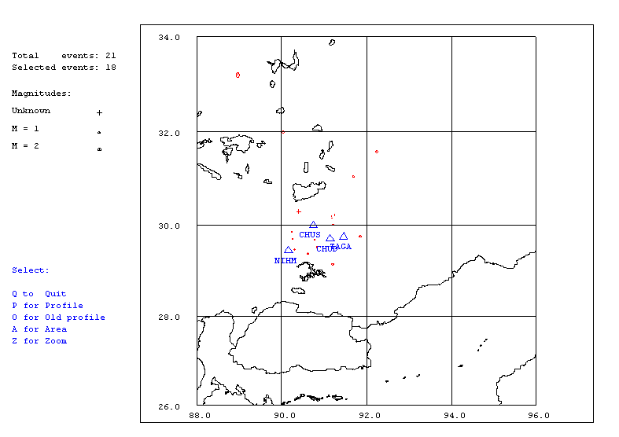
Figure 1. Seismicity of area around Lhasa for September 01-30, 2005. The network recorded 21 events for this time period and 18 could be located within the area shown.

Year Date HRMM Sec Latitud Longitud Depth AGA NST RMS Mc Ml Mb
2005 9 1 0647 55.9 31.583 92.244 15.0 TBU 1 0.0 1.5 2.6
2005 9 1 0649 29.9 31.042 91.685 15.0 TBU 1 0.0 1.3 1.8
2005 9 1 1102 28.3 30.150 91.192 15.0 TBU 1 0.1 0.3 1.6
2005 9 4 1802 46.5 29.846 90.238 15.0 TBU 1 0.0 0.7 1.3
2005 9 6 0614 39.2 30.215 91.251 15.0 TBU 1 0.0 2.7 3.2
2005 9 6 0714 6.1 29.671 90.773 15.0 TBU 1 0.0 0.5 1.0
2005 9 6 1152 24.4 30.000 91.216 15.0 TBU 1 0.0 0.9 2.1
2005 9 6 1734 33.9 31.998 90.041 15.0 TBU 1 0.0 1.5 2.4
2005 9 6 2143 38.6 29.746 91.848 15.0 TBU 1 0.4 1.2 1.5
2005 9 6 2149 6.5 29.141 91.211 0.0 TBU 2 4.8 1.4 1.7
2005 9 7 1100 40.2 29.688 90.254 15.0 TBU 2 1.8 0.9 2.2
2005 9 7 1528 48.8 30.194 91.181 15.0 TBU 1 0.0 0.2 2.3
2005 9 8 1130 38.2 30.217 90.342 15.0 TBU 1 0.0 0.1 2.2
2005 9 8 1237 22.1 30.294 90.413 15.0 TBU 1 0.0 -0.1 1.8
2005 912 1659 44.1 33.206 88.970 15.0 TBU 1 0.0 2.7 3.4
2005 912 2143 12.0 TBU 1
2005 913 1029 58.2 29.461 90.306 15.0 TBU 1 0.0 0.6 1.5
2005 914 1636 22.2 29.514 90.835 15.0 TBU 1 0.2 0.9 1.9
2005 918 0726 13.0 25.313 92.726 15.0 TBU 1 0.0 3.4 5.3
2005 918 12 0 8.4 TBU 0
2005 920 0956 18.0 29.371 90.620 15.0 TBU 1 0.0 1.1 1.9
Table 2 . All events of September 2005 recorded by TBU. Abbreviations are: HRMM: Hour and minute, Sec, Seconds, L: L or D for local or distant event, respectively, AGA: Agency, NST: Number of station used, RMS: Root mean square of location residuals, Mc, Ml and Mb: Coda wave magnitude, local magnitude and body wave magnitude, respectively.

