Report for December, 2005

for

The University of Tibet Seismic Network (UTB)

Operated by

The Department of Science

Address: Environmental Physics institute. Lhasa. Tibet. PRC

Responsible: Tsoja Wangmo
Email: tsoja2@yahoo.com

The UTB network operates short period stations in and around Lhasa with the purpose of studying the local seismicity. The first station started operating on June 18, 2004. The network is considered experimental and stable operation cannot be expected before more experience is gained. All data is freely available on request.

Stations:
Station name | Code | Latitude(N) | Longitude(E) | Height(m)
Jamag | JAMG | 29.6879° | 91.6694° | 4161
Nhimo | NHIM | 29.4336° | 90.1643° | 3823
Chuding | CHUD | 29.6978° | 91.1438° | 3794
Chusang | CHUS | 29.9970° | 90.7462° | 4113

Operation of stations in August 2005

Jamag
Down December 1-31:: Because of bad road conditions we couldn’t go to JAMG station to take data during the winter time.

Nhimo
Station running stable

Chuding
Could not make visit to the site, and data were lost due to limited memory on the system.

Chusang
Down December 28-31: System could not restart after power failure.

For the month of December a total of 11 events were recorded (Table 2). Of these, 8 were located with one station (see Figure 1) and one event located with two stations, the one station locations must be considered very uncertain due to the uncertainty in azimuth determination.

The crustal model used for location is given in Table 1.

Depth (km) | Vp (km/s) | Vs (km/s)
0-27 | 6.0 | 3.4
27-41 | 6.5 | 3.7
41-61 | 7.0 | 4.0
>61 | 8.0 | 4.6
Table 1. Crustal model of the area around Lhasa

The magnitude scales used are:
Mc = 2.6log(coda) + 0.001dist –3.0
Ml = log (amp) – 1.11 log (dist) – 0.00189 dist – 2.09

where Mc is coda magnitude, coda is coda length in seconds, dist is hypocentral distance in km, Ml is local magntude and amp is maximum S-amplitude in nm.

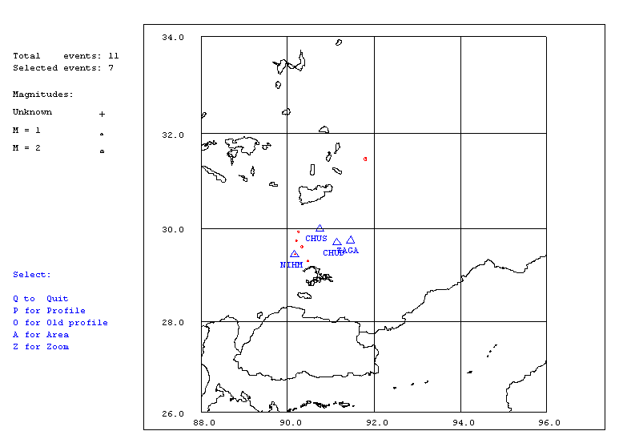
Figure 1. Seismicity of area around Lhasa for December 01-31, 2005. The network recorded 11events for this time period and 7 could be located within the area shown.

Year Date HRMM Sec Latitud Longitud Depth AGA NST RMS Mc Ml Mb
2005 12 1 0026 33.4 29.307 90.474 15.0 TBU 1 3.7 1.1 1.7
2005 12 7 1619 38.6 29.609 90.335 202.2 TBU 2 1.0 1.5 2.6
2005 1210 1942 58.9 TBU 0
2005 1210 2322 38.4 29.930 90.246 15.0 TBU 1 0.0 1.1 1.9
2005 1212 2147 20.5 29.564 69.002 15.0 TBU 1 0.0
2005 1212 2151 4.0 TBU 1
2005 1214 147 49.5 TBU 0
2005 1218 0100 7.9 31.468 91.799 15.0 TBU 1 0.0 2.0 2.5
2005 1221 1514 25.2 29.733 90.213 15.0 TBU 1 0.0 1.2 1.1
2005 1225 1330 20.8 29.449 90.170 15.0 TBU 1 0.4 0.6 1.7
2005 1226 1807 8.8 29.513 90.240 15.0 TBU 1 1.7 0.1 0.8
Table 2 . All events of December 2005 recorded by TBU. Abbreviations are: HRMM: Hour and minute, Sec, Seconds, L: L or D for local or distant event, respectively, AGA: Agency, NST: Number of station used, RMS: Root mean square of location residuals, Mc, Ml and Mb: Coda wave magnitude, local magnitude and body wave magnitude, respectively.

