Report for January , 2006

for

The University of Tibet Seismic Network (UTB)

Operated by

The Department of Science

Address: Environmental Physics institute. Lhasa. Tibet. PRC

Responsible: Tsoja Wangmo
Email: tsoja2@yahoo.com

The UTB network operates short period stations in and around Lhasa with the purpose of studying the local seismicity. The first station started operating on June 18, 2004. The network is considered experimental and stable operation cannot be expected before more experience is gained. All data is freely available on request.

Stations:
Station name | Code | Latitude(N) | Longitude(E) | Height(m)
Jamag | JAMG | 29.6879° | 91.6694° | 4161
Nhimo | NIHM | 29.4336° | 90.1643° | 3823
Chuding | CHUD | 29.6978° | 91.1438° | 3794
Chusang | CHUS | 29.9970° | 90.7462° | 4113
Tage | TAGA | 29.7400 ° | 91.4603° | 3788

Jamag
Station running stable

Taga
Station running stable
Note : Because of bad road conditions we couldn’t go to JAMG station to take data during the winter time. From Jan 19 2006, the JAMG station moved to Taga Xiang (TAGA).

Nhimo
Down January 24-31: System could not restart after power failures

Chuding
Down January 1-24 pc had some problems and had to restore and so on

Chusang
Down January 1-31: System could not restart after power failure.

For the month of Janury a total of 20 events were recorded (Table 2). Of these,17 were located with one station (see Figure 1). The one station locations must be considered very uncertain due to the uncertainty in azimuth determination.

The crustal model used for location is given in Table 1.

Depth (km) | Vp (km/s) | Vs (km/s)
0-27 | 6.0 | 3.4
27-41 | 6.5 | 3.7
41-61 | 7.0 | 4.0
>61 | 8.0 | 4.6
Table 1. Crustal model of the area around Lhasa

The magnitude scales used are:
Mc = 2.6log(coda) + 0.001dist –3.0
Ml = log (amp) – 1.11 log (dist) – 0.00189 dist – 2.09

where Mc is coda magnitude, coda is coda length in seconds, dist is hypocentral distance in km, Ml is local magntude and amp is maximum S-amplitude in nm.

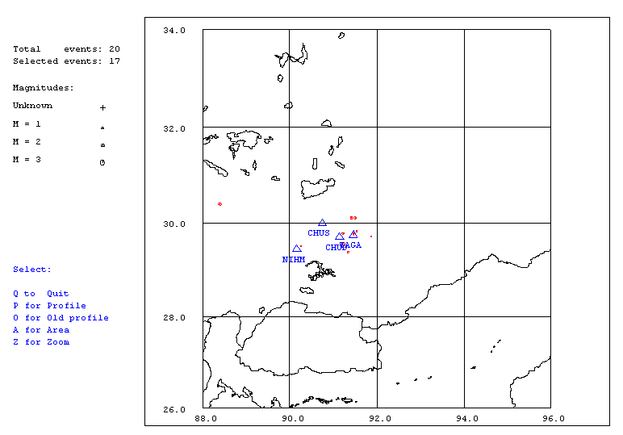

Figure 1. Seismicity of area around Lhasa for January 1-31, 2006. The network recorded 21 events for this time period and all 17 could be located within the area shown (top).

Year Date HRMM Sec Latitud Longitud Depth AGA NST RMS Mc Ml Mb
2006 1 5 1650 22.0 29.497 90.256 15.0 TBU 1 2.5 2.6 3.5
2006 1 5 2052 45.2 29.501 90.252 15.0 TBU 1 2.7 1.6 2.2
2006 115 1916 11.3 30.395 88.401 15.0 TBU 1 0.0 1.8 2.9
2006 119 2036 24.3 29.777 91.474 15.0 TBU 1 0.3 1.1 1.0
2006 119 2103 35.5 29.820 91.536 15.0 TBU 1 0.5 1.1 1.8
2006 119 2131 44.1 29.819 91.536 15.0 TBU 1 0.5 0.8 0.5
2006 120 2102 44.4 30.104 91.504 15.0 TBU 1 0.0 1.3 2.5
2006 121 1231 20.2 TBU 0
2006 123 0047 18.0 29.819 91.536 15.0 TBU 1 0.3 1.1 1.7
2006 125 0956 59.5 29.709 91.872 15.0 TBU 1 0.0 0.5 1.6
2006 126 1057 54.1 29.777 91.475 15.0 TBU 1 0.3 0.7 1.4
2006 126 1515 57.3 29.820 91.536 15.0 TBU 1 0.7 0.9 1.3
2006 126 1837 54.2 29.775 91.222 15.0 TBU 2 4.3 1.6 1.2
2006 126 1954 36.7 29.762 91.469 15.0 TBU 1 0.2 1.0 0.8
2006 126 2316 27.7 29.820 91.536 15.0 TBU 1 0.5 1.1 1.0
2006 127 0140 8.2 30.109 91.420 0.0 TBU 2 0.8 1.3 1.7
2006 127 1706 58.1 29.541 91.211 15.0 TBU 1 0.0 3.4 2.8
2006 128 2030 27.9 29.382 91.339 15.0 TBU 2 0.0 1.3 1.5
2006 131 519 7.5 TBU 0
2006 131 1920 58.0 TBU 1
Table 2 . All events of January 2006 recorded by TBU. Abbreviations are: HRMM: Hour and minute, Sec, Seconds, L: L or D for local or distant event, respectively, AGA: Agency, NST: Number of station used, RMS: Root mean square of location residuals, Mc, Ml and Mb: Coda wave magnitude, local magnitude and body wave magnitude, respectively.

