Report for February, 2006

for

The University of Tibet Seismic Network (UTB)

Operated by

The Department of Science

Address: Environmental Physics institute. Lhasa. Tibet. PRC

Responsible: Tsering and Tsoja Wangmo
Email: ciring_ciring@yahoo.com, tsoja2@yahoo.com

This report provides a summary of activities related to the Tibet University Seismic Network (TBU) during the February of 2006. The report is divided into three sections.

Stations:

Station name | Code | Latitude(N) | Longitude(E) | Height(m)
Nhimo | NHIM | 29.4336° | 90.1643° | 3823
Chuding | CHUD | 29.6978° | 91.1438° | 3794
Chusang | CHUS | 29.9970° | 90.7462° | 4113
Tage | TAGA | 29.7400 ° | 91.4603° | 3788

Operation time for February

NHIM:
11/2 2006 - 21/2 2006: Station down due to power loss.
CHUD:
8/2 2006 - 28/2 2006: Station down due to power loss.

For the month of February a total of 18 events were recorded (Fig 1). Of these, all events recorded by one station (Figure 1).

The crustal model used for location is given in Table 1.

Depth (km) | Vp (km/s) | Vs (km/s)
0-27 | 6.0 | 3.4
27-41 | 6.5 | 3.7
41-61 | 7.0 | 4.0
>61 | 8.0 | 4.6
Table 1. Crustal model of the area around Lhasa

The magnitude scales used are:

Mc = 2.6log(coda) + 0.001dist –3.0
Ml = log (amp) – 1.11 log (dist) – 0.00189 dist – 2.09

Where Mc is coda magnitude, coda is coda length in seconds, dist is hypocentral distance in km, Ml is local magntude and amp is maximum S-amplitude in nm.

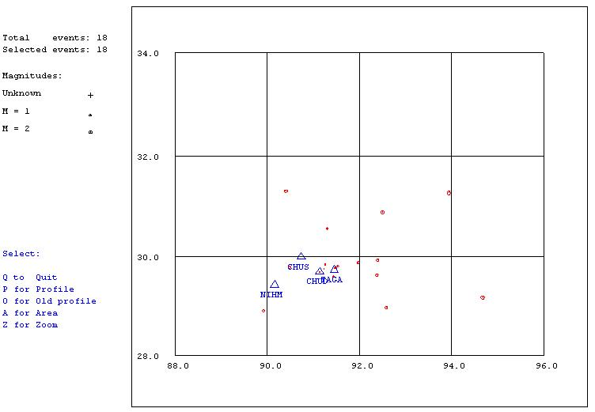

Figure 1. Seismicity of area around Lhasa for February 01-28, 2006. The network recorded 18 events for this time period and all events could be located within the area shown.
Year Date HRMM Sec Latitud Longitud Depth AGA RMS Mc Ml
2006 2 1 0020 43.4 29.881 91.985 15.0 TES 0.0 1.6 2.3
2006 2 1 1241 12.4 29.759 91.238 15.0 TES 0.3 0.7 1.0
2006 2 4 1502 59.7 29.844 91.262 15.0 TES 0.0 0.6 2.4
2006 2 4 2033 26.3 29.699 91.142 15.0 TES 1.7 0.2 0.9
2006 2 6 0639 54.5 28.916 89.921 15.0 TES 0.0 1.7 2.0
2006 2 6 2053 6.9 31.307 90.406 44.9 TES 0.6 2.3 3.2
2006 2 7 1700 24.5 29.600 91.438 15.0 TES 0.2 1.2 1.9
2006 2 7 2150 32.3 29.819 91.536 15.0 TES 0.5 1.3 1.8
2006 2 9 1155 23.7 29.777 91.481 15.0 TES 0.4 1.1 1.6
2006 215 1855 13.6 29.636 92.388 15.0 TES 0.0 1.6 1.5
2006 215 2134 49.6 29.937 92.400 15.0 TES 0.0 1.4 1.4
2006 216 0054 47.3 29.794 90.490 15.0 TES 0.0 1.6 2.3
2006 217 1809 7.7 30.560 91.304 15.0 TES 0.0 1.5 2.0
2006 223 2015 36.7 29.182 94.684 15.0 TES 0.0 2.5 2.9
2006 224 0005 13.7 31.273 93.951 15.0 TES 0.0 2.3 2.2
2006 225 0321 47.2 30.888 92.508 15.0 TES 0.0 2.1 2.7
2006 227 0631 49.9 29.773 91.480 15.0 TES 0.3 0.9 1.7
2006 228 0959 3.6 28.976 92.594 15.0 TES 0.0 1.8 2.7

Table 2 . All events of February 2006 recorded by TBU. Abbreviations are: HRMM: Hour and minute, Sec, Seconds, L: L or D for local or distant event, respectively, AGA: Agency, NST: Number of station used, RMS: Root mean square of location residuals, Mc, Ml and Mb: Coda wave magnitude, local magnitude and body wave magnitude, respectively.

