Report for March, 2006

for

The University of Tibet Seismic Network (UTB)

Operated by

The Department of Science

Address: Environmental Physics institute. Lhasa. Tibet. PRC

Responsible: Tsering and Tsoja Wangmo
Email: ciring_ciring@yahoo.com, tsoja2@yahoo.com

This report provides a summary of activities related to the Tibet University Seismic Network (TBU) during the March of 2006. The report is divided into three sections.

Stations:

Station name | Code | Latitude(N) | Longitude(E) | Height(m)
Nhimo | NHIM | 29.4336° | 90.1643° | 3823
Chuding | CHUD | 29.6978° | 91.1438° | 3794
Chusang | CHUS | 29.9970° | 90.7462° | 4113
Tage | TAGA | 29.7400 ° | 91.4603° | 3788

Operation time for March

NIHM no data’s
TAGA 01-31 OK
CHUD 01-31 OK

NHIM:
1/3 2006 - 7/4 2006: something wrong with data transfer by internet.

For the month of March a total of 33 events were recorded (Fig 1). Of these, 2 were located with 2 stations and 22 with one station (Figure 1).

The crustal model used for location is given in Table 1.

Depth (km) | Vp (km/s) | Vs (km/s)
0-27 | 6.0 | 3.4
27-41 | 6.5 | 3.7
41-61 | 7.0 | 4.0
>61 | 8.0 | 4.6
Table 1. Crustal model of the area around Lhasa

The magnitude scales used are:

Mc = 2.6log(coda) + 0.001dist –3.0
Ml = log (amp) – 1.11 log (dist) – 0.00189 dist – 2.09

Where Mc is coda magnitude, coda is coda length in seconds, dist is hypocentral distance in km, Ml is local magntude and amp is maximum S-amplitude in nm.

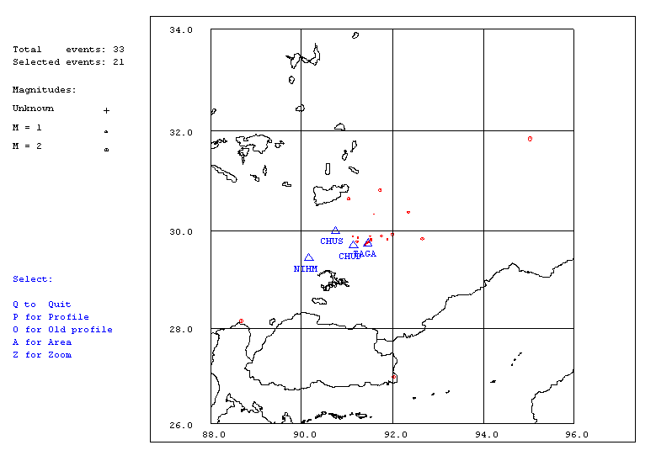
Figure 1. Seismicity of area around Lhasa for March 01-31, 2006. The network recorded 33 events for this time period and 21 could be located within the area shown.
Year Date HRMM Sec Latitud Longitud Depth AGA NST RMS Mc Ml
2006 3 1 0326 50.7 29.884 91.509 15.0 TBU 1 0.0 0.9 1.9
2006 3 2 1716 55.9 23.861 92.068 15.0 TBU 1 0.0 3.4 4.0
2006 3 3 722 56.2 TBU 0
2006 3 3 2241 46.4 29.835 92.660 15.0 TBU 1 0.0 1.8 1.4
2006 3 5 1511 4.9 TBU 0
2006 3 5 2335 34.8 TBU 0
2006 3 6 1652 38.0 28.143 88.672 15.0 TBU 1 0.0 2.4 2.3
2006 3 7 1050 17.1 29.782 91.477 15.0 TBU 1 0.4 1.0 1.0
2006 3 9 755 42.5 TBU 0
2006 3 9 1243 9.8 31.854 95.032 61.8 TBU 1 4.5 2.6 2.8
2006 3 9 1256 27.7 TBU 0
2006 3 9 2154 34.7 29.821 91.535 15.0 TBU 1 0.4 0.8 0.6
2006 3 9 2310 43.5 TBU 0
2006 311 1549 38.3 30.824 91.732 15.0 TBU 1 0.0 1.8 2.5
2006 313 2310 27.6 29.822 91.891 15.0 TBU 1 0.0 1.0 0.9
2006 316 0706 2.9 29.860 91.240 15.0 TBU 1 0.0 0.9 1.4
2006 319 0926 29.4 30.331 91.599 15.0 TBU 1 0.0 0.6 2.9
2006 320 145 54.8 TBU 0
2006 320 1741 53.8 29.892 91.755 15.0 TBU 1 0.0 1.5 1.7
2006 321 2143 8.4 29.775 91.222 15.0 TBU 2 3.2 1.3 1.6
2006 324 1029 4.9 30.370 92.351 15.0 TBU 1 0.0 1.5 1.8
2006 324 2109 8.0 30.644 91.042 15.0 TBU 1 0.0 1.7 1.7
2006 325 551 51.4 TBU 0
2006 325 2013 36.9 26.145 96.932 15.0 TBU 1 0.0 3.6 3.7
2006 327 0009 4.0 29.773 91.482 15.0 TBU 1 0.3 1.0 2.0
2006 328 1352 7.4 29.920 92.003 15.0 TBU 1 0.0 1.6 2.8
2006 328 2339 23.4 29.819 91.536 15.0 TBU 1 1.3 1.3 1.4
2006 329 1332 4.8 29.759 91.442 15.0 TBU 1 1.1 0.7 0.8
2006 329 1928 14.7 29.886 91.131 15.0 TBU 2 2.4 1.0 1.0
2006 330 1831 38.0 TBU 0
2006 330 2205 2.2 26.977 92.032 15.0 TBU 1 0.0 2.0 2.0
Table 2 . All events of March 2006 recorded by TBU. Abbreviations are: HRMM: Hour and minute, Sec, Seconds, L: L or D for local or distant event, respectively, AGA: Agency, NST: Number of station used, RMS: Root mean square of location residuals, Mc, Ml and Mb: Coda wave magnitude, local magnitude and body wave magnitude, respectively.

