Report for April, 2006

for

The University of Tibet Seismic Network (UTB)

Operated by

The Department of Science

Address: Environmental Physics institute. Lhasa. Tibet. PRC

Responsible: Tsering and Tsoja Wangmo
Email: ciring_ciring@yahoo.com, tsoja2@yahoo.com

This report provides a summary of activities related to the Tibet University Seismic Network (TBU) during the April of 2006. The report is divided into three sections.

Stations:

Station name | Code | Latitude(N) | Longitude(E) | Height(m)
Nhimo | NHIM | 29.4336° | 90.1643° | 3823
Chuding | CHUD | 29.6978° | 91.1438° | 3794
Chusang | CHUS | 29.9970° | 90.7462° | 4113
Tage | TAGA | 29.7400 ° | 91.4603° | 3788

Operation time for April

NIHM 08-19
TAGA 01-30 OK
CHUD 01-30 OK

NHIM:
1-7/4 2006: something wrong with data transfer by internet.
20/4 2006 - 9/5 2006: something wrong with data transfer by internet.

For the month of April a total of 29 events were recorded (Fig 1). Of these, 6 were located with 2 stations and 18 with one station (Figure 1).

The crustal model used for location is given in Table 1.

Depth (km) | Vp (km/s) | Vs (km/s)
0-27 | 6.0 | 3.4
27-41 | 6.5 | 3.7
41-61 | 7.0 | 4.0
>61 | 8.0 | 4.6
Table 1. Crustal model of the area around Lhasa

The magnitude scales used are:

Mc = 2.6log(coda) + 0.001dist –3.0
Ml = log (amp) – 1.11 log (dist) – 0.00189 dist – 2.09

Where Mc is coda magnitude, coda is coda length in seconds, dist is hypocentral distance in km, Ml is local magntude and amp is maximum S-amplitude in nm.

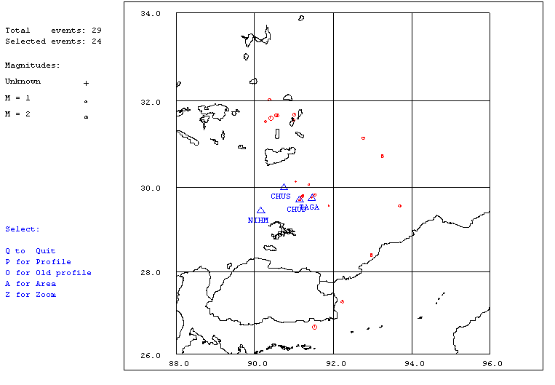
Figure 1. Seismicity of area around Lhasa for April 01-30, 2006. The network recorded 29 events for this time period and 24 could be located within the area shown. The all stations used are shown with triangles
Year Date HRMM Sec Latitud Longitud Depth AGA NST RMS Mc Ml
2006 4 1 1235 9.7 TBU 0
2006 4 1 1337 39.6 29.793 91.489 15.0 TBU 1 0.0 0.3 0.5
2006 4 2 15 1 33.0 TBU 0
2006 4 2 2151 26.2 29.819 91.536 15.0 TBU 1 1.3 1.4 1.4
2006 4 2 2153 30.3 29.756 91.449 15.0 TBU 1 1.1 0.8 0.9
2006 4 4 751 22.4 TBU 0
2006 4 6 0907 15.5 29.776 91.222 15.0 TBU 2 2.8 1.4 2.1
2006 4 7 1916 5.9 29.767 91.191 15.0 TBU 1 0.1 1.4 1.2
2006 4 7 2224 14.9 30.061 91.384 15.0 TBU 1 0.0 1.1 0.8
2006 4 7 2239 59.8 29.561 91.887 15.0 TBU 2 0.7 1.0 1.4
2006 4 8 1558 55.2 29.813 91.236 15.0 TBU 1 0.0 0.9 1.1
2006 4 8 2211 53.0 29.803 91.220 15.0 TBU 1 0.0 1.2 0.6
2006 4 9 1017 35.6 30.130 91.047 15.0 TBU 1 0.0 1.1 2.2
2006 410 1619 1.6 32.033 90.389 15.0 TBU 1 0.0 2.0 2.3
2006 411 0354 2.6 27.271 92.237 48.7 TBU 2 0.2 2.3 3.4
2006 412 1555 0.7 TBU 0
2006 415 1014 8.5 29.703 91.149 15.0 TBU 1 3.3 1.2 1.3
2006 419 2041 36.0 26.655 91.530 15.0 TBU 1 0.0 2.9 3.7
2006 419 2105 38.4 31.607 90.413 33.1 TBU 1 2.2 2.8 4.5
2006 419 2121 15.8 31.664 90.578 10.0 TBU 1 0.7 2.1 3.0
2006 419 2205 44.4 31.522 90.273 15.0 TBU 2 1.6 1.7 2.5
2006 419 2228 46.0 31.561 90.988 15.0 TBU 1 0.0 1.9 2.2
2006 420 2300 57.0 29.553 93.707 15.0 TBU 1 0.0 2.2 1.9
2006 421 946 14.9 TBU 0
2006 421 1455 11.8 31.148 92.774 15.0 TBU 2 2.4 1.9 2.6
2006 422 1252 5.1 30.726 93.255 15.0 TBU 1 0.0 2.1 2.3
2006 422 2049 13.5 28.390 92.982 15.0 TBU 1 0.0 2.0 2.4
2006 424 0041 45.3 31.692 91.005 15.0 TBU 2 1.3 2.1 2.7
2006 427 0049 17.7 31.674 90.541 41.1 TBU 1 0.6 2.2 3.8
Table 2. All events of April 2006 recorded by TBU. Abbreviations are: HRMM: Hour and minute, Sec, Seconds, L: L or D for local or distant event, respectively, AGA: Agency, NST: Number of station used, RMS: Root mean square of location residuals, Mc, Ml and Mb: Coda wave magnitude, local magnitude and body wave magnitude, respectively.

