Report for May, 2006

for

The University of Tibet Seismic Network (UTB)

Operated by

The Department of Science

Address: Environmental Physics institute. Lhasa. Tibet. PRC

Responsible: Tsering and Tsoja Wangmo
Email: ciring_ciring@yahoo.com, tsoja2@yahoo.com

This report provides a summary of activities related to the Tibet University Seismic Network (TBU) during the May of 2006. The report is divided into four sections.

Stations:

Station name | Code | Latitude(N) | Longitude(E) | Height(m)
Nhimo | NHIM | 29.4336° | 90.1643° | 3823
Chuding | CHUD | 29.6978° | 91.1438° | 3794
Chusang | CHUS | 29.9970° | 90.7462° | 4113
Tage | TAGA | 29.7400 ° | 91.4603° | 3788

Operation time for May

NIHM 10-15
TAGA 01-31 OK
CHUD 01-30 OK
CHUS 16-28 OK
NHIM:
1-9/5 2006: something wrong with data transfer by internet.
16-31/5 2006: something wrong with data transfer by internet.

For the month of May a total of 14 events were recorded (Fig 1). Of these, 1 was located with 2 stations and 9 with one station (Figure 1).

The crustal model used for location is given in Table 1.

Depth (km) | Vp (km/s) | Vs (km/s)
0-27 | 6.0 | 3.4
27-41 | 6.5 | 3.7
41-61 | 7.0 | 4.0
>61 | 8.0 | 4.6
Table 1. Crustal model of the area around Lhasa

The magnitude scales used are:

Mc = 2.6log(coda) + 0.001dist –3.0
Ml = log (amp) – 1.11 log (dist) – 0.00189 dist – 2.09

Where Mc is coda magnitude, coda is coda length in seconds, dist is hypocentral distance in km, Ml is local magntude and amp is maximum S-amplitude in nm.

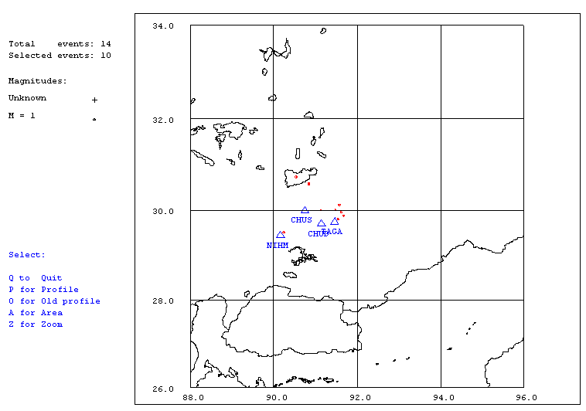
Figure 1. Seismicity of area around Lhasa for May 01-31, 2006. The network recorded 14 events for this time period and 10 could be located within the area shown. The all stations used are shown with triangles
Year Date HRMM Sec Latitud Longitud Depth AGA NST RMS Mc Ml
2006 5 4 1705 35.6 30.730 90.539 15.0 TBU 1 0.0 1.9 1.8
2006 5 6 031 59.9 TBU 0
2006 5 6 1753 24.2 30.581 90.845 15.0 TBU 1 0.0 1.4 0.9
2006 5 7 611 24.9 TBU 0
2006 5 8 1418 20.9 TBU 0
2006 5 9 2317 41.0 TBU 0
2006 511 1810 22.0 29.819 91.536 15.0 TBU 1 0.1 0.4 0.4
2006 512 1118 57.3 29.873 91.679 15.0 TBU 1 0.0 1.1 1.8
2006 512 1709 33.6 29.804 91.552 15.0 TBU 1 0.2 0.9 0.9
2006 515 1745 7.1 29.512 90.241 15.0 TBU 1 0.5 1.2 1.0
2006 516 1703 0.1 30.003 91.479 15.0 TBU 1 0.0 1.0 0.9
2006 518 0506 58.9 30.117 91.573 15.0 TBU 1 0.0 1.1 1.6
2006 519 2127 44.0 30.001 91.130 15.0 TBU 1 0.0 0.7 1.6
2006 530 1817 58.0 29.962 91.590 15.0 TBU 2 0.3 1.0 1.4
Table 2 . All events of May 2006 recorded by TBU. Abbreviations are: HRMM: Hour and minute, Sec, Seconds, L: L or D for local or distant event, respectively, AGA: Agency, NST: Number of station used, RMS: Root mean square of location residuals, Mc, Ml and Mb: Coda wave magnitude, local magnitude and body wave magnitude, respectively.

