Report for June, 2006

for

The University of Tibet Seismic Network (UTB)

Operated by

The Department of Science

Address: Environmental Physics institute. Lhasa. Tibet. PRC

Responsible: Tsering and Tsoja Wangmo
Email: ciring_ciring@yahoo.com, tsoja2@yahoo.com

This report provides a summary of activities related to the Tibet University Seismic Network (TBU) during the June of 2006. The report is divided into four sections.

Stations:

Station name | Code | Latitude(N) | Longitude(E) | Height(m)
Nhimo | NHIM | 29.4336° | 90.1643° | 3823
Chuding | CHUD | 29.6978° | 91.1438° | 3794
Chusang | CHUS | 29.9970° | 90.7462° | 4113
Tage | TAGA | 29.7400 ° | 91.4603° | 3788

Operation time for June
NIHM 20-30
TAGA 01-30 OK
CHUD 02-30 OK
CHUS 01-30 OK

NHIM:
01-19/6 2006: something wrong with data transfer by internet.

For the month of June a total of 14 events were recorded (Fig 1). Of these, 1 was located with 2 stations and 13 with one station (Figure 1).

The crustal model used for location is given in Table 1.

Depth (km) | Vp (km/s) | Vs (km/s)
0-27 | 6.0 | 3.4
27-41 | 6.5 | 3.7
41-61 | 7.0 | 4.0
>61 | 8.0 | 4.6
Table 1. Crustal model of the area around Lhasa

The magnitude scales used are:

Mc = 2.6log(coda) + 0.001dist –3.0
Ml = log (amp) – 1.11 log (dist) – 0.00189 dist – 2.09

Where Mc is coda magnitude, coda is coda length in seconds, dist is hypocentral distance in km, Ml is local magntude and amp is maximum S-amplitude in nm.

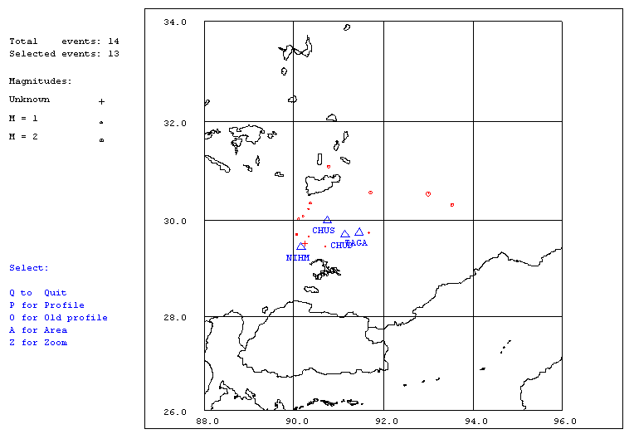
Figure 1. Seismicity of area around Lhasa for June 01-30, 2006. The network recorded 14 events for this time period and 13 could be located within the area shown. The all stations used are shown with triangles
Year Date HRMM Sec Latitud Longitud Depth AGA RMS Mc Ml
2006 6 8 0001 30.5 30.078 90.208 15.0 TES 0.0 1.5
2006 6 8 1021 17.6 29.739 91.676 15.0 TES 0.1 1.4 1.4
2006 6 8 1353 11.1 29.493 90.679 40.8 TES 1.2 0.6 1.6
2006 613 2105 21.8 30.019 90.107 15.0 TES 0.0 1.5 1.8
2006 617 1727 57.2 30.346 90.368 15.0 TES 0.0 1.4 1.6
2006 623 2039 44.3 30.535 93.006 15.0 TES 0.0 2.7 2.9
2006 626 1842 54.9 29.660 90.324 15.0 TES 0.0 0.5 1.4
2006 626 2120 51.8 29.705 90.066 15.0 TES 0.0 1.2 1.1
2006 627 0701 51.7 30.566 91.717 15.0 TES 0.0 1.6 1.4
2006 628 0052 57.1 30.313 93.537 15.0 TES 0.0 1.8 2.8
2006 628 0841 12.7 31.097 90.777 15.0 TES 0.0 1.7 1.8
2006 628 0853 47.7 29.513 90.240 15.0 TES 2.8 -0.4 3.4
2006 628 1516 18.6 30.227 90.326 15.0 TES 0.0 0.9 1.4

Table 2 . All events of June 2006 recorded by TBU. Abbreviations are: HRMM: Hour and minute, Sec, Seconds, L: L or D for local or distant event, respectively, AGA: Agency, NST: Number of station used, RMS: Root mean square of location residuals, Mc, Ml and Mb: Coda wave magnitude, local magnitude and body wave magnitude, respectively.

