Report for July, 2006

for

The University of Tibet Seismic Network (UTB)

Operated by

The Department of Science

Address: Environmental Physics institute. Lhasa. Tibet. PRC

Responsible: Tsering and Tsoja Wangmo
Email: ciring_ciring@yahoo.com, tsoja2@yahoo.com

This report provides a summary of activities related to the Tibet University Seismic Network (TBU) during the July of 2006. The report is divided into four sections.

Stations:

Station name | Code | Latitude(N) | Longitude(E) | Height(m)
Nhimo | NHIM | 29.4336° | 90.1643° | 3823
Chuding | CHUD | 29.6978° | 91.1438° | 3794
Chusang | CHUS | 29.9970° | 90.7462° | 4113
Tage | TAGA | 29.7400 ° | 91.4603° | 3788

Operation time for July

NIHM 01-07
TAGA 01-21 OK
CHUD 01-19 OK
CHUS 16-21 OK

For the month of July a total of 17 events were recorded (Fig 1). Of these, 2 were located with 2 stations, 1 was located with 3 stations, 1 was located with 4stations and 13 with one station (Figure 1).

The crustal model used for location is given in Table 1.

Depth (km) | Vp (km/s) | Vs (km/s)
0-27 | 6.0 | 3.4
27-41 | 6.5 | 3.7
41-61 | 7.0 | 4.0
>61 | 8.0 | 4.6

Table 1. Crustal model of the area around Lhasa

The magnitude scales used are:

Mc = 2.6log(coda) + 0.001dist –3.0
Ml = log (amp) – 1.11 log (dist) – 0.00189 dist – 2.09

Where Mc is coda magnitude, coda is coda length in seconds, dist is hypocentral distance in km, Ml is local magntude and amp is maximum S-amplitude in nm.

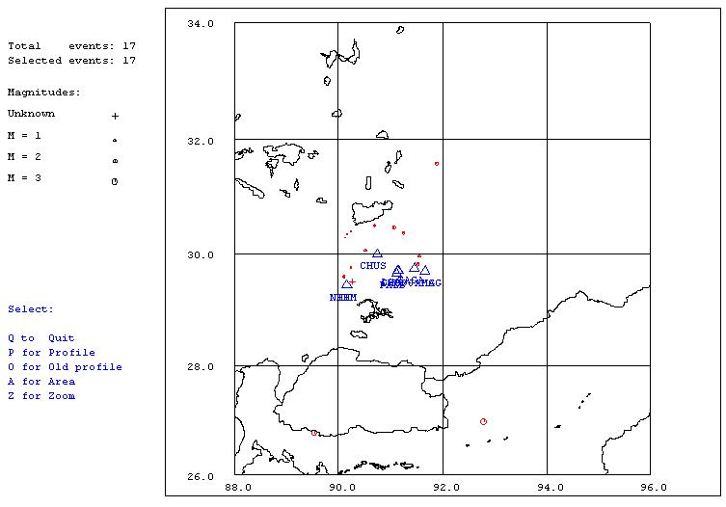
Figure 1. Seismicity of area around Lhasa for July 01-31, 2006. The network recorded 17 events for this time period and 17 could be located within the area shown. The all stations used are shown with triangles
Year Date HRMM Sec Latitud Longitud Depth AGA NST RMS Mc Ml
2006 7 3 0024 59.6 30.494 90.694 0.0 TBU 2 2.0 1.6 2.2
2006 7 3 1832 43.3 29.950 91.556 15.0 TBU 1 0.0 1.2 0.9
2006 7 5 1530 17.6 30.366 91.249 15.0 TBU 1 0.0 1.6 2.5
2006 7 6 1722 12.6 26.975 92.795 15.0 TBU 1 0.0 3.2
2006 713 1231 20.3 29.593 90.104 71.8 TBU 4 1.8 1.6 2.8
2006 713 2242 8.9 29.756 90.234 15.0 TBU 1 0.1 0.6 1.1
2006 715 0644 58.7 31.587 91.891 15.0 TBU 1 0.0 1.8 3.2
2006 717 1347 50.8 26.769 89.534 15.0 TBU 1 0.0 2.7 3.3
2006 717 2131 55.2 29.495 90.258 15.0 TBU 1 3.0 -0.5 0.6
2006 721 0712 56.4 30.542 90.422 15.0 TBU 1 0.0 1.0 1.9
2006 721 0720 24.0 30.461 91.070 15.0 TBU 3 2.5 1.4 2.4
2006 721 1635 29.0 30.060 90.519 77.8 TBU 2 0.3 1.0 -0.4
2006 722 1335 9.8 29.819 91.536 15.0 TBU 1 0.3 1.3 -1.5
2006 723 1503 17.5 29.781 91.487 15.0 TBU 1 0.1 0.3 -1.3
2006 724 0201 18.2 30.349 90.164 15.0 TBU 1 0.0 0.5 -0.2
2006 726 0801 47.6 30.284 90.134 15.0 TBU 1 0.0 0.3 -0.9
2006 730 0338 47.0 30.401 90.238 15.0 TBU 1 0.0 0.5 0.1
Table 2 . All events of July 2006 recorded by TBU. Abbreviations are: HRMM: Hour and minute, Sec, Seconds, L: L or D for local or distant event, respectively, AGA: Agency, NST: Number of station used, RMS: Root mean square of location residuals, Mc, Ml and Mb: Coda wave magnitude, local magnitude and body wave magnitude, respectively.

