Report for August, 2006

for

The University of Tibet Seismic Network (UTB)

Operated by

The Department of Science

Address: Environmental Physics institute. Lhasa. Tibet. PRC

Responsible: Tsoja Wangmo
Email: tsoja2@yahoo.com

The UTB network operates short period stations in and around Lhasa with the purpose of studying the local seismicity. The first station started operating on June 18, 2004. The network is considered experimental and stable operation cannot be expected before more experience is gained. All data is freely available on request.

Stations:
Station name | Code | Latitude(N) | Longitude(E) | Height(m)
Nhimo | NHIM | 29.4336° | 90.1643° | 3823
Chuding | CHUD | 29.6978° | 91.1438° | 3794
Chusang | CHUS | 29.9970° | 90.7462° | 4113
Tage | TAGA | 29.7400 ° | 91.4603° | 3788
Operation of stations in August 2006

TAGA
Down August 9-11, 29-31 : System could not restart after power failure

NHIM
Down August 24 : Because no power at the meteorology station

CHUD
Down August 23-25 : System could not restart after power failure

CHUS
Down August 23-26:. System down because of lighting strike

For the month of August a total of 22 events were recorded (Table 2). All those were located with one station (see Figure 1), the one station locations must be considered very uncertain due to the uncertainty in azimuth determination.

The crustal model used for location is given in Table 1.

Depth (km) | Vp (km/s) | Vs (km/s)
0-27 | 6.0 | 3.4
27-41 | 6.5 | 3.7
41-61 | 7.0 | 4.0
>61 | 8.0 | 4.6
Table 1. Crustal model of the area around Lhasa

The magnitude scales used are:
Mc = 2.6log(coda) + 0.001dist –3.0
Ml = log (amp) – 1.11 log (dist) – 0.00189 dist – 2.09

where Mc is coda magnitude, coda is coda length in seconds, dist is hypocentral distance in km, Ml is local magntude and amp is maximum S-amplitude in nm.

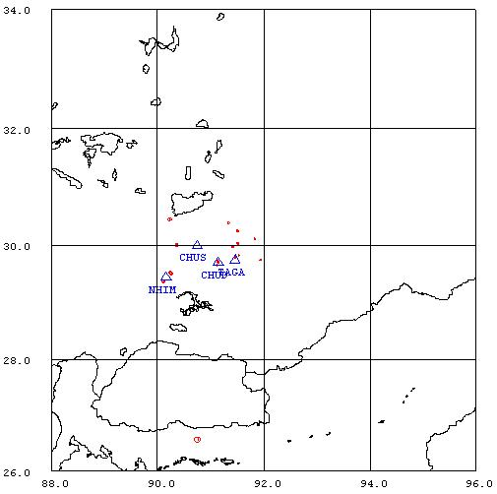

Figure 1. Seismicity of area around Lhasa for August 01-31, 2006. The network recorded 22 events for this time period and 20 could be located within the area shown.

Year Date HRMM Sec L Latitud Longitud Depth AGA NST RMS Mc Ml
2006 8 7 1352 32.4 L 30.447 90.226 15.0 TBU 1 0.0 1.7 1.6
2006 8 9 1437 15.6 L 34.669 93.453 15.0 TBU 1 0.0 3.4 4.1
2006 811 0535 43.3 L 29.519 90.234 13.8 TBU 1 70.0 1.3 1.7
2006 812 2045 36.2 L 27.979 98.425 15.0 TBU 1 0.0 4.0 4.6
2006 813 1719 16.5 L 29.706 91.146 15.0 TBU 1 2.5 1.0 0.8
2006 814 2051 49.4 L 29.755 91.954 15.0 TBU 1 0.2 0.9 0.9
2006 817 0748 23.1 L 29.791 91.453 15.0 TBU 1 0.7 1.1 1.5
2006 819 2336 4.9 L 29.728 91.133 15.0 TBU 1 2.4 0.6 0.7
2006 820 1546 46.5 L 29.651 91.118 15.0 TBU 1 2.8 0.8 1.0
2006 820 2241 50.3 L 29.994 90.366 15.0 TBU 1 0.0 1.6 1.3
2006 821 0427 2.6 L 30.382 91.337 15.0 TBU 1 0.0 1.3 1.4
2006 821 0944 45.7 L 29.819 91.537 15.0 TBU 1 2.1 0.7 1.4
2006 821 1510 39.3 L 29.968 91.425 15.0 TBU 1 0.0 0.9 0.8
2006 824 1908 53.9 L 30.250 91.507 15.0 TBU 1 0.1 1.2 1.1
2006 826 2021 45.8 L 30.109 91.832 15.0 TBU 1 0.0 0.7 1.0
2006 827 1653 14.0 L 30.029 91.512 15.0 TBU 1 0.1 1.5 1.6
2006 828 1731 46.9 L 29.498 90.256 15.0 TBU 1 3.3 1.6 1.4
2006 829 1617 49.9 L 29.495 90.258 15.0 TBU 1 2.3 0.5 0.9
2006 830 1258 16.2 L 29.366 90.127 15.0 TBU 1 3.2 1.0 1.7
2006 830 1718 4.6 L 29.377 90.116 15.0 TBU 1 3.2 1.7 2.0
2006 830 1836 32.8 L 29.374 90.118 15.0 TBU 1 28.8 1.6 1.1
2006 831 0536 12.5 L 26.566 90.755 15.0 TBU 1 0.0 3.0 3.5
Table 2 . All events of August 2006 recorded by TBU. Abbreviations are: HRMM: Hour and minute, Sec, Seconds, L: L or D for local or distant event, respectively, AGA: Agency, NST: Number of station used, RMS: Root mean square of location residuals, Mc, Ml and Mb: Coda wave magnitude, local magnitude and body wave magnitude, respectively.

