Report for September, 2006

for

The University of Tibet Seismic Network (UTB)

Operated by

The Department of Science

Address: Environmental Physics institute. Lhasa. Tibet. PRC

Responsible: Tsoja Wangmo
Email: tsoja2@yahoo.com

The UTB network operates short period stations in and around Lhasa with the purpose of studying the local seismicity. The first station started operating on June 18, 2004. The network is considered experimental and stable operation cannot be expected before more experience is gained. All data is freely available on request.

Stations:
Station name | Code | Latitude(N) | Longitude(E) | Height(m)
Nhimo | NHIM | 29.4336° | 90.1643° | 3823
Chuding | CHUD | 29.6978° | 91.1438° | 3794
Chusang | CHUS | 29.9970° | 90.7462° | 4113
Tage | TAGA | 29.7400 ° | 91.4603° | 3788

Operation of stations in September 2006

TAGA
Down September 9, 12-13, 20-21, 29 : system could not restart after power failure

NHIM
Down September 12-14 : No power in the meteorology station for two days .

CHUD
Station running stable ..

CHUS
Station running stable ..

For the month of September a total of 29 events were recorded (Table 2). Of these, 26 were located with one station (see Figure 1) and 3 events located with two stations, the one station locations must be considered very uncertain due to the uncertainty in azimuth determination.

The crustal model used for location is given in Table 1.

Depth (km) | Vp (km/s) | Vs (km/s)
0-27 | 6.0 | 3.4
27-41 | 6.5 | 3.7
41-61 | 7.0 | 4.0
>61 | 8.0 | 4.6
Table 1. Crustal model of the area around Lhasa

The magnitude scales used are:
Mc = 2.6log(coda) + 0.001dist –3.0
Ml = log (amp) – 1.11 log (dist) – 0.00189 dist – 2.09

where Mc is coda magnitude, coda is coda length in seconds, dist is hypocentral distance in km, Ml is local magnitude and amp is maximum S-amplitude in nm

.

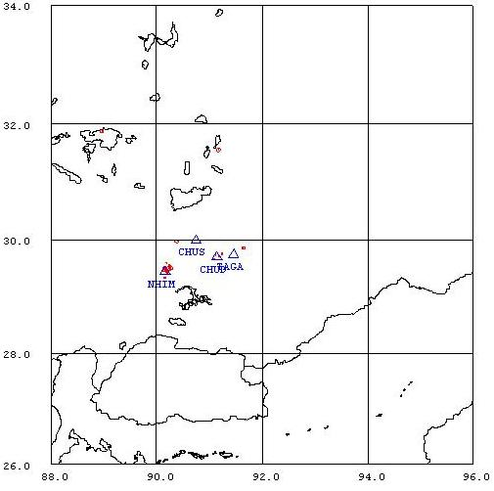
Figure 1. Seismicity of area around Lhasa for September 01-30, 2006. The network recorded 29 events for this time period and 28 could be located within the area shown.

Year Date HRMM Sec L Latitud Longitud Depth AGA NST RMS Mc Ml
2006 9 3 1832 16.6 L 29.428 90.213 15.0 TBU 1 3.7 0.9 1.1
2006 9 4 1340 9.4 L 29.454 90.200 15.0 TBU 1 3.1 1.4 1.6
2006 9 4 1400 41.0 L 29.333 90.161 15.0 TBU 1 3.3 0.8 1.3
2006 910 0122 38.0 L 29.459 90.161 15.0 TBU 1 2.4 1.7 1.9
2006 914 0156 0.9 L 29.558 90.242 15.0 TBU 1 0.0 0.4 0.5
2006 915 2141 21.5 L 31.880 88.969 15.0 TBU 1 0.0 2.1 2.7
2006 918 1548 51.4 L 29.474 90.203 15.0 TBU 1 1.9 0.5 0.8
2006 919 2015 29.0 L 29.600 90.184 0.0 TBU 2 1.7 0.5 0.2
2006 922 1707 5.8 L 29.514 90.239 15.0 TBU 1 2.8 0.6 0.3
2006 927 0217 41.4 L 31.557 91.174 15.0 TBU 1 0.0 2.1 2.2
2006 927 1105 27.4 L 29.735 91.112 15.0 TBU 1 3.6 1.0 0.9
2006 927 1402 18.3 L 29.434 90.206 0.0 TBU 2 2.6 1.7 2.2
2006 927 1413 10.8 L 29.497 90.256 15.0 TBU 1 3.3 1.3 1.1
2006 928 1250 13.3 L 29.494 90.259 15.0 TBU 1 3.3 1.0 1.1
2006 928 1304 52.4 L 29.500 90.253 15.0 TBU 1 3.3 1.1 1.2
2006 928 1309 15.1 L 29.969 90.386 15.0 TBU 1 0.0 1.9 2.2
2006 928 1334 33.2 L 29.500 90.253 15.0 TBU 1 3.3 1.1 1.6
2006 928 1407 24.7 L 29.498 90.255 15.0 TBU 1 3.3 2.8 3.1
2006 928 1417 34.9 L 29.496 90.257 15.0 TBU 1 3.5 1.1 1.1
2006 928 1509 55.8 L 29.499 90.254 15.0 TBU 1 3.4 0.9 1.5
2006 929 1124 50.3 L 29.755 91.242 15.0 TBU 1 0.7 1.1 1.0
2006 929 1422 6.6 L 29.658 91.085 15.0 TBU 1 3.1 0.5 0.4
2006 929 1426 37.0 L 29.858 91.647 15.0 TBU 1 0.0 1.3 1.4
2006 930 1144 57.8 L 29.498 90.153 15.0 TBU 1 3.2 1.7 1.7
2006 930 1304 29.7 L 29.494 90.259 15.0 TBU 1 3.3 0.9 1.3
2006 930 1758 45.0 D TBU 2
2006 930 2008 25.8 L 29.499 90.254 15.0 TBU 1 3.3 1.0 1.2
2006 930 2247 15.3 L 29.715 91.184 15.0 TBU 1 2.6 0.6 0.8
2006 930 2254 58.0 L 29.456 90.180 15.0 TBU 1 2.3 1.2 1.4
Table 2 . All events of September 2006 recorded by TBU. Abbreviations are: HRMM: Hour and minute, Sec, Seconds, L: L or D for local or distant event, respectively, AGA: Agency, NST: Number of station used, RMS: Root mean square of location residuals, Mc, Ml and Mb: Coda wave magnitude, local magnitude and body wave magnitude, respectively.

