Report for October, 2006

for

The University of Tibet Seismic Network (UTB)

Operated by

The Department of Science

Address: Environmental Physics institute. Lhasa. Tibet. PRC

Responsible: Tsoja Wangmo
Email: tsoja2@yahoo.com

The UTB network operates short period stations in and around Lhasa with the purpose of studying the local seismicity. The first station started operating on June 18, 2004. The network is considered experimental and stable operation cannot be expected before more experience is gained. All data is freely available on request.

Stations:
Station name | Code | Latitude(N) | Longitude(E) | Height(m)
Nhimo | NHIM | 29.4336° | 90.1643° | 3823
Chuding | CHUD | 29.6978° | 91.1438° | 3794
Chusang | CHUS | 29.9970° | 90.7462° | 4113
Tage | TAGA | 29.7400 ° | 91.4603° | 3788

Operation of stations in October 2006

TAGA
Down October 5-10, 18-19, 25: system could not restart after power failure .

NHIM
Down October 18-23 : since the person who take care of the system is away ,so the system could not restart after power failure .

CHUD
Station running stable .

CHUS
Down October 25-29: System could not restart after power failure.

For the month of December a total of 38 events were recorded (Table 2). Of these, 35 were located with one station (see Figure 1) and 3 events located with two stations, the one station locations must be considered very uncertain due to the uncertainty in azimuth determination.

The crustal model used for location is given in Table 1.

Depth (km) | Vp (km/s) | Vs (km/s)
0-27 | 6.0 | 3.4
27-41 | 6.5 | 3.7
41-61 | 7.0 | 4.0
>61 | 8.0 | 4.6
Table 1. Crustal model of the area around Lhasa

The magnitude scales used are:
Mc = 2.6log(coda) + 0.001dist –3.0
Ml = log (amp) – 1.11 log (dist) – 0.00189 dist – 2.09

where Mc is coda magnitude, coda is coda length in seconds, dist is hypocentral distance in km, Ml is local magntude and amp is maximum S-amplitude in nm.

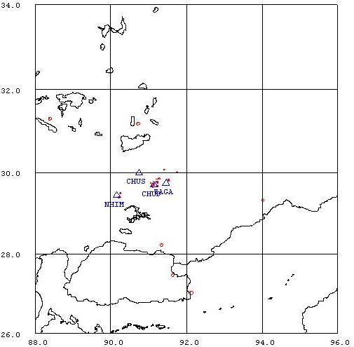
Figure 1. Seismicity of area around Lhasa for October 01-31, 2006. The network recorded 38 events for this time period and 37 could be located within the area shown.

Year Date HRMM Sec L Latitud Longitud Depth AGA NST RMS Mc Ml
2006 10 1 1312 6.8 L 29.496 90.258 15.0 TBU 1 0.4 1.1 1.7
2006 10 1 1404 54.2 L 29.723 91.129 15.0 TBU 1 1.7 0.7 0.8
2006 10 1 1710 46.3 L 29.839 91.307 15.0 TBU 1 0.0 1.0 1.0
2006 10 3 1126 34.7 L 29.740 91.062 15.0 TBU 1 3.5 0.7 1.0
2006 10 3 1217 11.0 L 30.075 91.410 15.0 TBU 1 0.0 1.1 1.3
2006 10 3 1710 5.6 L 29.819 91.536 15.0 TBU 2 0.7 1.3 1.3
2006 10 5 0055 41.8 L 29.499 90.254 15.0 TBU 1 3.3 1.3 1.4
2006 10 5 1241 56.7 L 29.779 91.218 15.0 TBU 1 2.8 1.0 1.1
2006 10 5 1940 56.0 D TBU 1
2006 10 6 1147 33.8 L 29.778 91.218 15.0 TBU 1 1.7 0.6 1.1
2006 10 6 1240 32.5 L 29.678 91.233 15.0 TBU 1 2.1 0.9 1.2
2006 10 6 2041 38.8 L 29.395 90.215 15.0 TBU 1 1.8 1.2 1.3
2006 10 8 1435 35.2 L 29.698 91.143 15.0 TBU 1 0.8 0.8 0.9
2006 10 9 2245 50.1 L 29.669 91.079 15.0 TBU 1 3.1 0.6 0.7
2006 10 9 2343 28.9 L 29.684 91.080 15.0 TBU 1 2.8 0.4 0.9
2006 1010 1747 11.1 L 29.326 94.023 15.0 TBU 1 0.0 1.9 1.8
2006 1010 2111 41.5 L 29.724 91.138 15.0 TBU 1 1.6 0.3 0.5
2006 1010 2225 21.5 L 29.498 90.255 15.0 TBU 1 3.2 0.7 1.0
2006 1011 0751 43.3 L 28.227 91.345 15.0 TBU 1 0.0 2.1 2.9
2006 1011 1713 5.9 L 29.627 91.110 15.0 TBU 1 3.3 0.2 0.5
2006 1011 1759 43.1 L 29.635 91.106 15.0 TBU 1 3.2 0.4 0.6
2006 1012 1848 13.7 L 29.497 90.256 15.0 TBU 1 3.3 1.0 1.3
2006 1012 1941 19.3 L 29.498 90.255 15.0 TBU 1 3.2 1.2 1.5
2006 1012 2025 17.7 L 29.498 90.256 15.0 TBU 1 3.2 0.9 1.2
2006 1012 2143 1.4 L 29.819 91.536 15.0 TBU 1 0.6 0.8 0.7
2006 1012 2323 0.5 L 31.298 88.384 15.0 TBU 1 0.0 2.3 2.6
2006 1014 0118 52.4 L 27.027 92.117 15.0 TBU 1 0.0 2.9 3.5
2006 1014 0526 22.6 L 29.735 91.105 15.0 TBU 1 3.4 0.7 1.0
2006 1019 1354 1.7 L 29.676 91.092 15.0 TBU 1 2.8 0.4 0.9
2006 1021 2045 35.1 L 29.760 91.237 15.0 TBU 1 2.6 0.1 0.5
2006 1021 2329 11.4 L 29.840 91.213 15.0 TBU 1 0.0 0.8 0.7
2006 1024 1158 20.9 L 29.763 91.234 15.0 TBU 1 1.0 1.4 1.5
2006 1024 1748 17.2 L 31.186 90.717 0.0 TBU 2 5.7 2.4 2.3
2006 1027 2208 0.9 L 27.470 91.647 15.0 TBU 1 0.0 2.1 2.3
2006 1028 1058 44.0 L 29.749 91.168 15.0 TBU 1 0.1 0.9 1.3
2006 1029 1024 20.4 L 29.819 91.537 15.0 TBU 2 1.8 1.3 0.7
2006 1029 2133 37.3 L 30.010 91.749 15.0 TBU 1 0.0 1.1 1.0
2006 1031 0510 33.7 L 29.734 91.108 15.0 TBU 1 3.4 0.9 1.0
Table 2 . All events of October 2006 recorded by TBU. Abbreviations are: HRMM: Hour and minute, Sec, Seconds, L: L or D for local or distant event, respectively, AGA: Agency, NST: Number of station used, RMS: Root mean square of location residuals, Mc, Ml and Mb: Coda wave magnitude, local magnitude and body wave magnitude, respectively.

