Report for November, 2006

for

The University of Tibet Seismic Network (UTB)

Operated by

The Department of Science

Address: Environmental Physics institute. Lhasa. Tibet. PRC

Responsible: Tsoja Wangmo
Email: tsoja2@yahoo.com

The UTB network operates short period stations in and around Lhasa with the purpose of studying the local seismicity. The first station started operating on June 18, 2004. The network is considered experimental and stable operation cannot be expected before more experience is gained. All data is freely available on request.

Stations:
Station name | Code | Latitude(N) | Longitude(E) | Height(m)
Nhimo | NHIM | 29.4336° | 90.1643° | 3823
Chuding | CHUD | 29.6978° | 91.1438° | 3794
Chusang | CHUS | 29.9970° | 90.7462° | 4113
Tage | TAGA | 29.7400 ° | 91.4603° | 3788
Operation of stations in November 2006

TAGA
Down November 5-6, 9 : No power in the village

NHIM
Station running stable

CHUD
Down November 4, 11-12, no power in the monastery .

CHUS
Station running stable

For the month of November a total of 39 events were recorded (Table 2). Of these, 30 were located with one station (see Figure 1) and 9 events located with two or more than two stations, the one station locations must be considered very uncertain due to the uncertainty in azimuth determination.

The crustal model used for location is given in Table 1.

Depth (km) | Vp (km/s) | Vs (km/s)
0-27 | 6.0 | 3.4
27-41 | 6.5 | 3.7
41-61 | 7.0 | 4.0
>61 | 8.0 | 4.6
Table 1. Crustal model of the area around Lhasa

The magnitude scales used are:
Mc = 2.6log(coda) + 0.001dist –3.0
Ml = log (amp) – 1.11 log (dist) – 0.00189 dist – 2.09

where Mc is coda magnitude, coda is coda length in seconds, dist is hypocentral distance in km, Ml is local magnitude and amp is maximum S-amplitude in nm.

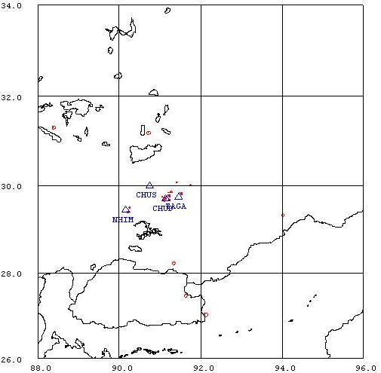
Figure 1. Seismicity of area around Lhasa for November 01-31, 2005. The network recorded 39 events for this time period and 29 could be located within the area shown.

Year Date HRMM Sec L Latitud Longitud Depth AGA NST RMS Mc Ml
2006 11 2 1532 23.3 L 29.690 91.042 15.0 TBU 1 3.3 0.7 0.8
2006 11 3 1443 21.7 L 23.310 92.974 15.0 TBU 1 0.0 3.8 3.9
2006 11 3 1555 48.3 L 30.398 93.745 15.0 TBU 1 0.0 2.1 1.6
2006 11 5 1233 44.0 L 29.668 91.080 15.0 TBU 1 3.1 0.3 0.3
2006 11 6 0119 55.3 L 25.010 94.956 4.3 TBU 3 4.7 3.7 4.4
2006 11 7 0426 12.9 L 29.628 92.054 15.0 TBU 1 0.0 2.1 1.6
2006 11 7 0753 36.2 L 29.800 92.095 15.0 TBU 1 0.0 1.5 1.5
2006 11 7 1749 0.0 D TBU 1
2006 1111 2120 1.6 L 26.983 89.844 15.0 TBU 1 0.0 2.2 1.8
2006 1111 2353 45.9 L 28.354 92.222 15.0 TBU 2 5.1 2.3 2.3
2006 1112 0514 24.9 L 29.451 92.663 15.0 TBU 1 0.0 1.6 1.6
2006 1113 1851 9.4 L 30.077 90.821 15.0 TBU 1 0.8 0.7 1.3
2006 1114 1303 31.1 L 30.270 92.691 15.0 TBU 1 0.0 1.9 1.8
2006 1114 1340 35.3 L 29.820 91.536 15.0 TBU 1 1.7 0.6 0.7
2006 1114 1429 3.0 L 29.087 91.290 24.7 TBU 3 4.3 1.6 1.9
2006 1114 1716 21.8 L 29.879 91.480 15.0 TBU 1 0.0 1.1 0.7
2006 1115 1122 40.2 L 29.962 91.563 195.5 TBU 2 0.2 3.1 3.2
2006 1115 1149 52.4 L 29.961 90.233 15.0 TBU 1 0.0 2.3 2.6
2006 1115 1905 27.3 L 30.226 91.516 15.0 TBU 1 0.3 1.2 1.1
2006 1115 2127 54.8 D 43.585 95.807 15.0 TBU 3 0.0
2006 1115 2140 6.5 D 29.060 91.534 27.6 TBU 3 0.3 2.7
2006 1115 2215 51.4 L 29.808 90.475 15.0 TBU 1 0.0 1.0 1.8
2006 1115 2309 4.1 L 29.464 90.210 15.0 TBU 1 2.9 1.0 1.1
2006 1115 2323 59.1 L 29.435 90.164 15.0 TBU 1 2.9 0.7 0.6
2006 1116 033 9.0 D TBU 1
2006 1118 046 26.0 D TBU 1
2006 1118 1400 6.3 D 25.005 87.686 15.4 TBU 2 71.4 2.7 3.3
2006 1118 1645 35.0 D TBU 0
2006 1122 1906 35.3 L 30.010 91.207 15.0 TBU 1 0.0 0.8 0.6
2006 1123 1026 44.0 L 29.776 91.220 15.0 TBU 2 3.5 1.0 1.3
2006 1124 2110 36.0 D TBU 1
2006 1125 1935 54.0 D TBU 1
2006 1126 1804 18.9 L 29.573 92.601 0.0 TBU 2 8.4 2.3 1.9
2006 1126 1943 6.0 L 30.291 91.530 15.0 TBU 1 0.3 1.2 1.1
2006 1127 1402 20.2 L 30.163 90.365 15.0 TBU 1 0.0 1.2 1.8
2006 1128 1928 45.1 L 29.713 93.310 15.0 TBU 1 0.0 1.6 1.5
2006 1129 0944 51.5 L 30.023 91.083 15.0 TBU 1 0.0 1.1 1.7
2006 1129 1819 19.7 L 29.837 92.188 15.0 TBU 1 0.0 1.3 1.6
2006 1130 1541 56.0 L 29.853 91.513 15.0 TBU 1 0.0 0.8 0.9
Table 2 . All events of November 2006 recorded by TBU. Abbreviations are: HRMM: Hour and minute, Sec, Seconds, L: L or D for local or distant event, respectively, AGA: Agency, NST: Number of station used, RMS: Root mean square of location residuals, Mc, Ml and Mb: Coda wave magnitude, local magnitude and body wave magnitude, respectively.

