Report for December, 2006

for

The University of Tibet Seismic Network (UTB)

Operated by

The Department of Science

Address: Environmental Physics institute. Lhasa. Tibet. PRC

Responsible: Tsoja Wangmo
Email: tsoja2@yahoo.com

The UTB network operates short period stations in and around Lhasa with the purpose of studying the local seismicity. The first station started operating on June 18, 2004. The network is considered experimental and stable operation cannot be expected before more experience is gained. All data is freely available on request.

Stations:
Station name | Code | Latitude(N) | Longitude(E) | Height(m)
Nhimo | NHIM | 29.4336° | 90.1643° | 3823
Chuding | CHUD | 29.6978° | 91.1438° | 3794
Chusang | CHUS | 29.9970° | 90.7462° | 4113
Tage | TAGA | 29.7400 ° | 91.4603° | 3788

Operation of stations in December 2006

TAGA
Down December 10-11: Because of power down.

NHIM
Station running stable

CHUD
Station running stable

CHUSg
Station running stable

For the month of December a total of 40 events were recorded (Table 2). Of these, 27 were located with one station (see Figure 1) and 13 events located with two or more stations, the one station locations must be considered very uncertain due to the uncertainty in azimuth determination.

The crustal model used for location is given in Table 1.

Depth (km) | Vp (km/s) | Vs (km/s)
0-27 | 6.0 | 3.4
27-41 | 6.5 | 3.7
41-61 | 7.0 | 4.0
>61 | 8.0 | 4.6
Table 1. Crustal model of the area around Lhasa

The magnitude scales used are:
Mc = 2.6log(coda) + 0.001dist –3.0
Ml = log (amp) – 1.11 log (dist) – 0.00189 dist – 2.09

where Mc is coda magnitude, coda is coda length in seconds, dist is hypocentral distance in km, Ml is local magntude and amp is maximum S-amplitude in nm.

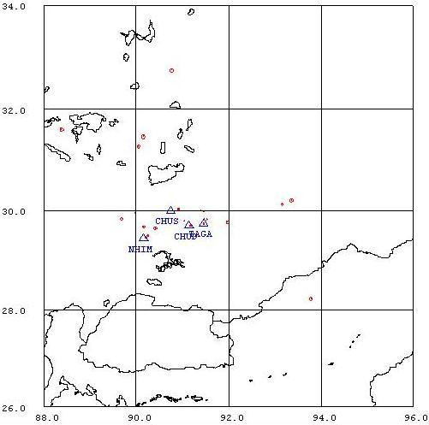
Figure 1. Seismicity of area around Lhasa for December 01-31, 2005. The network recorded 40 events for this time period and 22 could be located within the area shown.

Year Date HRMM Sec L Latitud Longitud Depth AGA NST RMS Mc Ml
2006 12 1 0402 39.9 L 25.828 91.744 15.0 TBU 1 0.0 3.3 3.0
2006 12 1 2231 25.7 L 29.946 89.980 0.0 TBU 2 0.6 1.2 1.7
2006 12 2 0638 48.6 L 29.695 91.180 15.0 TBU 1 1.4 1.2 1.0
2006 12 2 1127 47.2 L 29.497 90.256 15.0 TBU 1 2.9 1.3 1.9
2006 12 2 1148 58.3 L 29.740 91.464 15.0 TBU 1 0.3 1.2 1.1
2006 12 3 0216 56.5 L 30.200 93.363 15.0 TBU 1 0.0 2.2 2.3
2006 12 3 1321 4.7 L 29.831 89.688 15.0 TBU 2 0.1 1.5 1.9
2006 12 3 2059 28.7 L 29.498 90.255 15.0 TBU 1 2.9 1.0 1.2
2006 12 3 2332 11.8 L 29.820 91.535 15.0 TBU 1 0.0 0.7 0.2
2006 12 4 1830 56.0 L 32.762 90.765 15.0 TBU 1 0.0 2.4 2.3
2006 12 6 1844 49.0 D TBU 0
2006 12 7 0541 16.4 L 30.127 93.158 15.0 TBU 1 0.0 1.6 1.8
2006 12 7 1915 48.7 D 15.826 97.631 15.0 TBU 3 1.8
2006 12 7 2121 28.9 L 29.980 91.458 15.0 TBU 1 0.0 0.4 1.0
2006 12 7 2134 20.8 L 29.997 91.402 15.0 TBU 1 0.0 0.9 0.7
2006 12 7 2218 29.6 L 28.220 93.782 15.0 TBU 1 0.0 2.0 1.9
2006 12 9 1456 17.6 L 29.646 90.415 152.8 TBU 2 3.7 1.8 2.3
2006 12 9 23 0 11.0 D TBU 1
2006 1210 2248 29.3 L 29.901 96.275 17.1 TBU 2 3.6 3.2 3.6
2006 1212 1554 51.0 D TBU 1
2006 1214 0759 4.9 L 29.794 91.038 0.1 TBU 2 1.2 0.7 1.1
2006 1215 0055 2.0 L 30.028 90.920 107.3 TBU 2 0.4 1.2 1.7
2006 1215 17 7 31.0 D TBU 1
2006 1215 23 1 29.0 D TBU 1
2006 1216 2029 11.0 D TBU 1
2006 1217 1838 12.1 L 31.270 90.059 3.4 TBU 2 2.8 1.9 2.1
2006 1217 2115 4.0 D TBU 2
2006 1219 2341 16.4 L 31.602 88.386 15.0 TBU 2 1.5 2.3 2.0
2006 1220 1030 20.5 L 25.786 90.340 15.0 TBU 1 0.0 3.0 3.8
2006 1220 1302 45.3 L 29.765 91.977 15.0 TBU 1 0.4 1.6 2.0
2006 1222 1954 30.0 D TBU 2
2006 1222 2155 1.7 L 29.669 90.164 15.0 TBU 1 0.2 1.0 1.5
2006 1223 2142 46.0 D TBU 1
2006 1223 2345 18.0 D TBU 1
2006 1224 1721 38.8 L 31.461 90.156 9.5 TBU 2 2.2 2.5 2.8
2006 1225 20 4 28.0 D TBU 1
2006 1226 1239 28.0 D TBU 1
2006 1227 2025 37.0 D TBU 2
2006 1231 1948 36.3 L 29.456 90.208 15.0 TBU 1 0.1 1.2 1.9
2006 1231 2136 56.0 D TBU 1
Table 2 . All events of December 2006 recorded by TBU. Abbreviations are: HRMM: Hour and minute, Sec, Seconds, L: L or D for local or distant event, respectively, AGA: Agency, NST: Number of station used, RMS: Root mean square of location residuals, Mc, Ml and Mb: Coda wave magnitude, local magnitude and body wave magnitude, respectively.

