Tibet University Seismic Network
Summary report 2004-2006

by
Tsoja Wangmo
Tsering

Tibet University

August 2006

Introduction

This report provides a summary of activities related to the Tibet University Seismic Network (TBU) during the first three years of the project (2003-2006). The report is divided into four sections. First is given a presentation of the network development together with its current status and future wishes. Following is a summary of the network operation and a description of the data recorded by the network so far. At the end is given a technical report listing available data and causes for data loss.

Network

The Faculty of Natural Science of the University of Bergen has a close cooperation with the University of Tibet, and in 2003, funds were allocated to the Department of Earth Science to start building a small seismic network around Lhasa. Equipment for 3 stations was acquired using project funds for 2003 and suitable sites were located during a field work. 3 new stations were installed, however some technical problems arose due to the extreme elevation and only one station was partially operating in Lhasa. Operation was also difficult since no qualified personnel were available in Lhasa.

The project only really stated being active when Tsoja Wangmo finished her MSc in June 2004 and returned to Lhasa. In June 2004, Helge Johnsen visited Tibet and reinstalled the stations with new equipment, so by the beginning of July, 3 stations were in operation. Jens Havskov made a 2 week visit in August-September 2004. During this trip, further refinement of the network was made and one station was moved to a better location in Lhasa. The network at that time consisted of 4 stations. Two stations were located outside Lhasa in Jamag and Nhimo and two in Lhasa. One station is placed at the University seismological laboratory and is intended to continuously show a real time signal on a display. Due to the high noise level, this station will not record much, but it is good for public relations. Unfortunately the station has had many operational problems and has at no time been in stable operation. The other station in Lhasa was located in the Palub monastery (PALB), which has a rather deep cave with good signal to noise characteristics. Due to somebody tampering with the equipment, it had to be moved to a safer location within the monastery and started operating there on June 22, 2004. In 2005 the station had to be moved due to the monks at PALB not wanting to house the equipment anymore. A new station was established at the Chudi monastery (4 km from Lhasa) in April 2005 to replace PALB. Unfortunately some parameters were set up wrongly, and the station did not record anything until June 22, 2005. The Jamag station had good quality of data, but it has been difficult to visit the station to get data due to bad road conditions, especially in winter time. Based on this reason, JAMG has been moved out of the valley to a new site, TAGA, on Jan 19, 2006. The new station has good data quality as well, as see in the waveform in Figure 1. On Aug 25, 2005 a new station has been installed at the Chupsang monastery (CHUS) to improve data coverage north of Lhasa. In total, 4 stations are currently available for recording as shown in figure 2. There are three stations outside Lhasa (TAGA, NHIM and CHUS) and one in Lhasa (CHUD). In addition, equipment is installed at the university campus, which is currently not in operation. All stations operate quite stable except for occasional problems with PC restart after power failure. This has been solved by teaching local people to manually restart the PC after power failure.

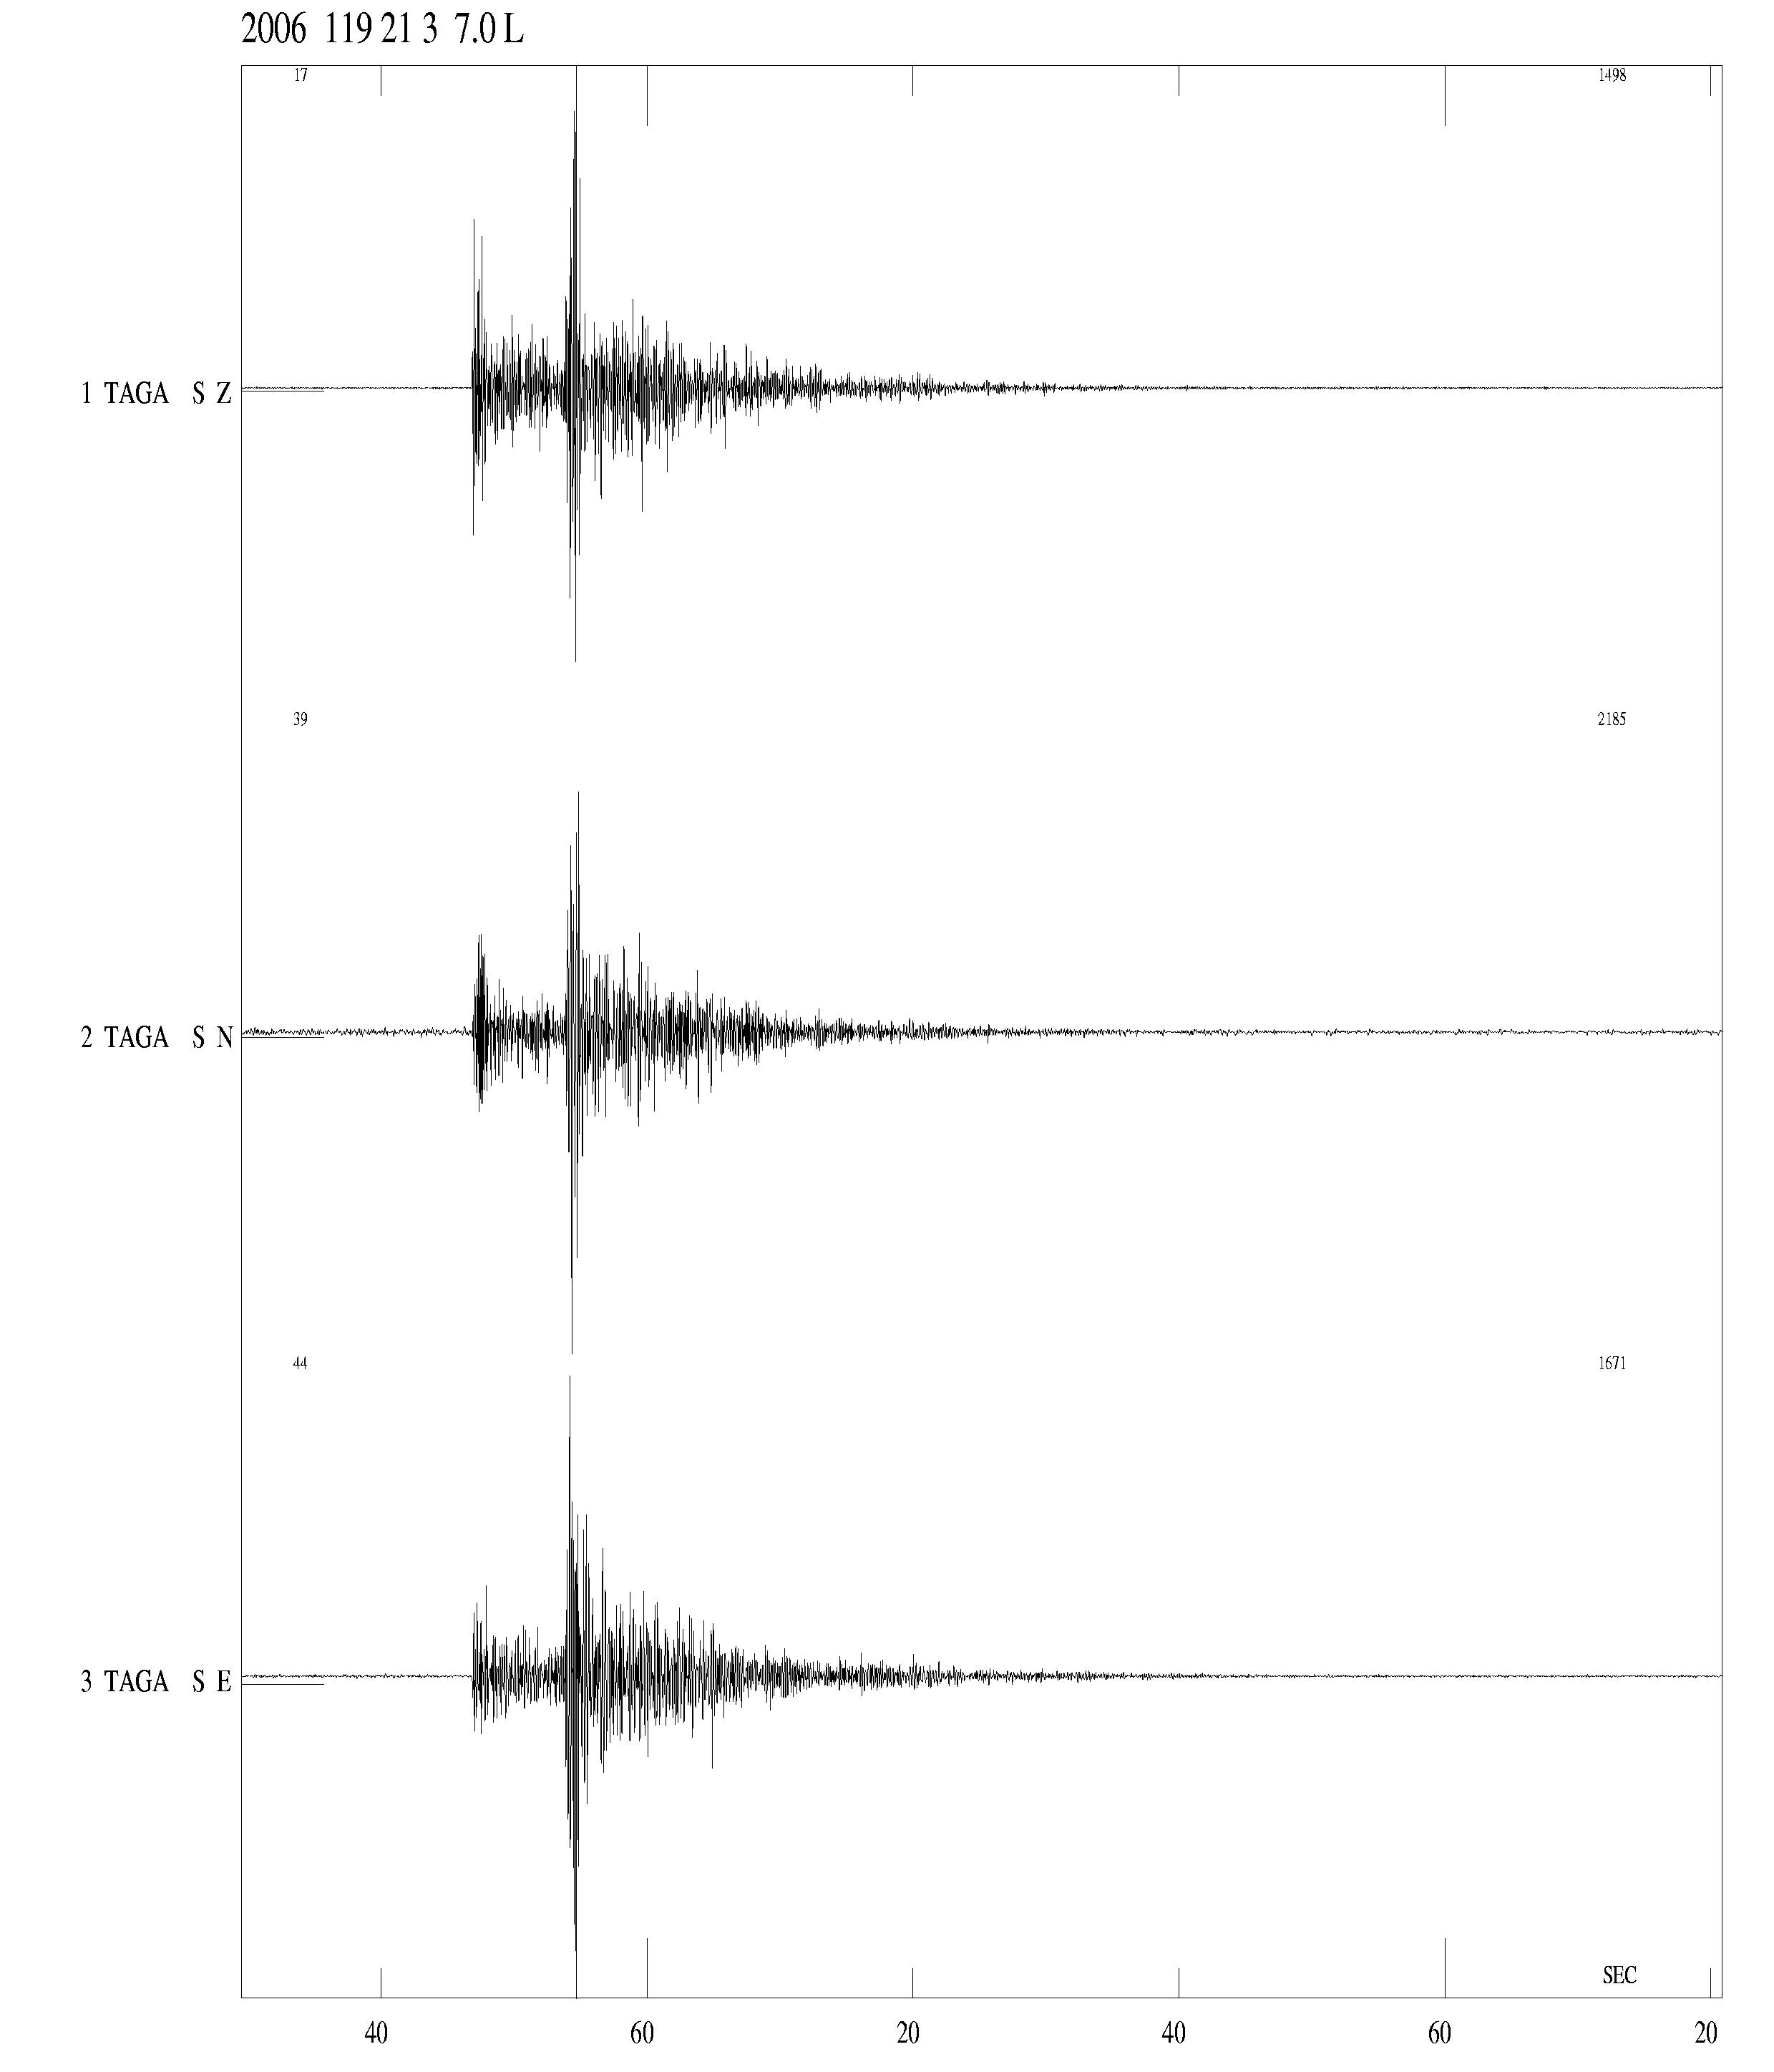
Figure 1: Earthquake recorded at TAGA on January 19, 2006, M_{L}=1.8.
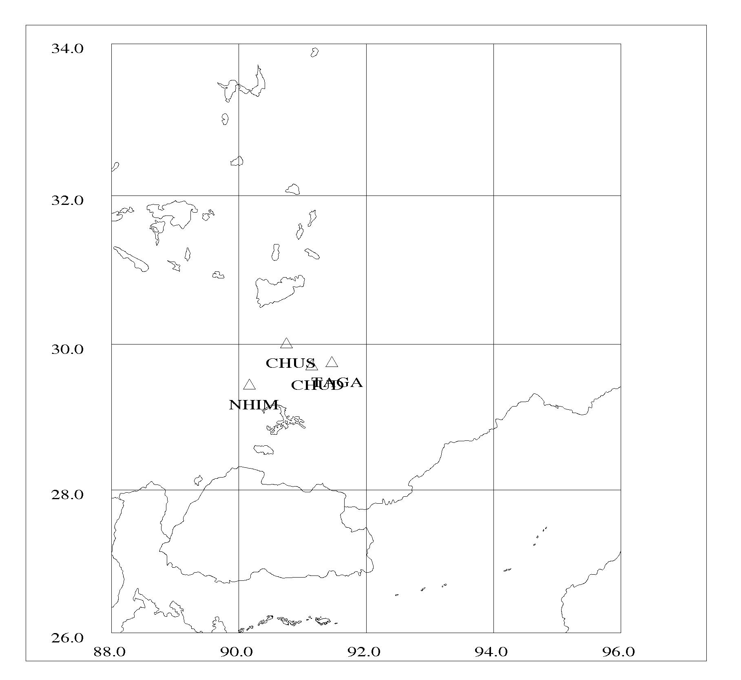
Figure 2: Stations of the TBU as of July 2006.

In the future it is desirable to extend the network in order to increase the data quality. In this respect, at least two more stations should be installed, one south of Lhasa and the other north of Lhasa in the area of the 1951 and 1952 earthquakes. Such stations will increase the data coverage and thereby provide important information about the local seismicity patterns. During field studies in July 2006, suggested locations have been found for the stations.

Operation

The seismological office at the Tibet University has set up daily routines agreed upon in 2004. Since September 2004, Tsoja Wangmo has been supposed to collect data at the stations and process the data, by making a seismic bulletin and reporting on station operation. This has not been working as smoothly as intended. The station operation has not been as stable as expected, partly due to lack of maintenance, visits have not been done as planned due to bad road conditions for some of the stations. More information in the station up-times is given below. The monthly reports have also been quite delayed and no reports have been written for the months of September 2004-present, although the data has been processed. The problems are partly related to having only one person (Tsoja Wangmo) to do the work, which has also a heavy teaching load and other duties. Zha Sang has been staying at the University of Bergen from November 15, 2004 to February 15, 2005 to get basic training in seismic data processing in order to have more people able to work with the data. Unfortunately Tibet University did not accept her as a research assistant since June 2005 and therefore she can not work with the data anymore. From March 2006, Tsamlha has been hired to process the data, who has good knowledge of computers as well as a basic level of English. With her help, data has been processed so that the processing is up to date as of July 2006. Future stability in processing is dependent upon the possibility of continued engagement of Tsamlha since the teaching load on the permanent staff is unlikely to be decreased. In case she can do the processing, bulletins can be produced on a regular basis.

Seismicity

The TBU has data available since January 2004. During the first eight months of operation, only one station was working for a limited time. The number of events has increase after the network was been properly established in Aug 2004. A total of 948 events have been record by TBU from the establishment until July 2006. Of these, 86 were distant events and 862 local events. A total of 705 events located within the target area as showed in Figure 3.

The seismicity pattern shown in the figure reveals several regions of increased activity. High activity is observed along the Dang Shung fault zone (running parallel to the southeastern shore of Lake Namtso). Activity increases near to NHIM, probably due to the increased detection threshold near the station. Another region of high activity is located around 29-31N, 91-92.5E. This activity is probably related to active tectonic structures in this area. From Figure 3 it is clear that the Lhasa region is a seismically active region in Tibet.

One of the main factors controlling the precision of earthquake locations is the number of stations recording a given event. Table 1 gives the number of stations recording the events in the TBU database. It is seen from the table that only 13 events are recorded by three or more stations and thereby are expected to have reliable locations. One of the main aims of the network in the future should be to increase the number of events recorded by three or more stations.
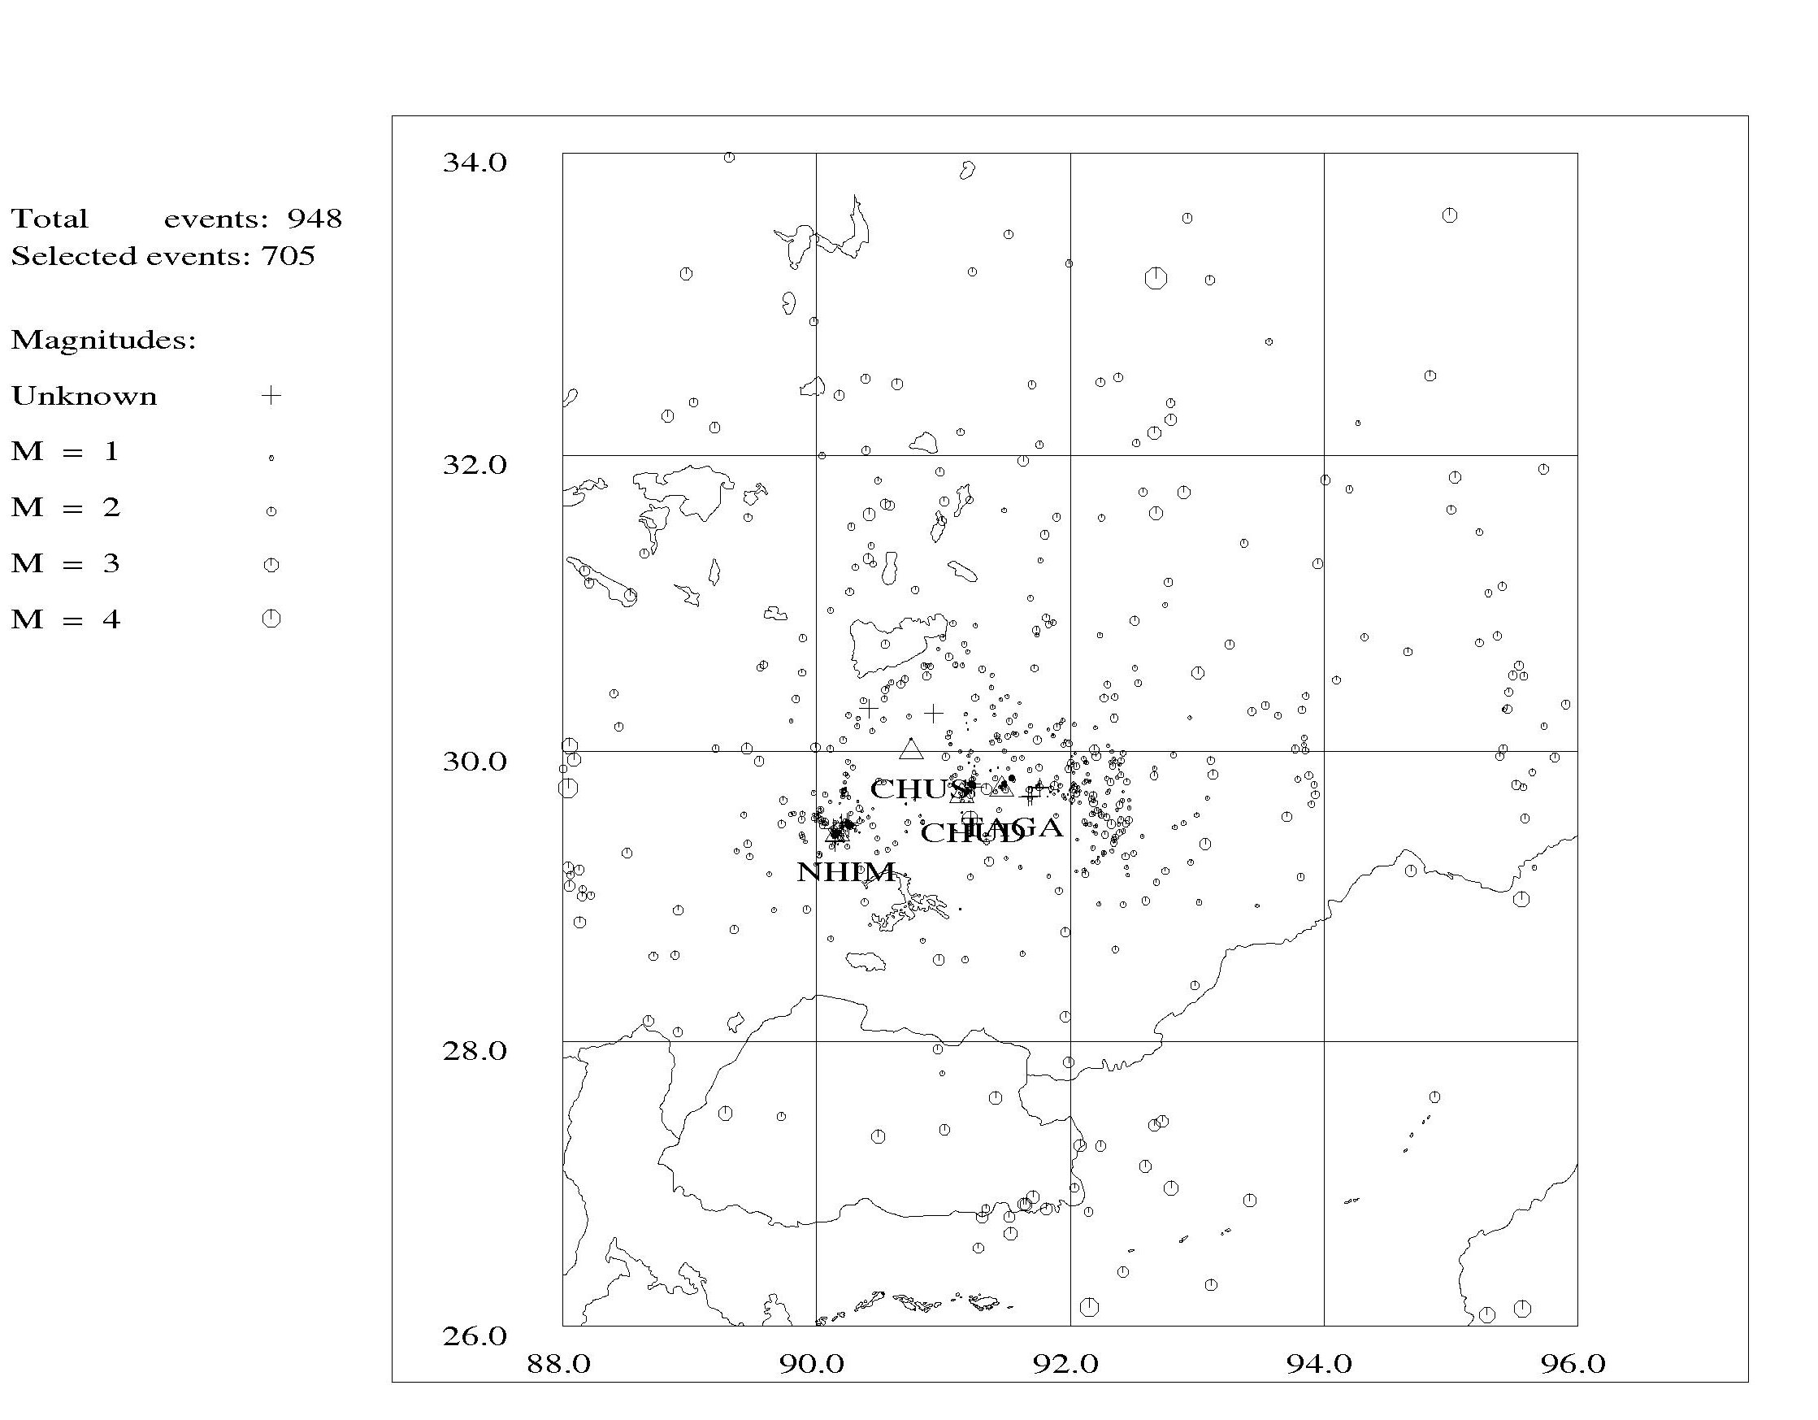
Figure 3: Seismicity around Lhasa from January 2004 to July 2006

Nr of stations | Nr of events
1 | 725
2 | 108
3 | 12
4 | 1
Table 1: Number of stations recording events in the TBU database.

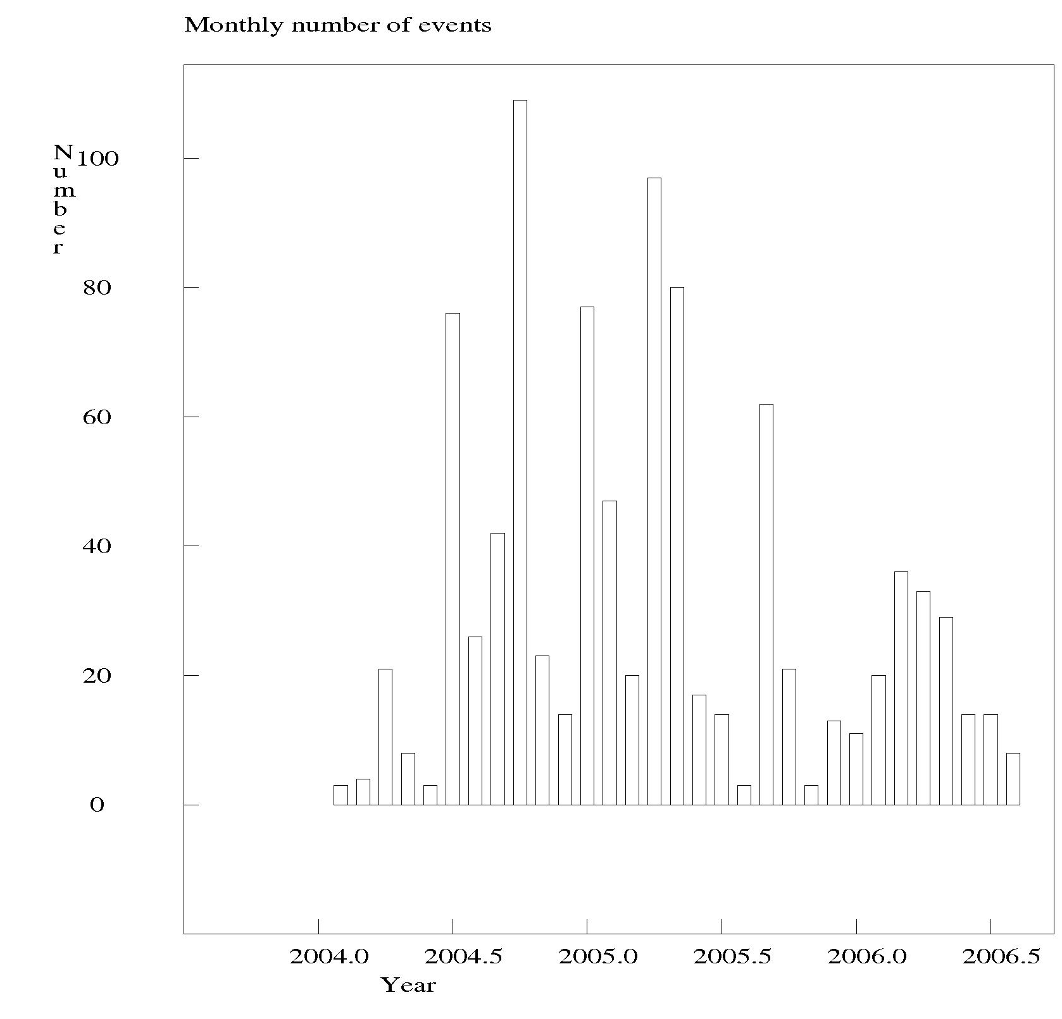
Figure 4: Monthly number of events in the TBU database.

Figure 4 shows the monthly distribution of events in the database. On average, ca 30 events are recorded by the network pr month. There is a clear increase in the number of recorded events after the improvement of the network in June 2004. Five periods of increased activity are observed around June, September and December 2004 and March and August 2005. Except for August 2005, all these periods are associated with the occurrence of one or more M=3+ earthquakes and the increased activity may be due to aftershocks. In August 2005, no large earthquakes were recorded and no obvious explanation is found for the increased activity. The activity level of July and October 2005 is very low due to only one station being in operation at these times (NHIM and CHUD, respectively).

As a result of the network operation, a poster has been presented by Tsoja Wangmo at the IASPEI international conference in Chile in October 2005. In addition, a paper about the network has been published in Journal of Tibet University, Vol. 3, 2005.

Summary of network performance

This section summarizes the operation of the Tibet University Seismic Network since its installation in 2004. Four stations are currently in operation. A fifth station, LHASA, located at the university campus, has not yet been stable in operation. First, a list of available data is given for each station including comments on missing data. Following, a summary is made for each individual station including comments on what has been done to solve problems. At the end is given a list of equipment at the stations and available spare parts at the office in Lhasa.

2004
Available data:
stations | Jamag | Nhimo | Chud | Chus
06 | 24 to 30 (23%) | 17 to 30 (47%)
07 | 01 to 03 (10%) | 01 to 13 (42%)
08 | 25 to 31 (23%) | 25 to 28 (13%)
09 | 01 to 30 (100%) | 04 to 08 (53%)  16 to 26
10 | 01 to 03 (10%) | 04 to 08 (19%)  and 17
11 | No data (0%) | 06 to 07 (20%)  27 to 30
12 | No data (0%) | 01 and 11 to 31 (71%)
Missing data:
JAMG:
4/7 2004 - 24/8 2004: After a power failure the system could not be restarted, and because of bad road conditions we could not make visit in time. Due to limited memory on system, data were overwritten on disk.
4/10 2004 - 13/3 2005: Due to bad road conditions we cold not visit the station. Due to limited memory on system, data were overwritten on disk.

NHIM:
14/7 2004 - 24/8 2004: Something wrong with the pocket PC.
1/9 2004 - 4/9 2004: Pocket PC could not restart after power failure.
9/9 2004 - 15/9 2004: Pocket PC could not restart after power failure.
27/9 2004 - 3/10 2004: Pocket PC could not restart after power failure.
9/10 2004 - 16/10 2004: Pocket PC could not restart after power failure.
18/10 2004 - 31/10 2004: Pocket PC could not restart after power failure.
1/11 2004 - 5/11 2004: Pocket PC could not restart after power failure.
8/11 2004 - 26/11 2004: Pocket PC could not restart after power failure.
2/12 2004 - 10/11 2004: Pocket PC could not restart after power failure.

2005
Available data:
stations | Jamag | Nhimo | Chud | Chus
01 | No data (0%) | 01 to 31 (100%)
02 | No data (0%) | 28 (4%)
03 | 14 to 31 (58%) | 01 to 28 (90%)
04 | 01 to 13 (43%) | 16 to 29 (47%)
05 | 21 to 31 (35%) | 15 to 31 (55%)
06 | 01 to 24 (80%) | 16 to 31 (53%)
07 | 01 to 04 (13%) | 01 to 31 (100%)
08 | 22 to 31 (32%) | 01 to 31 (100%) | 18 to 31 (100%)
09 | 01 to 30 (100%) | 01 to 29 (97%) | 01 to 20 (67%) | 02 to 15 (88%)
10 | 01 (3%) | No data (0%) | 29 to 30 (6%) | No data (0%)
11 | No data (0%) | 16 to 30 (50%) | 01 to 17 (57%) | 09 to 30 (73%)
12 | No data (0%) | 01 to 31 (100%) | No data (0%) | 01 to 27 (87%)
Missing data:
JAMG:
13/4 2005 – 21/5 2005: System could not restart after power failure.
24/6 2005 – 1/7 2005: Signal cable has been cut while they constructed fence around the room.
4/7 2005 – 27/8 2005: Could not fix the cable (problems with signal 1-4/7 2005), and changed to another instrument.
1/10 2005 - 31/12 2005: Because of bad road conditions we couldn’t go to JAMG station to take data during the winter time. From Jan 19 2006, the JAMG station moved to Taga Xiang (TAGA).

NHIM:
1/2 2005 - 28/2 2005: Something wrong with data transfer by internet.
28/3 2005 - 16/4 2005: System could not restart after power failure.
29/4 2005 - 14/5 2005: Something wrong with data transfer by internet.
1/6 2005 - 15/6 2005: Something wrong with data transfer by internet.
1/10 2005 - 15/11 2005: Something wrong with data transfer by internet.

CHUD:
28/3 2005 - 17/8 2005: The PC was infected by virus and we had to reinstall the windows system.
21/9 2005 - 28/10 2005: System could not restart after power failure.
18/11 2005 - 24/1 2006: Could not make visit to the site, and data were lost due to limited memory on the system.

CHUS:
16/9 2005-8/11 2005: Station down due to power shortage.

2006
Available data:
stations | Jamag | Taga | Nhimo | Chud | Chus
01 | 01 to 19 (100%) | 19 to 31 (100%) | 01 to 23 (74%) | 25 to 31 (23%) | No data (0%)
02 |  | 01 to 28 (100%) | 01 to 10  22 to 28 (61%) | 01 to 07 (25%) | No data (0%)
03 |  | 01 to 31 (100%) | No data (0%) | 01 to 31 (100%) | No data (0%)
04 |  | 01 to 30 (100%) | 08 to 19 (40%) | 01 to 30 (100%) | No data (0%)
05 |  | 01 to 31 (100%) | 10 to 15 (19%) | 01 to 30 (97%) | 16 to 28 (42%)
06 |  | 01 to 30 (100%) | 20 to 30 (70%) | 02 to 30 (97%) | 01 to 30 (100%)
07 |  | 01 to 21 | 01 to 07 | 01 to 19 | 01 to 21
Missing data:
TAGA:
28/4 2006 - 29/4 2006: Station down due to power loss.

NHIM:
11/2 2006 - 21/2 2006: Station down due to power loss.
1/3 2006 - 7/4 2006: something wrong with data transfer by internet.
20/4 2006 - 9/5 2006: something wrong with data transfer by internet.
16/5 2006 - 19/6 2006: something wrong with data transfer by internet.
8/2 2006 - 28/2 2006: something wrong with data transfer by internet.

CHUD:
8/2 2006 - 28/2 2006: Station down due to power loss.

Summary/general comments:
Total station up-time:
Station | Jamag | Taga | Nhimo | Chud | Chus
 | 28% | 100% | 53% | 61% | 39%
JAMG:
JAMG was installed on 24/6 2004. The main problem with the JAMG station has been the difficult access which has led to loss of data, especially in winter time, due to limited disk space. To solve this problem, the station has been moved to TAGA on 19/1 2006.

TAGA:
TAGA was installed on 19/1 2006. Except for a short power loss, the station has been running stable since the installation.

PALB:
PALB was installed on 24/8 2004. Data quality of this station was very good, but the chief of the monastery thought it would cause some problems for him, and the station has been moved to CHUD on 28/3 2005.

CHUD:
CHUD was installed on 28/3 2005. Except for reinstallation of the station and a power failure, the station has been running stable since the installation.

CHUS
CHUS was installed on 2/9 2005. There have been problems with several power shortages and a lightning strike destroying the UPS in the end of May 2006. Currently the data are quite noisy due to 50Hz noise in the vertical and EW components. An attempt was made to reduce the noise by improving the grounding of the system. New data will show if this has improved the quality. The many power shortages are due to weak cables leading power to the monastery. This problem may be solved by changing all cables in the future.

NIMO
NIMO was installed on 22/08 2003. The plan has been to transfer data by e-mail, however this has not been working stable and some data may have disappeared. An attempt is made to recover the lost data, and the operator has been told to make backup of the disk regularly. Another problem has been power failures which are difficult to avoid at this site.

Equipment used in TBU seismic network
Name of station | Lhasa | Nhimo | Taga | Chudi | Chusang | Total
Code | LHSA | NHIM | TAGA | CHUD | CHUS
Latitude | 29.3844°N | 29.2636°N |  | 29.4418°N | 29.5981°N
Longitude | 91.0831°E | 90.0843°E |  | 91.0816°E | 90.4477°E
Elevation (m) | 3670 | 3823 |  | 3771.82 | 4113
Date of  Installation | Aug 2003 | Aug 2003 | 19 Jan  2006 | Apr 2005 | Aug 2005
Computer | NormalPC | NormalPC | NormalPC | NormalPC | NormalPC | 5 NormalPC
Digitizer | GBV116 | 16 bit | 16bit | 24 bit | 16 bit | 4
Sensor | 4.5Hz | 4.5 HZ | 4.5HZ | 4.5 HZ | 4.5 HZ | 5
Component | 1 | 3 | 3 | 3 | 3
Distance (km)  From Lhasa | 0 | 140 | 39 | 5 | 78
Spare parts in office:
1 PC (in use for processing)
3 pocket PC
Mauro box (3 components, 16 bit)
Battery
Multimeter
Cables/connectors

Conclusions

The TBU network has now been in operation for more than two years. The network currently consists of four stations which are operating relatively stable. Previous instability in operation and difficult access to the stations has lead to significant loss of data. Overall, the stations have been working about 50% of the time.

The operational routines for the network have not been followed due to lack of personnel. The engagement of an extra person to do the processing has made it possible to become up-to-date, and all events until June 2006 have now been processed. It is desirable also in the future to hire a person to do the processing.

During the first two years of operation a total of 948 events have been recorded by the TBU network. Most of these events have been recorded by only one station, limiting the location accuracy. Two regions of high activity are observed along the Dang Shung fault and in the region 29-31N, 91-92.5E. It is desirable to extend the network in the future adding two or three more stations mainly to the north and to the south of Lhasa.

