Annual report for 2004

Seismic network around Lhasa



Prepared by

J. Havskov

Department of Earth Science, University of Bergen

Allégt.41, N-5007 Bergen, Norway

Tel: +47-55-583600 Fax: +47-55-583660 E-mail: jens@geo.uib.no

February 2005

Project title: Seismic network around Lhasa

Responsible: Tsoja Wangmo and Jens Havskov

Implementing institutions/applicata: Tibet University and University of Bergen, Department of Earth Science

Summary:

In a cooperative project between the University of Bergen and Tibet University, a small seismic network has been installed in June 2004. The Tibet University Seismic Network currently has 3 good stations and one with high noise level. The network has experienced some operational problems, which partly have been solved. The seismological office has been set up and the daily routines established. It is expected that the network will record about 5 local earthquakes per day. The local network is in full operation and is capable of calculating reliable magnitudes and epicenters for the region, however little data have been processed so far.

Project rationale and objectives:

The project has the goal of building local experience in earth science with special emphasis on seismology. This goal should be reached through practical experience with the following activities:
- Build and maintain a seismic network around Lhasa
- Locate earthquakes and determine magnitude.
- Advise the public about earthquakes occurring in the area
- Advise public authorities on all aspects of the local seismic risk and give general advice on earthquake related problems
- Teach basic seismology and geophysics
- Build up a local data base for research (will attract scientist from outside for cooperative projects)

Development goal:

- Collect base data for research
- Institution building
- Develop cooperation between University of Tibet and UiB in seismology

Project activities 2004:

In 2003, the first stations were installed. However due to unforeseen altitude problems, only one station was partially operating in Lhasa. Operation was also difficult since no qualified personnel were available in Lhasa The project only really stated being active when Tsoja Wangmo finished her MSc in June and returned to Lhasa. In June Helge Johnsen visited and reinstalled the stations with new equipment, so by the beginning of July, 3 stations were in operation.
Jens Havskov made a 2 week visit in August-September. During this trip, further refinement of the network was made and one station was moved to a better location in Lhasa.
The network now consist of 4 stations. There are two outside Lhasa in Jamag and Nhimo and 2 inside Lhasa. One is placed at the University seismological laboratory and continuously show a real time signal on a display. Due to the high noise level, this station will not record much, but it is good for public relations. The other in Lhasa is in the Palub monastery (PALB),which has a rather deep cave with good signal to noise characteristics. In total, 3 stations are therefore available for recording.
The seismological office at the Tibet University was set up and daily routines agreed upon. The intended seismology operation is as follows:

Daily: Check Lhasa local station for events.
2-3 times a week: Get data from PALB, read and locate events. In this way it is possible to have preliminary information about current earthquakes.
Every 2 weeks: Get data from another station, read and locate events, this means visiting JAMG and NHIMO once a month to get the data. (Funds have been transferred to cover this).
Monthly: When all data have come in; make monthly report, and submit data to international agencies.

Since September, Tsoja Wangmo has been collecting data at the station and processed the data, by making a seismic bulletin and reporting on station operation. In order to have more people able to work with the data, Zha Sang has been staying at the University of Bergen from November 15, 2004 to February 15, 2005 to get basic training in seismic data processing (http://www.geo.uib.no/seismo/REPORTS/TIBET/).

During the fall, the Nhimo station was upgraded with a new PC configured by Wangmo. She has also registered the seismic station with the International Seismic Center in the UK, so data from the network will get international recognition.
.

Project results 2004:

Tsoja Wangmo graduated at the Department of Earth Science, University of Bergen with a MSc degree in June. Title: “Analysis of seismicity and setting up a new local seismic network around Lhasa”.

Travel reports have been made for the two trips from University of Bergen (http://www.geo.uib.no/seismo/REPORTS/TIBET/).

Monthly reports have been made by Tsoja Wangmo for the months June – August. (http://www.geo.uib.no/seismo/REPORTS/TIBET/BULLETIN/).

The station operation has not been as stable as expected, partly due to lack of maintenance, so the local data base is currently not up to date. Visits have not been done as planned. The monthly reports are also quite delayed and no information is available on operational stability for the months of September-present, although most of the data from 2004 has been processed. The problems are partly related to having only one person (Tsoja Wangmo) doing the work, however it seems difficult to follow up on the scheduled routines.

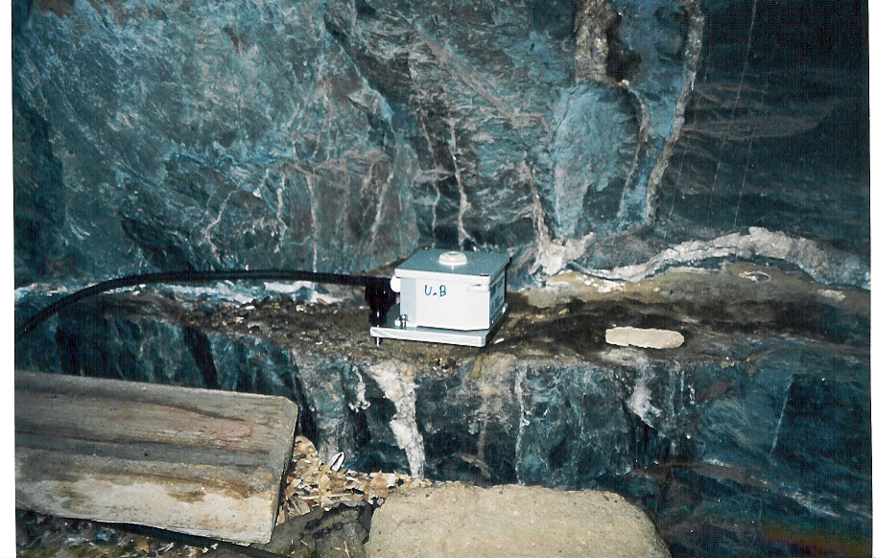

Seismometer installation in the cave under the Palub monastery

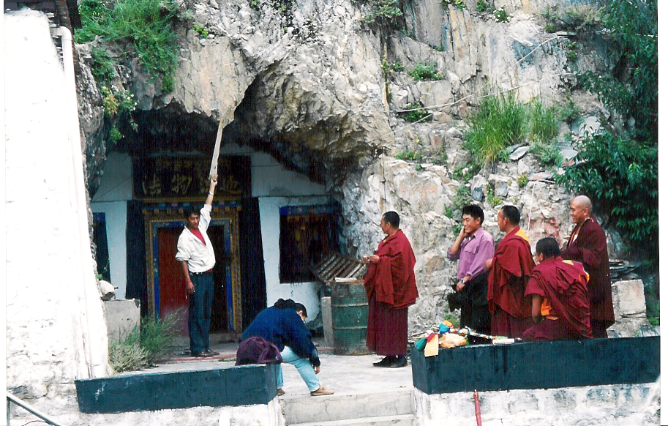

Entrance to the cave at the Palub monastery

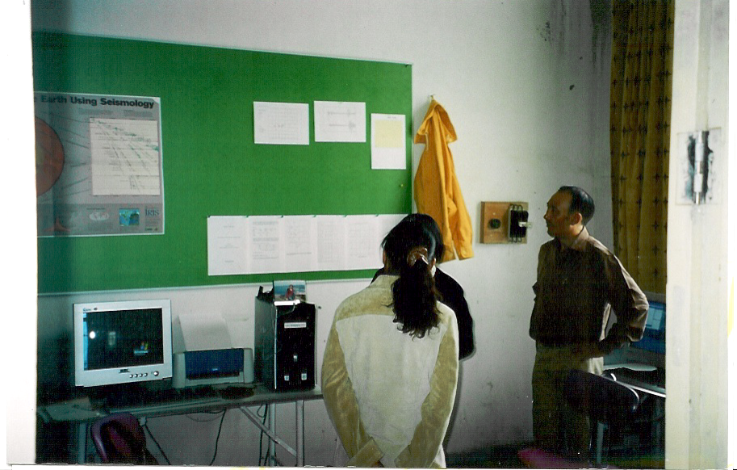

The seismological office in Lhasa. Tsoja Wangmo and Norsang

