Annual report for 2005

Seismic network around Lhasa



Prepared by

J. Havskov

Department of Earth Science, University of Bergen

Allégt.41, N-5007 Bergen, Norway

Tel: +47-55-583600 Fax: +47-55-583660 E-mail: jens@geo.uib.no

January 2006

Project title: Seismic network around Lhasa

Responsible: Tsoja Wangmo and Jens Havskov

Implementing institutions: Tibet University and University of Bergen, Department of Earth Science

Summary:

In a cooperative project between the University of Bergen and Tibet University, a small seismic network was installed around Lhasa between June 2004 and September 2005. The network currently has 4 good stations. During the first year of operation, the network experienced operational problems, which now mostly have been solved. During the same time (June 2004 to June 2005), the network recorded around 600 earthquakes and the results show that the network significantly increases the amount of local data available. However, processing of data is lacking behind, partly due to manpower problems. In 2005, one paper describing the network was published locally and the first results from the network were presented by Tsoja Wangmo at a seismological conference in Chile. There was one visit from Bergen to Lhasa and one from Lhasa to Bergen.

Development goal:

The project has the goal of building local experience in earth science with special emphasis on seismology. This goal should be reached through practical experience with the following activities:
- Build and maintain a seismic network around Lhasa
- Locate earthquakes and determine magnitude.
- Advise the public about earthquakes occurring in the area.
- Advise public authorities on all aspects of the local seismic risk and give general advice on earthquake related problems.
- Teach basic seismology and geophysics.
- Build up a local data base for research (will attract scientist from outside for cooperative projects) .

Project activities 2005:

The Tibet University Seismic Network, has now been in operation for one and a half years. During 2005 one station was moved and one new station was installed. The network now consists of 4 stations:

Station name | Station code | Distance from Lhasa (km) | Time to travel | In operation since
Nhimo | NHIM | 130 | 2 hours | June 2004
Jamag | JAMG | 90 | 2 hours | June 2004
Chudi | CHUD | 4 | 10 min | April 2005
Chusang | CHUS | 70 | 1.5 hours | September 2005

Technical

The technical operation has worked reasonably well considering local difficulties, however all stations have not been operating at all times. The main problem has been the long time used to travel to the station, particularly Nhimo. However, since the road has been reopened, the time to reach Nhimo has been cut from 6 hours to 2 hours. The best station Jamag, is now the most difficult to get to and requires a four wheel drive. The other 3 stations can be reached with a normal car. In 2005, one new station at Chusang was installed and the network now has 4 stations. Station Palub in the center of Lhasa had to be moved to the outside of town (Chudi) since the owner of the site did not want the station there. There is no plan to install more stations, but Jamag might be moved to a site with easier access if a suitable site can be found.

Apparently the problem with altitude for the PC’s was not a general problem, although it has been seen with both a laptop and the first PC tested. The new PC bought for Palub in 2004 was tested at altitude and worked ok. So all PocketPc’s have gradually been replaced by normal PC’s.

The digitizers and sensors seem to have worked well. One digitizer was taken to Bergen for repair and upgrade, and is now back in Lhasa so a full set of spare parts are available. The PC’s have been working ok and GPS reception is also good.

Operation

The operation has not been going as smooth as expected and the stations have not been visited as often as required to get a stable operation. This has meant that it takes time to discover local problems and data is lost. Part of the reason for the fewer visits than planned, is the difficulty in getting to some stations.
The local skills, in terms of installing new hardware and software, is now good and no help was needed to change from PocketPC to PC operation.
The processing of data has not been following a regular schedule and some backlog is waiting to get processed. Most data were processed until June 1, 2005. The lack of regular processing also makes it difficult to spot operational problems. Part of the reason for not doing all the processing is the heavy teaching load on Tsoja Wangmo, she has not been able to reduce teaching load to work with network.
It was expected that theoretically, up to 5 events could be detected per day at the best station Jamag. For the network as a whole, about 2 events have been detected per day. This reduction in numbers is partly due to the operational problems. Unfortunately, most events are recorded by only one station, partly due to the size of the events but also because of the operation problems. Never the less, a large data set (600 earthquakes) has been collected for the first year of operation (June 2004 to June 2005) which gives a good idea about the local activity and can help the further planning of the network and be used for research (Figure 1).
The network primarily records events around Lhasa, as is the purpose. However, also larger global events are recorded (Figure 2).

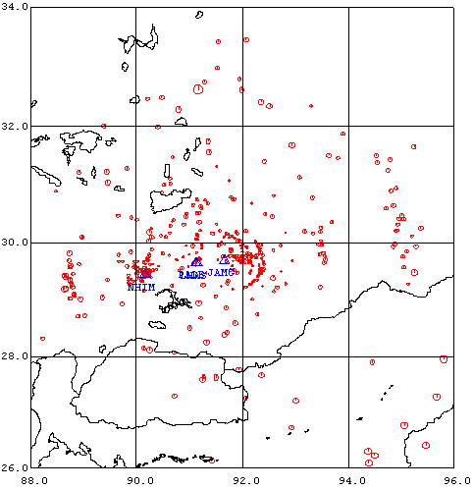
Figure 1 Seismicity around Lhasa located by the network for the period June 2004 to June 2005. Blue triangles refer to stations. Red dots refer to events. The size of the dots is proportional to magnitude.

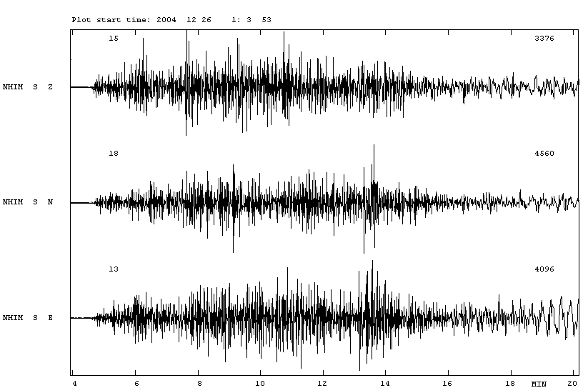

Figure 2 The M 9.3 large Indonesia event of December 26, 2004 was also recorded on the network.

Visits

Jens Havskov made a 2 week visit in August-September 2005. During this trip, Jamag was visited and more noise tests were made for a possible move of Jamag and also to find a site for the last station. No good replacement site was found for Jamag but a very good site was found for the new station (Chusang). The station was installed in September by local staff. For more details, see travel report http://www.geo.uib.no/seismo/REPORTS/TIBET/tibet_visit_2005.doc.

Tsoja Wangmo has visited the China Seismological Bureau in Beijing to try to initial more cooperation with the Chineese. She has also visited University of Bergen for 10 days to work on the preparation of the poster for the Chile conference.

Project results 2004:

Tsoja Wangmo presented first results from the network at the IASPEI (International Association of Seismology and Physics of the Earths Interior) conference in Chile in September 2005:
www.geo.uib.no/seismo/REPORTS/POSTERS/lhasa_seismicity.ppt

Tsoja Wangmo and Norsang have published a paper describing the network in a local Tibet University journal.

A travel reports have been made for the trip from University of Bergen (www.geo.uib.no/seismo/REPORTS/TIBET/tibet_visit_2005.doc.

Acknowledgements: Berit Storheim read and corrected this report.

Some pictures

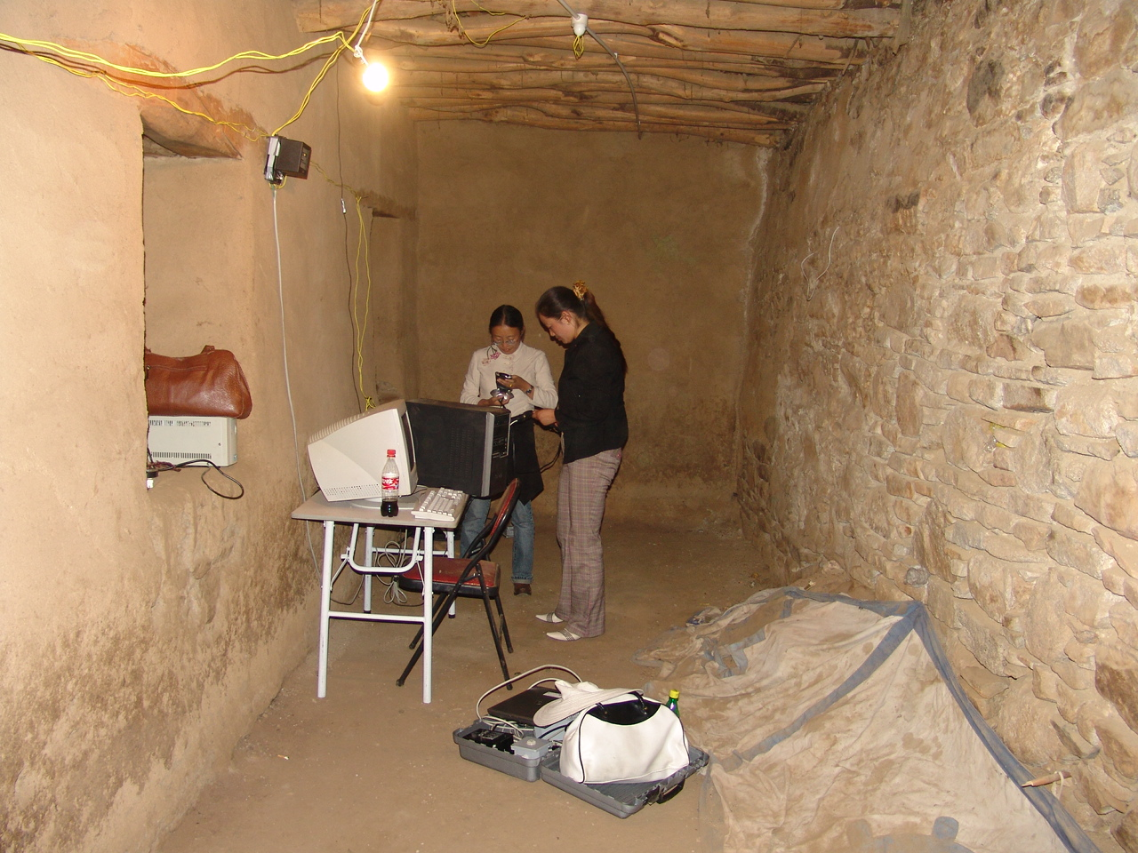

The new location of the seismic station Chudi

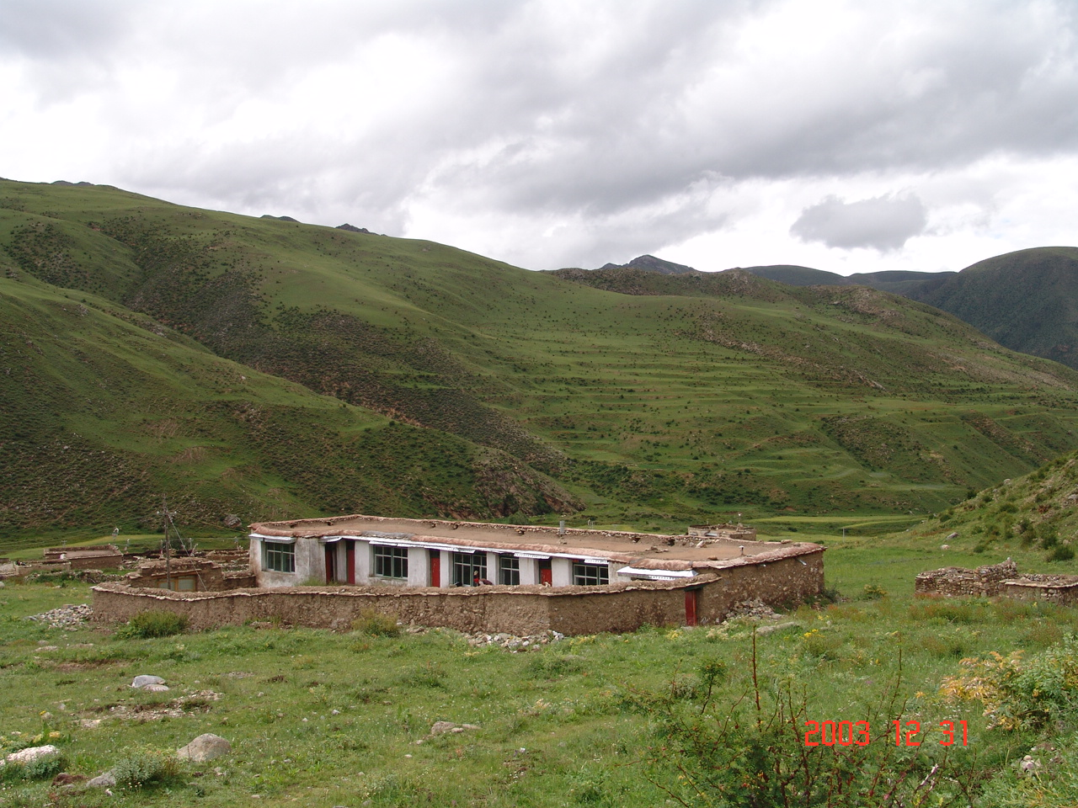

The Jamag station with the new wall around the building.

