Annual report for 2006

Seismic network around Lhasa



Prepared by

J. Havskov

Department of Earth Science, University of Bergen

Allégt.41, N-5007 Bergen, Norway

Tel: +47-55-583600 Fax: +47-55-583660 E-mail: jens@geo.uib.no

January 2007

Project title: Seismic network around Lhasa

Responsible: Tsoja Wangmo and Jens Havskov

Implementing institutions: Tibet University and University of Bergen, Department of Earth Science

Summary:

In a cooperative project between Tibet University and the University of Bergen, a small seismic network was installed around Lhasa between June 2004 and September 2005. The network currently has 4 good stations. The network has experienced operational problems, however during 2006 the network operation was improved due to station relocation. During the first 2 years of operation, (June 2004 to July 2006), the network recorded around 950 earthquakes. In 2006 results from the network were presented by Tsoja Wangmo at a seismological conference in Nepal. There was one visit from Bergen to Lhasa and one MSc student (Tsering) graduated from the University of Bergen.

Development goal:

The project has the goal of building local experience in earth science with special emphasis on seismology. This goal should be reached through practical experience with the following activities:
- Build and maintain a seismic network around Lhasa
- Locate earthquakes and determine magnitude.
- Advise the public about earthquakes occurring in the area.
- Advise public authorities on all aspects of the local seismic risk and give general advice on earthquake related problems.
- Teach basic seismology and geophysics.
- Build up a local data base for research (will attract scientist from outside for cooperative projects).

Project activities 2005:

The Tibet University Seismic Network (TBU), has now been in operation for two and a half years. During 2006 one station was moved. The stations are:

Station name | Station code | Distance from Lhasa (km) | Time to travel from Lhasa | In operation since
Nhimo | NHIM | 130 | 2 hours | June 2004
Taga | TAGA | 70 | 1 hours | January 2006
Chudi | CHUD | 4 | 10 min | April 2005
Chusang | CHUS | 70 | 1.5 hours | September 2005

The technical operation has worked better in 2006 than earlier years since relocation of stations has made access easier. Earlier the Jamag station was very difficult to access but it was moved to Taga in January, 2006. Now travel time to any station is less than 2 hours and it is easier to maintain the network. It is also possible to get to all stations with a normal car.

The TBU has data available since June 2004. During the first 2t months of operation, only one station was working for a limited time. The number of events has increased after the network was properly established in August 2004. A total of 948 events have been record by TBU from the establishment until July 2006. Of these, 86 were distant events (outside Tibet) and 862 local events. A total of 705 events are located within the target area as showed in Figure 1.

The seismicity pattern shown in the figure reveals several regions of high activity. High activity is observed along the Dang Shung fault zone (running parallel to the southeastern shore of Lake Namtso). Activity increases near to NHIM, probably due to the increased detection threshold near the station. Another region of high activity is located around 29-31N, 91-92.5E. This activity is probably related to active tectonic structures in this area. From Figure 1 it is clear that the Lhasa region is a seismically active region in Tibet.

One of the main factors controlling the precision of earthquake locations is the number of stations recording an event. Table 2 gives the number of stations recording the events in the TBU database. It is seen from the table that only 13 events are recorded by three or more stations and thereby are expected to have reliable locations. One of the main aims of the network in the future should be to expand the network in order to increase the number of events recorded by three or more stations.

Nr of stations | Nr of events
1 | 725
2 | 108
3 | 12
4 | 1

Table 2: Number of stations recording events in the TBU database.

The monthly reports have been quite delayed and no reports have been written for part of the time. The problems are partly related to having only one employee (Tsoja Wangmo) to do the work. She also has a heavy teaching load and other duties. From March 2006, Mrs Tsamlha has been hired to process the data. She has good knowledge of computers as well as a basic level of English. With her help, data has been processed so that the processing is up to date as of July 2006. Future stability in processing is dependent upon the possibility of continued engagement of Tsamlha since the teaching load on the permanent staff is unlikely to be decreased. However, Tsering is now also back and has started to help processing. It is expected that processing will take place on a more regular basis now and a better data base for research can be made.
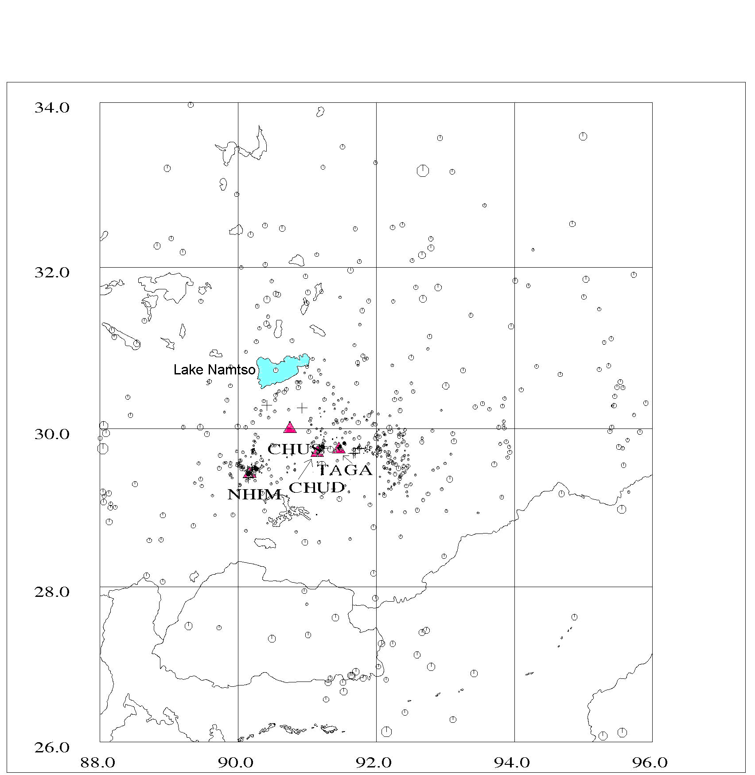

Figure 1 Seismicity around Lhasa located by the network for the period June 2004 to July 2006. Triangles refer to stations. The size of the dots is proportional to magnitude. Lhasa is very close to station CHUD.

Visits

Mathilde Bøttger Sørensen made a 3 week visit in July-August 2006. During this trip, new possible sites for future field station were visited and noise measurements were made. For more details, see travel report http://www.geo.uib.no/seismo/REPORTS/TIBET/tibet_visit_2006.doc.

Project results 2006:

Tsoja Wangmo presented a poster at the International Workshop on Seismology, Seismotectonics and Seismic Hazard for Himalayan region. 28-29
November 2006, Kathmandu. The title was: Lhasa Seismicity during 2004-2006.

A travel reports have been made for the trip from University of Bergen (www.geo.uib.no/seismo/REPORTS/TIBET/tibet_visit_2006.doc.

Wangmo T. and Tsering made a technical report “Tibet University Seismic Network, Summary report 2004-2006”, http://www.geo.uib.no/seismo/REPORTS/TIBET/Network_summary_2003-2006.doc

Tsering finished his MSc at the University of Bergen in June 2006. Thesis title: Local seismicity and seismic hazard around Lhasa, Tibet.

Acknowledgements: Berit Storheim read and corrected this report.
Some pictures

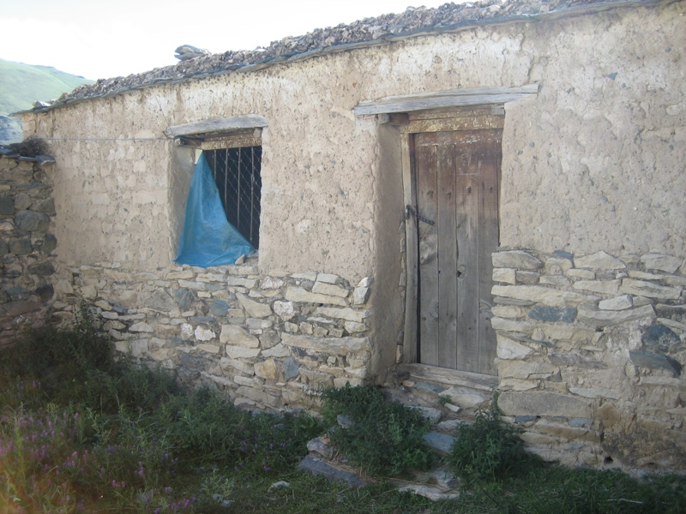

The location of the seismic station Chudi

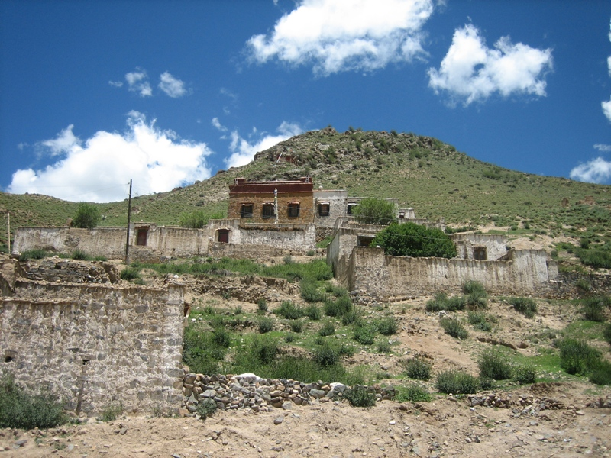
The Chupsang monastery housing the CHUS station. The instruments are in one of the topmost buildings to the right.

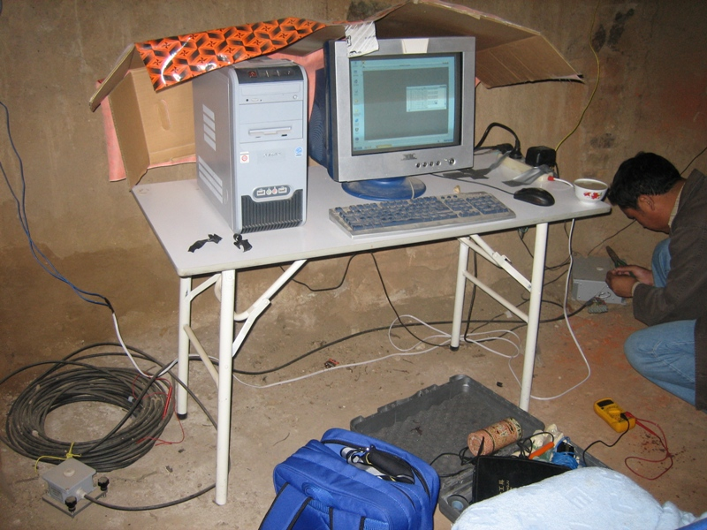
The CHUS installation. The sensor is to the left, digitizer to the right.

