Annual report for 2008

Seismic network around Lhasa



Prepared by

Tsoja Wangmo and Jens Havskov,

Department of Earth Science, University of Bergen

Allégt.41, N-5007 , Norway

Tel: +47-55-583600 Fax: +47-55-583660 E-mail: jens@geo.uib.no

February 2009

Project title: Seismotectonics and seismic hazard around Lhasa

Responsible: Tsoja Wangmo and Jens Havskov

Implementing institutions: Tibet University and University of Bergen , Department of Earth Science

Summary:

In a cooperative project between Tibet University and the University of Bergen, a small seismic network was installed around Lhasa between June 2004 and September 2005. The network currently has 4 good stations. In 2008 the stations were running quite stable. A total of 2181 events has been record by TBU (Tibet university seismic network) during 2008 which is more than in any previous year. TBU has also recorded the magnitude 8.0 May 12 Wenchuan earthquake, and the magnitude 6.6 earthquake on October 6 in Dangxiong near Lhasa, Tibet.
Two students from Tibet University did their thesis in seismology in 2008. A publication has been made about the April 20, 2006 Bange (northern part of Tibet) magnitude 5.6 earthquake. Teaching in geophysics and seismology has also been done in 2008. The planned network expansion, visits and field work could not be done in 2008 due to political problems. A new student was supposed to start MSc in seismology at the University of Bergen in August, however this was postponed to 2009.

Development goal:

The project has the goal of building local experience in earth science with special emphasis on seismology. This goal should be reached through practical experience with the following activities:
- Build and maintain a seismic network around Lhasa
- Locate earthquakes and determine magnitude.
- Advise the public about earthquakes occurring in the area.
- Advise public authorities on all aspects of the local seismic risk and give general advice on earthquake related problems.
- Calculate seismic hazard
- Teach basic seismology and geophysics.
- Build up a local database for research (will attract scientist from outside for cooperative projects).

Project activities in 2008:

The TBU (Tibet University Seismic Network) has been operating since 2004. At present time there are four stations running quite stable:

CHUD: In January 2008, station CHUD (Figure 1 - 3) had significant technical problems with PC, screen, sensor, antenna and so on, and for a long period it could not be visited. It is now working ok.

NHIM: At station NHIM, we had to replace the instrument by a portable station. It has been placed there for several months, however it records in continuous mode so it is not so easy to process the data.
CHUS: Station CHUS is running quite stable, there was lighting once which burned the UPS and the power supply but this has been replaced.

TAGA: Station TAGA has been reinstalled and improved compared to last year.

The seismic stations of the TBU network are given in Table 1.

Station name | Station code | Distance from Lhasa (km) | Time to travel from Lhasa | In operation since
Nhimo | NHIM | 130 | 2 hours | June 2004
Taga | TAGA | 70 | 1 hours | January 2006
Chudi | CHUD | 4 | 10 min | April 2005
Chusang | CHUS | 70 | 1.5 hours | September 2005
Table 1: Seismic stations of TBU network running by Tibet University.

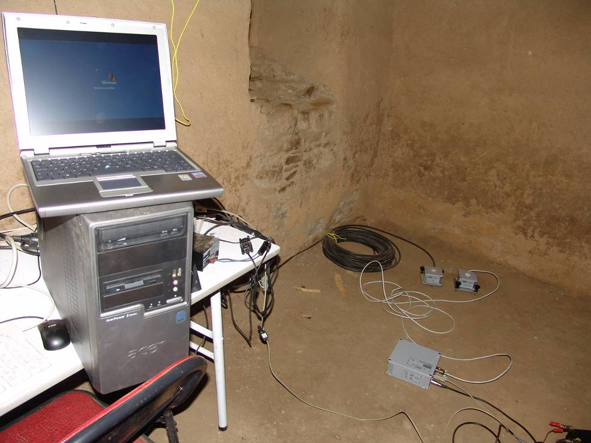
Figure 1: The Chuding monastery housing the CHUD station.

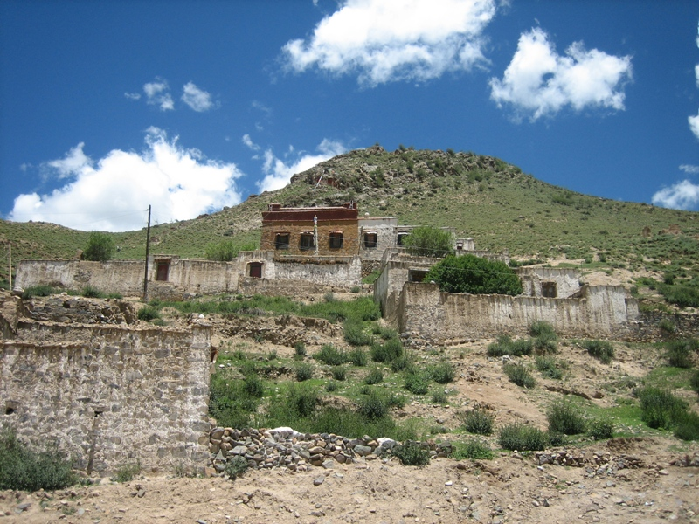
Figure2: The Chupsang monastery housing the CHUS station. The instruments are in one of the topmost buildings to the right.

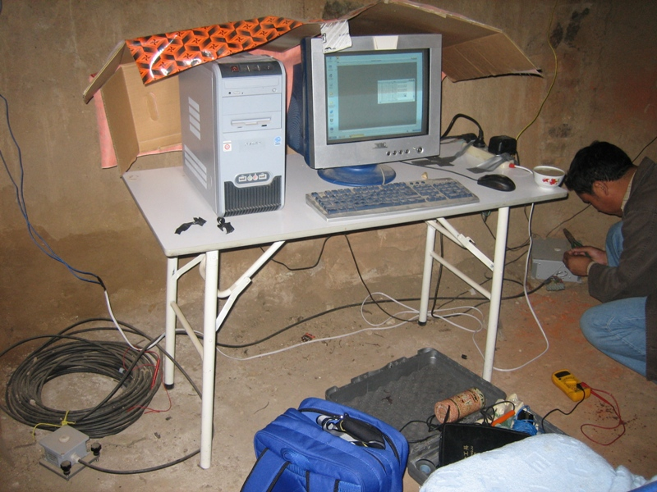
Figure 3: A typical installation of each of the four current stations of TBU network. This is the CHUS installation, with the sensor to the left (small gray box), and the digitizer to the right.

The technical operation worked better in 2008 than in 2007.

Data processing

In 2008, a total of 2181 events has been record by TBU ( Figure 4 ).

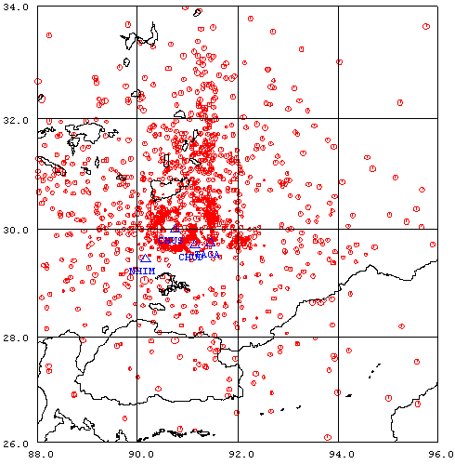
Figure 1: Seismicity around Lhasa 2008. The number of recordings for this period is more than 2128, while 1837 of them fall in the above region. The stations are marked with blue.
As it can be seen from Figure 4, many of the events appear to be located in a circle around Lhasa. This is probably an artifact of the events being located by only one station.

The data processing worked much better than previous years. In 2008 we hired a student to process the data. His training period was about a month to go through all the routine processing steps. He has spent lot of time processing data, therefore, this year the data processing part has finished on time for the first time since we started this project.

The two largest events in the Tibet – China region recorded by the network were Wenchuan earthquake an Dangxiong earthquake located with distances about 1500 km and 70 km respectively to the network. The seismograms are seen in Figures 6 and 7, respectively,

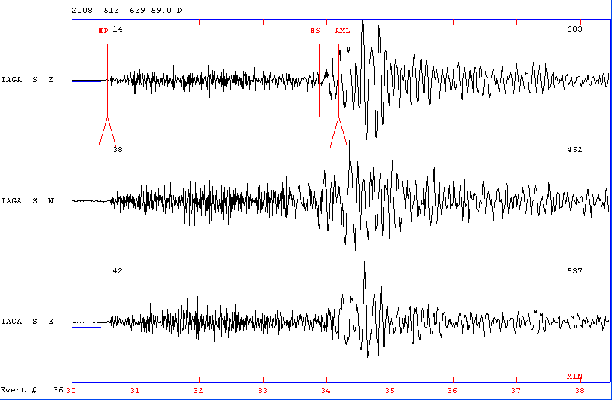
Figure 6:The Wenchuan earthquake record by TBU. Magnitude Ms is 8.0

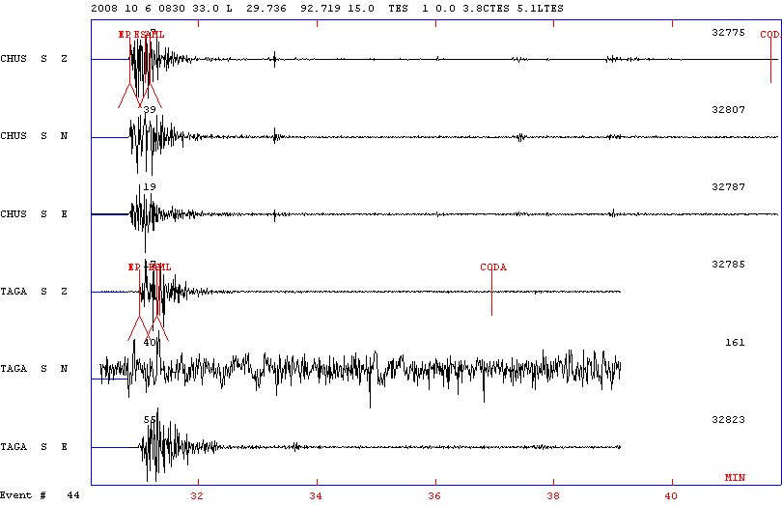 Figure7: The Dangxiong earthquake record by TBU. Magnitude Ms is 6.6.

The most important event was the Dangxiong earthquake. It occurred at a distance of 70 km from Lhasa and was strongly felt in Lhasa. Significant damage occurred in a village near the epicenter (6 people died). Many aftershocks were recorded from this event. The quake occurred in a remote region of Tibet, at a distance of 50 km from the station CHUS. This region coincides with the new seismic station we have planed to place (see next section). Unfortunately, this new station could not be installed in 2008 due to political problems

Expansion of the network

One of the main factors controlling the precision of earthquake locations is the number of stations recording an event. To enhance the precision of the network, we concluded that the network should be expanded in order to increase the number of events recorded by three or more stations.

The TBU recorded events have led us to have a better understanding of the pattern of seismicity around Lhasa, and accordingly we are going to install 4 more mobile seismic stations (Figure 8) around the area with high seismicity which also covers part of an important strike-slip fault, Damshung, to the west of Lhasa.

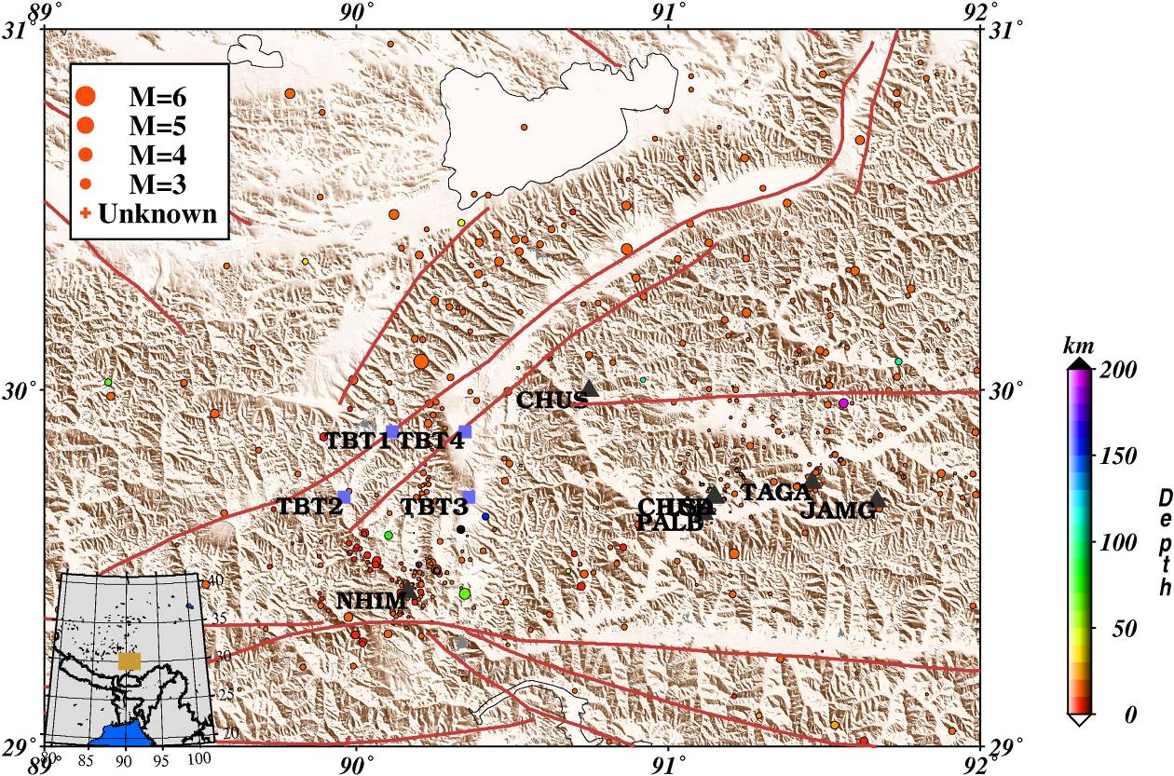

Figure 8: Seismic network of TBU. The triangles are the current or displaced stations. The squares are the planned stations to be installed in 2009. Station JAMG is displaced and PALB has a limited recording rime and none of them are operating anymore.

To the west of Lhasa, about (30N, 90E), there is a well-demonstrated high activity region based on the TBU network, which cannot be recognized on the PDE locations (US Geological Survey locations). It can be said that this is one of the important results of the installation of TBU network. The proximity of this high seismicity area to Lhasa and other residential areas along Yangbajing, Damshung, Nagqu line had been among other parameters for installation of the new temporary network, which includes 4 seismic stations. By installation of these stations, totally 8 stations will be in TBU network. During 2008, due to political reasons, no installations could be made.

More specific activities:

Teaching

During March–July, Tsoja Wangmo had 36 hours lectures about basic geophysics for students. Contents of the lectures included:

- Global seismotectonics
- Different fault types and wave types
- Regional seismicity mainly dealing with Lhasa area related to regional structure
- Earthquake location

Research

In June 2008 two students finished their undergraduate thesis about Lhasa seismicity during 2007. Both were supervised by Tsoja Wangmo.
A new student has started MSc in seismology at the University of Bergen in January 2009 (should have started August 2008).

Visits

There has been no travelling this year due to political problems.

Publications

Duojezhuoma wrote her thesis titled “Earthquakes around Bange Region”
Renguolin wrote his thesis titled “ Earthquake Data Processing“

Tsoja Wangmo, Duojiedrunma, Chongda. “Bange Ms 5.6 earthquake location and hazard”. Jurnal of Tibet University Vol.23 No.2 Oct 2008

