Visit report

Visit to UiB, November 16, 2004 to February 15, 2005

as part of the project

Tibet University Seismic Network

Training in processing data from Tibet University Seismic Network



Prepared by

Zha Sang, Tibet University

Department of Earth Science, University of Bergen

Allégt.41, N-5007 Bergen, Norway

Tel: +47-55-583600 Fax: +47-55-583660 E-mail: seismo@geo.uib.no

February 2005

Introduction

The purpose of the stay in Norway was to get training in processing data with SEISAN. After doing the SEISAN training course, and some test processing, a complete processing was done on the data from September 2004 as outlined below.

Processing September 2004

- From CD, data from station JAMG is copied to directory c:\seismo\JAMG\09.
- Open the command prompt window, type WO to go to \seismo\wor, and then type cd. To go down one directory, then cd JAMG to go to C:\seismo\JAMG, cd 09 to go to September, then type dir to check.

- Type dirf *-09-*JAMG* to get a list of events

- Type mulplt, then plot events and chose good events, use Menu, then Regis to save events (register events). Events are saved in TEST data base (default) since no specific base was set up for Tibet. S-files in \seismo\read\test_\2004\09 and waveform files in \seismo\wav. Then type quit.

- Find data, which belong to the same event. Do EEV on September, start with first event, type s enter, to find data with the same times, which belong to the same event, then type AA append events. Do this for the whole month.

- After finishing appending events, read P, S and coda. Then choose channel, click toggle, click Azim (Azimuth), find azimuth, if the azimuth is good, we are can type e where azimuth is read, if the azimuth isn’t good , click Quit, then type com to make a comment that this event is bad. Do this for all the events.

- Find AML (amplitude for Ml), start with 1st event, type po, choose Z-channel, then click toggl, type wa, click zoom, then the WA trace is seen below, type a at bottom maximum, after type a at top maximum which finish picking the AML.

- Then go to first event, type update to put location in S-file. All events can also be updated with command update outside eev.

- Then get all event in a file with commened collect, makes output file collect.out.

10) Epimap, to show map.
Type command epimap enter, then comes out a white window and a black window, we can click the black window then choose the 3 to use projecting number 3, enter.
Type latitude range enter, and longitude range enter, then also enter latitude of any grid line space, and enter longitude of any grid line space. Then type yes enter, choose 2nd no. (WORLD. MAP) enter, enter, then type no or enter.
Type collect.out enter, also type collect.out enter, type enter, then type no enter.
The plot can be captured pressing Prints, then put into Paint and from there moved to Word, see Figure 1 below.

Show list of events (use norhead collect.out), see Table 1 below.

Figure 1
Map of epicenters for September 2004. Triangles show stations. Events are numbered.

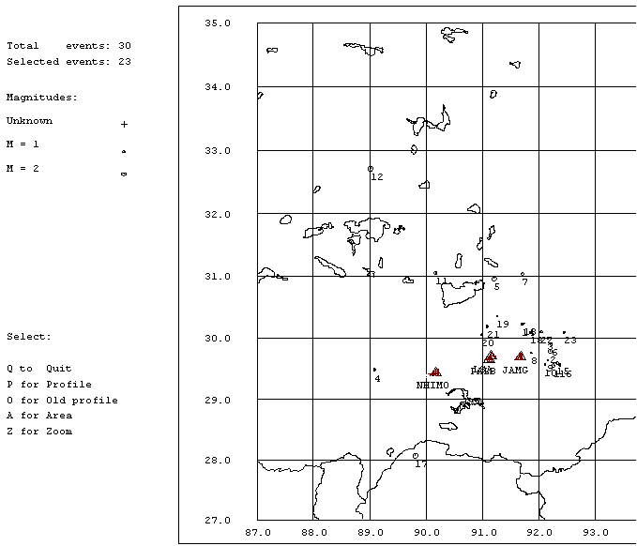

Table 1
Table of events from September, 2004

Abbreviations are: MM: Month, DD: Day, HRMM: Hour and minute, Sec Seconds L: L or D for local or distant event, respectively, Aga: Agency, N: Number of station used. rms: root mean square of location residuals, Mc and Ml: Coda wave magnitude and local magnitude, respectively.

Year MMDD HRMM Sec L Latitude Longi Depth Aga n rms Mc Ml
2004 9 1 0033 22.8 L 29.551 92.262 15.0 TES 1 0.0 1.5CTES 2.2LTES
2004 9 1 631 49.0 L TES 0
2004 9 1 933 23.0 L TES 1
2004 9 2 844 35.0 L TES 0
2004 9 2 2241 37.3 L 29.786 92.197 15.0 TES 1 0.0 1.7CTES 1.3LTES
2004 9 3 1024 48.3 L 29.810 95.635 15.0 TES 1 0.0 2.0CTES 2.4LTES
2004 9 4 0637 12.9 L 29.998 92.153 15.0 TES 1 0.0 1.1CTES 1.6LTES
2004 9 5 1021 41.2 L 29.481 89.080 15.0 TES 2 1.4 1.3CTES 2.6LTES
2004 9 5 1330 24.8 L 30.957 91.205 15.0 TES 1 0.0 2.0CTES 2.0LTES
2004 9 6 0019 53.7 L 30.223 95.854 15.0 TES 1 0.0 2.0CTES 2.0LTES
2004 9 6 1142 33.9 L 29.900 92.218 15.0 TES 1 0.0 1.5CTES 1.1LTES
2004 9 6 1224 27.0 L TES 1
2004 9 7 0219 53.3 L 31.037 91.708 15.0 TES 1 0.0 1.5CTES 2.2LTES
2004 9 7 0716 36.8 L 29.756 91.862 15.0 TES 1 0.0 0.9CTES 0.8LTES
2004 9 8 0628 13.4 L 29.638 92.155 15.0 TES 1 0.0 0.5CTES 1.9LTES
2004 9 8 1456 30.2 L 29.565 92.108 15.0 TES 1 0.0 0.9CTES 2.4LTES
2004 911 1324 48.4 L 31.051 90.164 15.0 TES 1 0.0 1.8CTES 1.7LTES
2004 911 1740 47.7 L 32.713 89.013 15.0 TES 1 0.0 2.4CTES 2.9LTES
2004 912 0853 43.9 L 30.236 91.731 15.0 TES 1 0.0 1.1CTES 1.4LTES
2004 912 0913 5.8 L 30.222 91.702 15.0 TES 1 0.0 1.2CTES 1.3LTES
2004 912 1011 57.7 L 29.591 92.320 15.0 TES 1 0.0 1.6CTES 1.3LTES
2004 912 1032 6.4 L 29.559 92.358 15.0 TES 1 0.0 1.1CTES 2.2LTES
2004 913 0812 59.1 L 28.067 89.811 15.0 TES 1 0.0 2.2LTES
2004 913 1750 22.1 L 30.097 91.854 15.0 TES 1 0.0 0.9CTES 1.5LTES
2004 913 1845 24.9 L 30.361 91.251 15.0 TES 1 0.0 0.5CTES 1.6LTES
2004 914 0039 30.4 L 30.052 90.984 15.0 TES 1 0.0 0.8CTES 2.4LTES
2004 914 0117 24.6 L 30.189 91.080 15.0 TES 1 0.0 1.0CTES 2.7LTES
2004 914 1039 12.6 L 30.105 92.037 15.0 TES 1 0.0 1.1CTES 2.6LTES
2004 915 1310 55.5 L 30.698 95.731 15.0 TES 1 0.0 2.0CTES 2.4LTES
2004 915 1541 4.8 L 30.097 92.444 15.0 TES 1 0.0 0.8CTES 1.4LTES

