
Travel report

Visit to Lhasa, September 6-18, 2003

Lhasa local seismic network

Prepared by

Helge Johnsen

Department of Earth Science, University of Bergen

Allégt.41, N-5007 Bergen, Norway

Tel: +47-55-583600 Fax: +47-55-583660 E-mail: seismo@geo.uib.no

February 2004

The purpose of this visit was to establish a seismic network of 3 stations around Lhasa. The network is sponsored by the Faculty of Natural Sciences, the University of Bergen.
On my last visit in 2001, one station was established for testing in the basement of Lhasa University,however this turned out to be a very noisy site and other sites outside Lhasa was needed. During my visit I worked with Tsoja Wangmo, who is also a MSc student at out department. She will later operate the network.

Before arrival Tsoja had already installed the software and tested the digitizers and seismometers to use. All seemed to work ok except that the type of PC’s used did not have the possibility to start automatically in case of power failure. This could be a serious problem in case of unattended operation.

LOCATION OF NEW SITES: Tsoja had visited two locations before I arrived. The location in Nhimo is situated 170 km Northwest of Lhasa. Some noise tests had been done in a building belonging to the Weather Station of Nhimo.
The location in Jamag is situated 80 km East of Lhasa, in a new Scientific Observatory built in 2003. The noise test made by Tsoja failed due to the laptop malfunctioned in the extreme elevation.

LHASA: At the University we started to test the equipment. Tsoja had bought 3 PC’s in Lhasa and installed the software Seislog for Windows. 3 digitisers/GPS/power supplies had been brought from Norway. The equipment worked properly during the test in Lhasa.

.
NHIMO: The equipment was installed and started without problems. During testing with stop/start of recording, the serial line occurred to be unstable and the software would not start. After several attempts, the recording restarted. A lot of tests were made trying to find out what caused this problem. The PC seemed to otherwise operate normally. No cause of the failure to read data from the digitizer was found.
Timing from the GPS was ok and the station was left running on return to Lhasa.

We went back to Nhimo after 2 days. When we arrived, the station had stopped. The local operator at the Metrological Observatory informed us that there had been a power break. This time we were not able to restart the station. Continued testing with replacing digitiser, PC and power supply did not help. The equipment was therefore brought back to Lhasa.

JAMAG: After the problems in Nhimo, we started to do some tests at the Institute in Lhasa before going to Jamag. We were not able to reproduce the problems occurring in Nhimo and the same equipment seemed to work properly.

The equipment was installed in the Jamag Observatory. After starting Seislog, the recording did not start. After trying several times, another PC, digitiser and power supply was used, but none of the equipment would work. Testing also with a laptop did not work.

The equipment was brought back to the Institute in Lhasa to verify if it was still working at a lower elevation. We had no problem to start the recording at the Institute. After a discussion with my Institute in Bergen, another software for recording was installed in one PC in order to test if the software could be the problem. The next day we went back to Jamag to do a test with the new software. The new test made no improvement, and the equipment again work when back in Lhasa.

Due to the problems of high elevation, the last day of my stay was used to noise tests outside Lhasa. The test was done with a laptop and a digitiser and the equipment worked ok.

The conclusion is that the high elevation seems to affect the operation of the equipment. In Lhasa, at the lowest elevations of the tests at 3698 m, equipment was ok. At Nhimo at an elevation of 3809 m, it worked sometimes and at the highest point, Jamag at 4565 m, the equipment never worked. A stationary PC seemed to work, but not a laptop.

During my stay in Lhasa we informed the company who is producing the digitisers regarding our problem. The company made some tests, but unfortunately could not solve the problem. Later on the company has made some laboratory tests reproducing this extreme elevation. During this test the digitiser worked well. The most like cause of the problem is thus the serial line on the PC’s bought in Lhasa. So when new equipment will be installed in 2004, all components must be tested under low air pressure to simulate the high elevation.

Since we did not succeed to have station running in Nhimo and Jamag, we decided to reinstall the station at the University. The data has to be copied from the hard disk and sent to University of Bergen.

One digitiser was brought back to Bergen for further testing.

In the following, some pictures are seen from the area.

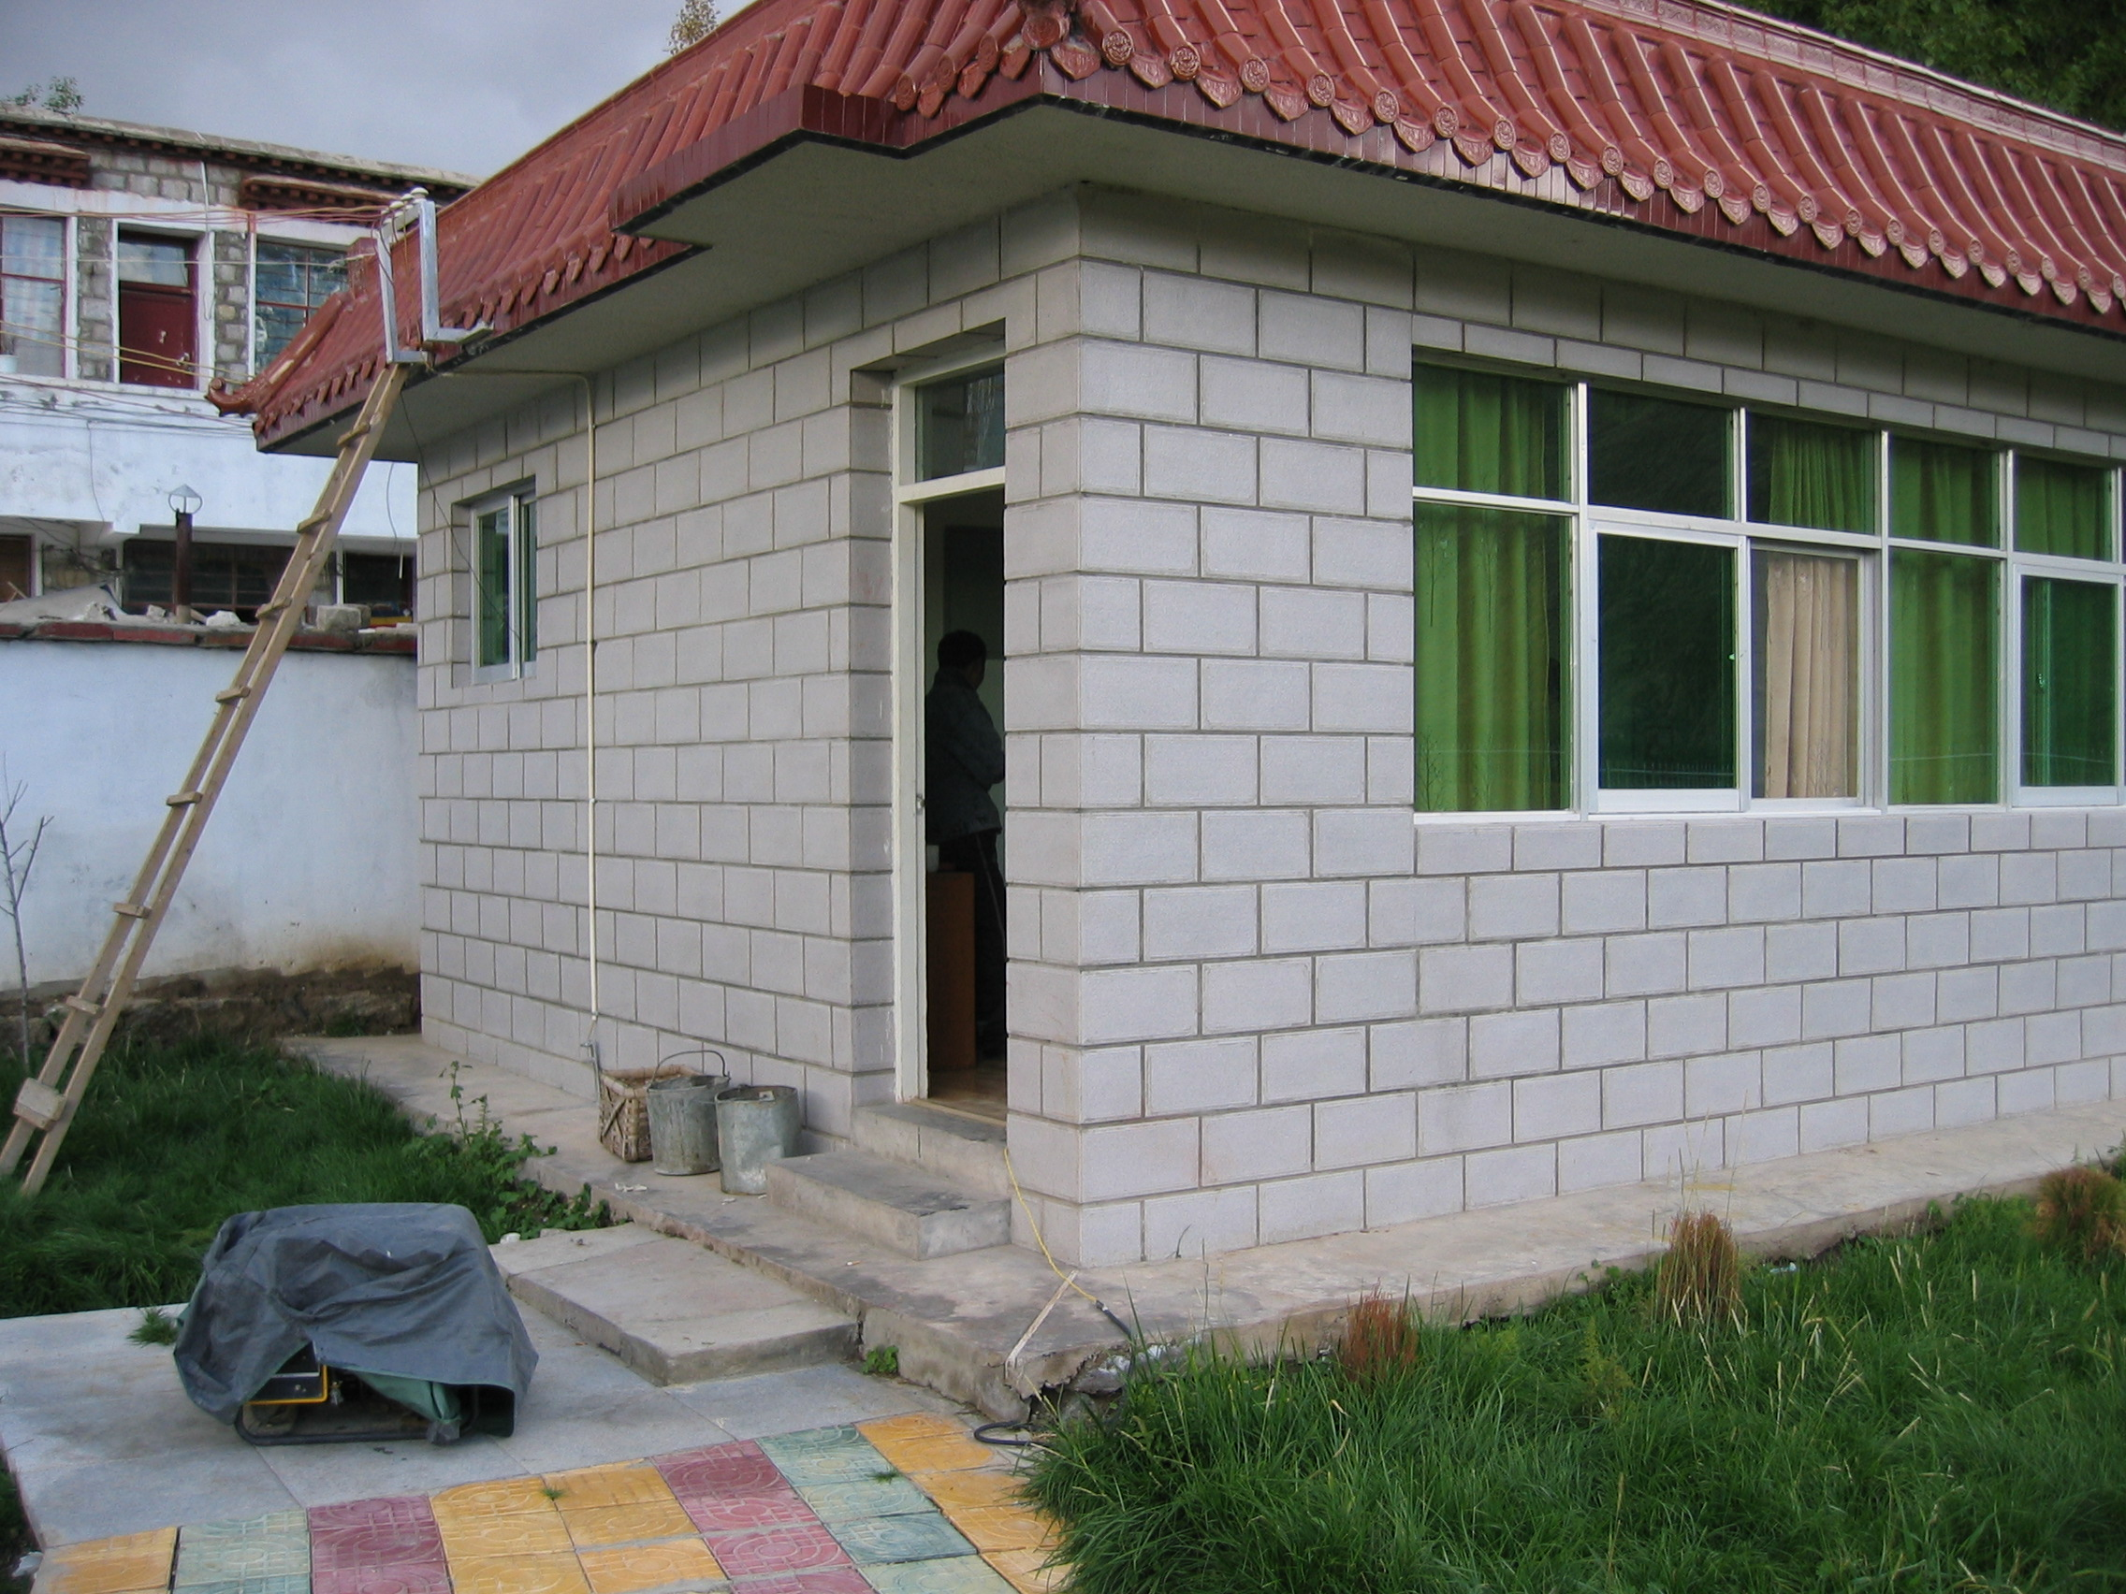
Weather Station of Nhimo

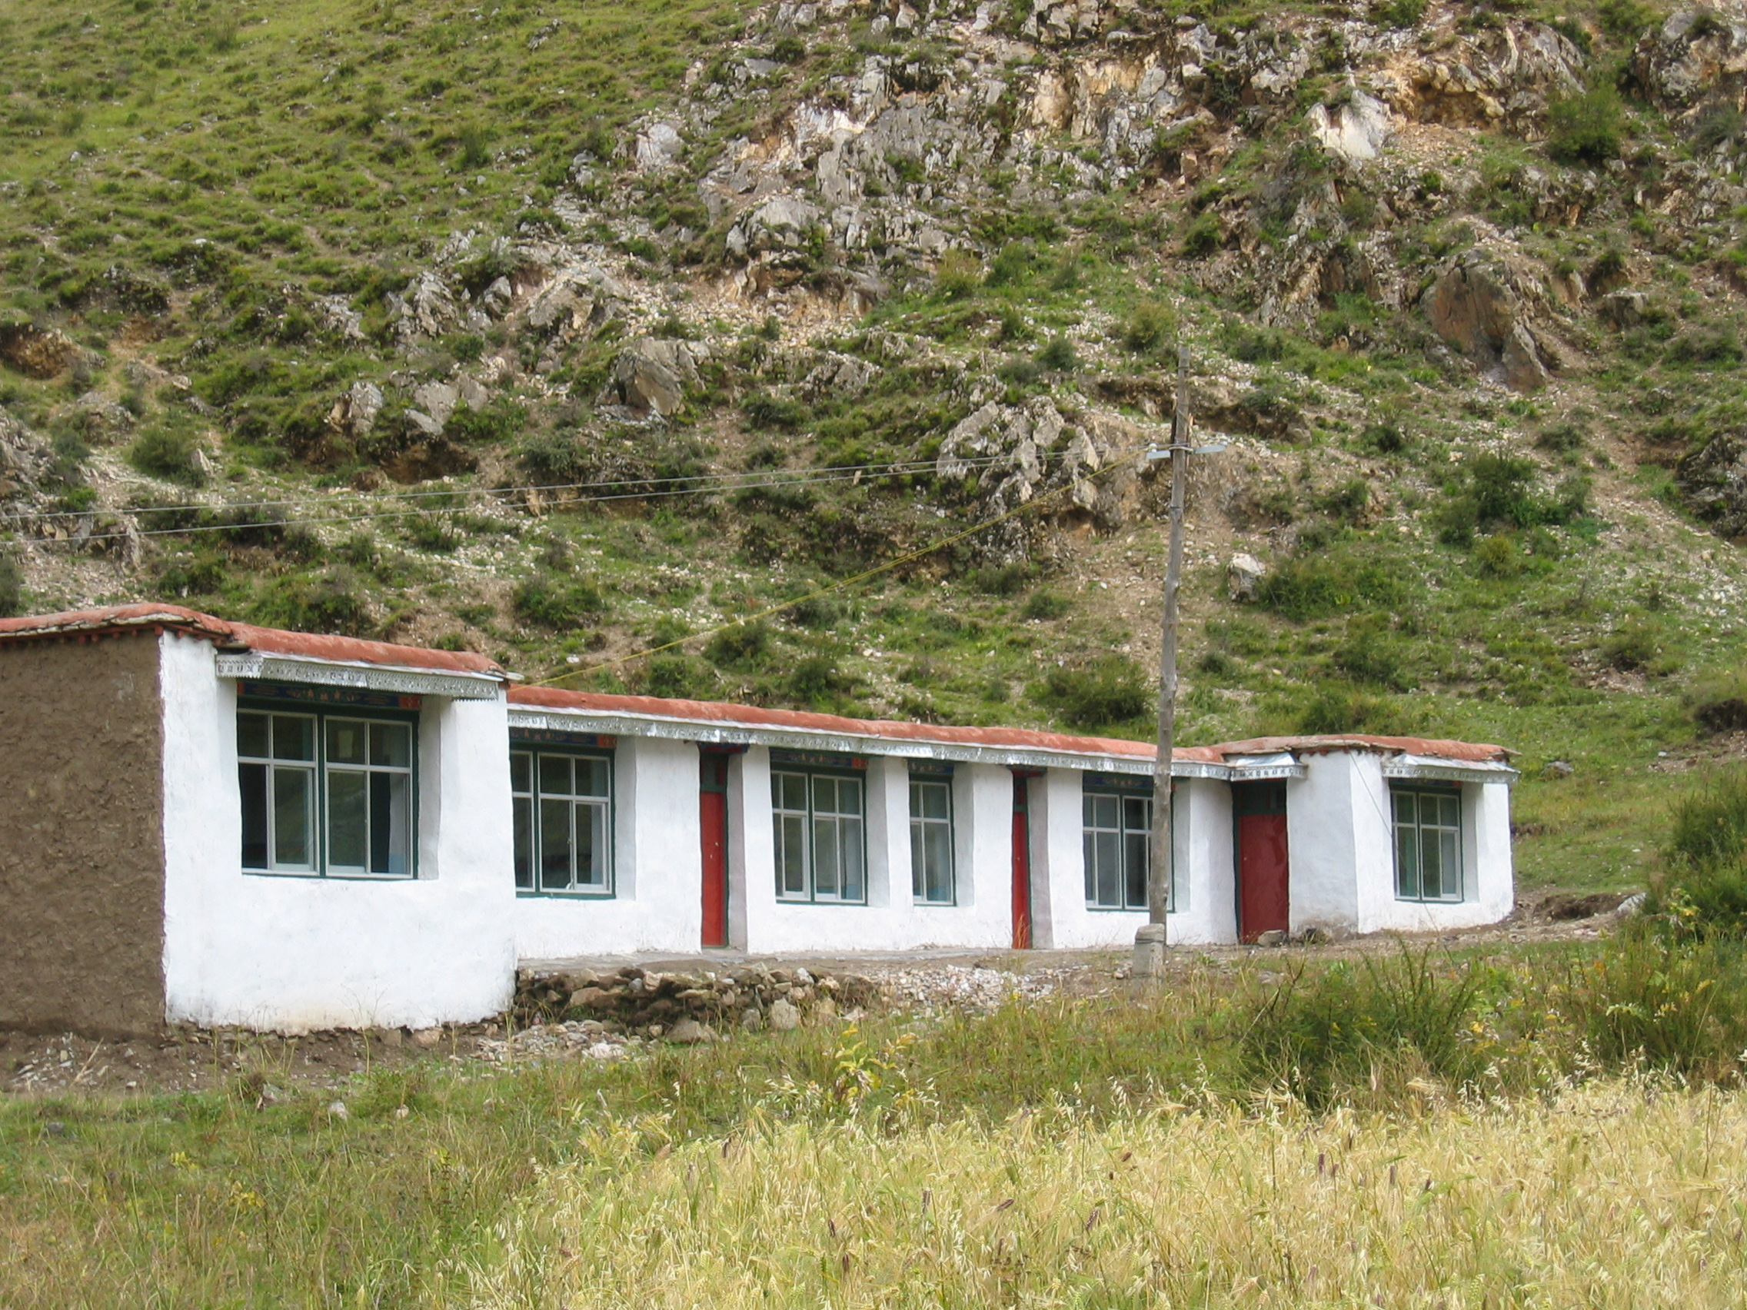
Jamag Scientific Observatory

