Travel report

Visit to Lhasa, July 16 to August 5, 2006

Tibet University Seismic Network



Prepared by

Mathilde Bøttger Sørensen

Department of Earth Science, University of Bergen

Allégt.41, N-5007 Bergen, Norway

Tel: +47-55-583600 Fax: +47-55-583660 E-mail: mathilde.sorensen@geo.uib.no

August 2006

Summary

The Tibet University Seismic Network, supported by the University of Bergen, has now been in operation for two years. The network consists of 4 stations, which have all been suffering from some operational problems. During the visit, three stations were visited for making noise measurements and checking the installations. Data processing was brought up-to-date and an overview was made over available data and causes of data loss. In addition, two potential sites for new stations were visited and noise measurements were taken.

Purpose

The purpose of this visit was to help with processing data from the four stations of the network, to visit some of the stations for quality control and to do noise measurements at possible sites for future stations.

Status of stations:

Lhasa (LHAS)

This station is located at the university campus in Lhasa. The station has not been operating for the last year due to problems with the PC, which was very old. During the visit, a new PC was set up, but there was a problem getting data to the PC. The station uses a GBV-116 as digitizer and no signal was received when connecting to the instrument via Seislog. In an attempt to locate the problem, the GBV unit was contacted using the AV software (in order for this to work, the keyboard must be defined as a Norwegian keyboard). Through AV it was possible to access parts of the system ('Power and battery', 'Warnings/errors' and ‘Sampling’) whereas other gave a message of ‘communication error’ (trace plotting, trigger settings and permanent settings). This indicated that the problem was related to receiving data from the digitizer. The problem could not be solved during the visit. There is a chance that the problem is related to the PC using Windows XP. No Windows 2000 computer was available during the visit, but Tsoja Wangmo and Tsering will try to connect a Windows 2000 PC and see if this solves the problem.

Jamag (JAMG)

Due to difficult access, the Jamag station has been moved to a new location in January 2006 (see station TAGA).

Panbu Gunsar (TAGA)

As a substitute for the Jamag station, TAGA was installed in a village ca. 40 km east of Lhasa on January 19, 2006. The station is now easy to access by normal car, requiring less than 1 hour of driving. The station was visited on July 21st to check the new installation and do some noise measurements. The installation looks good and data quality seems to be ok. Figure 1 shows an event recorded at the TAGA station.

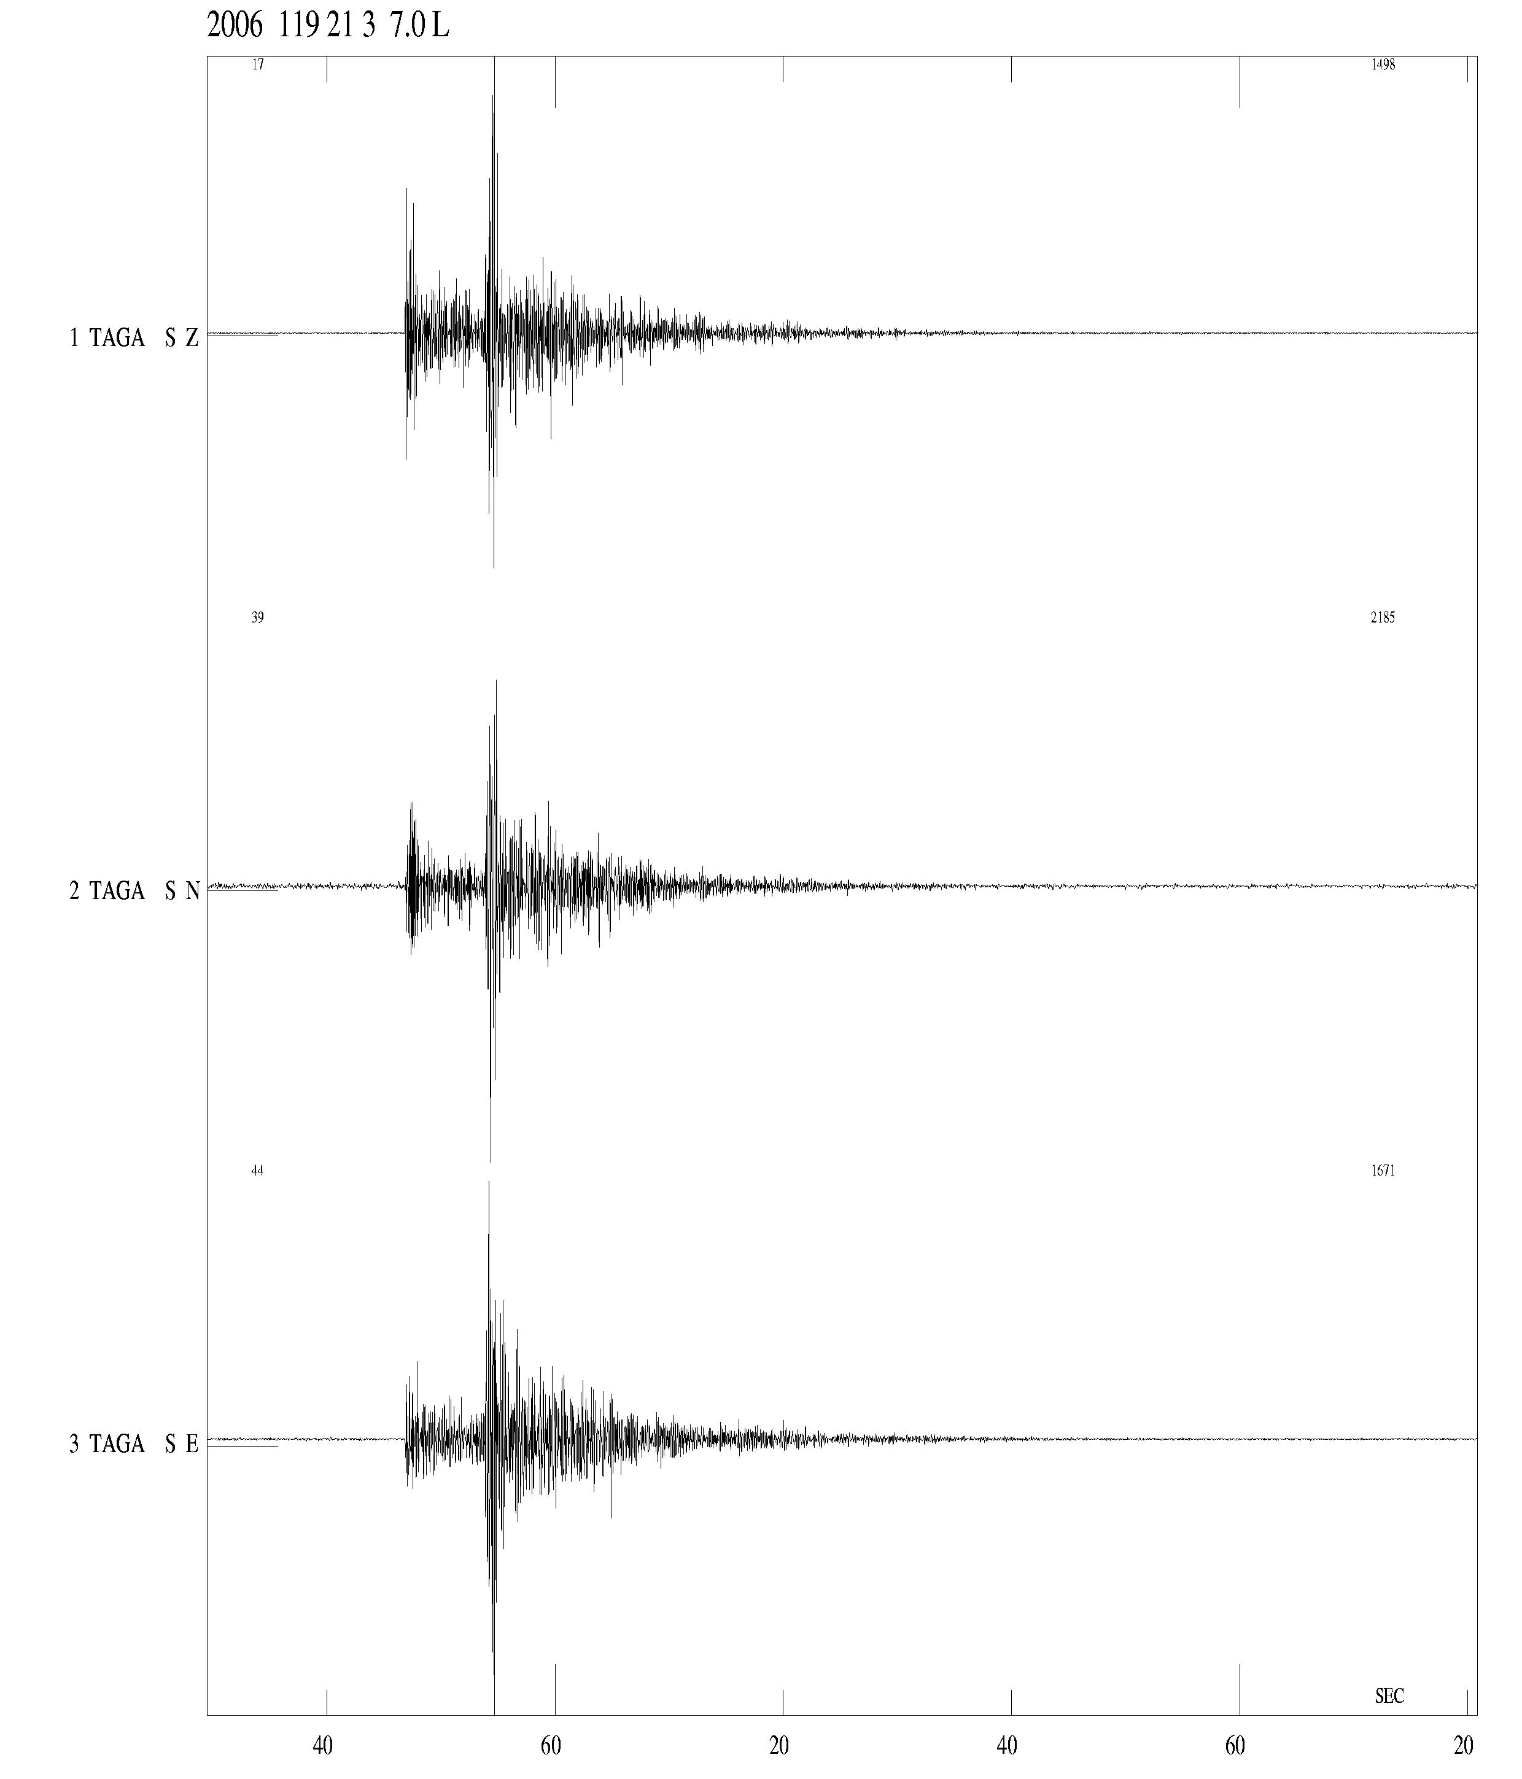
Figure 1: Earthquake recorded at TAGA on January 19, 2006, M_{L}=1.8.

To test the quality of the recordings, ca. 4 min of noise measurements were taken during the visit, using the installed equipment. Figures 2-4 show the noise curves for the recordings with a comparison to the Peterson curves. It is seen that the noise level is fairly low at all channels and well below the high-noise Peterson curve for frequencies above ca. 0.2 Hz. Using a shorter time window containing only the low-noise part of the signal did not change the noise curves significantly.

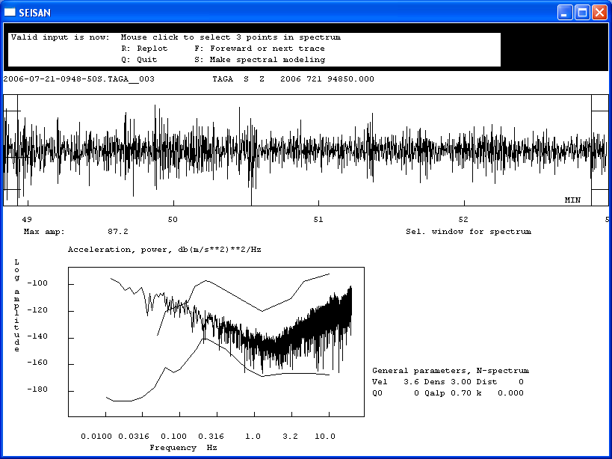
Figure 2: Noise spectra for vertical channel of the new TAGA station based on ca 4 min of recorded noise.

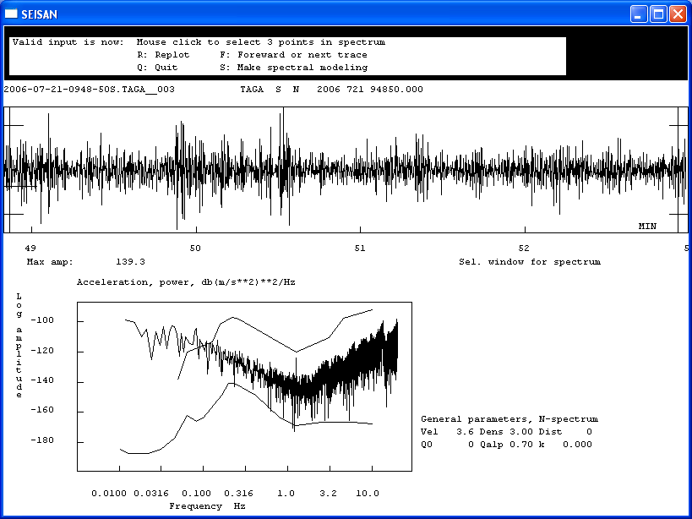
Figure 3: Noise spectra for NS channel of the new TAGA station based on ca 4 min of recorded noise.

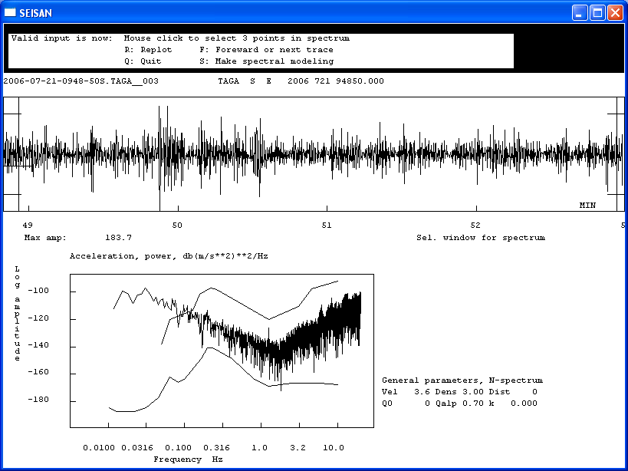
Figure 4: Noise spectra for EW channel of the new TAGA station based on ca 4 min of recorded noise.

For comparison to previous measurements, the most quiet 10 s section of the noise record has been analyzed in a way similar to what has been presented in earlier reports. The maximum amplitude was measured on the raw traces and for band pass filters 1-5 Hz and 5-10 Hz. The results for all three channels are presented in Table 1 later in this report.

Figures 5-6 show some pictures from the station.
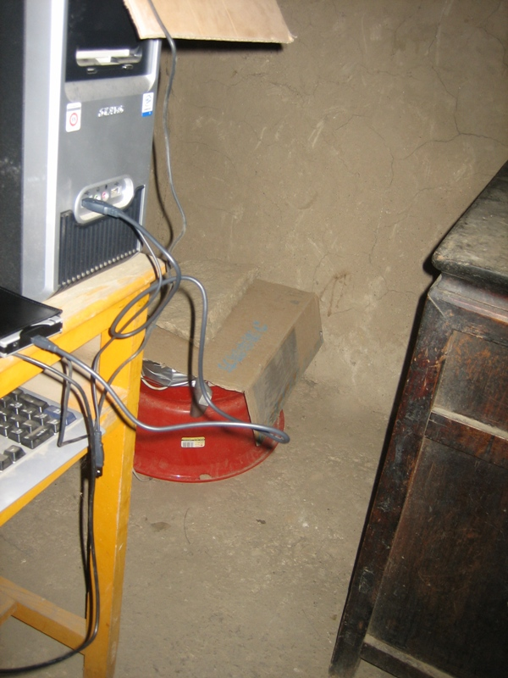
Figure 5: The installation at TAGA. The sensor is placed under the red bucket.

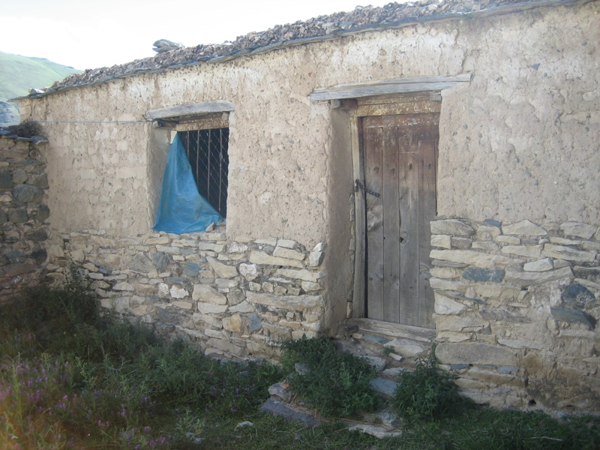
Figure 6: The housing of the TAGA station. The equipment is inside to the left of the window.

Nihmo (NIHM)

The station has been running well and was not visited. It has been tested to transfer data via e-mail. This is time consuming due to large file size and data may have been lost, but it adds flexibility in case data are needed quickly and visits to the station can be avoided. E-mail transfer will be continued in the future, but in addition the personnel have been asked to make back-up of data regularly.

Chudi (CHUD)

The station is running well and provides good recordings. The local monk is interested in the station, making operation smoother. The station was visited to collect the most recent data for processing. There is still a problem with a large number of triggers at the station. Figure 7 shows the location of the station inside the monastery on the mountainside.

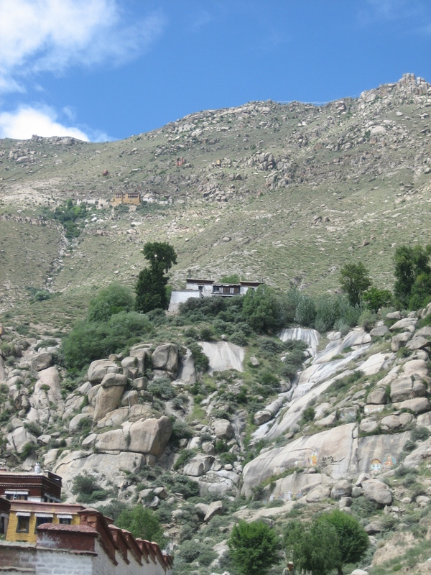
Figure 7: The monastery housing the CHUD station

Chupsang (CHUS)

The new station CHUS was installed at the Chupsang monastery, north of Lhasa, on September 2, 2005. The station is installed inside the monastery far from the main road. The operation has been unstable due to a power failure followed by a lightning strike destroying the UPS. Since May 2006, the station has been operating continuously with a new digitizer. The data quality at the station is not good and there is significant 50 Hz and low-frequency noise, especially on the vertical and EW components. The station was visited to try to fix these problems. The installation looked ok. There is a very long cable between the sensor and the digitizer because the equipment was previously used at PALB where the long cable was needed. At installation, the digitizer and the PC had been grounded. During the visit the grounding of the cable connecting digitizer and PC was checked and the sensor was grounded. Also, all connectors were checked and everything looked ok. The extra grounding decreased the noise at the vertical and EW channels, but the data is still not very good. It was decided to leave the system running to see if the improved data quality is sufficient for obtaining good recordings.
Another problem at the site is the available power, which is running through very thin and weak cables. This causes numerous power losses and may also be the origin of many spikes in the data. It is a possibility to change the power cables in the future, this will require ca. 600m of cable. Figures 8-10 show some pictures from the visit.

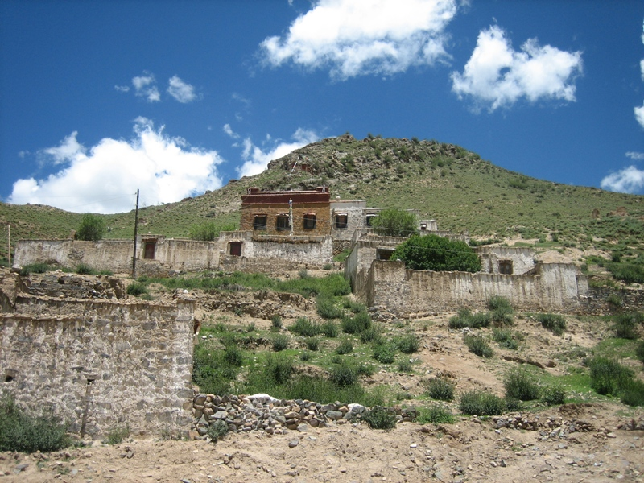
Figure 8: The Chupsang monastery housing the CHUS station. The instruments are in one of the topmost buildings to the right.

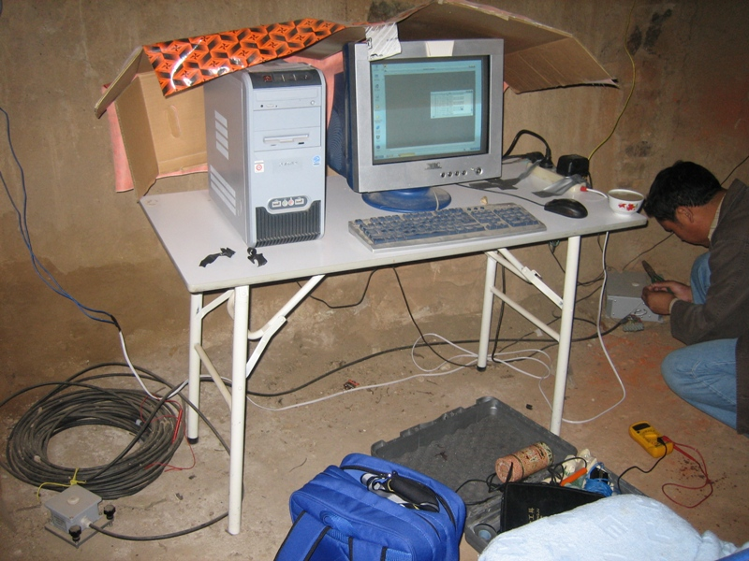
Figure 9: The CHUS installation. The sensor is to the left, digitizer to the right.

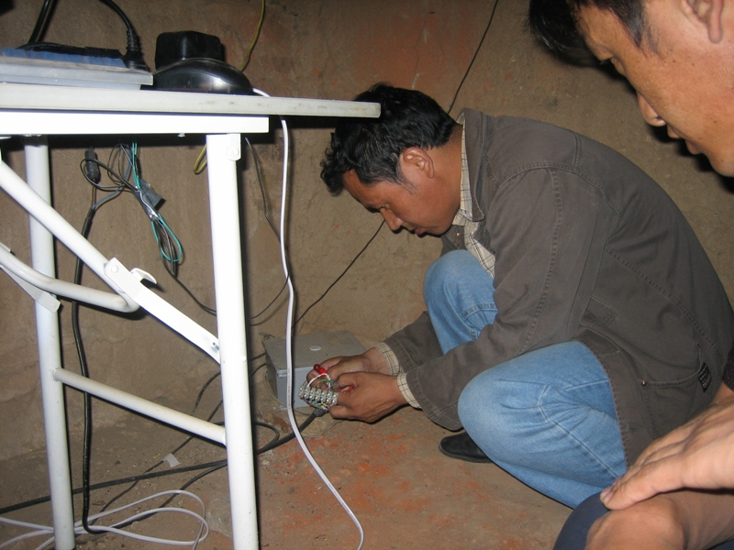
Figure 10: Checking the connector on the cable between digitizer and PC at CHUS.

Operation

Station operation has been unstable due to problems with access to the stations and limited time for the staff to visit the stations to collect data and solve operational problems. However, most operational problems have been solved and all four stations are operating as of July 2006.

One of the main purposes of the visit was to become up-to-date with data processing and to clean up the event database. Much data had not been processed and many events were duplicate in the database or contained several waveforms from the same station. To update the database the following steps were followed:

- All available data was collected from the stations and events were located
- Duplicate events were deleted
- All events were checked manually to ensure that all possible phases were read, that there were not double phase readings and that only one waveform was included for each station
- All available PDE locations within the main area (26-34N, 88-96E) were included in the database and merged with local data when available. Events were fixed at the PDE location since this is expected to be more reliable.
- Data from the LSA station extracted by Tsering (June 2004 – May 2005) were merged into the database and phases were read. Data from May 2005 – July 2006 have been downloaded and will also be included in the database.
After updating the database, a new seismicity map was made, and a report was written on the first two years of network operation (appendix 1).

Most routine processing is currently done by Tsamlha, who has been working for the university since March 2006. She was involved in steps 1-4 mentioned above and thereby got a better understanding of how to do the processing and how to distinguish noise from earthquakes.

Noise tests

In order to find possible locations for new stations, the area of the 1951 and 1952 earthquakes and a site to the south of Lhasa were visited to make noise measurements.
During the visit to the area of the 1951 and 1952 earthquakes, close to the lake Namtso, the plan was to drive to a lake north of Namtso to look for a village or a monastery suitable for housing a station. When we reached the area the road was closed so we had to find another location. We passed a monastery on the open part of the dust road, but the location was remote and data transfer would be problematic.
In search of an alternative location, we drove further north to the location where the fault crosses the main road. Here we found a small village a few kilometers from the main road where we made a set of noise measurements. People of the village were curious and followed the measurements closely, and therefore the noise level is probably slightly higher than what can be expected for a permanent installation. Noise measurements were made using the SARA instrument. The noise curve for the site is shown in Figure 11. The noise level is higher than at the other stations in the network, but the location of the site on the fault makes it an attractive location. The villagers are willing to house the station. They are planning to build a new house, which should be finished during autumn 2006. After the house is finished, there will be a room available for the instrument. The village does not have power and therefore the station must be powered by solar panels.

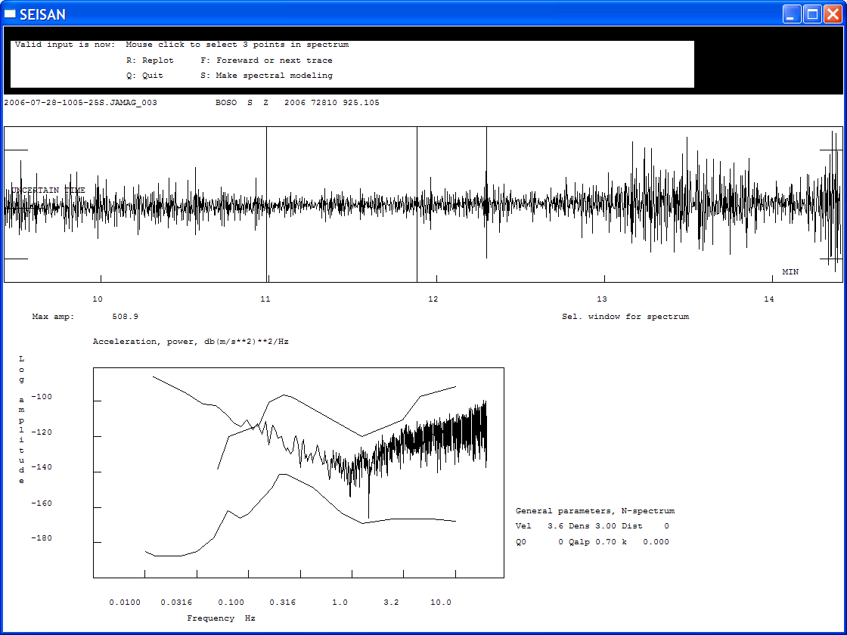
Figure 11: Noise curve (vertical component) for potential site for new station close to Lake Namtso

The second site visited was the village Sigong (Tsering’s home town) south of Lhasa. Also this village is located far from the main road, and we can install a station at the house of Tserings parents. There are two possible locations of the station. On possibility is to place the instrument in a room next to the living room. Here there will be significant noise when the living room is in use. Alternatively, a small house can be built in the garden behind the house. Noise measurements were made at both locations (Figures 12 and 13), and the noise level seems to be similar.

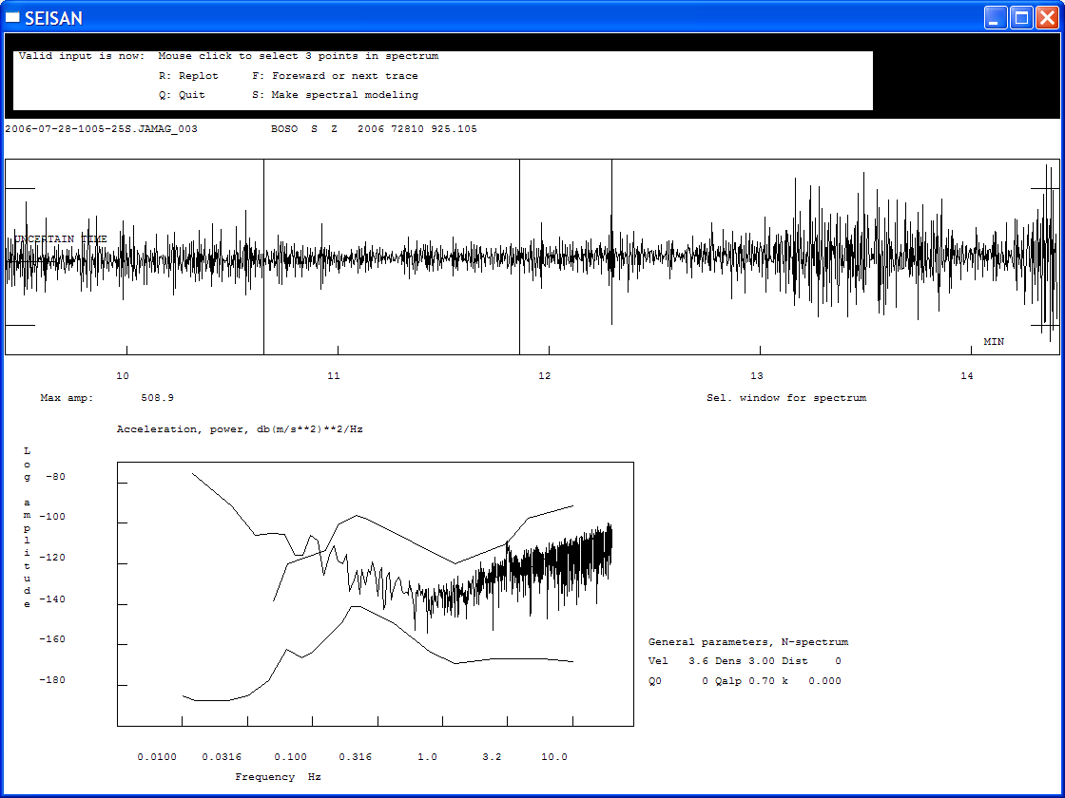
Figure 12: Noise curve (vertical component) for room next to living room at Tsering’s partents’ house in Sigong

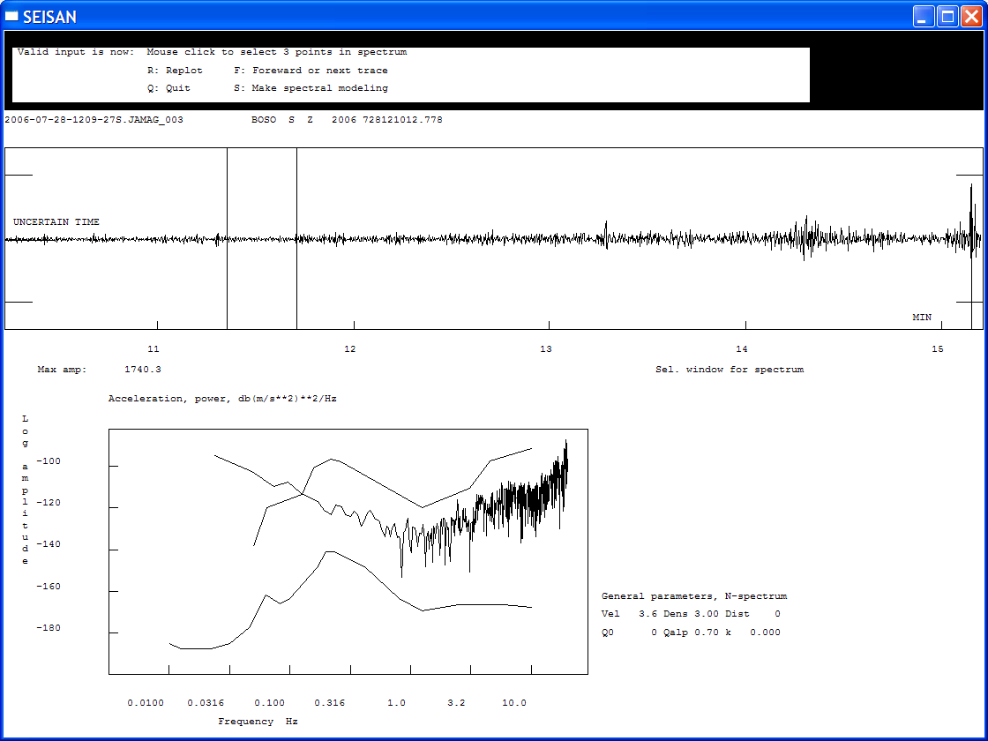
Figure 13: Noise curve (vertical component) for garden behind Tsering’s parents’ house in Sigong

The noise measurements are summarized in Table 1 where also data from 2004 and 2005 are included for comparison. The most quiet 10 s section of the noise record has been selected and the maximum amplitude was measured on the raw traces and for band pass filters 1-5 Hz and 5-10 Hz. Lower frequency bands were not used since the instrument has a 4.5 Hz sensor. For the comparison, all values have been converted to GBV values by multiplying data from the SARA instrument by a factor of 2.

Site | Raw | 1-5 Hz | 5-10 Hz | Comment
2004 measurements
LHAS, at lab | 850 | 110 | 280 | Soil
University park | 450 | 120 | 260 | Soil
Lhasa bridge, near university | 33 | 9 | 12 | Rock, car sensitive
Xiangga, gully, 100 m from road | 72 | 21 | 39 | Rock, car sensitive
Jamag, inside instrument house | 11 | 3 | 5 | Soil, motion sensitive
Jamag, by rock | 8 | 4 | 4 | Rock gully
East of Lhasa, Poligo (5 km) | 18 | 8 | 14 | Rock, very car sensitive
Tea shop by Potala | 63 | 6 | 22 | Rock cave, little car sensitive
Palub monastery, East of Potola | 21 | 6 | 14 | Deep rock cave
Road up to Sheuruling monastery | 7 | 2 | 3 | Loose rock, sensitive to walking by
Sheuruling monastery, below outside wall near kitchen | 25 | 8 | 11 | Loose rock, sensitive to walking by
Sheuruling monastery, inside, North corner | 125 | 13 | 66 | Floor on soil, very sensitive local motion
Sheuruling monastery, 30 m below, near track | 32 | 7 | 11 | Loose rock, sensitive to walking by
Nhimo, most quiet | 20 | 10 | 8 | Soil (from recorded data)
Nhimo, noisy | 120 | 30 | 40
2005 measurements
CHUD | 18 | 5 | 6 | Sensitive
Village near JAMG | 14 | 4 | 6 | Rock, not sensitive
----, monastery | 14 | 6 | 8 | Boulder, very sensitive
Lhamo, on large rock | 18 | 4 | 18 | Very car sensitive
Lhame, ---, cars passing | 200 | 34 | 140
Lhamo, rock further back | 16 | 6 | 10 | Not car sensitive
Lhome, ---, cars passing | 40 | 12 | 16
Namtso lake, research station | 48 | 22 | 31 | Soil, very sensitive
Road to Galu monastery, | 14 | 6 | 8 | Soil, sensitive
Village with power plant | 83 | 26 | 76 | Soil, sensitive
Village, no power | 38 | 8 | 20 | Soil, rock near, sensitive
Across rail, 300m from river | 16 | 5 | 13 | Soil, sensitive
Across rail, 300 m from river | 11 | 5 | 10 | Rock, sensitive
Shurond, near road | 38 | 12 | 16 | Large boulder, car sens.
Chusang monastery, upstairs | 6 | 2 | 3 | Near rock, not sensitive
Chusang monastery, downstairs | 4 | 2 | 2 | Near rock, sensitive
2006 measurements
TAGA, Z | 40 | 8 | 20
TAGA, N | 50 | 16 | 32
TAGA, E | 60 | 16 | 40
Village near Namtso | 70 | 34 | 34 | Soil
Sigong, inside house | 60 | 34 | 40
Sigong, outside behind house | 90 | 46 | 70 | Soil

Table 1: Noise measurements at different sites: The values given are maximum amplitude in counts, raw means unfiltered data. The vertical component of ground motion has been considered unless differently mentioned.

Appendix I

Summary report for TBU network 2004-2006

