Erzurum SEISAN workshop

held at

the

Earthquake Research Center
Ataturk University

21-25 November, 2011.

Participants and authors of this report

Civil Eng. Mehmet OZYAZICIOGLU mehmetoz@atauni.edu.tr
Geologist Goksin AKSOY gokaksoy@yahoo.com

Address: ATATURK UNIVERSITY - EARTHQUAKE RESEARCH CENTRE
Cat Yolu Kiremitlik Tepe Mevkii
25240 Erzurum/Turkey

Geophy. Kenan YANIK kenan@deprem.gov.tr
Geophy. Tugbay KILIC tugbay@deprem.gov.tr
Geophy. Recai F. KARTAL kartal@deprem.gov.tr

Address: DISASTER AND EMERGENCY MANAGEMENT PRESIDENCY
Eskisehir yolu 13. km.
Ankara/Turkey

Instructor

Jens Havskov jens@geo.uib.no
Department of Earth Science
University of Bergen
Norway

Introduction

The purpose of the workshop is to do basic Seisan training, test and adopt procedures for importing data from the national network in Ankara as well as getting data from the Guralp system into Seisan. Different crustal models will be tested as well as magnitude scales and fault plane solution methods. Ankara is especially interested in calculating Mw using spectral methods.

During the workshop, several practices in Ankara processing were discussed and ways of improving them could be:

- Read maximum ground displacement on a Wood-Anderson trace instead of a raw trace
- Calculate Ml using the maximum S instead of maximum P, requires a recalibration of magnitude scale
- Report ground displacement in nm instead of counts, then others can also use the amplitudes
- Use angle of incidence for fault plane solutions corresponding to the model used instead of the angles from the JB model in azmtak
- Store all parameter in same data base
- Calculate Mw using spectral analysis

Calibration functions

Initial functions were made using Seisan format (more than 600 channels). It turned out that some earlier Guralp digitizers are single ended so generator constant is not multiplied by 2. No info on this is given in manual so we have to wait for Guralp to supply info. So some curves will have an error of a factor 2. Some response file examples were made with poles and zeros to be implemented when there is no doubt about the response.

Magnitude Ml

Erzurum: Tests were made to use the standard California scale. However, compared to Mw from the spectra, and magnitudes calculated by Ankara and Kandelli, they seemed too small, maybe due to higher attenuation in the region. See last section of Erzurum report.

Ankara: The procedure is to read the maximum count on the raw trace in the P-waves, correct for instrument gain to get amplitude on a Wood Anderson seismogram . This is not correct according to the definition of local magnitude where maximum amplitude should be read on a maximum displacement Wood-Anderson trace in the S-waves. However, when Ankara tried to use S. It gave too large amplitudes (maybe as much as 1000) so P was used instead. The standard procedure in the Hypoinverse program is used for the actual calculation. (http://www.jclahr.com/science/software/magnitude/ml/index.html)
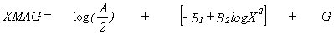
XMAG | = | Log base 10 of maximum zero-to-peak amplitude in mm as recorded on a standard Wood-Anderson seismograph. | + | Approximation to Richter's logA _{o}from Eaton (1970), which accounts for amplitude attenuation with distance.  See Figure 4-1. | + | Station Correction
XMAG | = | log(A/2) | + | (-B₁ + B₂ log(X²)) | + | G
where:
A = Maximum peak-to-peak amplitude in mm
For 1 km < D < 200 km
B₁ = 0.15
B₂ = 0.80
For 200 km < D < 600 km
B₁ = 3.38
B₂ = 1.50
and D is the epicentral distance and Z the focal depth in km.
G = Station correction (not used by Ankara).

However the Ankara magnitudes seems to be quite consistent with other magnitudes (see Figure below) either by luck or maybe some other unknown adjustments have been used.
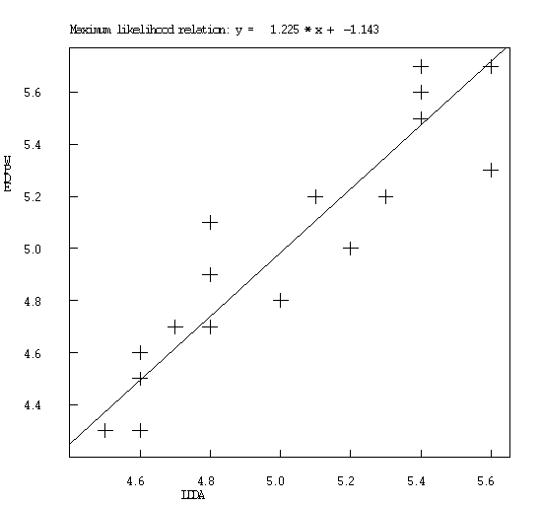
Ankara original Ml versus PDE magnitudes (supposed to be proportional to Mw). The events are most aftershocks of the Van event. The average of both magnitudes is 5.0.

The source of the error was investigated and it was found there was a mistake in the response calculation. Before the course, an example of the amplitudes of P and corresponding magnitudes (calculated with Hypocenter) were:

(E)arthquake (A)nalysis - Developed by. Kenan YANIK 2011
Code | Component | Ml | Amp (millimeter) | T (second)
GEVA | Z | 4.9 | 559.94 | 0.18
VMUR | Z | 5.54 | 2076.25 | 0.12
TUTA | Z | 5.84 | 1534.717 | 0.12
EKAR | Z | 5.9 | 1129.414 | 0.48

After correcting the error the, the maximum S wave amplitude was measured on velocity trace, corrected for response and multiplied with the Wood Anderson response (gain 1) (top part of Table below). The bottom part of Table shows the amplitude measurents using Seisan where maximum is measured on WA trace.

(E)arthquake (A)nalysis (EA) - Developed by. Kenan YANIK 2011
Called EA system
Code | Component |  | Ml | Amp (nanometer) |  |  | T (second)
GEVA | N |  | 4.3 | 34089.53 |  |  | 0.24
VMUR | N |  | 4.8 | 87944.5 |  |  | 0.2
TUTA | N |  | 4.6 | 23321.37 |  |  | 0.18
EKAR | N |  | 4.3 | 7528.03 |  |  | 0.18
Seisan
Code | Component |  | Ml | Amp (nanometer) |  |  | T (second)
GEVA | N |  | 4.3 | 29026.4 |  |  | 0.48
VMUR | N |  | 4.7 | 78099.9 |  |  | 0.52
TUTA | N |  | 4.5 | 23206.1 |  |  | 0.36
EKAR | N |  | 4.1 | 5717.4 |  |  | 0.44
(EA) Mean Ml: |  | 5.5 |  |  | Before using P
(EA) Mean Ml: |  | 4.5 |  |  | After using S
(Seisan) Mean Ml: |  | 4.4 |  |  | After

It is seen that the amplitude measurements using EA and Seisan are almost the same. In both cases, the Ml is substantially smaller than before, again indicating the need to revise the Ml scale for Turkey.

Comparison of a location with Hypocenter and Seisan

(E)arthquake (A)nalysis
Agency | Network | Time | Latitude | N/S | Longitude | E/W | Depth (km) | RMS | Station
DDA | ERD | 26/10/2011 03:16:18 | 38.6782 | N | 43.2143 | E | 7 | 0.31 | 6
Seisan
Agency | Network | Time | Latitude | N/S | Longitude | E/W | Depth (km) | RMS | Station
DDA | ERD | 26/10/2011 03:16:18 | 38.693 | N | 43.262 | E | 0 | 1.5 | 6

As it can be seen, locations are very similar but rms is larger in Seisan.

Magnitude Mw

We were not aware of attenuation scales for eastern Turkey. Some fast trial and error tests indicated that Q=60*f**0.7 and kappa=0.02 would give reasonably looking spectra so these values were used for the test. More studies are needed to establish proper attenuation relations.

Compare magnitudes

Using the standard California Ml scale and the Q values above, magnitudes were calculated for 5 large events to get an idea how the different magnitude scales work for Turkey. The moment magnitude was always calculated using P-spectra since the S were saturated for several events. The results are seen in Table 1

Origin time Latitude Long.Depth Ank Ml Seisan mags NS PDE mag
23 Oct 2011 10:41 21 38.724 43.424 3.2 6.7L DDA 5.7L 7.1S 7.0W 19 7.1W PDE
23 Oct 2011 11:32 40 38.784 43.392 15.0 5.5L DDA 5.3L 5.4S 5.5W 21 5.0b PDE
24 Oct 2011 15:28 7 38.668 43.148 21.0 4.8L DDA 4.6L 4.8w 16 5.0b PDE
25 Oct 2011 14:55 7 38.862 43.770 15.0 5.5L DDA 5.1L 5.5S 5.6W 22 5.6W PDE
26 Oct 2011 03:16 19 38.696 43.216 18.8 4.8L DDA 4.3L 4.1S 4.7W 21 4.7b PDE

The most important observation is that the magnitude of the main Van earthquake comes out correct calculated with Seisan Mw and MS, while both the Ankara Ml and Seisan Ml are too small, as expected. For smaller events, it seems that also Mw and MS are quite good while Ml sometimes are quite similar to each other. We can thus conclude that calculating MS and Mw for local large events seem to be a reliable way of quickly estimating magnitude for large events.

Crustal structure:

Different crustal structures are used in Turkey. It is generally thought that the crust is between 40 and 50 km in eastern Turkey (Turkelli et al (2003) and maybe around 40 for a large part of the country. In order to test the models, a test data set from Ankara with 725 events in Eastern Turkey were used. Ankara locates events with Hypoinverse. The program is set up to both use distance weighing and residual weighting. The distance weighting is dependent on distance to nearest station. If the 2. nearest station is closer than 150 km, the distance weighting starts at 150 km end weight zero is at 2*150 km. However, if 2. nearest stations is > 150 km, weighting starts at (distance to nearest station) and is zero at 2*(distance to nearest station). In this way nearly all events can be located. In practice, most events would start distance weighting at 150 km and zero weight at 300 km. In Seisan, distance weighting is at 2 constant distances and we chose to use 150 and 300 km in order to compare solutions to Ankara. Hypoinverse also uses residual weighting, which is rms dependent so events with a high rms will weight out larger residuals while events with a smaller rms will also weigh down smaller residuals. Seisan do not use residual weighting for local events so in general Seisan rms will be larger than Hypoinverse rms.

Five different velocity models were tested, see below. As it can be seen, the Moho varies between 42 and 50 km except for the Kandelli model, which has a Moho at 25 km, which seems a bit unrealistic.

Caldera Long Velocity Modell |  |  |  | Turkeli & etc. Velocity Model |  |  |  | GFZ Velocity Model |  |  |  | Kandilli Velocity Model |  |  |  | Herrin Velocity Model
Depth km | Vp, km/s | Vs, km/s |  | Depth, km | Vp, km/s | Vs, km/s |  | Depth, km | Vp, km/s | Vs, km/s |  | Depth, km | Vp, km/s | Vs, km/s |  | Depth, km | Vp, km/s | Vs, km/s
0 | 3.55 | 1.99 |  | 0 | 4.93 | 2.77 |  | 0 | 5.6 | 3.15 |  | 0 | 3.77 | 2.12 |  | 0 | 3.55 | 1.99
0.5 | 3.57 | 2.01 |  | 2 | 6.3 | 3.54 |  | 19 | 6.4 | 3.6 |  | 1 | 4.64 | 2.61 |  | 0.5 | 3.57 | 2.01
1 | 3.7 | 2.08 |  | 42 N | 7.69 | 4.32 |  | 47 N | 8 | 4.49N |  | 3 | 5.34 | 3 |  | 1 | 3.7 | 2.08
2 | 5.35 | 3.01 |  |  |  |  |  |  |  |  |  | 6 | 5.75 | 3.23 |  | 2 | 5.35 | 3.01
3 | 5.67 | 3.19 |  |  |  |  |  |  |  |  |  | 14 | 6.22 | 3.49 |  | 3 | 5.67 | 3.19
5 | 5.9 | 3.31 |  |  |  |  |  |  |  |  |  | 25 N | 7.98 | 4.48 |  | 5 | 5.9 | 3.31
7 | 6.02 | 3.38 |  |  |  |  |  |  |  |  |  |  |  |  |  | 7 | 6.02 | 3.38
10 | 6.07 | 3.41 |  |  |  |  |  |  |  |  |  |  |  |  |  | 10 | 6.07 | 3.41
14 | 6.1 | 3.43 |  |  |  |  |  |  |  |  |  |  |  |  |  | 14 | 6.1 | 3.43
18 | 6.18 | 3.47 |  |  |  |  |  |  |  |  |  |  |  |  |  | 18 | 6.18 | 3.47
30 | 6.67 | 3.75 |  |  |  |  |  |  |  |  |  |  |  |  |  | 30 | 6.67 | 3.75
50 N | 8 | 4.49 |  |  |  |  |  |  |  |  |  |  |  |  |  | 50 N | 8 | 4.49

For each model, locations are compared to the original locations, residuals and rms calculated by Ankara. Due to the different weighting schemes, it is not to be expected that the locations will be identical. However, the tests might indicate the model best fitting the data. The output is the standard output from the Hypocenter program (end of print.out) is given for each model as well as maps and profiles (Table below). The procedure is to locate one event at a time and compare its location to the original location by Ankara. The average of all the changes with rms is calculated.

The abbreviations are o.time: origin time, lon, average longitude change in km, rms: rms of longitude (or latitude) change in km, lat: latitude, depth: average change in depth, Av rms: average rms of all events.

Model name | # | o.time | rms | lon | Rms | lat | rms | depth | rms | Av rms
Ankara Caldera | 1 | -1.7 | 8.0 | 0.0 | 10.3 | 1.3 | 9.4 | 4.4 | 10.1 | 2.057
Turkelli | 2 | -0.3 | 8.1 | 1.7 | 9.4 | 0.8 | 7.5 | 2.8 | 11.9 | 2.128
GFZ | 3 | -1.5 | 8.1 | 0.2 | 9.5 | 1.2 | 9.2 | 4.7 | 9.2 | 2.061
Kandelli | 4 | -1.6 | 7.9 | 1.5 | 8.3 | 1.2 | 6.6 | -5.2 | 9.6 | 2.328
Herrin | 5 | -0.2 | 8.1 | 1.6 | 13.3 | 0.8 | 7.0 | -4.1 | 10.1 | 1.869

In all the following figures, the red symbols are Ankara original locations and the blue the new locations. Note that Ankara has many of hypocentral depths at 5 km, since Hypoinverse automatically put zero depth events at 5 km. The Seisan locations are not moved so we see clustering at zero depth.

The first model (#1) to test is the Ankara model used originally for the locations. It is seen that epicentres are similar but depth are a bit more spread out. The Turkelli and GFZ shows similar results to the Ankara model while the Kandelli and Herrin model seem to move the hypocentters unrealistically close to the surface. The average rms is not very different. The Herrin model has the lowest rms but does not look realistic. The Turkelli and GFZ models seem to make the sharpest epicentral patterns so either of theses two models seems to be the best.

- ANKARA CALDERA VELOCITY MODEL

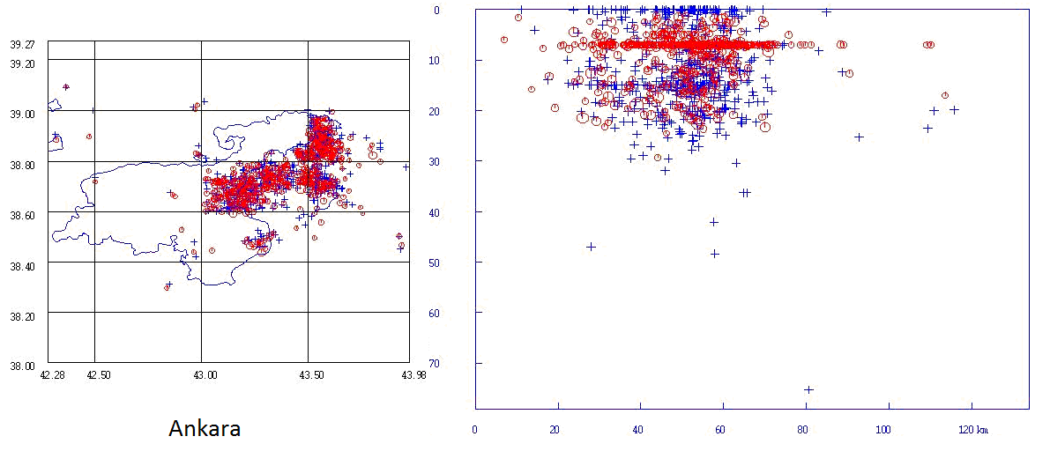
2 TURKELLI VELOCITY MODEL

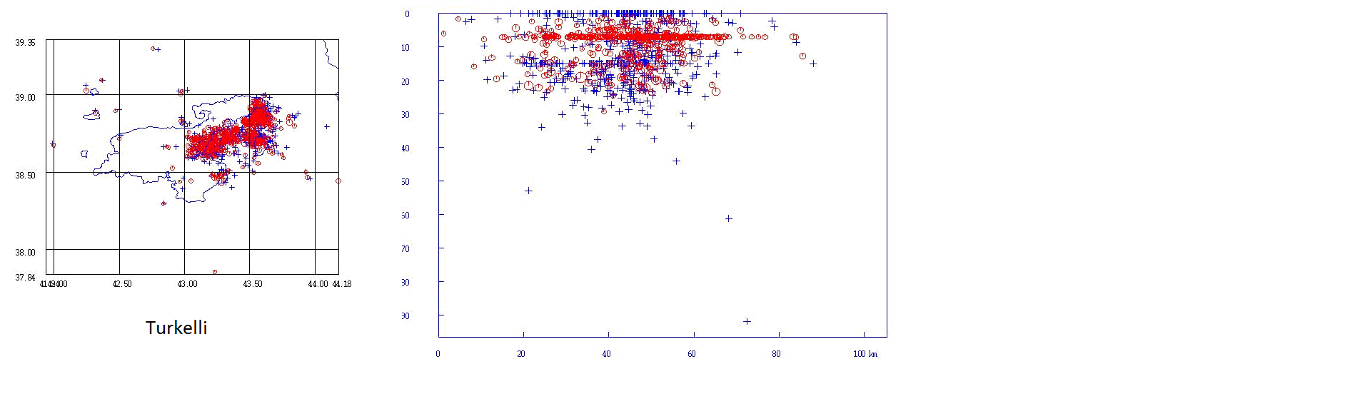
3. GFZ VELOCITY MODEL
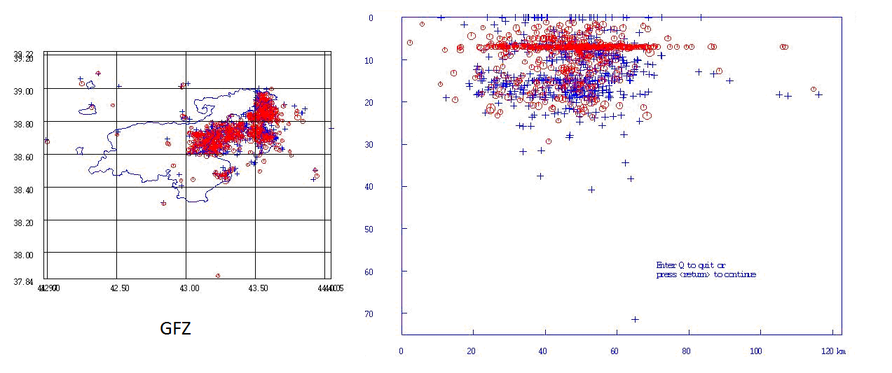

4. KANDILLI VELOCITY MODEL

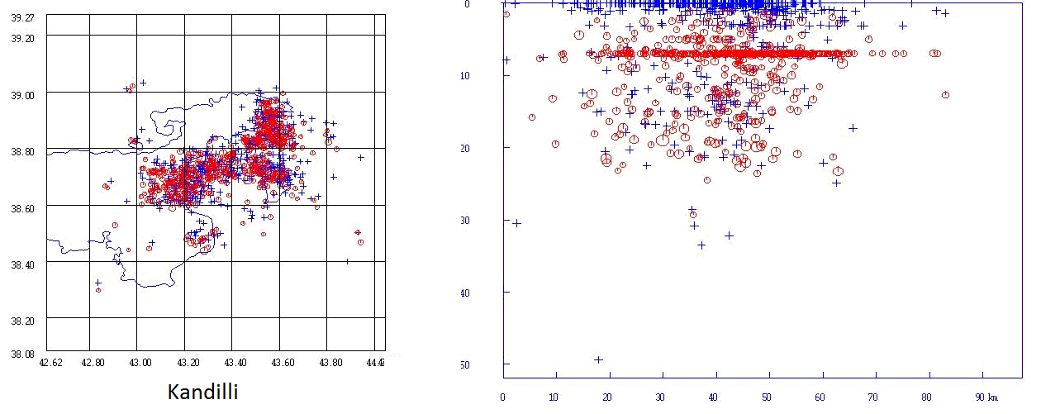

5. HERRIN VELOCITY MODEL RESULT (ANKARA SECOND MODEL)
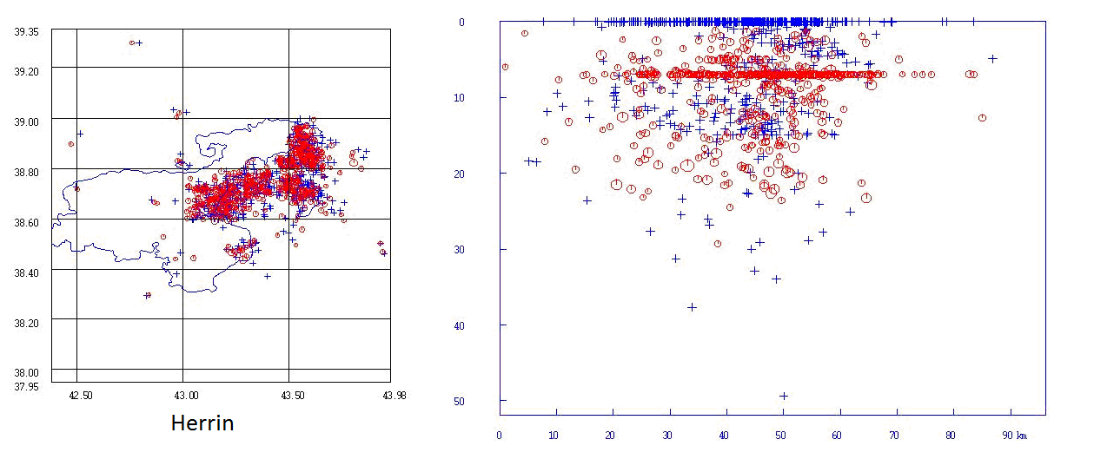

Fault plane solutions

Ankara routinely calculates fault plane solutions using polarities. The procedure used is to put polarities and hypocenter into a separate file for each event. Then run program azmtak (Suetsugu, 1996) which generates azimuth and angle of incidence and combine all in an output file. This file is used as input to the pinv program (also used in Seisan). Both pinv and azmtak are old programs originating in Japan.

Compare Ankara fault plane solutions with solutions made with Seisan

Since the pinv program is rather simple, it would be interesting to see how fault plane solutions would look with Seisan using focmec, fpfit and hash. However, that was not so easy. First an attempt was made to use the routine Ankara polarity readings. But they did not even plot on the focal sphere at the same place as when using Seisan, and polarities were different. It turned out that polarities had been reread and not put back into the data base. Furthermore angles of incidence were different since they were calculated with azmtak, which, according to the source code uses JB tables to calculate the angles. It seems that the JB tables for short distances is used up to 18 degrees. Thus the model for angle of incidence calculation is significant different from the Turkish model. Some events were reprocessed in Seisan and the solutions compared to the original solutions make by Ankara. The results of this comparison is shown below. As it is seen, only in a few cases are the solutions the same so it seems that the difference in models could be significant..

Seisan solutions DDA solutions

Blue is fpfit, green is hash and red is pinv

2011-10-23_10:41
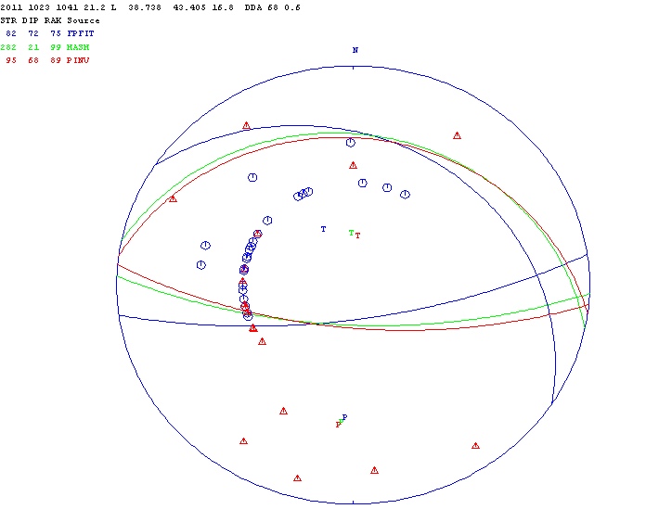

2011-10-23_10:56
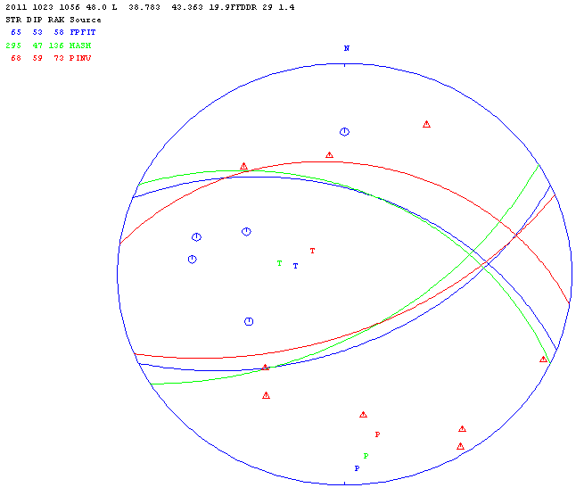

2011-10-23_11:32
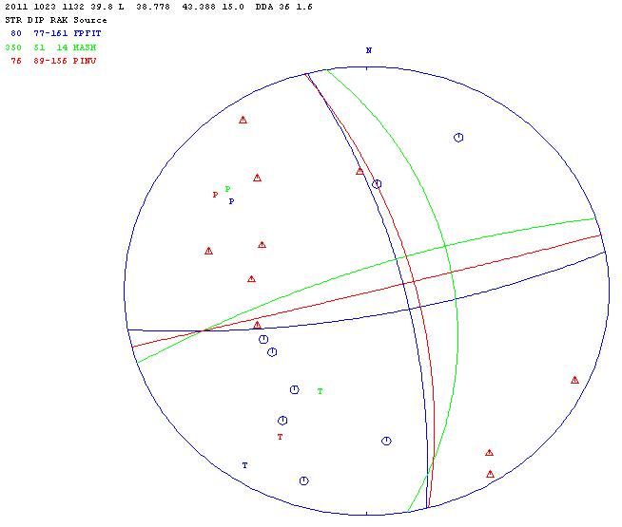

2011-10-23_12:17
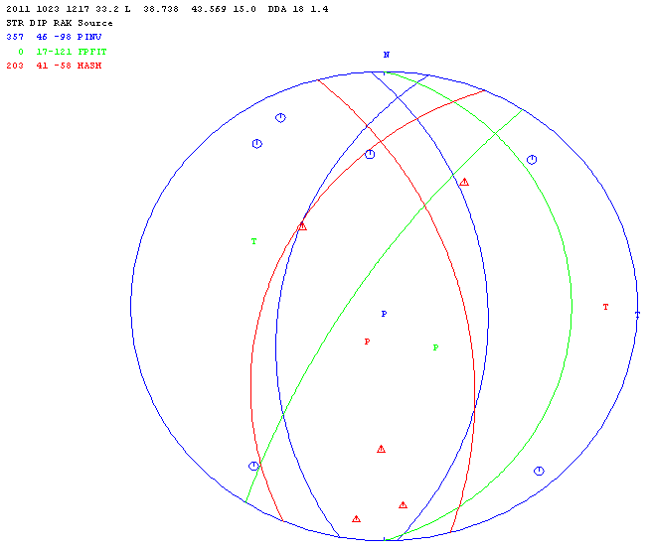

2011-10-23_12:19
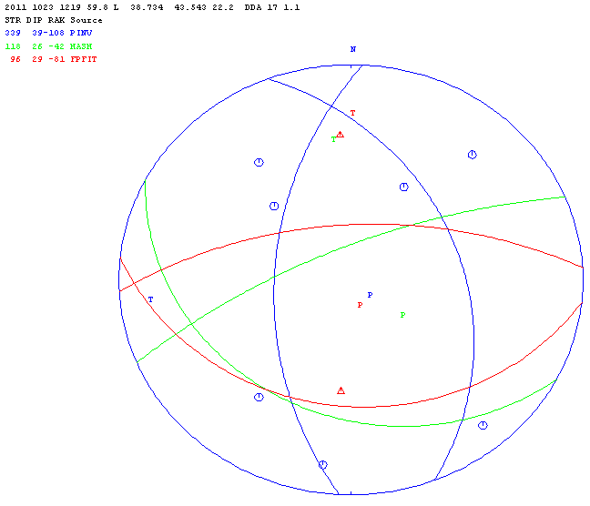

2011-10-23_12:30
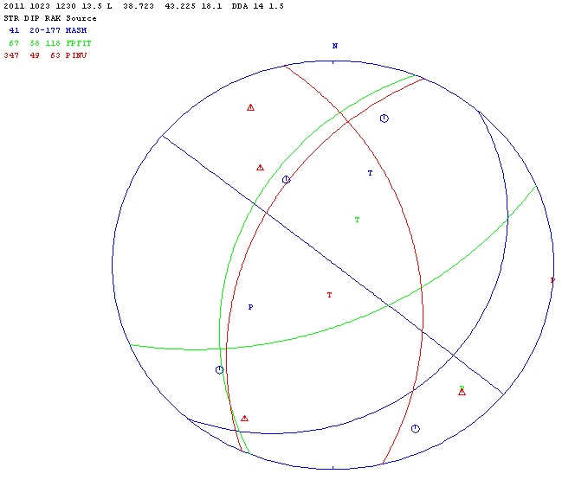
2011-10-23_12:42
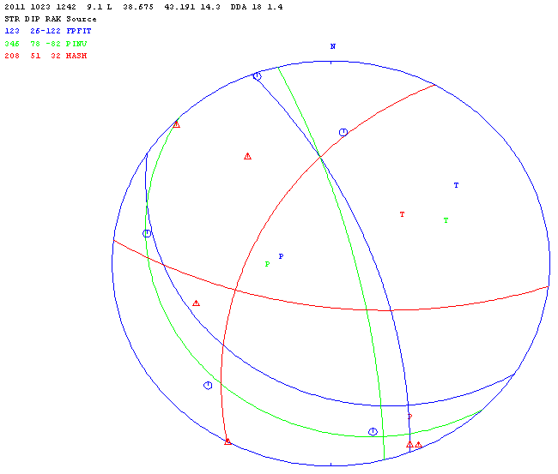

2011-10-23_18:10
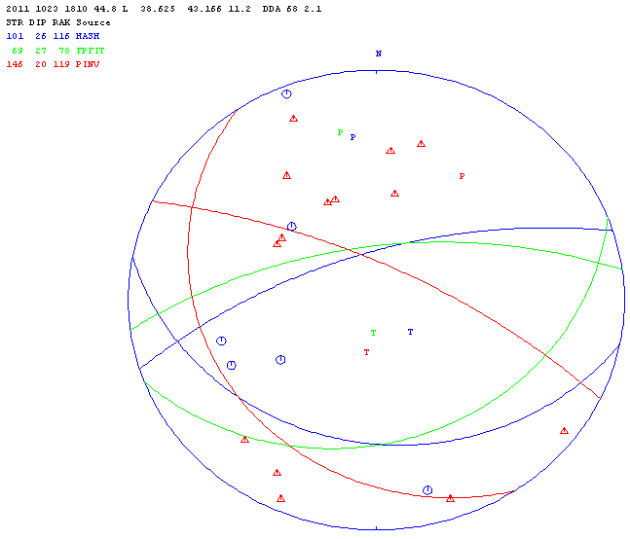

2011-10-23_19:06
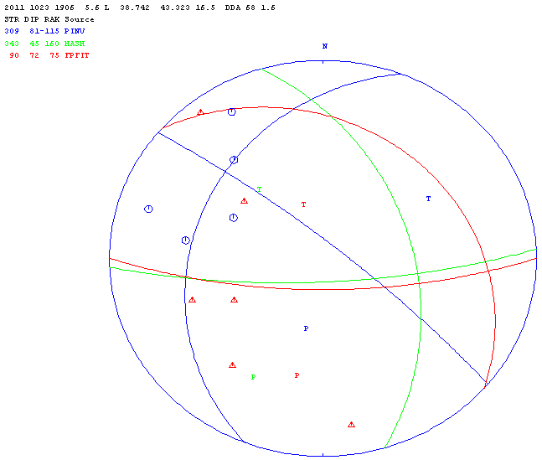
2011-10-24_08:48
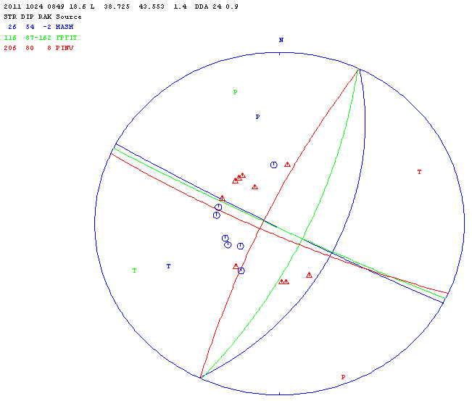

Seismological Research Institute, Ataturk University processing

During the workshop, data was processed by the Seuismological Research Institute, the report is seen below

EARTHQUAKE ACTIVITY OCTOBER – NOVEMBER 2011

Year Date HRMM Sec Latitud Longitud Depth Mc Ml Mb Ms Mw
2011 1022 0 7 30.5
2011 1022 954 39.4
2011 1023 1040 44.3 38.611 47.743 0.0
2011 1023 1041 24.0 38.689 43.544 15.0
2011 1023 1040 37.2
2011 1023 1056 39.0
2011 1023 1131 18.0
2011 1024 1528 5.5 38.668 43.148 21.1 4.6 4.8
2011 1026 0316 18.0 38.693 43.262 0.0 4.4
2011 11 2 0012 34.1 38.765 43.270 0.0 2.6 3.0 4.0
2011 11 2 0404 48.2 38.236 43.470 41.0 2.5 4.2
2011 11 2 0434 18.8 38.771 43.816 10.9 3.4 6.2
2011 11 2 543 56.9
2011 11 3 0249 7.3 38.682 43.088 0.5 2.0 1.2
2011 11 4 0003 2.7 38.141 42.875 15.0 0.7 2.0 2.2
2011 11 5 013 16.0
2011 11 5 023 50.3
2011 11 5 110 5.7
2011 1114 048 0.0
2011 1114 136 0.0
2011 1114 2 0 0.0
2011 1114 224 0.0
2011 1114 324 30.3
2011 1114 0405 3.8 -0.095 129.049 0.0
2011 1116 0040 15.3 11.600 -85.900 181.0
2011 1116 0044 1.5 34.200 141.500 38.0 5.4
2011 1116 0218 49.2 38.956 42.177 20.8 1.2 1.5 2.4
2011 1116 0251 51.4 38.687 43.373 15.0 2.6 2.2 3.4
2011 1116 0328 3.3 39.518 41.170 3.7 2.2 2.4 3.1
2011 1116 0328 3.2 39.555 41.228 8.9 1.7 2.2 3.2
2011 1116 1050 14.5 38.691 43.155 0.0 2.1 2.3 3.6
2011 1116 1144 3.7 38.748 43.565 23.7 2.7 2.2 3.5
2011 1116 1503 38.0 38.601 43.656 22.0 1.7 2.4 3.4
2011 1116 1607 23.2 39.031 43.492 15.3 2.1 2.0 3.6
2011 1116 1742 15.7 38.835 43.478 15.0 2.3 2.1 3.4
2011 1116 1842 39.1 38.685 43.027 0.8 1.9 2.2 3.4
2011 1116 1856 7.2 38.859 43.506 6.5 2.8 2.5 3.9
2011 1116 2205 54.3 65.200 145.800 15.0 4.7
2011 1116 2214 7.6
2011 1117 0051 18.4 38.673 43.413 1.9 1.9
2011 1117 0055 48.4 38.598 42.656 15.3 1.3
2011 1117 0150 54.7 39.751 43.315 15.0 2.0
2011 1117 0226 34.0 38.895 43.518 8.5 2.6 1.5
2011 1117 0237 16.9 39.141 41.609 0.1 3.7 3.9 4.8
2011 1117 0237 17.7 39.169 41.612 11.0 3.5 3.8 4.8
2011 1117 0307 27.6 39.165 41.555 2.9 3.0 2.8 3.9
2011 1117 0307 28.2 39.117 41.598 20.0 2.2 2.6 3.9
2011 1117 0504 30.3 38.864 43.605 20.5 2.5
2011 1117 0504 30.9 38.824 43.428 0.0 2.7 2.5 3.7
2011 1117 0534 37.0 39.173 41.546 20.3 2.2 2.4 3.2
2011 1117 0737 26.8 38.632 43.132 5.8 2.5 3.9
2011 1117 0737 26.4 38.615 43.084 5.1 2.6 2.3 3.5
2011 1117 849 44.1
2011 1117 0851 31.1 38.391 42.816 0.1 2.6 2.0 3.5
2011 1117 919 53.2
2011 1117 1133 37.5 38.996 43.447 11.2 2.6 2.6 3.8
2011 1117 1238 32.6 38.898 43.472 21.6 3.3 3.5 4.7
2011 1117 1515 6.7 38.630 43.102 0.0 2.3 2.8 3.8
2011 1117 1515 8.3 38.680 43.106 11.9 2.9 2.4 3.7
2011 1117 1848 50.9
2011 1117 1850 0.5 38.513 43.267 2.6 2.2
2011 1117 1936 0.0
2011 1117 2056 5.0
2011 1117 2312 0.0
2011 1117 2341 1.8
2011 1118 0031 30.7 38.697 43.095 0.0 3.0 2.2
2011 1118 0130 58.5 38.675 43.228 15.0 2.4 2.2 3.5
2011 1118 0207 20.8 38.792 43.676 21.0 2.6 1.8 3.1
2011 1118 3 1 30.7
2011 1118 0324 52.5 38.675 43.023 7.6 1.5 2.1 3.1
2011 1118 0346 1.6 38.870 44.153 15.0 3.4 2.2 4.0
2011 1118 452 32.3
2011 1118 0600 54.6 33.700 -38.510 9.9 5.4
2011 1118 0607 31.7 39.783 38.387 30.3 2.8 3.5
2011 1118 0730 21.0 38.742 43.117 5.1 1.5 2.3 3.3
2011 1118 0730 21.8 38.705 43.098 11.5 1.9 2.2 3.3
2011 1118 755 12.0
2011 1118 8 2 0.0
2011 1118 0952 20.5 38.647 43.243 32.6 2.4 3.5
2011 1118 1027 28.8 38.844 42.952 2.0 3.0 2.6 4.0
2011 1118 1127 15.4 38.782 43.246 5.1 2.1 2.4 3.6
2011 1118 1233 13.2 38.664 43.211 0.0 2.0 2.2 3.2
2011 1118 1715 37.6 38.790 43.176 5.8 2.2 1.5 3.2
2011 1118 1739 35.8 38.779 44.477 15.0 3.6 3.6 5.1
2011 1119 0037 6.2 38.592 44.358 149.4 3.6 2.5 4.8
2011 1119 0037 6.6 38.514 44.411 133.0 3.5 2.7 4.6
2011 1119 0510 1.2 38.038 46.804 15.0 3.4 2.7 4.5
2011 1119 0653 21.3 38.923 44.287 0.5 3.2 2.7 4.2
2011 1119 714 23.6
2011 1119 0808 54.5 38.106 39.028 20.7 1.8 2.3 3.5
2011 1119 1153 4.1 39.012 42.638 29.7 2.9 2.1 3.3
2011 1119 2043 11.1 38.393 42.862 0.0 1.7 2.3 3.7
2011 1119 2121 41.7 38.840 43.427 0.0 2.8 2.3 3.8
2011 1119 2351 2.8 38.680 43.607 0.0 2.7 1.8 3.8
2011 1120 0140 36.9 38.729 43.298 44.4 2.3 2.3 3.4
2011 1120 0458 25.5 38.721 43.050 7.1 1.9 2.1 3.2
2011 1120 0930 31.1 38.857 43.612 29.0 2.7 2.1 3.7
2011 1120 1043 34.2 38.738 43.268 47.7 2.3 2.2 3.2
2011 1120 1043 34.3 38.739 43.252 46.0 2.1 2.3 3.3
2011 1120 1120 22.7 38.676 44.515 15.0 3.4 2.8 4.8
2011 1120 1130 32.5 38.507 44.477 8.2 3.1 2.6 4.1
2011 1120 1427 43.5
2011 1120 1451 0.2 38.594 43.223 24.7 2.3 2.5 3.4
2011 1120 2247 59.1 38.687 43.129 5.7 2.4 3.0 3.9
2011 1120 2300 41.0 38.925 43.512 0.1 2.5 2.4 3.6
2011 1120 2300 41.5 38.917 43.553 20.5 2.6 2.3 3.5
2011 1121 147 0.0
2011 1121 0315 48.1 25.523 92.708 0.1
2011 1121 527 55.8
2011 1121 0626 48.1 39.066 43.359 36.1
2011 1121 0626 47.5 38.966 43.521 43.7 3.0 2.4 3.9
2011 1121 0626 46.3 39.073 43.740 33.4 3.0 2.6 3.7
2011 1121 839 48.4
2011 1121 840 8.6
2011 1121 938 27.7
2011 1121 10 6 53.9
2011 1121 1150 51.0
2011 1121 1956 50.0
2011 1121 2055 55.8
2011 1123 1152 41.5
2011 1123 1217 21.1 33.861 22.045 0.0 5.1 5.1

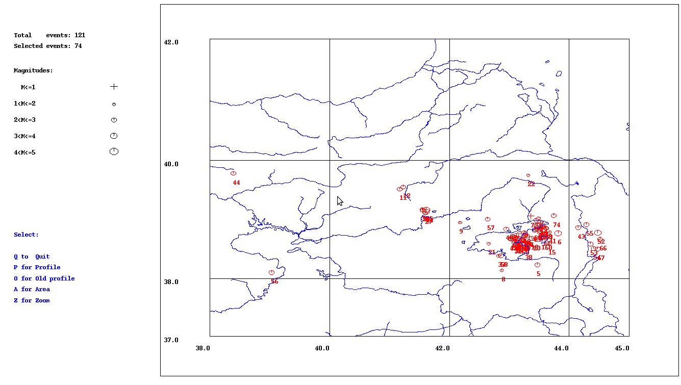
Figure 1a. Earthquakes in Eastern Anatolia, October-November 2011
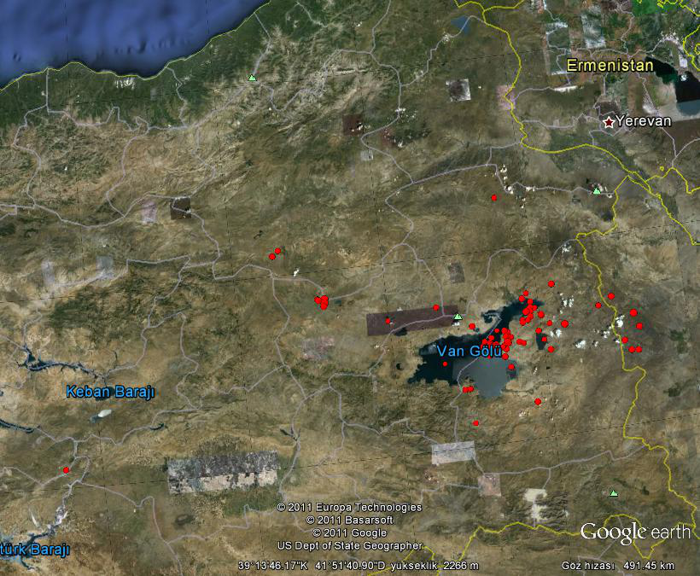

Figure 1b. Earthquakes in Eastern Anatolia, October-November 2011, Total 121 events.

List of Events M > 4.0 (October – November 2011)

Year Date HRMM Sec Latitud Longitud Depth Mc Ml Mb
2011 11 2 0012 34.1 38.765 43.270 0.0 2.6 3.0
2011 11 2 0404 48.2 38.236 43.470 41.0 2.5
2011 11 2 0434 18.8 38.771 43.816 10.9 3.4
2011 1116 0044 1.5 34.200 141.500 38.0 5.4
2011 1116 2205 54.3 65.200 145.800 15.0 4.7
2011 1117 0237 16.9 39.141 41.609 0.1 3.7 3.9
2011 1117 0237 17.7 39.169 41.612 11.0 3.5 3.8
2011 1117 1238 32.6 38.898 43.472 21.6 3.3 3.5
2011 1118 0346 1.6 38.870 44.153 15.0 3.4 2.2
2011 1118 0600 54.6 33.700 -38.510 9.9 5.4
2011 1118 1027 28.8 38.844 42.952 2.0 3.0 2.6
2011 1118 1739 35.8 38.779 44.477 15.0 3.6 3.6
2011 1119 0037 6.2 38.592 44.358 149.4 3.6 2.5
2011 1119 0037 6.6 38.514 44.411 133.0 3.5 2.7
2011 1119 0510 1.2 38.038 46.804 15.0 3.4 2.7
2011 1119 0653 21.3 38.923 44.287 0.5 3.2 2.7
2011 1120 1120 22.7 38.676 44.515 15.0 3.4 2.8
2011 1120 1130 32.5 38.507 44.477 8.2 3.1 2.6
2011 1123 1217 21.1 33.861 22.045 0.0 5.1

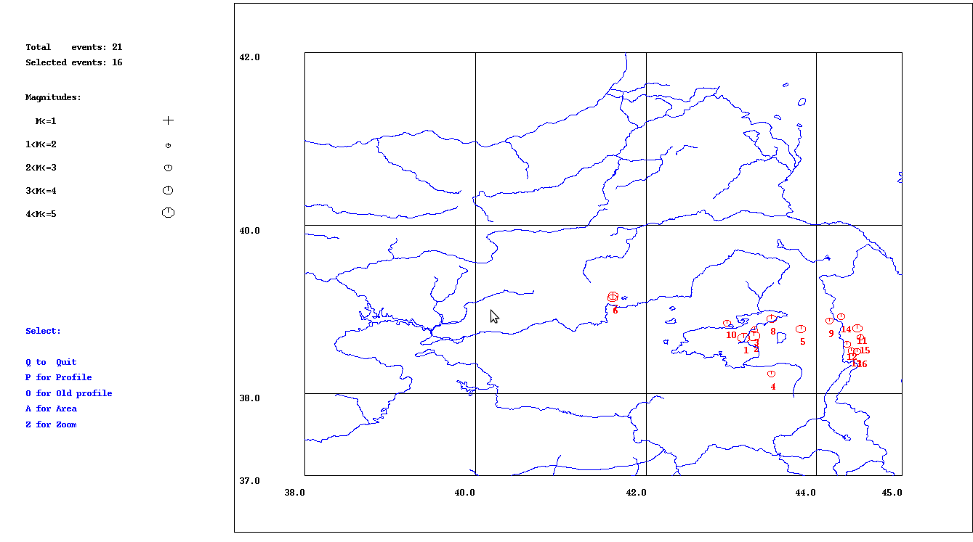
Figure 2. Earthquakes M > 4 in Eastern Anatolia, October-November 2011

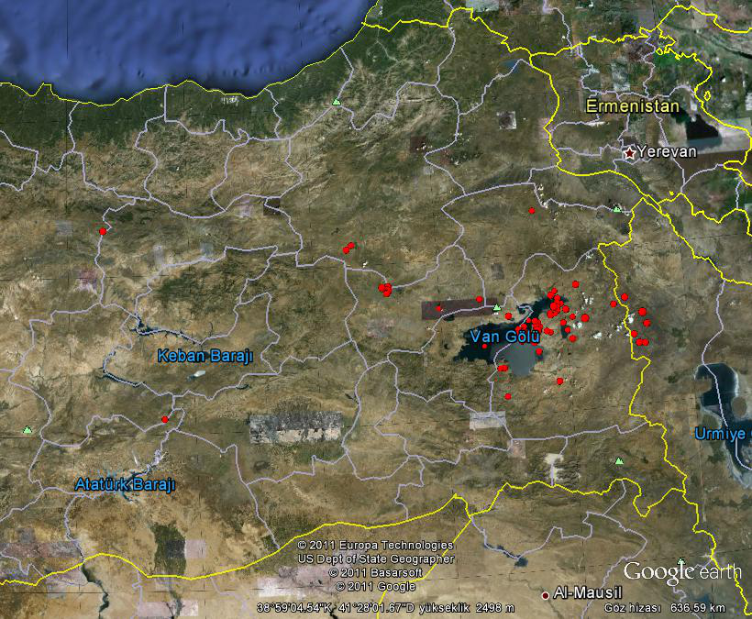
Figure 3. Earthquakes M > 3.5 in Eastern Anatolia, October-November 2011.

Magnitude Correlation M_{w} vs M_{L} (ATA – 121 EVENTS in 2011)
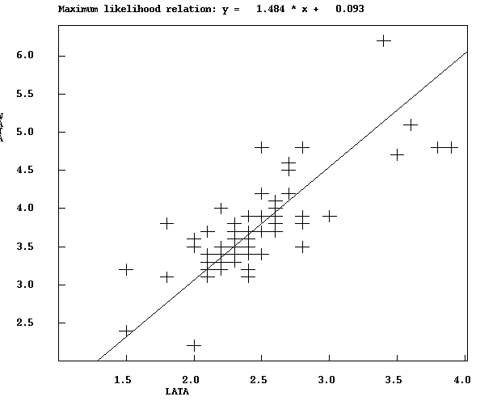
Figure 4. Correlation of Moment and Local (Richter) magnitudes for 121 events by ATA
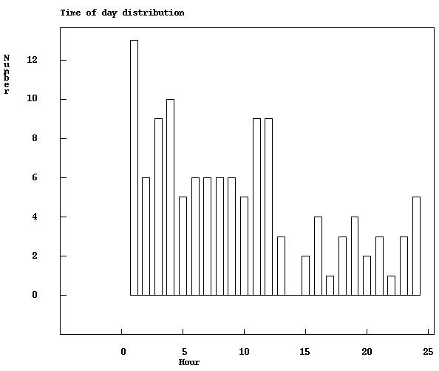
Figure 5.Time of the day distribution of events in OCT-NOV 2011, (121 events by ATA)

References

Niyazi Turkelli, Eric Sandvol, Ekrem Zor, Rengin Gok, Tolga Bekler, Ali Al-Lazki,
Hayrullah Karabulut, Sadi Kuleli, Tuna Eken, Cemil Gurbuz, Salih Bayraktutan,
Dogan Seber, and Muawia Barazangi3 (2003) . Seismogenic zones in Eastern Turkey. GEOPHYSICAL RESEARCH LETTERS, VOL. 30

Suetsugu, D., 1996. Source Mechanism Practice. In: Training Course in Seismology and
Earthquake Engineering II. Japan Int. Cooperation Agency (JICA), Ibaraki-ken 305
Japan.p.13-48.

