Report

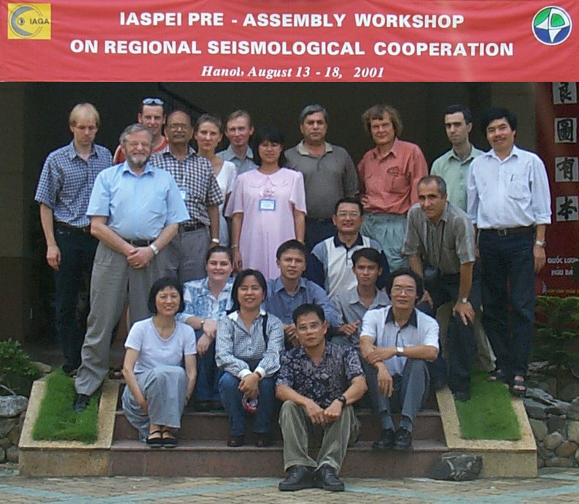

IASPEI Pre-Assembly Workshop on Regional Seismological Cooperation

Organizer : IASPEI and LOC

Convenors: Jens Havskov
Gary Gibson

INTRODUCTION

A Pre-Assembly Workshop on “ Regional Seismological Cooperation “ was conducted during 13-18 August 2001 at Hanoi, Vietnam. The International Association of Seismology and Physics of the Earth’s Interior (IASPEI) supported the workshop, attended by 18 participants from 9 countries including 4 from Vietnam (Appendix 1). The Local Organizing Committee organized the workshop. The main focus was to provide training in digital data processing to the persons involved in operation of seismological networks and analysis of data in their respective countries. To achieve this goal, the participants provided data for earthquakes recorded on their networks during January 2001. Because of the enormity of data and limitation of time, five events were selected for imparting training using the SEISAN software. Manuals of the SEISAN (version 7.2) software along with a CD were provided to each of the participants. In the first part of the SEISAN training the participants worked on a common test data set. Later on, they worked with their own data sets for the five selected events. The salient features of the outcome was in the form of locations of 5 selected events using individual country’s network and later locating one event with all the network data. These locations were then compared with PDE locations and are presented in this report.
In a lecture during the workshop Dr. Gary Gibson spoke about the decisions taken in the earlier meetings of the Asian Seismological Commission (ASC) for the establishment of an ASC Data Exchange set-up. He stressed the need for data exchange between organizations working on observational earthquake seismology in the Asia-Pacific region, the emphasis being on fast near real-time data exchange of significant earthquakes through Internet. At present there is little data exchange between the Asia-Pacific countries because of the different formats used. There is an urgent need for homogenisation of earthquake data in a common format for easy and fast exchange, which will benefit each contributing country and also help in our scientific endeavours in the field of seismology. During the workshop it was seen how the location accuracy benefits from an extended regional data set.

PROGRAMME

Prof. Jens Havskov and Mr. Lars Ottemöller delivered the lectures and provided assistance to the participants with processing the earthquake data.

The Programme was designed to make the best use of the limited time of six days to impart optimum training so as to make each participant self-sufficient in digital data analysis. The break-up of the programme is as follows:

Day Lecture on Working on test data Working on individual Working on Presentation
SEISAN by participants country’s data set one Earthq.

1 General Installation of -- -- Thailand
instructions SEISAN, commands, -- -- Vietnam
on SEISAN creating database etc. -- --

2 General Plotting maps, putting -- -- --
instructions digital data into data -- -- --
bases, plotting data,
phase picking, location ,
magnitude determination etc. -- --

3 Earthquake -- Creating data base, -- India
location, phase locating large events, -- Iran
picking plotting events, spectral --
analysis etc.

4 Digital formats, -- Generation of response -- Australia
Calibration etc. -- curves, calibration, -- Indonesia
location of 5 events,
magnitude determination,
spectral analysis

5 Single event -- -- Earthquake Philippine
location with location with China
data from several data from
stations several stations

6 Review of data processing and analysis and suggestions/comments Russia

Participants data: Experience from pre-workshop data

collection

One of the requirements for participation in the IASPEI pre-assembly workshop was that the participants submit data from seismic stations in the respective countries prior to the workshop. The data was collected by the organizers and distributed on CD together with the SEISAN software that was used for the processing during the course. The objective with using the participants’ data was to demonstrate what can be achieved through regional data exchange, but also to increase the benefits from the training by using real data that the participants are used to. The workshop showed that the benefits from this approach out-weighted the difficulties with data preparation prior to the workshop and also the difficulties with planning the exact content.

Data was collected for five large earthquakes that occurred in the Asia-Pacific region in January 2001. In addition the participants submitted data from local earthquakes. Information on station locations and instrument calibration was also provided by the participants. The process of collecting the data started about six weeks before the workshop. Data were sent through ftp, email and by mail on CD. The process of converting the data to a common format turned out to be more elaborate than anticipated, and was finished only shortly before the workshop started. The total data set had a size of more than 400 MB.

The main problem with the data exchange was that no standard for data exchange existed in the region. The organizations in the region make use of a number of different acquisition systems, processing software and data formats. The waveform data formats used for sending the data included SEED, SAC, CSS, PCSUDS, SEISAN, GSE, Nanometrics and PASSCAL Reftek. All data was converted to SEISAN format in order to be able to process all data in a common format and processing system. The problems encountered in this process were mostly related to data transfer problems (like the transfer of binary data as ASCII) and the ambiguous use of station and component codes. In case of the Indonesian network, which is using a seismic network system provided by LDG (France), the problem was that no program was available to convert to a standard format. This meant that the data needed to be sent to the LDG, which modified a conversion program, converted the data to GSE and then gave the data to the organizers. The conversion program was still not given to the Indonesian network or the organizers and the format description and complete calibration information is also unavailable.

The difficulties with the data integration clearly showed that there is a need to work on a standard for data exchange. The use of a standard format like GSE would certainly help to facilitate the data exchange. This in practice would mean that all organizations should be able to convert their data to GSE. Then the data could easily be exchanged through the Internet (ftp, email, etc.). The choice of the format for exchange is really independent of the processing system, however, regional cooperation may also benefit from a common processing system. There are already some standard definitions for data exchange. The AutoDRM system, which is an automated data exchange system that is based on email requests, is currently widely used and gives access to data from more than 1000 digital seismic stations.

Experience from processing the regional earthquakes using participants data set

During the workshop, the participants worked on integrating the data sets and organizing it in a database structure. In addition, station information and instrument calibration was prepared. It was quite impressive that it was indeed possible to analyse the complete data set in one processing system (more than 200 channels of digital data available for large events), and to determine hypocenter locations and magnitudes, despite the fact that not all participants were experienced neither with the analysis of digital data nor with the use of SEISAN.
The first task of the participants, after the initial training was completed, was to locate and calculate magnitudes of the 5 large events in the region. This was a new experience for nearly all, since the general practice is only to locate data within the local network. Consequently very little teleseismic data is processed and reported to the ISC. All networks were able to locate the events when the network was far away from the epicenter location. Location accuracy was good in some cases and a few hundred km off in other cases (direction and distance still reasonable). Some locations were even made with just one or two stations using azimuth determined from 3 component stations (new to most).

Setting up the calibration database was an important task. Most networks do not use calibrated signals so this task was also new to most participants. Making use of instrument calibration is often considered more problematic than it really is. The participants got some experience on how to prepare the instrument response and on how to test it. For the IRIS stations, the response given by IRIS (in poles and zeros) were used. Very few people had worked with poles and zeros before. For the remaining stations, instrumental parameters like sensor free period, damping etc. were used to generate the response curves. Verification of the response were made by calculating magnitudes and comparing to mb. It seems that most networks have correct response information.

After doing the instrument calibration, mb magnitudes were also calculated and most were quite accurate. This work showed that, even for small networks, it is of value to process events outside the networks to get preliminary epicenters and magnitudes of events in the region. The additional processed data will then also be available for ISC, which then can provide better regional locations.

The second task was to locate the large regional earthquakes using the complete data set (all networks). Although not all stations were used, the locations were very close to PDE locations and also mb and Ms magnitudes determined compared well with the PDE magnitudes. The regional exchange of data could provide more accurate locations. The hypocentral depths were not very good using first arrivals, partly because all 5 events were shallow. For some stations it was possible to read pP (new to many participants), which significantly improved depth determinations.

Suggestions for a Prototype Asian Seismological Commission Data Exchange

Introduction

At the 3rd Assembly of the Asian Seismological Commission (ASC) in Tehran during October 2000, it was decided that the ASC should investigate the establishment of an ASC Data Exchange. The main aim would be to facilitate exchange of data between organizations working on observational earthquake seismology in the Asia-Pacific area.
The emphasis will be on near real-time data exchange, encouraging local analysis of data, and providing support to allow the local network to be the key source of public information after significant events.

Problems Faced by Individual Networks
- Small events outside any network are very difficult to locate.
Unless active cooperation is undertaken many of these events will not be analysed.
- Large local earthquakes often introduce major new problems.
Locations may be difficult if S phase arrivals cannot be picked, and magnitudes cannot easily be determined if seismographs are driven to full scale.
Small events within a network can usually be analysed easily without the need for data from other organizations.

Why Cooperate?

Support regional networks.
Help each network to be the key provider of seismological information to their government and people. If neighbours are familiar with the operation of surrounding networks, then a higher level of support can be provided in case of emergency.
Encourage local analysis.
The more local analysis is done, the better that observatory staff will understand their region, and the less likely there will be a problem after a major event. This especially involves routine location of small out of network earthquakes and preparation for analysis of large local earthquakes.
Learn from others.
Other people are often doing things better, and we can learn from their experience. Different analysis programs perform some analysis tasks better than others. An observatory can choose the analysis system that best suits their work. Developers of analysis systems can learn what improvements are really required, both for routine analysis and research purposes.

How can this be done?

New technology and access to the Internet has completely changed how this can be done. The people and governments who fund our seismological observatories now place much greater emphasis on near real-time analysis of data, and the ability of local networks to provide reliable preliminary earthquake information within seconds or minutes of a major event. The value of the network is judged by the quality of this rapid response information.
The International Seismological Centre (ISC) currently provides long-term data exchange, and all of our members should be encouraged to contribute their data to ISC. Programs such as the GARNET project in the Asia-Pacific area are improving medium-term data exchange.
However short-term data exchange (within minutes to an hour of an event) is often limited. This information is often needed when seismologists are extremely busy, and do not have time to request data. It is essential that data analysis continues within each observatory, but there are often cases when it is desirable to share data or results. Recent experience in the use of Australian and Philippine data to locate events in southeast Asia and the southwest Pacific has shown the clear advantage of sharing data for reliable earthquake locations and magnitudes
Waveform data is becoming available from more seismographs, but it can take time to download individual seismograms and then to pick the arrival times and amplitudes. Many observatories are not yet able to provide real-time digital data. Under any circumstances it is useful to have immediate, unsolicited, efficient and well-organised (but inconspicuous) support from neighbouring networks at a time of crisis. This allows staff to concentrate on providing information to their government, emergency services and media, especially at observatories with limited staff numbers.
Only larger or damaging events should be included, or those events for which any contributor would like more data. All contributions should be acknowledged clearly by inclusion of standard observatory or agency codes as well as seismograph site codes, etc.
Routine analysis of data will still be undertaken by the contributing organisations. The data exchange web site should have simple formats with text only, and file transfers should be by simple ftp.
Perhaps later there could be an associated public web page for results moderated by a seismologist for content. We have spoken of an ASC web site in the past, but this needs even more work from a dedicated editor. The Australian Earthquake Engineering Society publishes an 8 to 10 page Newsletter several times each year, and a near identical copy is kept on the web site (together with more up-to-date news). An ASC Newsletter similar in format to the Developing Countries Newsletter currently produced by NGRI could be appropriate.
One of the main purposes of this proposal is to encourage Internet connection and use at small observatories. Near real-time data exchange gives the opportunity to increase the scope of work possible for many seismologists. Even those seismologists who do not perform further analysis will see their data being used for urgent and useful purposes.

Data Exchange

There are many factors when considering data exchange

How Much Information?

Full event information, phase data and waveforms (e.g. S file and WAV files)
- Limited event information, phase data only (e.g. S file)
- Locations and magnitudes (earthquake catalogue entries)

Data Available to Whom?
- Open to anybody (no restrictions)
- Exchange partners (no approval required, no delays)
- Individually approved recipients
- Restricted data (only for use within an organisation)

How is Data Available?
- On-line (data freely available, automatically)
- On request (each transaction handled manually)

How Soon is Data Available?
- Seconds
- Minutes
- Hours
- Days
- Weeks
- Months
- Years
Near real-time response is usually defined as seconds to minutes.
Emergency response requires data in a time scale of seconds to hours.

Any Restrictions on Use of Data?
- None, re-publication allowed
- For internal use of recipient only
- Data to be used for specific applications only

Proposal from Workshop

Some questions to consider are:
- What additional data would help you in your analysis?
- What data can you provide to others?
- How soon is the data required for it to be useful?
- How would you prefer to communicate?
- Is your internet connection fast and reliable?

Some suggestions for the ASC Data Exchange
- The ASC should establish a Data Exchange, primarily aimed at improving communication between neighbouring networks in the Asia-Pacific region.
- Emphasis will be given to near real-time data exchange for key events, plus any other medium or long-term data exchange considered useful to individual participants.
- This is not a data centre, and has no long-term archival role. All members are encouraged to submit earthquake location and phase data to the International Seismological Centre for long–term archival, and to maintain easily accessible waveform archives for their own network.
- This should be internet based, including a web page with email input and ftp server, and will need to be low cost and semi-automatic.
- It is easy to obtain very poor earthquake locations and magnitudes when limited data are available, especially for events outside our network. The data exchange web site should be private, to avoid embarrassment over inaccurate early analyses. A separate public web site may be provided later for presentation of key results, with emphasis on links to the web pages of contributing organisations.
- The Exchange will include requests for data or other information, submitted event data, copies of bulletins, news, etc.
- Earthquake information included in the Data Exchange will be listed chronologically, with event association. Immediately that an earthquake location and magnitude has been estimated, a list of potential contributors is automatically contacted with a request for arrival times and amplitudes. This may be by email, or even a text message direct to a pager or a cellular telephone.
- Data will be exchanged for larger events throughout the Asia-Pacific area, and on request for events of particular interest to any participants.
- For small events located between neighbours, the Data Exchange will not replace any existing cooperation agreements.
- The data exchange web site will include news from each network, plus regularly updated contact information (staff details, email, telephone, facsimile, web site links)

SEISMOLOGICAL NETWORKS OF PARTICIPATING COUNTRIES

The following countries provided the digital data and were represented at the Workshop:

- Australia

- China

- India

- Indonesia

- Iran

- Philippine

- Russia

- Thailand

- Vietnam

A list of participants who attended the workshop is attached as Appendix -2. The details of the seismological networks operational in the above countries are given below. Five events located during the workshop along with the instrument details are also given.

Australia:

The Australian seismological network comprises 106 stations, which includes 35 broadband and 80 short-period instruments. A few of the short-period stations are accelerographs. Figure below shows the disposition of the instruments.

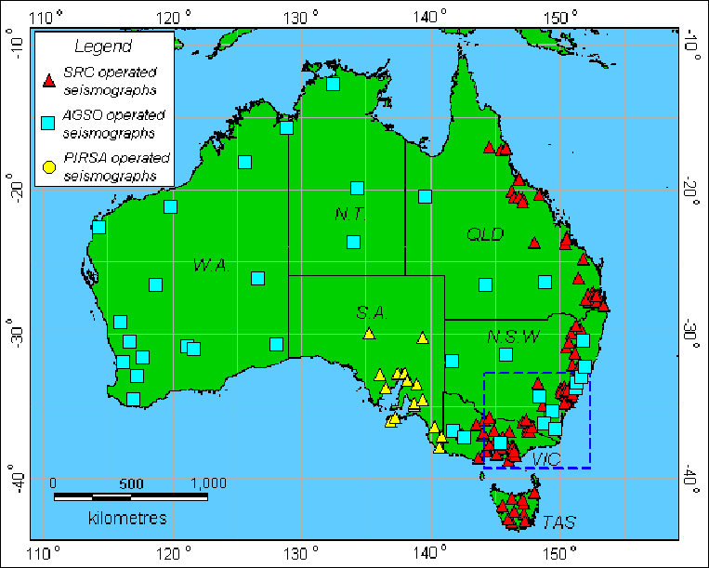

Locations using Australian network
Number of stations used: 2-15
Number of events located: 5
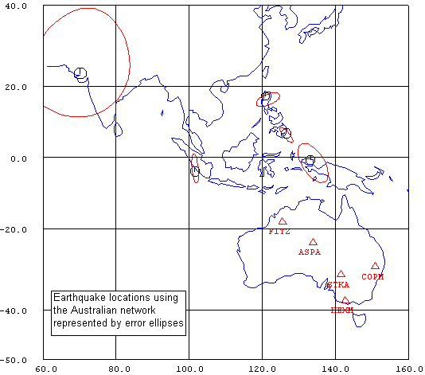

SELECTED SEISMOGRAMS
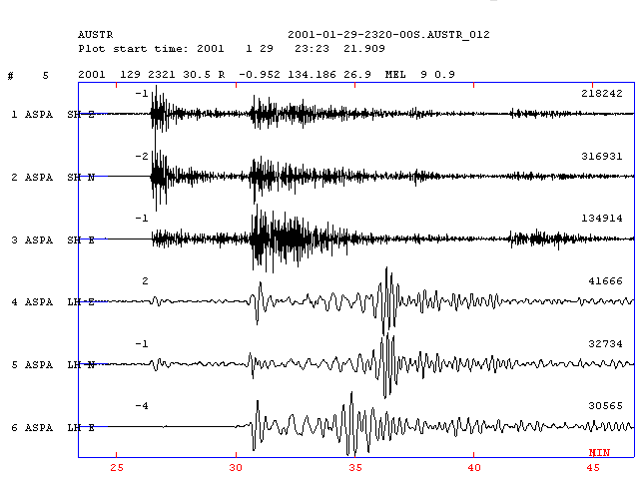

AUSTRALIAN SEISMOGRAPH CALIBRATION INFORMATION

Seismograph code: STKA
Location: 31.877°S, 141.595°E
Authority: AGSO
Transducer type: Guralp CMG – 3 (broadband seismometer)

Response file calculated using poles and zeros

5 poles, 4 zeros, scaling factor = 1739.16

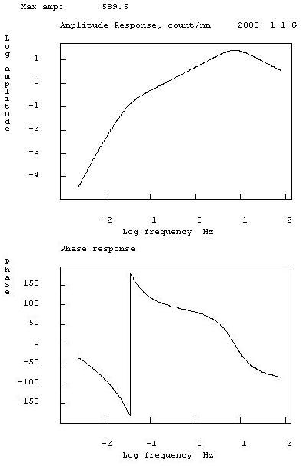
Seismograph code: COPM
Location: 29.918°S, 150.935 °E
Authority: SRC
Transducer type: Springnether 6000 (short period seismometer)

Calibration information

Damped generator constant: 175.4 V/m/s
Natural Period: 0.59 s
Damping: 0.61
Recorder gain: 6553.6 counts/V
Amplifier gain: 40 dB

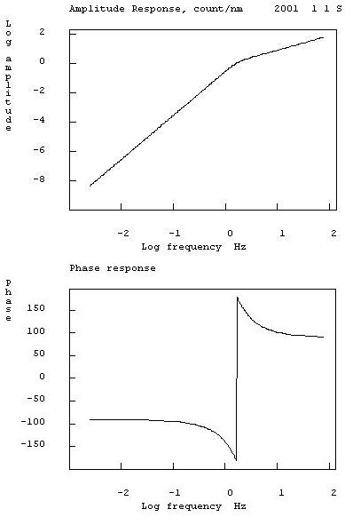

Magnitudes (Australia)
 | Australia |  |  |  |  | PDE
Date | Long | Lat | Depth | mb | Ms | Long | Lat | Depth | mb | Ms
2001-01-01 0657  Mindanao | 126.646 | 6.398 | 0 | 6.4 |  | 126.610 | 6.890 | 33 N | 6.4 | 7.2
2001-01-12 1918  Luzon | 121.951 | 16.511 | 33 N | 5.1 |  | 120.950 | 17.350 | 33 N | 5.5 | 5.0
2001-01-16 1325  Southern Sumatera | 101.724 | -3.168 | 0 | 6.5 | 7.0 | 101.660 | -3.970 | 33 N | 6.5 | 6.8
2001-01-26 0316  Bhuj, India | 70.523 | 24.886 | 77 | 7.2 |  | 70.320 | 23.400 | 24 | 6.9 | 8.0
2001-01-29 2321  Java | 133.950 | -1.601 | 0 | 5.6 | 6.3 | 133.240 | -0.690 | 33 N | 5.9 | 5.8

China

The Chinese seismological network consists of 300 analog, 200 digital short-period instruments and 75 broadband stations (including 10 x 300s sensors). All stations belong to the Chinese Seismological Bureau (CSB). Data is transmitted to the data center in real-time from 47 BB stations. The data is available to researchers from China. Data from the IRIS stations are available from the IRIS website.

China Center of Digital Seismic Network, long-period stations

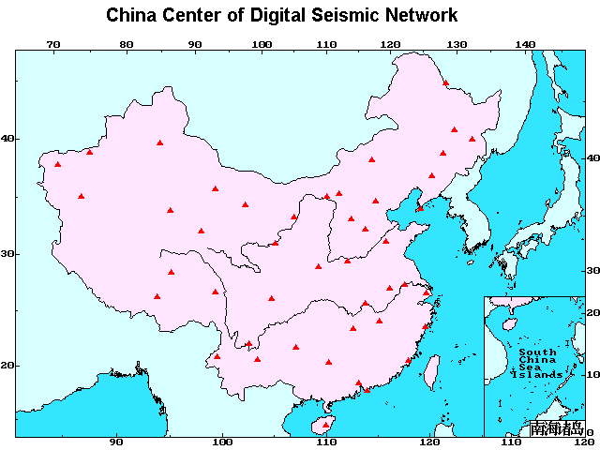

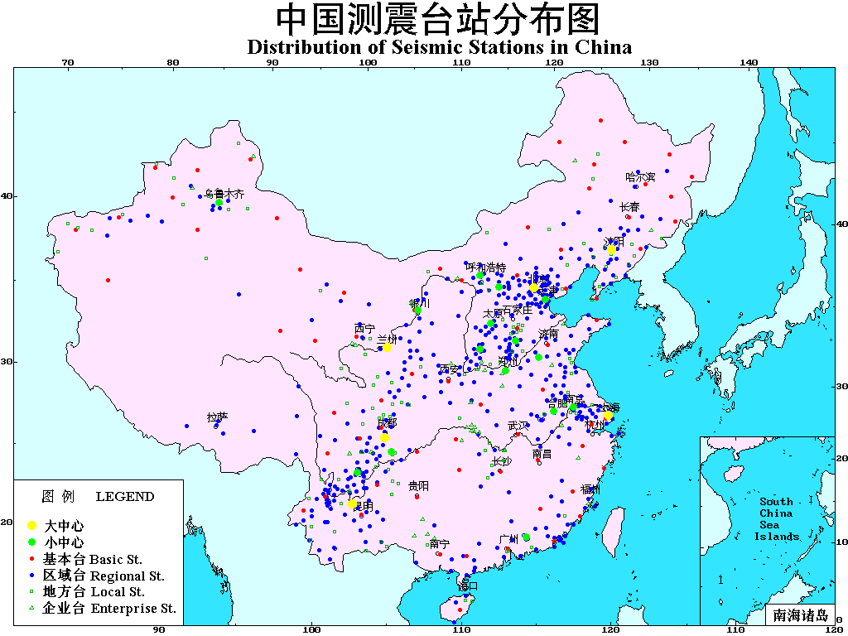

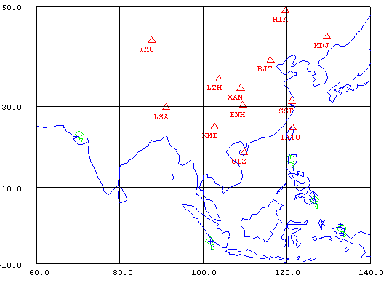

SELECTED SEISMOGRAMS (CHINA)
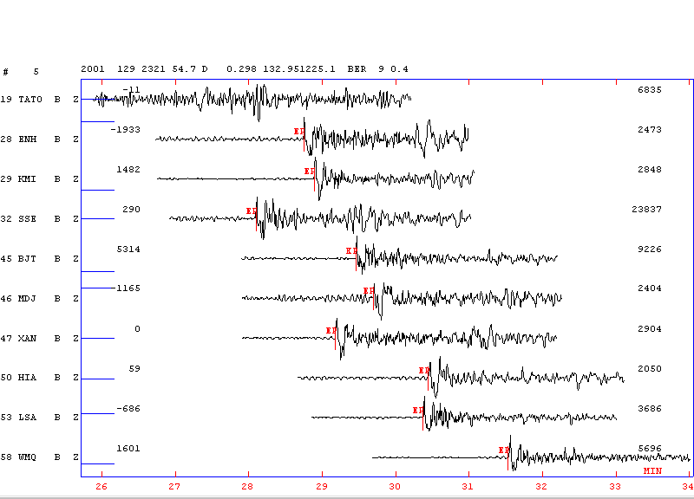

INSTRUMENT RESPONSE

Station Type: IRIS Broad Band

Sensor: STS-1
Digitizer: Quanterra

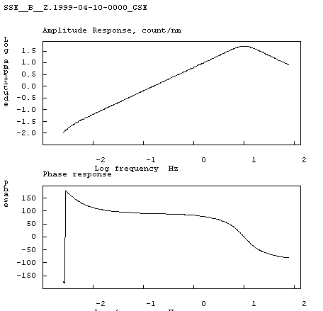

Location with China (CDSN) Network

EVENT | TIME | LAT | LON | DEPTH  (km) | Ms | Ms  (PDE) | Mb | Mb  (PDE)
1 | 2001-01-01-16.3 | 8.061 N | 126.382 E | 44 | 7.0(4) | 7.2 | 5.9(4) | 6.4
2 | 2001-01-12-30.6 | 17.54 N | 121.780 E | 35 | 5.4(6) | 5.0 | 5.6(6) | 5.5
3 | 2001-01-16-16.7 | 4.060 S | 101.759 E | 17 | 7.1(7) | 6.8 | 6.0(4) | 6.5
5 | 2001-01-29-34.7 | 0.298 N | 132.951 E | 22 | 5.9(5) | 5.9 | 5,5(6) | 5.9

India

The Indian seismological network comprises 35 broadband and 66 short-period digital seismographs spread over the Indian Peninsular Shield and the Himalayan regions. There are 20 digital and more than 100 analogue accelerographs. These stations are being operated by several organisations like the India Meteorological Department (IMD), National Geophysical Research Institute (NGRI), Geological Survey of India (GSI), Indian Institute of Technology, Mumbai, Roorkee University, Wadia Institute of Himalayan Geology and several other departments and Universities. The parametric data readings from the Indian seismic stations are contributed to USGS on a regular basis. Also, there is collaboration with GEOSCOPE and GARNET.

LOCATIONS WITH INDIAN NETWORK
NUMBER OF STATIONS USED: 5
NUMBER OF EVENTS LOCATED: 4

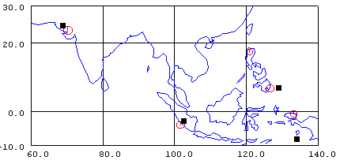
Locations with Indian stations
PDE locations

SELECTED SEISMOGRAMS (INDIA)

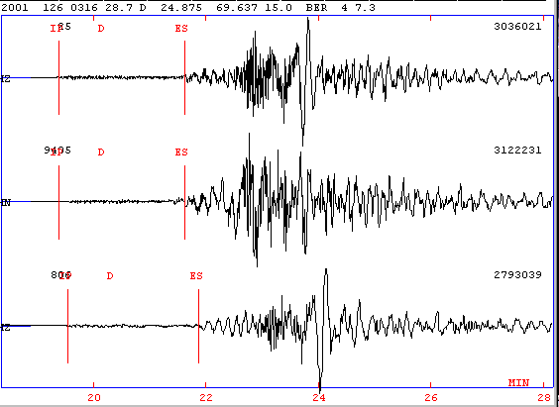

RESPONSE CURVES FOR CUDDAPAH (CUD) INDIAN NETWORK STATION

STATION TYPE : BROADBAND
SENSOR : CMG-40T
FREQ. RESP : 0.033 Hz TO 50 Hz
NATURAL P[ERIOD : 30 SEC
GEN.CONSTANT : 800 v/m/sec
COUNTS : 1 volt=419727 counts
DATA LOGGER : REFTEK DIGITIZER
SAMPLE RATE : 100 SPS

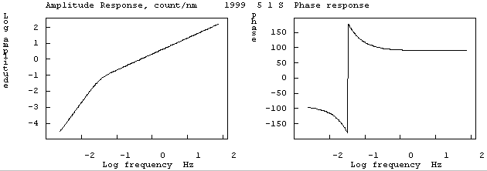

COMPARISION OF PDE & NETWORK MAGNITUDES

EVENT NO mb India mb PDE

1 6.4 6.4
3 5.5 6.5
4 7.0 6.9
5 5.6 5.9
AVERAGE 6.1 6.4

Indonesia

Seismological network in Indonesia consists of digital network, run and maintained by BMG. To monitor a destructive earthquake BMG is equipped with a near real time system, which is expected to determine the preliminary earthquake information. The epicenter determinations are improved by including the arrival time data recorded by the analog stations. There are several international agencies and research group (JISNET, IRIS CTBTO, OHP, AEIC) who have cooperation program with BMG to operate temporary seismological networks and data exchanges.

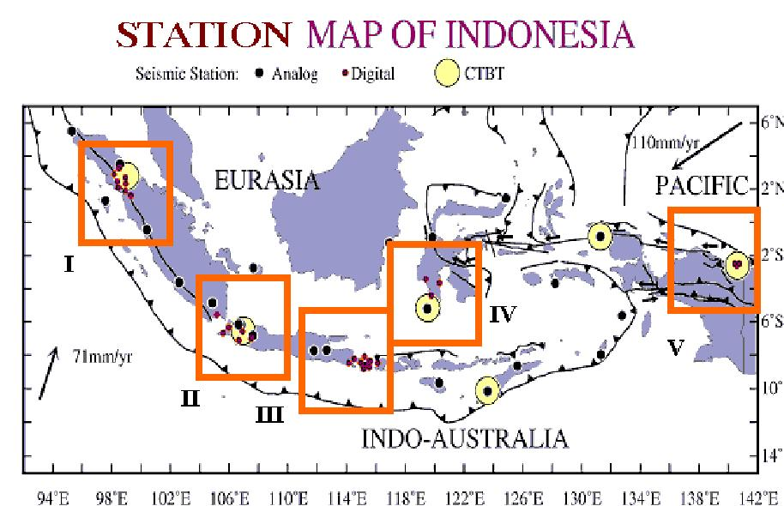

Currently, the BMG is operating 58 short period seismograph consisting 30 analog seismological stations and 28 digital stations. In addition there are temporary networks owned by international agencies or scientific research group, operated and maintained by BMG.

SELECTED SEISMOGRAMS

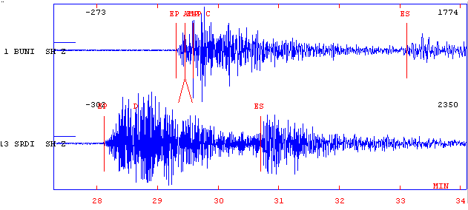

Instrument Response

Station Code : PANCE

Sensor : ZM 500

Nat. Period : 1 second
Sensor Damping : 0.7
Generator Const : 2500 V/m/s

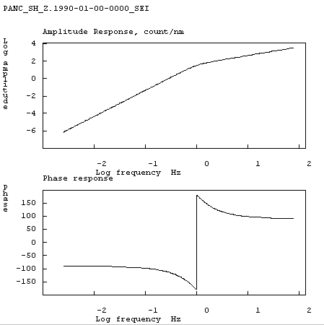

Iran
The Iran seismological network comprises 7 Digital Broadband (bore hole type) and 41 short-period instruments with SS1 sensors.

Located earthquakes by Iranian Seismic Networks
Number of stations used : 8-10
Number of events : 3
Selected events
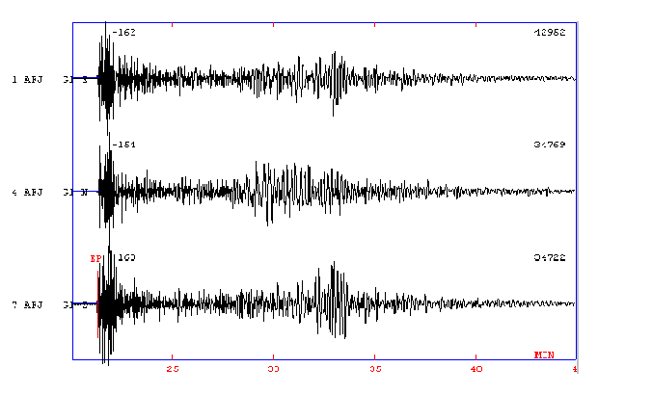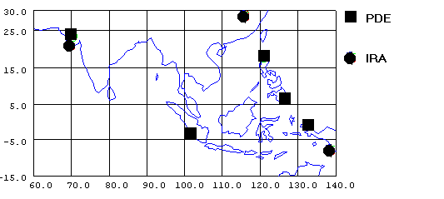

Specifications of Iranian National Seismographic Network Sensors

Sensor Type: Broadband (Guralp CMG-3)
Natural Period: 100sec.
Critical Damping Ratio: 0.7
Sensor Generator Constant: 1500 V/m/sec.
Digitiser Counts per Volt: 262144
Anti Alias Filter: Low pass 23.4 Hz , 4 poles.
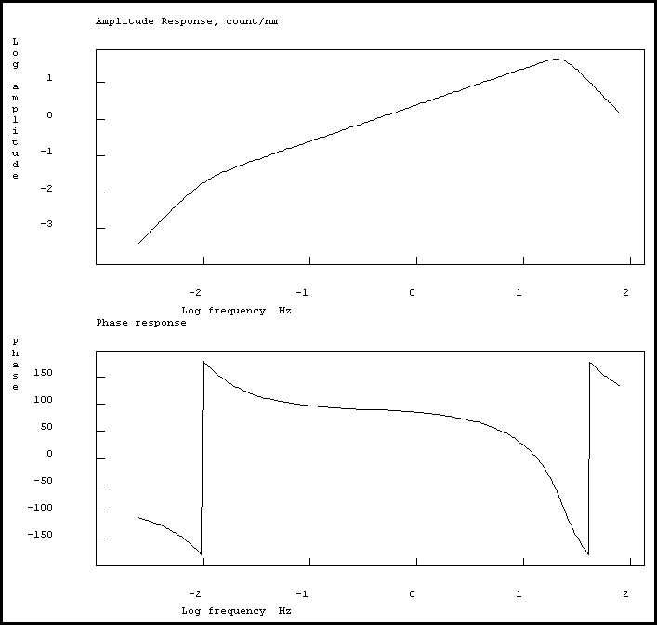

Philippines
The earthquake monitoring with modern instruments started in Philippines in 1986. At present there are 34 digital short-period instruments operational in the country’s seismological network.
Locations of the 34 new digital seismic stations in the Philippines.

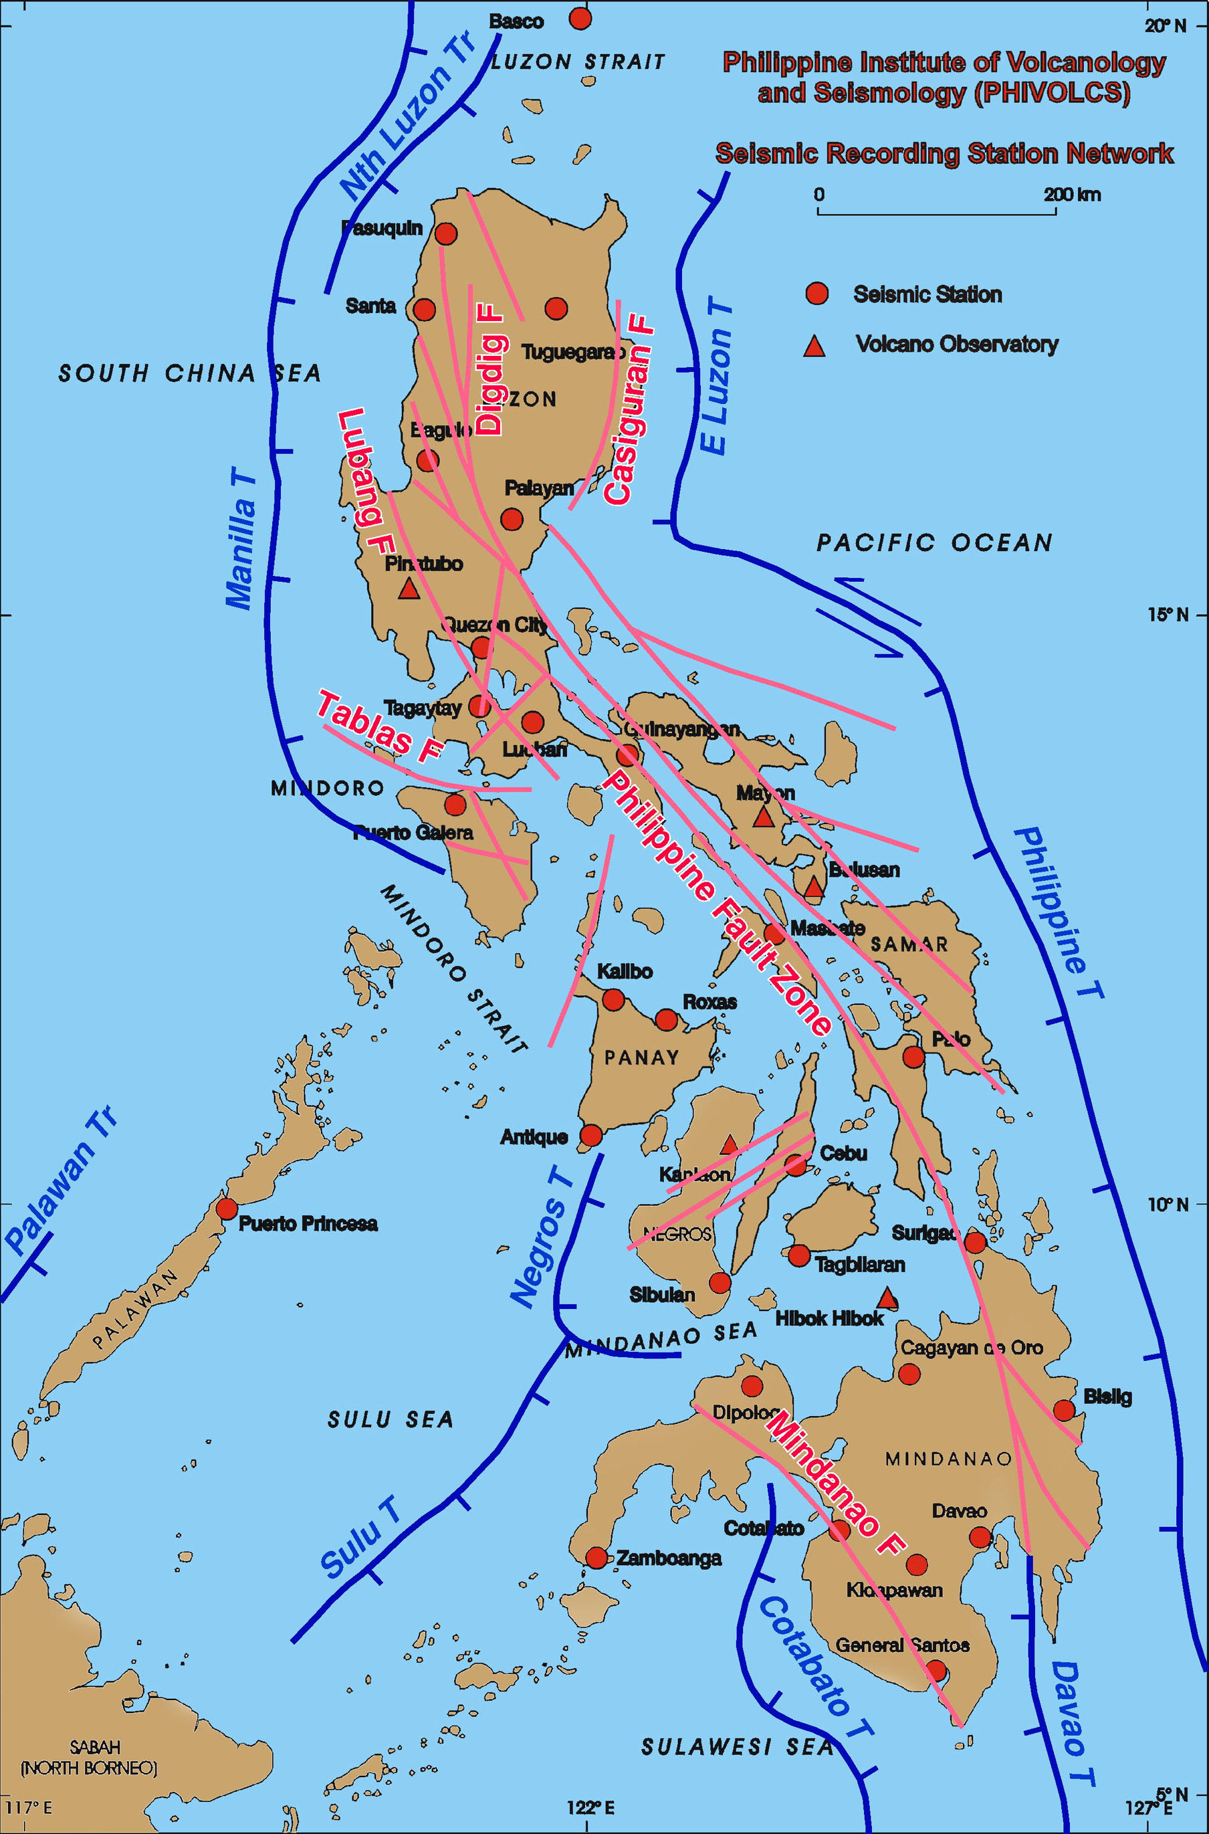

Calibration Data for Short Period Seismographs

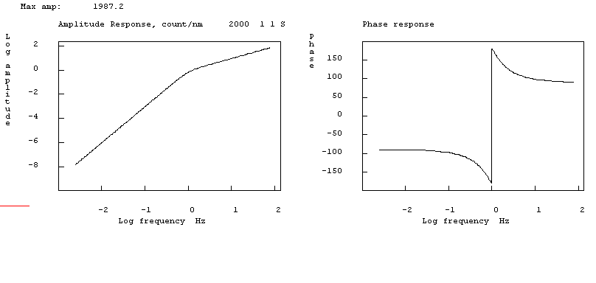

sensor type .......short period Teledyne Geotech S13J
seismometer natural period (in seconds) ............. 1
damping.................0.7
sensor loaded generator constant (V/m/sec)..........200
recording media gain (counts/v)........419330
recording amplifier gain ( in dB) ........ 0

Calibration Data for Accelerometers
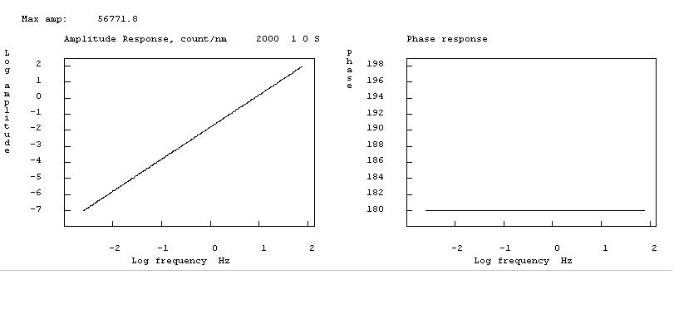

type of sensor .....accelerometer Geotech PA22
sensor loaded generator constant (V/g).... 2.25
recording media gain (counts/v)............... 419330
recording amplifier gain ( in dB) ............. 12

Locations Using Only Philippine Data
No. of Stations Used: 40
No. of well-located events: 4 (events 1, 2, 3, 5)
No. of poorly-located event: 1 (event 4)

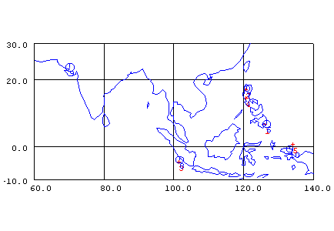
2a
3a
3b
4a
4b
5aa
5b
1a
1b
2b

Events | Event Code | Comparison of Epicenters
 |  |  | mb | Ms | Mw
Jan. 1, 2001 | 1a | 6.890 126.610 - PDE | 6.4 | 7.2 | 7.5
 | 1b | 6.618 126.222 - PhilNet |  |  | 7.1
Jan. 12, 2001 | 2a | 17.350 120.650 - PDE | 5.5 | 5.0 | 5.5
 | 2b | 17.285 120.945 - PhilNet |  |  | 5.6
Jan. 16, 2001 | 3a | -3.970 101.660 - PDE | 6.5 | 6.8 | 6.8
 | 3c | -1.975 103.934 - PhilNet | 5.6
Jan. 26, 2001 | 4a | 23.400 70.320 - PDE | 6.9 | 8.0 | 7.7
 | 4b | 15.515 116.678 - PhilNet
Jan. 29, 2001 | 5a | -0.690 133.240 - PDE | 5.9 | 5.8 | 6.2
 | 5b | -1.374 133.824 - PhilNet | 5.8
 |  | Note: PhilNet= Philippine Network

Russia

In Russia and some part of the former Soviet Union, there are about 40 analog and 17 digital stations. Analog stations have wide variety of frequency range from periods 0.1 to hundreds seconds. Most usual is SM3-kv ( short period) and SM3-os ( broadband). Digital stations are mostly IRIS stations( IRIS /IDA, IRIS/USGS), but there are some stations with Russian digital equipment . For example DASS s, which has seismometer SKD with period’s 0.2-25 seconds, 16-bit ADS, two gain level by registration. Stations MOS, NVL and VRS equipped with DASS. Four stations ( ARU, KIV, TLY, OBN works in NRTS -regime).

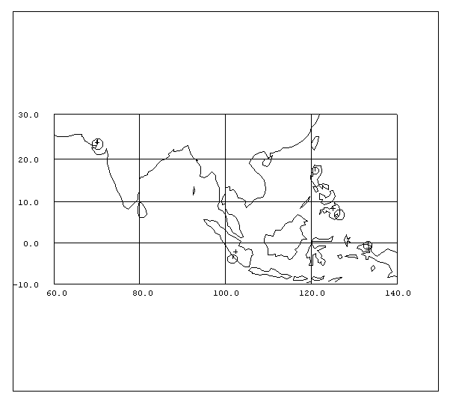
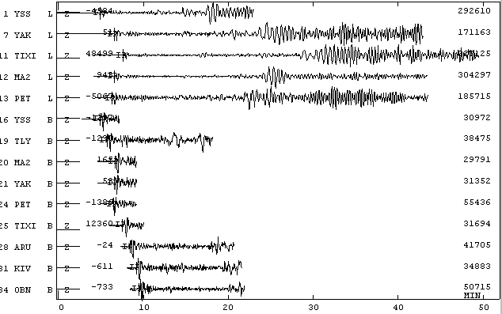
The National Data Centre (COME GS RAS) use program SigPro for automated data processing, Dbpick and WSG for fast interactive data processing and ARS ( made by COME GS RAS) for more accurate interactive data processing. Control Group analyses quality of work of the stations and results send to station’s managers every half of year. There are several criteria’s of quality of work at the station. The first -the numbers of reports about local events and times of its arrivals. The second- number and quality of reports about global events with the M>=6.5. The third one - the quality of records and quality of processing ( chosen records controlled by Control Group). For digital stations in NRTS quality of operation is controlled line connection breakdown, etc ). Data from IRIS stations situated in Russia and response characteristics are available from IRIS Internet page.
Selected Seismograms
Location using Russian Networks
Number of station used : 9
Number of event located :4

Preliminary location of 5 large events used for workshop
and location from Russian Stations

yr | mon | day | hr | mn | sec | typ | Lat PDE/  Lat RUS | Lon PDE/  Lon RUS | Dep PDE/  Dep RUS | Mb PDE/  MB RUS | Ms PDE/  MS RUS
2001 | 1 | 1 | 6 | 57 | 3.0 | D | 6.890  8.170 | 126.610  125.200 | 33.0 | 6.4  6.2 | 7.2  6.8
2001 | 1 | 12 | 19 | 18 | 25.0 | D | 17.350 | 120.950 | 33.0 | 5.6 | 6.2
2001 | 1 | 16 | 13 | 25 | 0.0 | D | -3.970  -2.168 | 101.660  102.412 | 33.0 | 6.5  5.7 | 6.8  6.7
2001 | 1 | 26 | 3 | 16 | 41.0 | D | 23.400  23.859 | 70.320  70.145 | 23.6  30.1 | 6.9  6.3 | 8.0  8.0
2001 | 1 | 29 | 23 | 21 | 26.0 | D | -0.690  -1.306 | 133.240  133.382 | 33.0 | 5.8  5.6 | 5.9
Instrumental responce (BHZ)

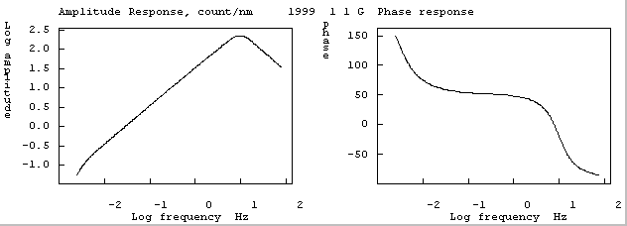

Thailand
The Thailand seismological network consists of 25 seismographs network. Eleven stations are digital broadband and the others are short-period seismometers. In addition there are 11 accelerographs in operation.

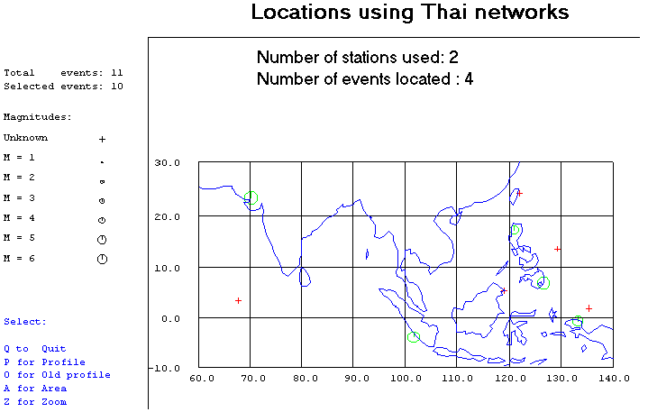

Selected Seismograms

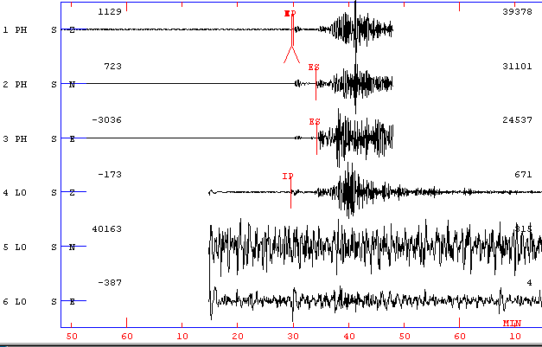

Response curves
Seismic Monitoring and Statistics Center
Thai Meteorological Department

Station type : Broadband
Sensor : CMG-40T
Frequency response : 0.033-50 Hz
Natural period : 30 Sec
Generator constant : 802 V/m/s
Recording Gain : 524383.8 Count/V
Data logger : Reftek Digitiser
Sample Rate : 100 s/Sec

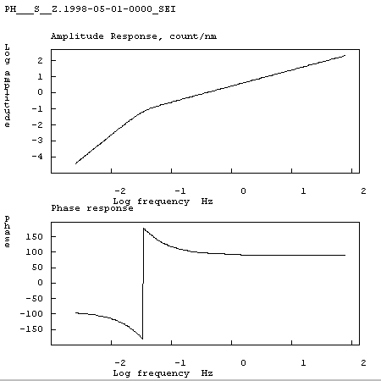

Location with Thailand Station compare with PDE

Event NO. Mb Thai Mb PDE
1. 6.7 6.4
- 5.8 5.5
- 6.5 6.5
- 6.1 6.9
- 5.9 5.9

Vietnam

At present in Vietnam there are 19 seismic stations, 16 stations are in the North and 3 in the south. Depending upon the seismic equipment Vietnam Seismological Network divides into 2 different system of observation. 1) Telemetry seismic array and 2) Independent stations. Instrument details are as follows:

Seismometer Mark Products 1 Hz
Sensitivity 176 V/M/S

Damping 0.7
Amplifier Gain 64 (2⁶)
Digitiser 15 bit for 10 volts
0,305 m V/count
Cut-off freq. 24 Hz
Butt. Filter 5 poles
High-pass 0.1 Hz
-1 pole

3 components (2stations)
1 vertical component (6stations)
Transmission frequency: 475 MHz
Sampling rate: 75 sps

Seismometer Lennartz Electronic, model LE-3D, 1 Hz
Sensitivity 400 V/M/S
Amplifier Gain 64 (2⁶)
Digitiser 16 bit for 10 volts
0,153 m V/count
Cut-off freq. 24 Hz
Butt. Filter 8 poles
High-pass 0.1 Hz
-1 pole
3 components
Sampling rate: 75 sps

Locations using Vietnam network
Number of stations used: 5

Number of events located: 4

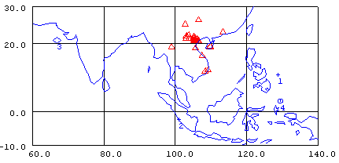

Selected seismograms

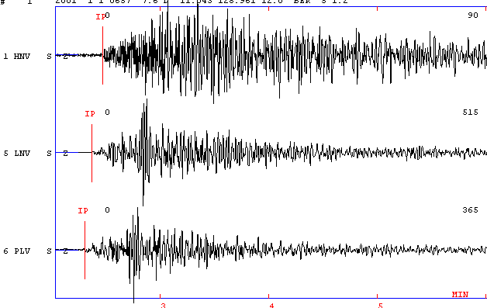

SINGLE EVENT LOCATION USING COMBINED NETWORK DATA
The five selected events were located using combined data sets from all the participating countries. The participants were divided into five group for this exercise. Given below are the results obtained by different groups.

GROUP - 1

2001 01 01 0657H Event

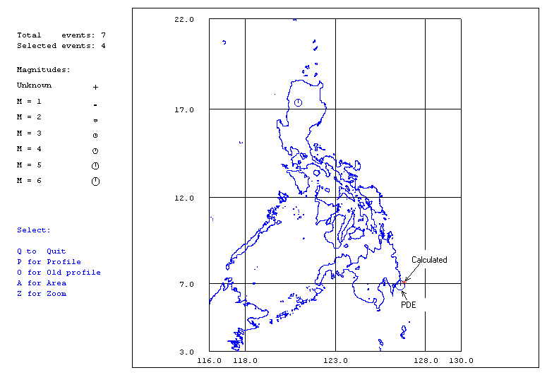

Calculated Average Magnitudes

Mb = 6.2 Ms = 6.8 Mw = 6.5

Calculated Location

Lat = 7.009 Lon = 126.727 Depth = 107 Km
No. of stations used = 46

PDE Parameters
2001 1 1 657 3.0 D 6.890 126.610 33.0 7.2SPDE 6.4BPDE 7.5WHRV

GROUP - 2

Moment Magnitude Determination of the 2001-01-12 1918UT Luzon Earthquake

Lukban, Quezon, Philippines Station, 383km southeast of the epicentre

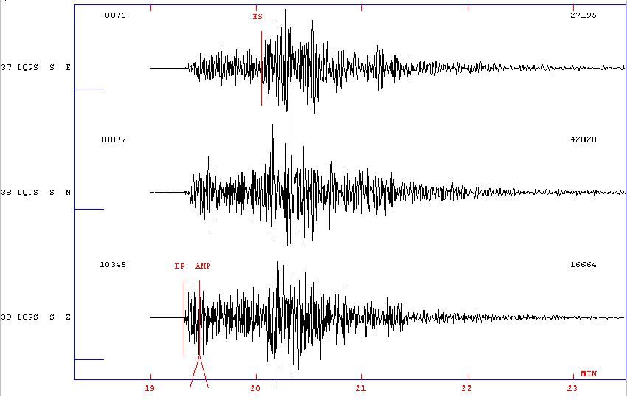

Spectrum for the Lukban seismograph
Mw 5.5 using fo = 0.9 Hz and Q=200f0.7

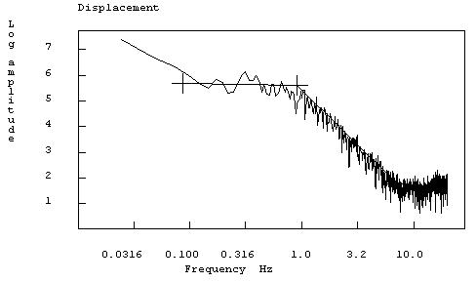

GROUP - 3
January 16, 2001 – 13 :25

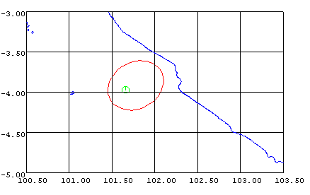

Number of station used = 35
Mb : 6.5 (PDE) , 6.1 (ASIA)
Ms : 6.8 (PDE), 5.9 (ASIA)
Depth : 28 (PDE); 47.0(ASIA)
Circle : PDE
Ellipse : Located by Asian Network

GROUP - 4

INDIAN EARTHQUAKE 2001

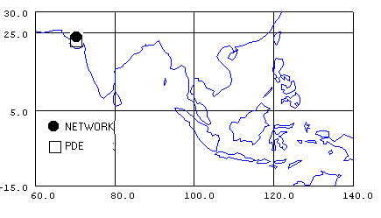

2001 126 316 41.0 D 23.400 70.320 23.6 7.9 PDE
2001 126 0316 36.9 D 23.662 70.186 25.0 7.9 NETWORK

GROUP - 5

Indonesia earthquake

January 29, 2001

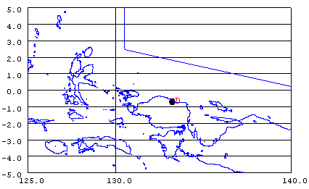

ASA  Mb = 5.7 using 6 stations  Ms = 5.8 using 2 stations  Depth = 46.8  Lat. 0.618S Long. 133.498E  Location using 42 stations | PDE  Mb = 5.9  Ms = 5.8  Depth = 33 N  Lat. 0.677S Long. 133.334E

Appendix 1

IASPEI Pre-Assembly Workshop
Hanoi, August 13 - 18, 2001

List of participants

Lectures:
Prof. Jens Havskov  Institute of Solid Earth Physics  University of Bergen  Allegt. 41, 5007 Bergen, Norway  Web: http://www.ifjf.uib.no  Email: iens@ifjf.uib.no  Phone: (+47) 55 58 34 14  Fax: (+47) 55 58 96 69 | 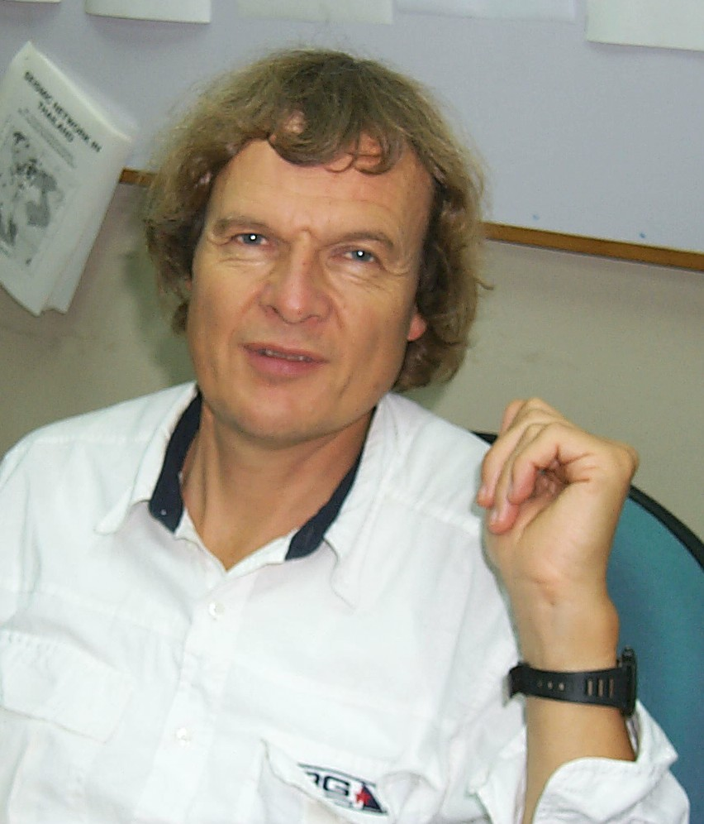
Mr. Lars Ottemöller  Institute of Solid Earth Physics  University of Bergen  Allegt. 41, 5007 Bergen, Norway  Email: larso@ifjf.uib.no  Phone: (+47) 55 58 34 14  Fax: (+47) 55 58 96 69 | 
Dr. Gary Gibson  Seismology Research Centre  2 Park Drive, Bundoora,  VIC 3083, Australia  Web: http://www.seis.com.au  Email: gary@seis.com.au  gary@rmit.edu.au  Phone: +61 3 94552011  Fax: +61 3 94551940 | 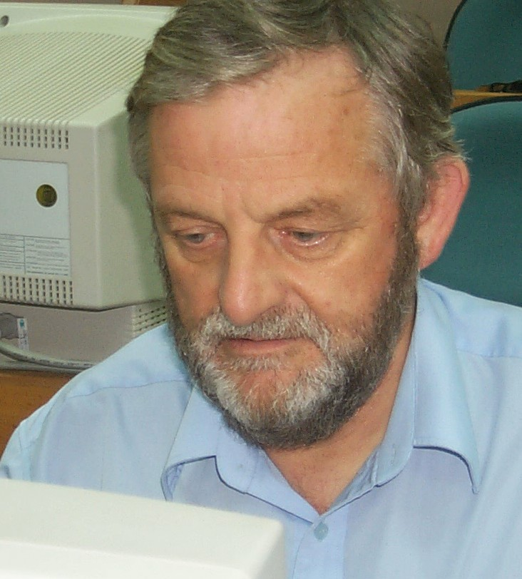
Australia:
Mis Amy Brown  Seismology Research Centre  2 Park Drive, Bundoora,  VIC 3083, Australia  Email: amy@seis.com.au  Phone: +61 3 94552011  Fax: +61 3 94551940 | 
Mr. Trevor Allen  Department of Earth Sciences  PO Box 28E, Monash University,  3800 VIC, Australia  Email: trev@mail.earth.monash.edu.au  Phone: +61 3 9882 1747 | 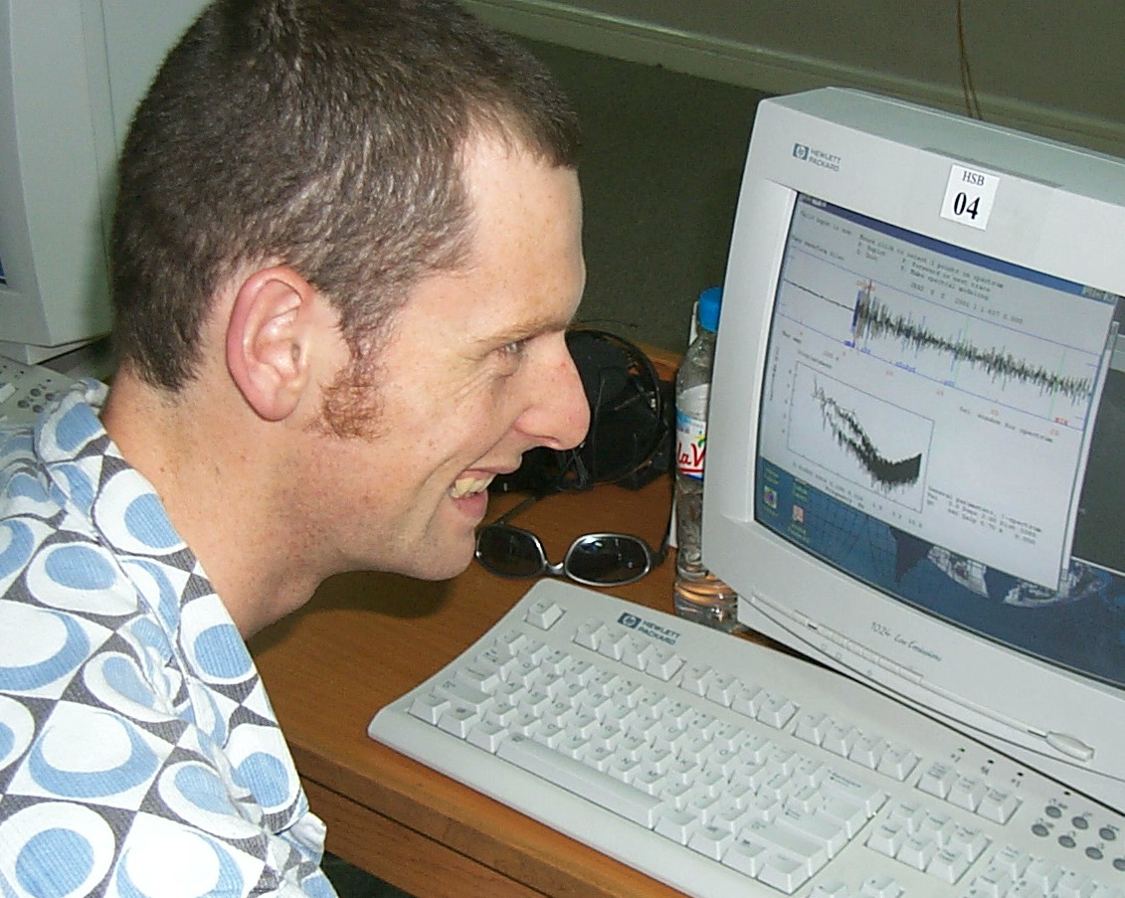
China:
Ms. Sun Ruomei  Institute of Geology and Geophysics  Chinese Academy of Sciences  PO Box 9701, 100101 Beijing, China  Email: sunrm@sina.com.cn  Phone: +86 10 64889072  Fax: +86 10 64889006,  +86 10 64871995 | 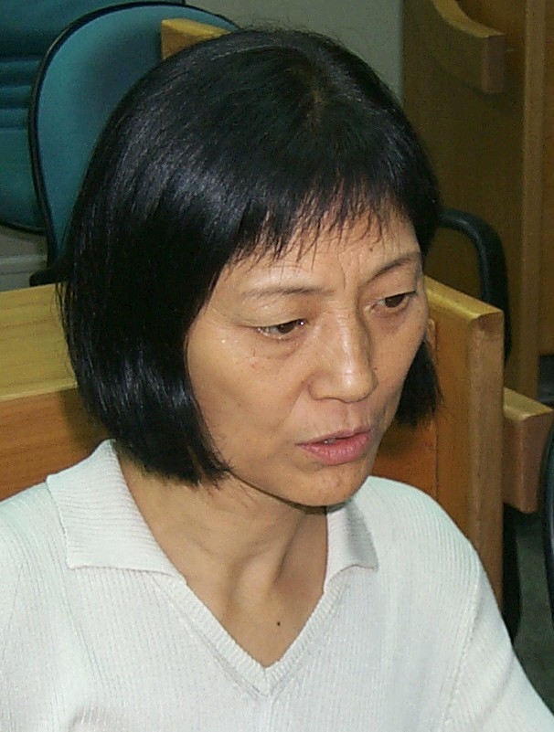
India:
Dr. Chadha R. K.  National Geophysical Research Institute  Uppal Road, Hyderabad-500 007, India  Email: postmast@csngri.ren.nic.in  Phone: +91-40-7170141 (work);  +91-40-7114129 (home)  Fax: +91-40-717564 | 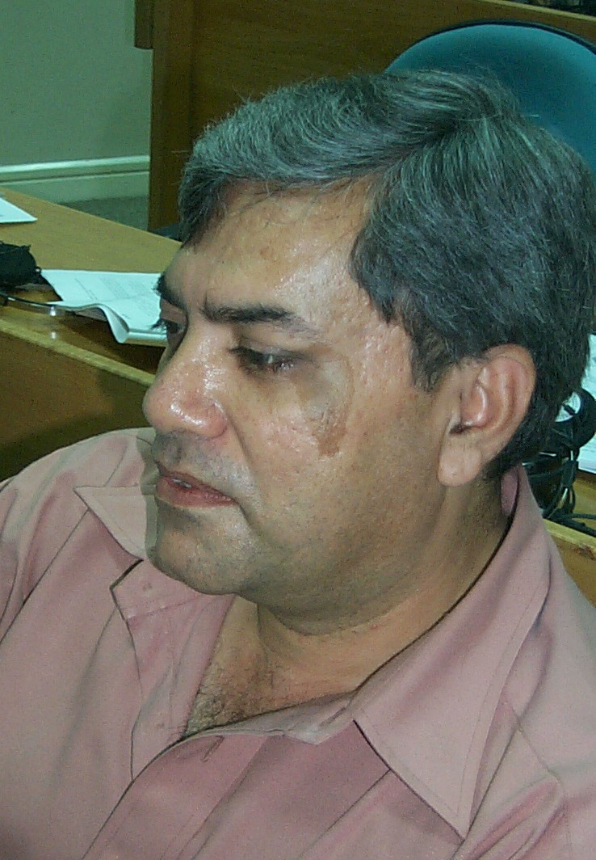
Dr. Bal Krishna Rastogi  National Geophysical Research Institute  Uppal Road, Hyderabad-500 007, India  Email: postmast@csngri.ren.nic.in  brastogi@yahoo.com  Phone: +91-40-7170101(o), 7173641 (r)  Fax: +91-40-717564 | 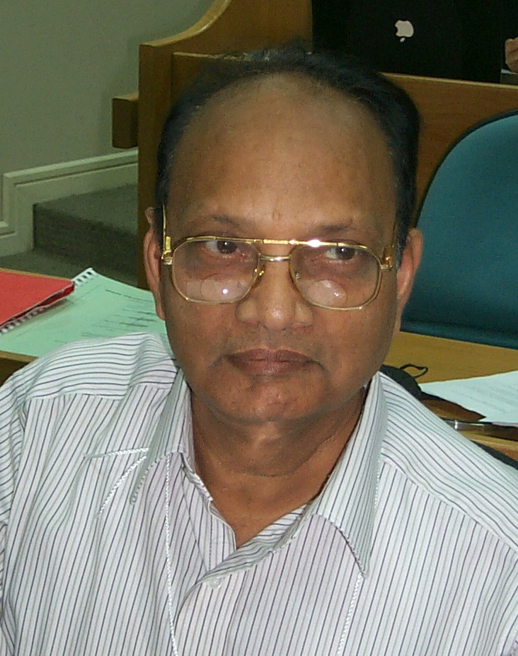
Indonesia:
Mr. Masturyono  Indonesian National Seismological Center  Badan Meteorologi dan Geofisika  Jl. Angkasa I/2, Kemayoran, Jakarta, 10720  Email : mastur@bmg.go.id  Phone : 62 021 654-6316;  62 021 654-6311 ext 5310  Fax : 62 021 654-6316 | 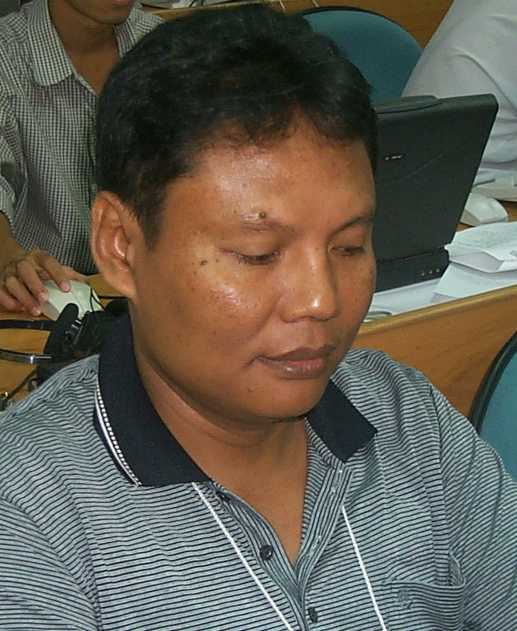
Iran:
Mr. Mohammad Reza Gheitanchi  Institute of Geophysics of Tehran University  Kargar Ave, Tehran, Iran  Web: http://www.ut.ac.ir/geo  Email: mrghchee@chamran.ut.ac.ir  P.O.Box 14155-6466  Phone: +98 21 8028161  Fax: +98 21 8009560 | 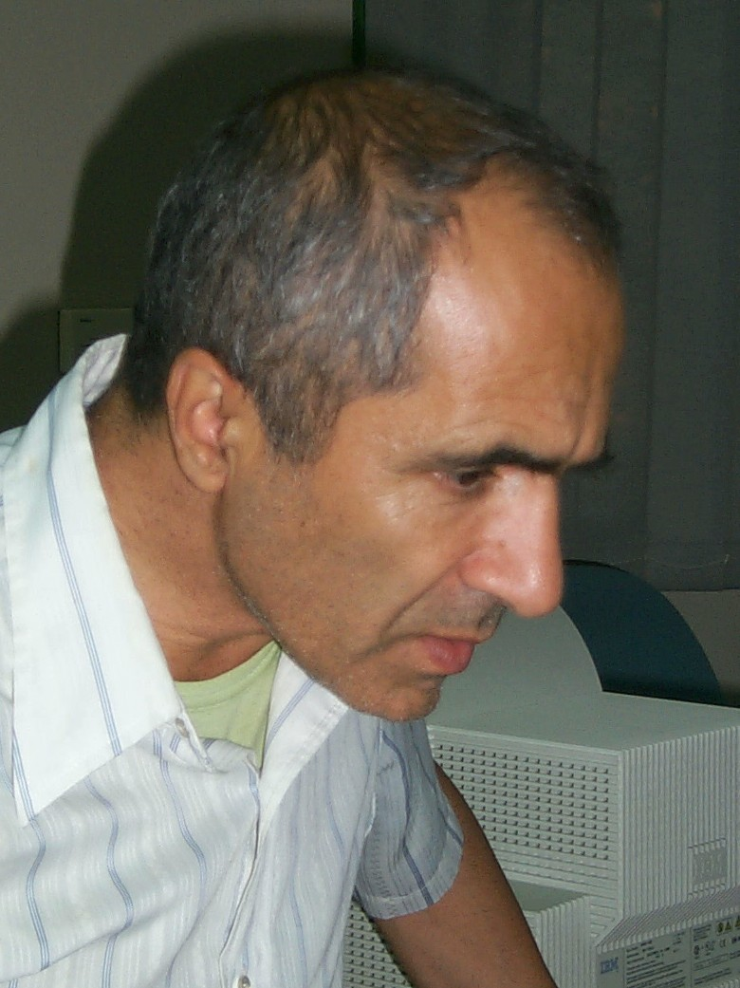
Mr. Karen Assatourians  International Institute of Earthquake  Engineering and Seismology  #27, Arghavan St., Dibaji,  Farmanieh, Code: 19531, Tehran, Iran  Web: http://www.iiees.ac.ir  Email: karen@dena.iiees.ac.ir  Phone: (+98) 21 2831116-19,  (+98) 21 2830826-30  Fax: (+98) 21 2299479 | 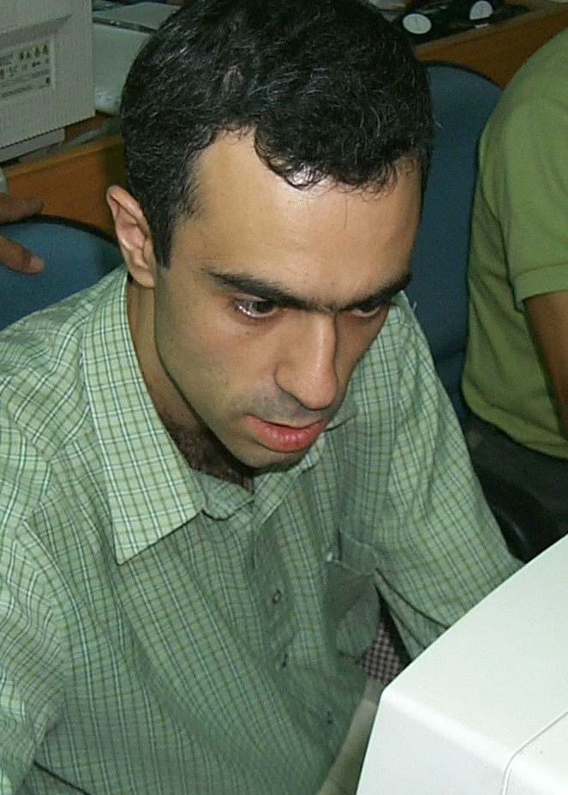
Phillipines:
Dr. Bartolome C. Bautista  Philippine Institute of Volcanology and Seismology (PHIVOLCS)  C.P. Garcia Ave., UP Campus  Diliman, Quezon City, Philippines  Email: bart@phivolcs.dost.gov.ph  Phone: (632) 426 1468  Fax: (632) 927 1342 | 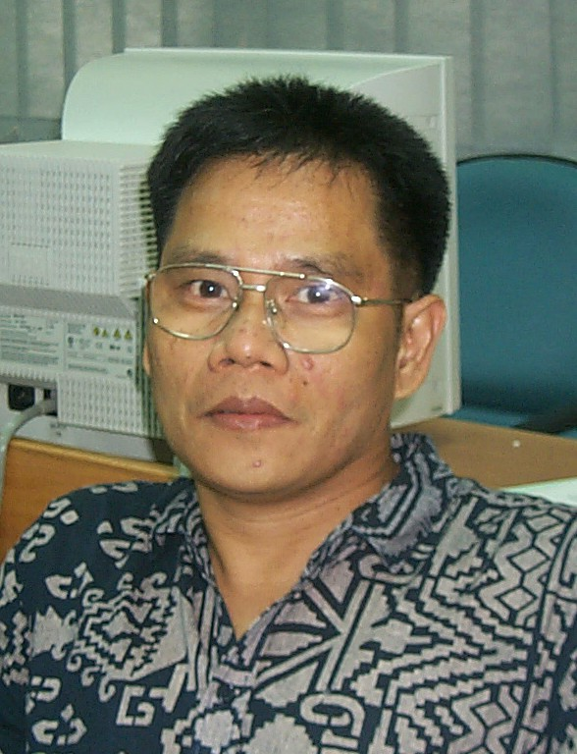
Dr. Ma. Leonila P. Bautista  Philippine Institute of Volcanology and Seismology (PHIVOLCS)  C.P. Garcia Ave., UP Campus  Diliman, Quezon City, Philippines  Email: leyo@phivolcs.dost.gov.ph  Phone: (632) 426 1468  Fax: (632) 927 1342 | 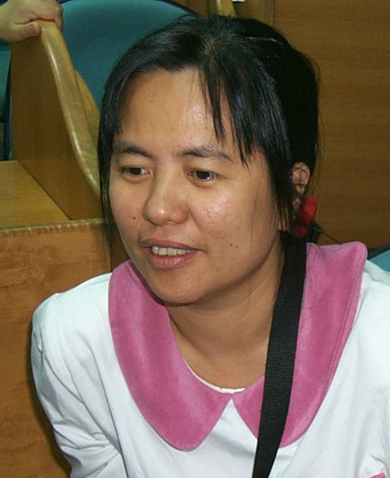
Russia:
Ms. Natalia Zakrghevskaya  Institute of Physics of the Earth (IPE RAS)  B.Gruzinskaya,10, Moscow, Russia  Email: sobolev@uipe-ras.scgis.ru | 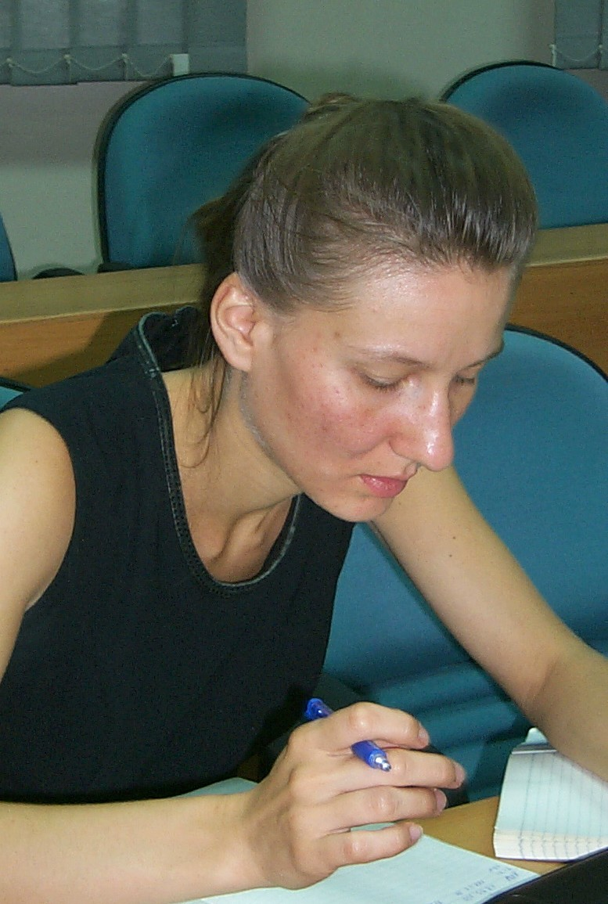
Mr. Yeugeny Chirkov  Institute of Physics of the Earth (IPE RAS)  B.Gruzinskaya,10, Moscow, Russia  Email: chirkov@uipe-ras.scgis.ru  Phone: (7095) 254 15 64 | 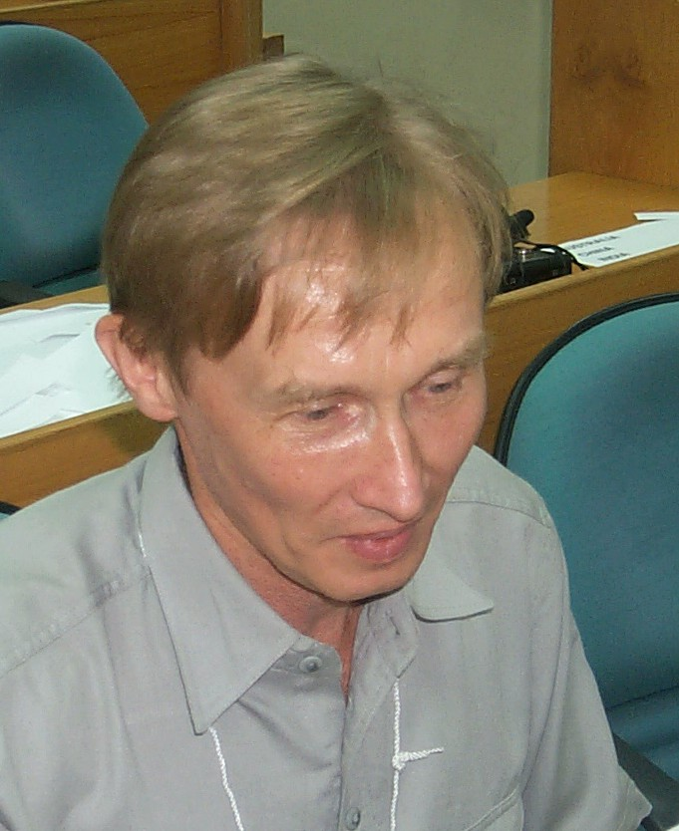
Thailand:
Ms. Kamolrat Saringkarmphasit  Seismic Monitoring and Statistics Center (SMSC)  Geophysics Sub-division  Thai Meteorological Department  4353 Sukhumvit Road, Bang Na,  Bangkok 10260 Thailand  Email : kamolrat_s@hotmail.com  Phone : (662) 399-4547  Fax : (662) 399-4547, (662) 399-0973 | 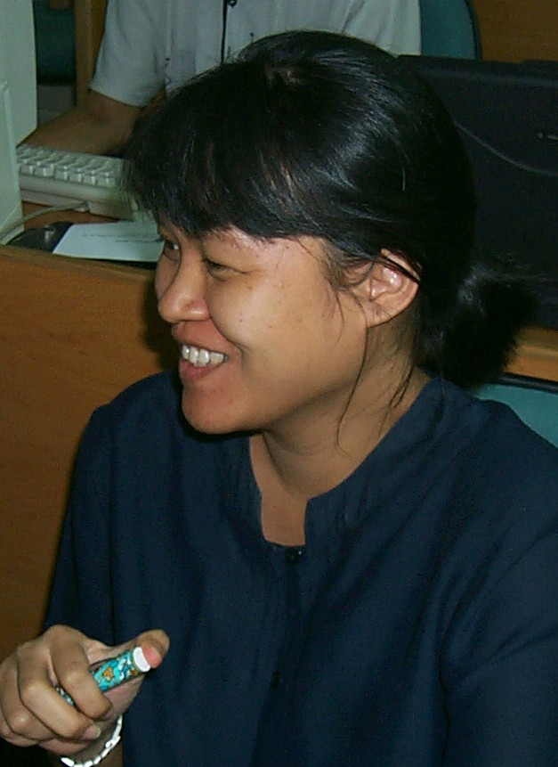
Mr. Yanyong Ouprasitwong  Seismic Monitoring and Statistics Center (SMSC)  Geophysics Sub-division  Thai Meteorological Department  4353 Sukhumvit Road, Bang Na,  Bangkok 10260 Thailand  Email : thaiseis@pacific.net.th  burin@pacific.net.th  kamolrat_s@hotmail.com  Phone : (662) 399-4547  Fax : (662) 399-4547,  (662) 399-0973 | 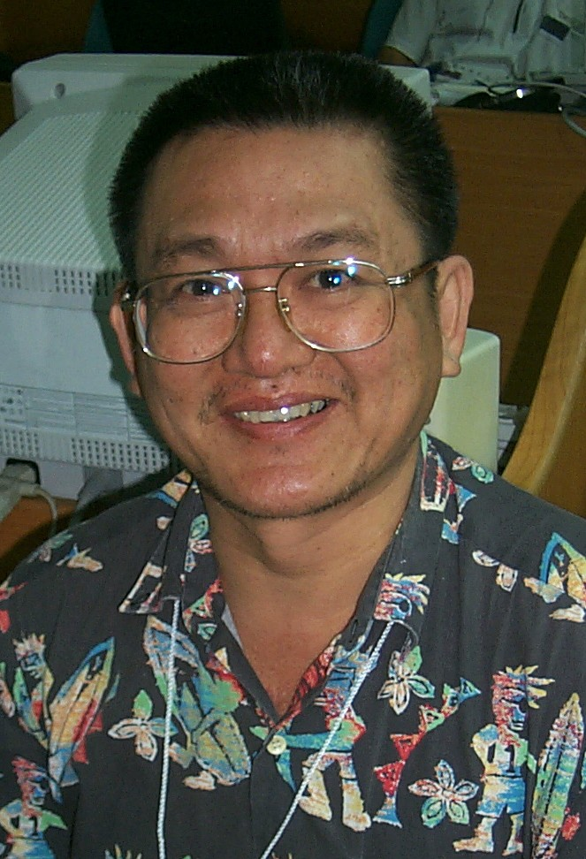
Vietnam:
Mr. Nguyen Quoc Dzung  Vietnam National Center for Science and Technology  Institute of Geophysics  Seismological Survey Department  Hoang Quoc Viet - Cau Giay  Hanoi - Vietnam  Email: nqdung@igp.ncst.ac.vn  Phone: (+84 4) 756.27.99  Fax: (+84 4) 836.46.96 | 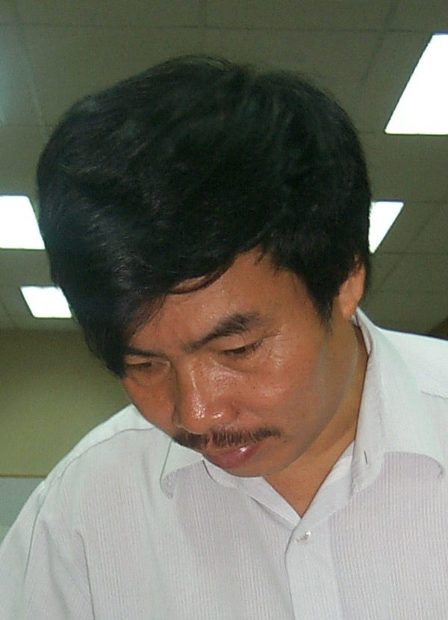
Mr. Trinh Hong Nam  Vietnam National Center for Science and Technology  Institute of Geophysics  Seismological Survey Department  Hoang Quoc Viet - Cau Giay  Hanoi - Vietnam  Phone: (+84 4) 836.39.14  Fax: (+84 4) 836.46.96 | 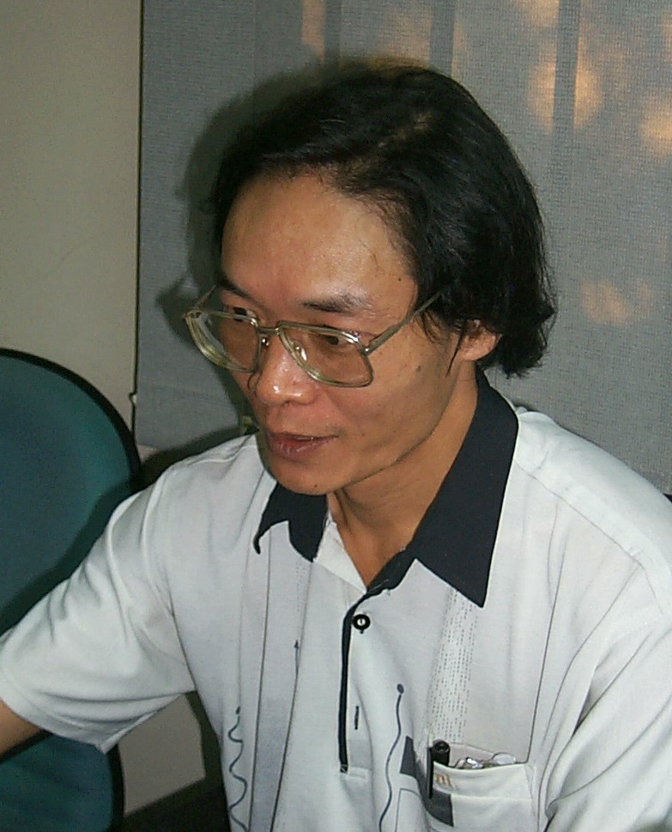
Mr. Tran Thanh Son  Vietnam National Center for Science and Technology  Institute of Geophysics  Seismological Survey Department  Hoang Quoc Viet - Cau Giay  Hanoi - Vietnam  Phone: (+84 4) 836.39.14  Fax: (+84 4) 836.46.96 | 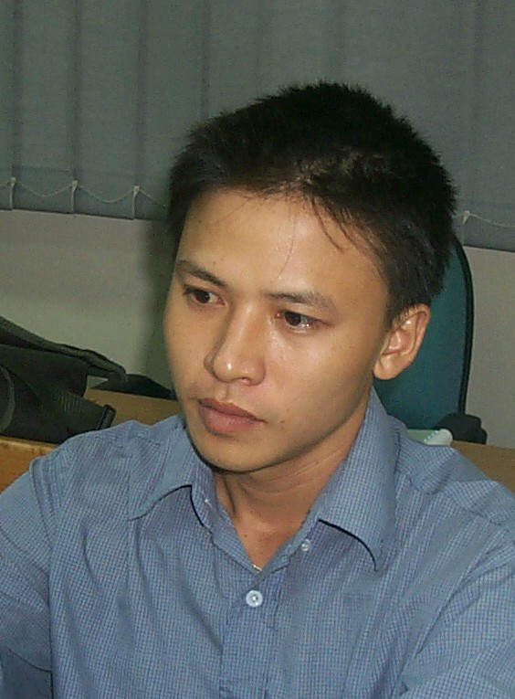
Mr. Nguyen Anh Dzuong  Vietnam National Center for Science and Technology  Institute of Geophysics  Seismic Research Department  Hoang Quoc Viet - Cau Giay  Hanoi - Vietnam  Email: duongna@igp.ncst.ac.vn  Phone: (+84 4) 756.27.99  Fax: (+84 4) 836.32.37 | 