Installation of seismological

stations in Tibet using SeislogCE.

Tutorial



University of Bergen
Department of Earth Science.
José Åsheim Ojeda

June 2004

Contents

1 The components of the stations. 3
1.1 Cabling 3
1.2 PocketPC and Secure Digital (SD) memory card. 5
1.3 Digitizer 6
2 Maintenance 9
2.1 Environmental parameters. 9
2.2 Power failure 9
2.3 Install SeislogCE and correct parameters. 10
2.4 How much memory left on SD memory card. 10
2.5 How to kill not responding programs. 10
2.6 Exit/Close SeislogCE. 11
3 PocketPC exercises. 12

1 The components of the stations.

Figure 1 represents the different components of the seismological station. The components are: Three component seismometer in a watertight box, digitizer-amplifier box, iPAQ PocketPC for recording, power supply for digitizer, power supply for iPAQ and GPS antenna. The components will now be described separately.
Figure 1. The different components of the seismological station.

Local power is 230V AC, and the connectors are the same as for Norway. Surge protection is essential for protecting equipment from voltage spikes and over voltage. Both the PocketPC and the digitizer should have surge protection.

1.1 Cabling
The battery eliminator comes with the PocketPC equipment. It connects to the USB/serial cable at a split close to the PocketPC end of the cable.

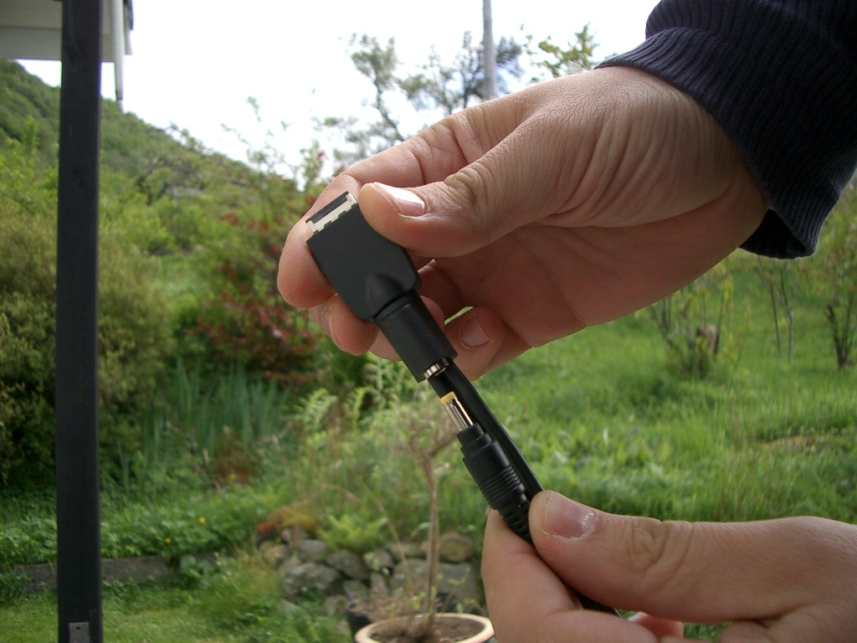

Figure 2. Power connected to USB/serial cable.

The USB/serial cable is connected to the PocketPC at the bottom of the device. It is good practice to turn off PocketPC, while inserting or removing connectors from the device. The connector is polarized and fragile. Keep connector clean and avoid dust. The marking (arrows) on the plug shall be seen on the front side (screen side) of the PocketPC.

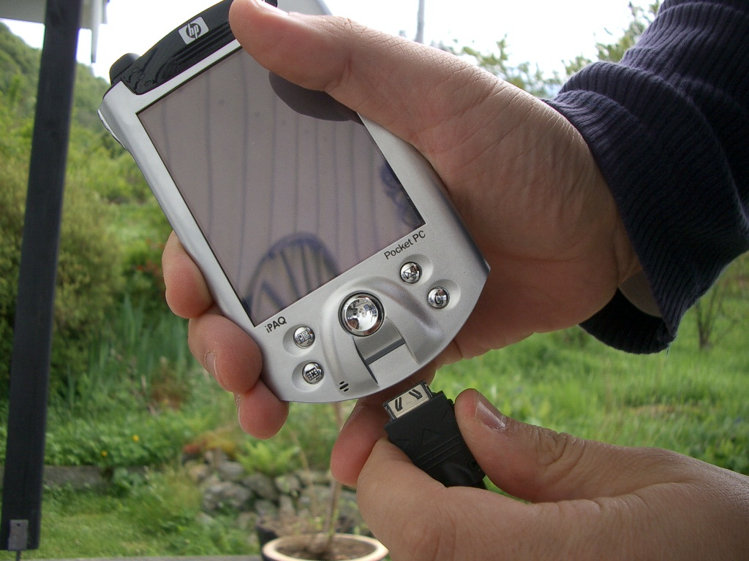

Figure 3. Insert USB/serial cable on PocketPC.

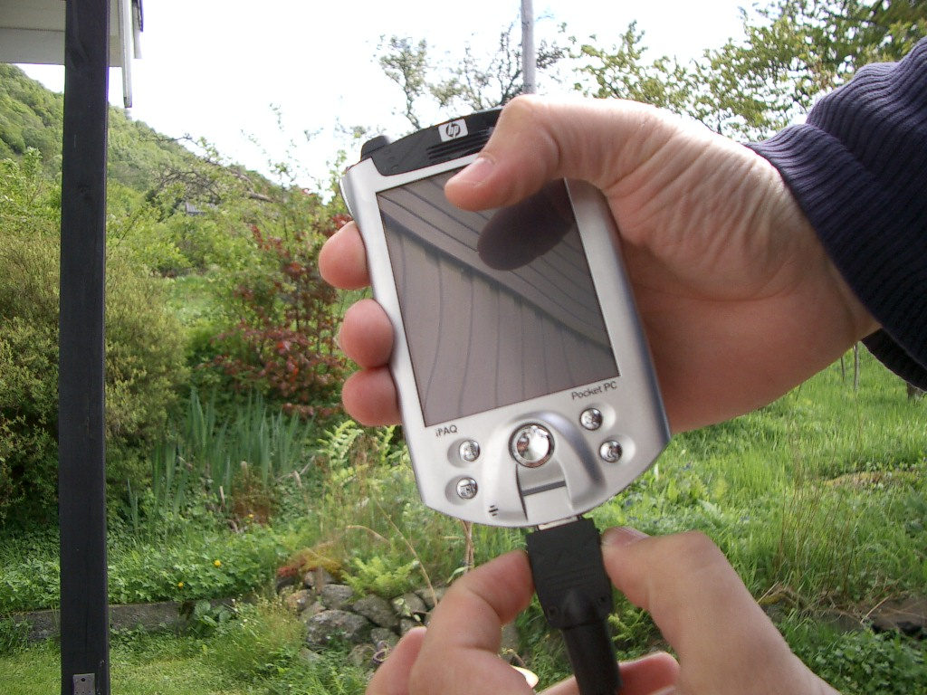

Figure 4. Release the USB/serial cable. Press the two buttons on the side of the connector.

After inserting the connector, it can not be removed without pressing two buttons on the side of the connector to release cable. Note: Do not use force on the connector, it is very fragile, and check for dust before inserting.

The USB/serial cable is meant to connect to a PC either by serial or USB port. Now the serial cable is connected to a digitizer instead. Hence a modification is needed, that is why the null-modem cable is needed. It only change the TX and RX pins. (Routing pin 2 to pin 3, and pin 3 to pin 2). See Appendix 1 for schematics of the null-modem cable.

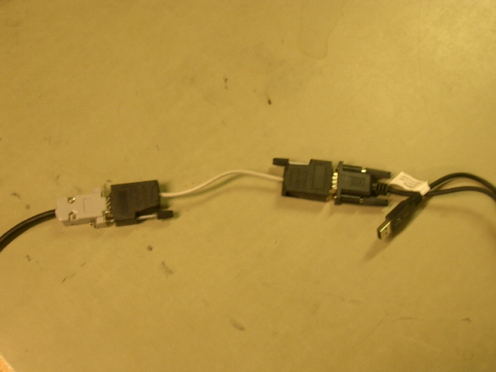

Figure 5. Null-modem cable connected between digitizer and PocketPC serial cables.

1.2 PocketPC and Secure Digital (SD) memory card.
Turn off PocketPC (one press at upper right corner button, another press turn on). Insert SD memory card at the top of the PocketPC (see Figure 6). The card must be inserted the right way with text facing the front and the rounded corner at the lower left side (see Figure 7).

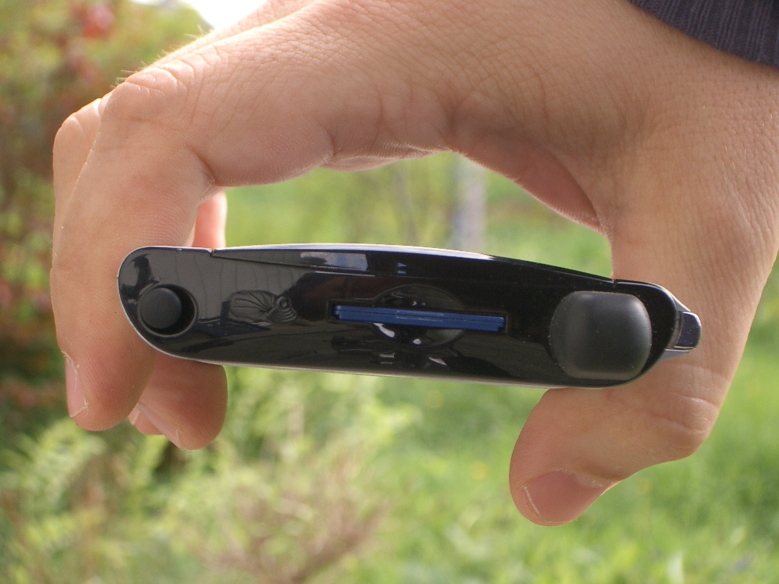

Figure 6. SD memory card inserted in the PocketPC.
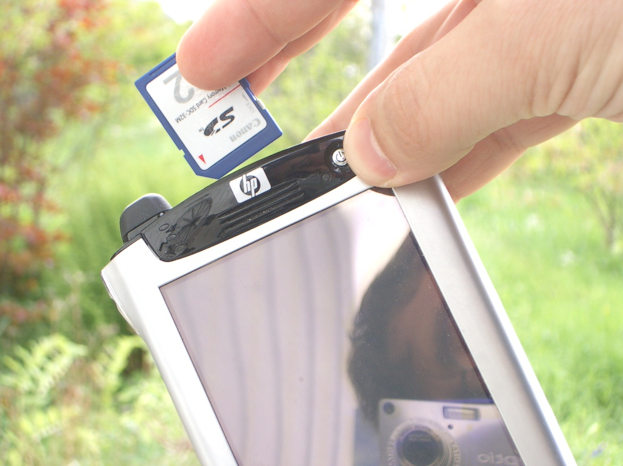

Figure 7. How to insert the SD card. Remember rounded corner lower left side.

When the SD memory card is completely inserted, there is a small click. Press once again to release the card, and a spring pushes the card out.

1.3 Digitizer
Here is the connectors of the M. Mariotti SADC10 digitizer.

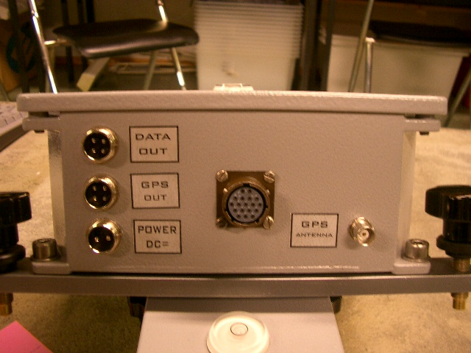
Figure 8. Digitizer connectors. Data out is RS232 to PocketPC, GPS out is not used and GPS is for the GPS antenna. The large connector is for connecting the sensors.

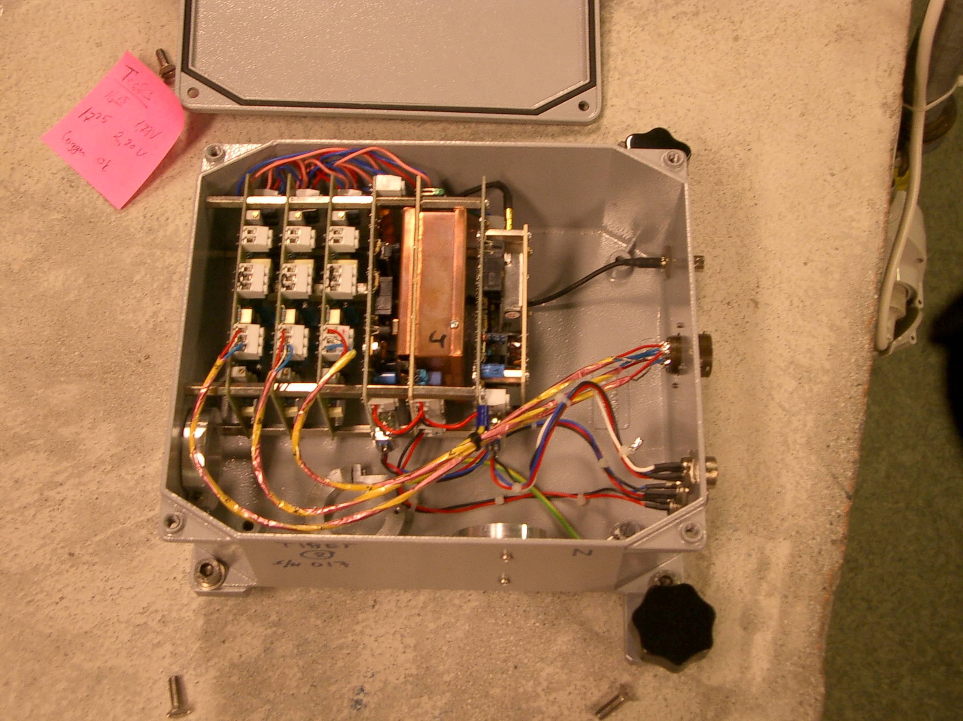
Figure 9. Inside Digitizer. The three cards to the left are amplifier and filter cards, then follows digitizer, power supply and GPS.

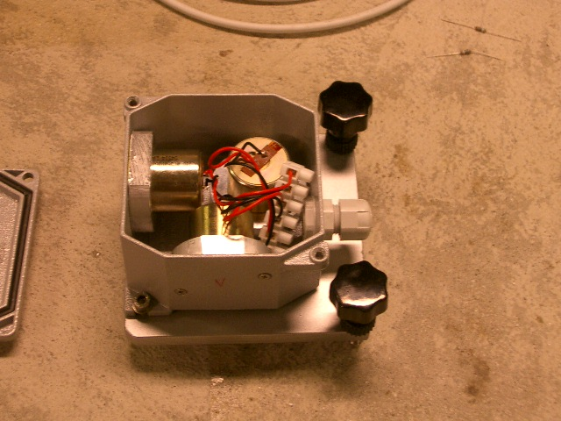
Figure 10. Sensor Housing. The housing is waterproof provided that the cable connection is tight.

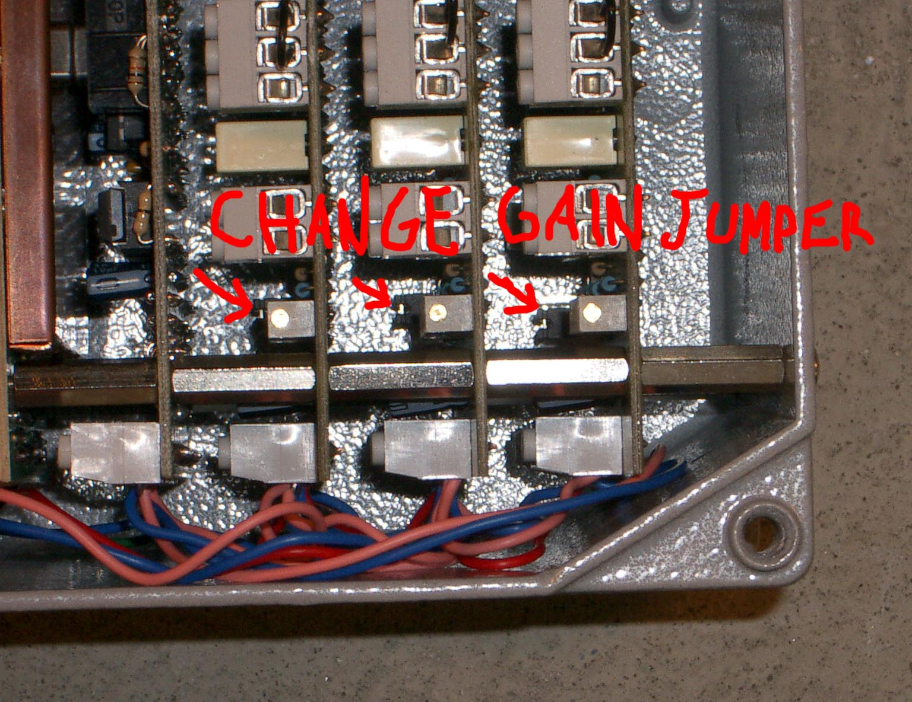
Figure 11. SADC10. Gain adjustment by changing jumper.

2 Maintenance

2.1 Environmental parameters.
The PocketPC needs a dry and dust free environment. It should be kept in a box protecting it from direct exposure to water. Temperature range for the PocketPC should be between 10 and 35 degree Celsius. The PocketPC and digitizer have been test for operating at 6000 m over sea level (vacuum chamber test).

2.2 Power failure
If there is power failure, the Compaq iPAQ automatic change to internal battery, which can run for 10-14 hours on a new battery. So a power failure of less than 10 hour will for sure not stop SeislogCE. But if battery runs completely flat ( >10-14 hours power failure), a visit to the seismological station is needed, and SeislogCE has to be reinstalled from a backup. Alternatively a spare iPAQ can be sent to the station. (This has to do with the nature of the PocketPC, the programs are installed in battery backup RAM). The recorded data are not lost, because they are stored on SD memory card that do not need power to hold the data.

Note: The digitizer will stop to send data to PocketPC after power failure since there is no battery connected to the digitizer.

Backup SeislogCE so that one is prepared for battery running flat.
- The “iPAQ Backup” program is found under Start | Programs on the PocketPC. The operating system and some important programs including this program, is stored in ROM, hence never lost.
- Choose what to backup. In “iPAQ Backup” check that Registry and Windows and Seislog directory under File System is set up for back up
- Start a backup. Remember that the backup file must be stored in the “\iPAQ File Store” directory, because data on this directory is not lost when battery runs flat.

Complete power failure. Battery running flat. Restore SeislogCE.
- Going through Windows CE startup procedure. First one has to align touch screen. Learn cut and paste. Set local time to GMT time (Casablanca time, because Casablanca has no summertime).
- Restore SeislogCE from backup using iPAQ backup found under Start | Programs on PocketPC.
- After restore you are asked for a soft reset of the PocketPC. Use the stylus pen to press the small reset button under the PocketPC. Only the stylus pen fits in the hole.

2.3 Install SeislogCE and correct parameters.
The SeislogCE.exe is placed in the \Windows\Start Menu folder on the PocketPC, by using Microsoft ActiveSync 3.7.1 to upload the file from your desktop PC. Prior ActiveSync has to be installed on the desktop PC, and then USB can be used to transfer files between PocketPC and desktop PC. For details see User Guide for SeislogCE. What is not mentioned in the guide is to put a shortcut to SeislogCE in \Windows\Start up folder, then SeislogCE will start up automatically after a soft reset.

The settings of the SeislogCE program are by default often correct. What you have to set is:
- Program settings: Have to define short and long network name.
- Administer devices: Choose SADC10/18/20. Use default settings. Com1, 4 channels, 16 bits, baud 38400, sample rate 100Hz, support 200Hz, support date and time, Sync system time from SADC10.
- Administer channels: Define station code. Let channel 1 be SZ component, channel 2 SN, and channel 3 SE. Remember to set channel 1 to physical channel 1, channel 2 to physical channel 2 and channel 3 to physical channel 3. For filter and trigger use default, can be changed later if needed.
- Configure trigger set: This must be done after the 3 channels are defined. Give it a name, like trig24062004 (date of setup included in name). Use default on events tab. On channel selection tab, select trig all, and dump all channels. Double tap all channels both for trig and dump, so that 6 stars are seen.

Note: The PocketPC is default configured to turn itself off automatically after 3 minutes when running on battery, it will do so even if SeislogCE is running. Go to Start | Settings. System tab. Power icon, and disable turn of device if not used.

2.4 How much memory left on SD memory card.
An event with 3 channels use about 1 kB per second of recording. If an average event last 100 s, 100 kB is used per event. If there are 10 triggers a day, the daily consumption of memory is 1000 kB or 1 MB. Every SD memory card has effectively 120 MB of storage. Then the station can run for 120 days. But if there are 100 events a day the station can only run for 12 days, before changing the SD memory card.

Go to Start | Settings. Choose System tab. Tap on Memory icon. Finally choose tab for storage card. Here you can see how much of the SD storage card memory that is used.

2.5 How to kill not responding programs.
Go to Start | Settings. Choose System tab. Tap on Memory icon. Finally choose tab for Running Programs. Here it is seen which programs that runs on the PocketPC, and the programs can be stopped (killed) by tapping stop button. For an operating seismological station only Seislog for PocketPC shall be running.

Soft reset
Press small reset button under PocketPC with stylus pen. Programs are not lost, but PocketPC is reset and programs stopped. Try this if system hangs, but first one can try to kill programs from running programs overview.
Start | Settings. Tab System. Memory icon. Tab Running Programs.

Hard reset (loss all memory and SeislogCE, do not use this unless in serious trouble).
Hold two outermost button on front + press stylus pen on reset button under PocketPC.
Wait some seconds before it starts up again.
Going through Windows CE start up procedure. Taping on screen to align screen. Learning cut and paste. Set time zone, use GMT time (Casablanca time). SeislogCE will be gone. SeislogCE should have been backed up with iPAQ Backup program, so now do a restore (see section 2.2). After restore you are asked for a soft reset.

2.6 Exit/Close SeislogCE.
The X button on the upper right corner is not closing the SeislogCE application! It only hides the windows, but the application is still running. It is the same for other applications too. Only way to close SeislogCE is to tap File | Exit within the SeislogCE menu.

3 PocketPC exercises.

Exercise 1. Text input / Pocket Word
Start Pocket Word. (Start | Programs). Using both keyboard and character recognizer to input (tap up arrow lower right corner). Write this text:
This is my first text written using PocketPC, may it not be the last. June 6 the equipment is shipped to Tibet. Save the text as test.doc to default directory. (Folder: None equals My documents folder).

Exercise 2. File Explorer. Move file
Use File explorer. Go to directory where you saved test.doc and cut file (hold pen over file for 2 s), go the SD memory card directory (Storage Card). Hold pen over empty space (no file), and choose paste on menu that arise. File is now moved.

Exercise 3. Use Active Sync to download file.
Install ActiveSync 3.7 on desktop PC. Free download from www.microsoft.com. Connect the PocketPC to PC with USB. Active Sync should detect the PocketPC. Asked for setting up partnership, do not. Use guest instead. (hence no automatic synchronization of files). Use Mobile explorer to navigate the directory of the PocketPC, move a video or music file from the PC down to the PocketPC with normal drag and drop. Play the music or video in Windows Media.

Exercise 4. Install SeislogCE.
Using ActiveSync. Download SeislogCE from PC to PocketPC folder My Device\Windows\Start menu
SeislogCE now appear in Start Menu. Put a shortcut to SeislogCE.exe in \Windows\Start Up folder.

Exercise 5. Setup SeislogCE
Tap SeislogCE to start program. First time SeislogCE runs you are asked to define some initial settings. (This can later be changed in menu Configure | Program Settings)

Exercise 6. Backup SeislogCE to iPAQ file store.
The “iPAQ Backup” program is found under Start | Programs. Check that Registry and Windows and Seislog directory under File System is set up for back up. Do a backup. Remember that the backup file must be stored in the “\iPAQ File Store” directory, because data on this directory is not lost when battery runs flat.

Force a hard reset of the PocketPC (all memory lost) by holding the outermost buttons (most left and most right) and pressing reset with stylus pen.

Go through the Windows CE start up procedure and set local time to GMT (Casablanca time). See that SeislogCE has disappeared.

Perform a restore of registry and SeislogCE using iPAQ backup program (see restore tab at bottom of screen). Find and start up SeislogCE. See if previous settings remain.

Appendix 1. Null modem cable.

The device (digitizer) should be configured on “COM1”. This serial port is usually not a standard D-SUB connectors. A special cable (usually supplied with the PocketPC) must be used to connect the PocketPC to a D-SUB connector. Unfortunately, this cable is meant for connecting to a PC, not a digitizer (hence wrong gender), so you need an adapter to connect devices to the PocketPC. The next figure shows how you can build this adapter of two male 9 pin D-SUB connectors and three chords:

5
2
3
3

2
5

The serial connector on most PocketPCs is a combined serial and USB interface. This means serial and USB communication is not possible on the same time. Make sure no other programs on the PocketPC are using this port when running SeislogCE. Also, make sure ActiveSync is not running. To find out which programs are running, open the “Settings” panel on the PocketPC, tap on the system tab, and select Memory. Then tap on the “Running Programs” tab.

