Seislog for PocketPC (SeislogCE)

- User’s guide

Odd Johan Berland & Frode Fjeldstad
Institute of Solid Earth Physics
University of Bergen
Allégaten 41, 5007 Bergen
Norway

September 2001. Revised Havskov & Ojeda
June 2004. Revised Ojeda (SeislogCE v0.9.99)
■ About this guide

This guide assumes that you are familiar with Seislog for Windows. Only topics specific for Seislog for PocketPC (SeislogCE) are covered in this manual. For topics not covered in this guide, please refer to the manual for Seislog for Windows. When installing SeislogCE or downloading data, it is also assumed that you have successfully installed Microsoft ActiveSync 3.7 and have a working connection between the desktop PC and PocketPC. ActiveSync is usually supplied with the PocketPC. Consult the manual for information on how to install and use this software. If you are interested in understanding the source code a detailed technical manual called Sluttrapport(Norwegian text) is also available at the download site, see below.

■ Hardware requirements

SeislogCE requires a PocketPC with Windows CE 3.0. The program file require about 300K of storage space. This is a bare minimum, and data files produced by the program will require more storage space depending on set up.

■ Installing SeislogCE

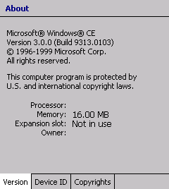
PocketPC’s are equiped with either a MIPS, SH3 or ARM processor. There is one version of SeislogCE for each processor type. You must use the version corresponding to your PocketPC. To determine the processor type, choose Settings from the Start menu, then select the System property page and open the About window.

All versions of SeislogCE as well as source code and manuals can be found on ftp.geo.uib.no under pub/seismo/SOFTWARE/SEISLOG/CE. Put the version you need to a directory on the Desktop PC and connect your PocketPC for file transfer. If the file is zipped, unzip the file. (Winzip can be downloaded from www.winzip.com.)

In ActiveSync on the desktop PC, choose Explore, and then double-click on My device. Open the \Windows directory, and from there open the \Windows\Start Menu directory. Now, copy the program file to this directory. SeislogCE can now be started from the start menu of the PocketPC.

■ Configuring the PocketPC

In order to reduce battery consumption and ensure correct operation, it is important to configure the Power and display properties on the PocketPC correctly.

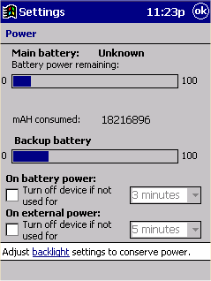
Power settings
The Power settings are found in the System property page in the Settings panel. Configure the PocketPC to not turn itself off if not used, or set the timer to a suitable amount of time.

Note: When the PocketPC is configured to turn itself off automatically, it will do so even if SeislogCE is running.
!

When battery is drained, the device will turn off automatically to prevent loss of data. This will happen even if the device is configured not to turn itself off automatically. If the backup battery is drained, both SeislogCE and the data collected will be erased. The iPAQ does not have backup battery.

Screen settings
The Brightness Properties controls is found in the System property page in the Settings panel. You should set the display as dim as possible, and turn on auto dim.

System clock
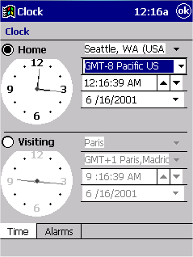
The time shown in the top right corner of the screen is the local time. Local time is the system time of the PocketPC corrected for time zone and daylight saving. SeislogCE uses the system time and not local time everywhere in the program, except from messages in the eventlog, which are local time. One consequence of this is that the time shown of a network trigger event in the eventlog, can be different from the time of the event in the event-file.

You can configure the clock of the PocketPC in the Clock option of the System property page in the Settings panel. It is important to set the time zone, date and localization correctly as this is used to calculate local time from system time. When GPS is used, the system time will be set equal to the time read from the GPS.
!
Note: In the Main Monitor window, you can see which time source is used for timestamping the data. Check this when you start logging. Remember that this time may differ from the time show in the eventlog, depending on how the PocketPC clock is configured.

■ Starting SeislogCE for the first time
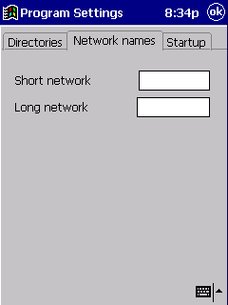
If properly installed, SeislogCE can be found on the Start menu . When you start SeislogCE for the first time on a PocketPC, you will get a warning message telling you that “the configuration setting in the Windows registry is missing or incorrect”. Pressing OK will open the Program Settings dialog box. Most parameters are initialised with default values, but you have to set the short and long network names in the “Network names” property page, before you can close the dialog.

■ Managing applications

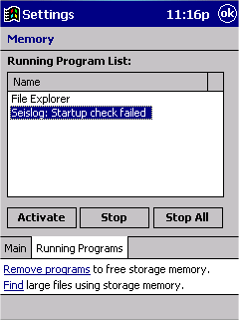
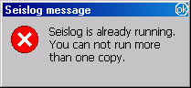
Starting another application after SeislogCE has been started, will cause SeislogCE to be put in the background. To get SeislogCE to the foreground, you can try to choose SeislogCE from the start menu. This will start another instance of SeislogCE that will try to get the first instance of SeislogCE to the foreground. If this operation fail, you will see the message (from the second instance) “Seislog is already running. You can not run more than one copy”. When you click OK, the first instance terminate and you have to get SeislogCE to the foreground manually. Open the Settings panel and select the System Property page. Then select the Running Programs property page. Select SeislogCE from the list of running programs and then click Activate.

Note: It is not possible to run multiple instances of SeislogCE at the same time. SeislogCE has a built-in protection to avoid this.
!

■ Configuring devices

SeislogCE currently support the following digitizers:

- GeoSIG AG - GBV-x16
- Nanometrics - RD3 / RD6, software rev 3/5
- Internal Wave-Generator
- Earth Data Ltd - PS2400
- SeisProd – SeisAD18
- M. Mariotti – SADC10/18/20

Earth Data Ltd - EDM006 is also programmed, but this device has not yet been tested in the SeislogCE.

Note: Switch off the PocketPC before connecting or disconnecting devices from the PocketPC.
!

The device should be configured on “COM1”. This serial port is usually not a standard D-sub connectors. A special serial cable (supplied or optional with the PocketPC) must be used to connect the PocketPC to a D-SUB connector. The serial cable for the PocketPC is supposed to be connected to a PC. Most digitizers (all we have tested) use modem pinout, which is different from PC serial port pinout. The TX and RX line is reversed, so you need an adapter to connect devices to the PocketPC. The next figure shows how you can build this adapter of two male 9 pin D-SUB connectors and three wires (note: this can not be directly transferred to 25 pins type serial connectors, they have different pinout):

5
2
3
3

2
5

The serial connector on most PocketPCs is a combined serial and USB interface. This means serial and USB communication is not possible at the same time. Make sure no other programs are using this port when running SeislogCE. Also, make sure ActiveSync is not running. To find out which programs are running, open the “Settings” panel on the PocketPC, tap on the system tab, and select Memory. Then tap on the “Running Programs” tab.

Note: Microsoft ActiveSync and SeislogCE must not run at the same time. If you start SeislogCE when ActiveSync is running, SeislogCE will not be able to open the serial port. Also, if you start ActiveSync while a device is connected to the PocketPC, the PocketPC may hang. To recover from this, use the “reset” button on the PocketPC (consult the user manual for the PocketPC to locate this button). ActiveSync can be configured to start automatically when the PocketPC is connected to a PC. This feature must be turned off.
!

In the Windows version of Seislog, you will find some additional information when configure a new device. This information is left out in the PocketPC version, but you will find it in the table below:

Device | Configuration
Earth Data Ltd  PS2400 | Device must have all 3 channels enabled.  Driver does not support the 1 or 2 bytes pr sample configuration.  Driver does not support sample rates above 250 hz.
GeoSIG AG  GBV-x16 | Device must be configured to run in 'Packet Protocol' mode.  On GBV316, all 3 channels must be enabled.  Firmware revision 3.00 or later is required.
Nanometrics  RD3 / RD6,  software rev 3/5. | Device must be set up as follows:  1 - Data transmission mode must be set to 'burst mode'.  2 - XON/XOFF and scrambling must be turned off.  3 - First channel must be set to '1'.  4 - All channels must be active.

■ Configuring channels and ringbuffer

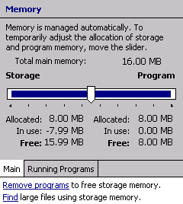
PocketPC’s has very limited storage space, so the buffersize in SeislogCE is measured in hours and not days. When configuring channels with a ringbuffer, be careful with how much storage space you use. To find out how much memory is free, choose Settings on the Start menu, tap on the System tab, and then select Memory. All data saved in SeislogCE are placed in the “Storage Memory”. The total amount of storage space you use when configuring ringbuffer for a set of channels, is the sum of the total buffer size for each channel. Make sure you leave enough space on the PocketPC for the event files when configuring ringbuffers.

■ Configuration files

SeislogCE store parameters for the devices, channels, ringbuffers and triggerset in configuration files. Configuration files made with Seislog for Windows 9X cannot be used with the SeislogCE versions and vica verca. It is neither possible to exchange configuration files between the different versions of SeislogCE.
!

Note: Although some of the configurations files can be used on other versions of Seislog than it was made, you should not rely on this.

All parameters found in the “Program Settings” dialog, are saved in the Windows Registry in the key HKEY_LOCAL_MACHINE\SOFTWARE\IFG\Seislog. This is identical to the Windows 95 version.

■ Monitoring channels

You can only monitor one channel at the time. To monitor a channel, select “Monitor Channel” from the monitor menu, and then pick the channel from the combo box. When this dialog is opened, it is not possible to see the Main Monitor and Eventlog.
!

Note: When you select a channel to monitor, it may take a while before the samples are shown. Be patient!

You can change the time scale of the monitored channel by applying sample reduction. Sample reduction is configured in a dialog you can open by pushing the Properties button.

To stop monitoring channels, push the OK button. This will also close the dialog.

■ The eventlog

The eventlog window only shows the last 20 messages, and there is no option of viewing the logfile from SeislogCE. To view the file, use PocketWord, or upload it to a desktop PC and view it there. The log file is located in the root of the Seislog directory (usually \seislog\). You may want to create a shortcut to the eventlog file.
!
Note: The eventlog file cannot be viewed while SeislogCE is running.

■ Downloading data files

Use Activesync to download data files from the PocketPC to a desktop PC. To simplify this process, you can configure SeislogCE to use \My Documents instead of \Seislog as the Program root directory. Then you establish partnership in ActiveSync and simply syncronizing will download the files.

An alternative way of of downloading file is to connect an ethernet card and download by File Transfer Protocol (FTP) running FTP server. This can be done while the SeislogCE is running.

