SEISAD18
18 bit seismic digitizer

Development and user manual

Miguel Abril, Marcello Martini, Jens Havskov, Gerardo Alguacil, Javier Moreno

Instituto Andaluz de Geofísica (Universidad de Granada)

Osservatorio Vesuviano

University of Bergen

October 2001

- DESCRIPTION

SEISAD18 (SEISmic Analog to Digital converter 18 bits) is a three channel seismic digitizer developed by Instituto Andaluz de Geofísica (from University of Granada, Spain), University of Bergen (Norway) and Osservatorio Vesuviano (Naples, Italy). The main objective of this development was to design a system with the following features:

- Low power consumption.
- Low cost.
- High resolution.
- Flexibility to operate in different configurations:
- Different number of channels (from 3 up to 24) using several cards.
- Operate with or without time reference.
- Possibility of exact synchronisation of all channels for e.g. array operation.
- Ease of operation for other users.
- Easy integration with the SEISLOG system.

Figure 1 shows the digitizer’s block diagram. As it can be seen, there are three Analog to Digital Converters (ADCs), model AD7710 from Analog Devices. AD7710’s nominal resolution is 24 bits, but with the frequencies commonly used in seismology (up to 200sps), its effective resolution is lowered to 16-22 bits. The name of the system (SEISAD18) makes reference to the effective resolution obtained when using a sampling frequency of 100sps.
All three ADCs are controlled by a single PIC16F84 microcontroller. This model forms part of Microchip’s PIC family, which is a set of 8-bit, low power, high speed RISC microcontrollers with different features.
There are two serial data interfaces integrated in the card. The first one is an RS-232 interface, thought to be used in single card configurations. The second is an RS-485 interface, which will be used when two or more cards are working together connected to the same serial line. The chosen serial data interface is selected by means of a number of configuration jumpers placed on the card.
The ADCs’ clock signal source is also hardware selectable. In single card configurations (or with multiple cards which do not need a precise synchronisation) a crystal oscillator can be used. For synchronised multiple card configurations, there is a PLL circuit available to generate the ADCs’ master clock signal. As before, the master clock signal source is selected through a configuration jumper placed on the card.
The PLL circuit’s block diagram is also shown in figure 1. As it can be seen, the heart of the circuit is a microcontroller, from Microchip’s PIC family as well. In this case, model PIC16C73 was chosen, to take advantage of its timer and CCP modules which prove to be very useful in time control applications like this one.
The PIC16C73 controls the operation of a Voltage Controlled Crystal Oscillator (VCXO). There are two different VCXOs integrated in the PLL circuit. In the first one, the variation of capacity needed for the crystal frequency control is achieved by two varactor diodes. The second option is a commercial VCXO module. Commercial VCXOs modules are available with a great range of stability and pullability values, so a different model can be chosen depending on our application’s expected features and environmental conditions.
The time reference for the operation of the PLL circuit is a one pulse per second (PPS) signal, which can be supplied by a GPS or any other source. PPS signal inputs directly to the microcontroller – if TTL levelled -, or through an RS-485 interface - if it is transmitted using this standard. This possibility is useful when the PPS signal source is far away, as in array configurations.
Figures 2 and 3 show, respectively, the electric schemes of the digitizer and the PLL circuit.

- CONFIGURATIONS

Several different data acquisition systems can be obtained using a number of SEISAD18 cards with different configurations. The cards’ configuration is changed through jumpers JP3 to JP7 and switch SW2 (figure 2). The function of each one of these elements is:
- JP3: Position A selects RS-485 input data line 0; position B, RS-232 input data line.
- JP4: Position A selects RS-485 output data line 0; position B, RS-232 output data line.
- JP5: Position A selects ADCs clock from PLL circuit through connector CONN7. Position B, ADCs clock from crystal oscillator.
- JP6: Position A selects RS-485 input data line 0 or RS-232 input data line, depending on the state of JP3. Position B selects switch 2/7 from SW2.
- JP7: Position A selects RS-485 input data line 1; position B, PPS input signal.
- SW2: Different functions.

Some examples of different configurations are next shown:

2.1. Array configuration

SEISAD18 was originally designed for the array configuration shown in figure 4. As it can be seen, there are several A/D cards (up to 16) connected to a central module through four RS-485 lines. The central module consists of a serial/parallel module, a memory module and a low power PC. The serial parallel module converts serial data to parallel format and writes them to the memory module, including the time information received from a GPS based clock module. The memory module works as a data buffer, from which the PC reads data every certain time. In that manner, the PC can spend the rest of the time processing data. This system will be installed in the next months in Mount Vesuvius, and further information will soon be accessible in an open file report from Osservatorio Vesuviano.

2.2. Three channel station

The scheme in figure 5 shows how to get a 3 channel station using a single SEISAD18 card. The principal features of the card with this configuration are:
- Data transmission: RS-232. As transmission is point to point, and the digitizer is very close to the PC (usually in the same case), it is not necessary to use RS-485.
- PPS signal transmission: TTL levels. The PPS signal can be transmitted using RS-485 or RS-232 from the GPS to the PC, where it is converted to TTL levels. It then inputs SEISAD18 card through its connector CONN8.
- Digitizer identification: Not needed.
- Power supply: +12V, through SEISAD18’s connector CONN8 (figure 2).
- ADCs synchronisation: As there is only one card, it is not necessary to use a PLL circuit, so the crystal oscillator option can be selected. However, in this case it makes necessary to have a way to synchronise the three ADCs at the beginning of the programme and every certain time after. This is achieved through switch 1/8 from SW2, which connect an input/output line from the PIC to ADCs’ pin SINC.

To achieve this configuration, the jumpers and switches in the SEISAD18 card must be in the next positions:

- JP3: Position B
- JP4: Position B
- JP5: Position B
- JP6: Position A
- JP7: Position B
- SW2 configuration:
- Switch 1/8: ON (ADCs synchronisation)
- Switch 2/7: Not used
- Switch 3/6: OFF
- Switch 4/5: Not used

2.3. Multi channel station

Figure 6 shows the scheme of a multi channel station controlled by a PC. In this example, three cards have been used, but this configuration allows for up to eight cards (24 channels). As it can be seen, all of the cards are connected to the same serial port, using RS-485 transmission. The PC needs, if it does not have it implemented, an RS-485/RS-232 adapter card. As all the cards would be close together, the ADCs synchronisation would be achieved by means of a single PLL circuit. The principal features of the SEISAD18 card with this configuration are:
- Data transmission: RS-485. In usual RS-485 applications, the serial data line length limits the baud rate values that can be used. In this configuration, however, all the components are close together, so the serial line length does not suppose a problem. Thus, the only limit to the baud rate is fixed by software.
- PPS signal transmission: TTL levels. The PPS signal inputs directly to the PLL circuit, through its connector CONN4 (figure 3).
- Digitizer identification: It is necessary to provide a way to identify the different digitizers in the serial line. This is done through switches 2/7, 3/6 and 4/5 from SW2. In this manner, up to eight digitizers can be connected to the same serial line.
- Power supply: +12V, trough SEISAD18’s connector CONN8.
- ADCs synchronisation: PLL circuit, one for all A/D cards.

The jumpers and switches must be in the next positions:

- JP3: Not used
- JP4: Position A
- JP5: Position A
- JP6: Position B
- JP7: Position A
- SW2 configuration:
- Switch 1/8: OFF
- Switch 2/7: Digitizer ID (1st bit)
- Switch 3/6: Digitizer ID (2nd bit)
- Switch 4/5: Digitizer ID (3rd bit)

2.4. Lineal array configuration

With the same configuration of jumpers and switches shown in 2.3, a lineal array can be obtained (figure 7). The differences between this configuration and 2.3 are:

- ADCs synchronisation: As the digitizers are now in different locations, each one of them need a PLL circuit, instead of the single one used in 2.3.
- Power supply: +12V, trough SEISAD18’s connector CONN1 or CONN2. A single battery can be used to power the whole system, connecting all the modules by means of twisted pair cables. These cables allow for transmitting data as well as power signals, and the connection to the SEISAD18 cards is made using a single connector (CONN1 or CONN2). The connections between CONN1 and CONN2 are pin to pin, so one of them can be used as input from the precedent module and the other as output to the next one.
- PPS signal transmission: RS-485. The PPS signal inputs to SEISAD18 cards trough the same connectors used for the data and power supply (CONN1 or CONN2), and it is then transmitted to the PLL circuit through the PLL interface connector (CONN7).

- SOFTWARE DEVELOPMENT

The hardware configuration described in section 2.1 (array configuration) need a complex communication protocol, which will not be discussed here. Thus, from now on, all the discussion applies to the configurations described in 2.2, 2.3 and 2.4.

3.1. Data format

This format primarily describes how it is used with one or several SEISAD18 digitizers, however it can also be implemented with other digitizers. Because one or several 3 channels SEISAD18 are used, the number of channels is a multiple of 3.

Sample rates for SEISAD18: 25, 50, 100, 200, for other digitizers, any rate between 1 and e.g. 1000 can be chosen.

Each card has 3 channels and the format is:

-----------------------------------------------------------
3 bytes header
-----------------------------------------------------------
9 bytes data from 3 channels
-----------------------------------------------------------
3 bytes header
-----------------------------------------------------------
9 bytes data from 3 channels
-----------------------------------------------------------
etc

The 12 bytes are repeatedly sent. The header information is contained in the 3 byte segments and spread out over a whole second. If e.g. the sample rate is 25 Hz, there is room for 75 bytes of header information for each second. The header info starts with the first 3 bytes sent after the whole second and the content in the continuous string of 3 byte elements is:

- Byte 1-3: Digitizer 1 (number 0) sends Hex 55 55 55 indicating start of 1 s block (but not necessarily on the whole second), first sample following is taken at the whole second. To avoid the possibility of mistaking any sample with this header, the last bit of every data is set to zero.
- Digitizer 2 (or first group of 3 channels) sends: Hex 77 77 77
- Digitizer 3 sends: Hex 99 99 99
- Digitizer 4 sends: Hex BB BB BB
- If more than 12 channels are used, they will send the headers Hex DD DD DD, Hex FF FF FF, Hex 11 11 11 and Hex 33 33 33. This allows for up to 24 channels.
- Byte 4: Digitizer number, 0-n (can be used to find out how many channels there are).
- Byte 5-8: Checksum of previous 1 s block of data, NOT the one following.
- Byte 9-10: Sample rate.
- Byte11 : GPS 1Hz synchro 0: Synchronised with 1 Hz GPS, 1: No 1 Hz pulse.
- Byte 12-13 : Block sequence number.
- Byte 14 : Gain.

The following is not possible in the SEISAD18, but is available for future use:

- Byte 15-16: GPS status
- Byte 17--20: Year
- Byte 21-22 : Month
- Byte 23-24 : Day
- Byte 25-26 : Hour
- Byte 27-28 : Min
- Byte 29-30 : Sec
- Byte 31-33 msec

- Remaining header bytes are zero, reserved for future use.

For one digitizer, the sequence is, starting from first transmission after the second mark or (if no second mark) the first sample in a one second block:

3 bytes, first header (Hex 55 55 55)
9 bytes, sample 1 from 3 channels

3 bytes, digitizer number (0), first 2 bytes of checksum
9 bytes, sample 2 from 3 channels

3 bytes, last 2 bytes of checksum, 1st byte of sample rate
9 bytes, sample 3 from 3 channels

3 bytes, 2nd byte of sample rate, 1 byte of GPS 1Hz synchro , 1st byte sequence number
9 bytes, sample 4 from 3 channels

3 bytes, 2nd byte sequence number, 1 byte gain, 1st byte GPS status
9 bytes, sample 5 from 3 channels

etc.

For one second of samples, the number of bytes is: 12 x sample rate x number of AD cards (or total number of channels divided by three).
The checksum only uses 3 of the 4 reserved checksum bytes. It is calculated byte by byte, which means that the checksum in reality consists of 3 independent one byte checksums. For each sample, byte one is continuously summed into byte one of the checksum, and the same is done for bytes two and three. So the sum of e.g. two bytes with ASCII value 255 will be 254.
The AD data bytes are 3 byte samples (positive only) with order channel 1, channel 2, channel 3 (for one card). The order is from most significant byte to least significant byte.
Up to 4 SEISAD18 digitizers can be connected to the same input line. Digitizers 1, 2 and 3 send data time shifted compared to digitizer 0. The following example shows the data string when 3 digitizers are used:

Digitizer 0
3 bytes, first header (55 55 55)
9 bytes, sample 1 from 3 channels

Digitizer 1
3 bytes, first header (77 77 77)
9 bytes, sample 1 from 3 channels

Digitizer 2
3 bytes, first header (99 99 99)
9 bytes, sample 1 from 3 channels

Digitizer 0
3 bytes, digitizer number (0), first 2 bytes of checksum
9 bytes, sample 2 from 3 channels

Digitizer 1
3 bytes, digitizer number (1), first 2 bytes of checksum
9 bytes, sample 2 from 3 channels

Digitizer 2
3 bytes, digitizer number (2), first 2 bytes of checksum
9 bytes, sample 2 from 3 channels

Digitizer 0
3 bytes, last 2 bytes of checksum, first byte of sample rate
9 bytes, sample 3 from 3 channels

etc

If all channels come out of one digitizer, the format is the same, but there will be no gaps in the data stream.

3.2. Timing

There are 2 different possible configurations:

- Digitizer without 1 Hz: If the digitizer does not receive the 1 Hz pulse, byte 11 will remain with status 1 and the header is not synchronized. Timing must then be done in Seislog, which then must have accurate timing.

- Digitizer with 1 Hz: The digitizer is normally synchronized with 1 Hz, but has no absolute time so operating system of Seislog must be better then 0.5 s. The sample following the header corresponds to the integer second. If 1 Hz signal disappears, the indicator becomes 1.

For other digitizers, there might be absolute time information available and can be put in the header as defined above.

3.3. Digitizer set-up and baud rate

The digitizer has a default setup of 100 Hz, 19200 bps and a gain of 4. In order to use other parameters, a setup sequence must be sent. When a start-up sequence is sent, the digitizer is reset and starts sending out data with the new parameters. The reset can be done at any time. If power is lost to the digitizer, it reverts to the original setup. Setup consists of sending a series of pulses to the digitizer. One pulse is made by sending the NULL character, so any number of pulses can be sent by sending that many NULL characters. The advantage of sending pulses is that the digitizer will understand the message even if the baud rate is not correct. The sequence starts with 10 pulses, so that any random noise spike will not initiate the digitizer.
For simplicity, SEISAD18 will only be able to work with three baud rates: slow (9600bps), medium (19200bps) and fast (115200bps). The set up codes are (in order to reduce the number of codes, the three 115200bps/25sps combinations are not allowed):

Number of pulses | Baud rate | Sample rate | Gain
11 | 9600 | 25 | 1
12 | 9600 | 25 | 4
13 | 9600 | 25 | 16
14 | 19200 | 25 | 1
15 | 19200 | 25 | 4
16 | 19200 | 25 | 16
17 | 9600 | 50 | 1
18 | 9600 | 50 | 4
19 | 9600 | 50 | 16
20 | 19200 | 50 | 1
21 | 19200 | 50 | 4
22 | 19200 | 50 | 16
23 | 115200 | 50 | 1
24 | 115200 | 50 | 4
25 | 115200 | 50 | 16
26 | 19200 | 100 | 1
27 | 19200 | 100 | 4
28 | 19200 | 100 | 16
29 | 115200 | 100 | 1
30 | 115200 | 100 | 4
31 | 115200 | 100 | 16
32 | 115200 | 200 | 1
33 | 115200 | 200 | 4
34 | 115200 | 200 | 16

$B\text{.}R{\text{.}}_{\text{min}}=\frac{N⋅\text{12}\frac{\text{bytes}}{\text{sample}}⋅\text{10}\frac{\text{bits}}{\text{byte}}}{T}$ However, not all these combinations can be used in any case, because the number of channels fixes a limit to the baud rate. To calculate the practical limits, it has to be taken into account that, when using SEISAD18 digitizers, the time available for the transmission of one sample is the sampling period minus the acquisition time (that is, the time during which the microcontroller is busy reading the sample). If, for the calculations, we set the acquisition time to 1ms, the minimum baud rate for every case can be calculated according to the next expression:
$\left[1\right]$
where:
N = Number of SEISAD18 digitizers
T = Available time for one sample transmission (sampling period minus 1ms, expressed in seconds)

According to the SEISAD18 data format seen before, we have used the value 12 bytes per sample. On the other hand, we have used the value 10 bits per byte considering the type of serial transmission used by SEISAD18 (one start bit, eight data bits, no parity bit, one stop bit).

As an example, the minimum necessary baud rate when using a sampling rate of 100sps and 3 SEISAD18 cards would be:

$B\text{.}R{\text{.}}_{\text{min}}=\frac{3\text{cards}⋅\text{12}\frac{\text{bytes}}{\text{sample}}⋅\text{10}\frac{\text{bits}}{\text{byte}}}{9⋅{\text{10}}^{−3}s}=\text{40000}\text{bps}$
So in this case, the biggest of the three permitted baud rate values should be used (115200bps). Similar calculations for the rest of combinations give the next table of minimum required baud rates:

 | 25sps | 50sps | 100sps | 200sps
1 card | 9600bps | 9600bps | 19200bps | 115200bps
2 cards | 9600bps | 19200bps | 115200bps | 115200bps
3 cards | 9600bps | 19200bps | 115200bps | 115200bps
4 cards | 19200bps | 115200bps | 115200bps | Not allowed

Taking all this into account, the SEISLOG driver must limit the permitted combinations depending on the number of operating channels. All the permitted combinations, in function of the number of channels, are:

Number of channels | Permitted combinations
Number of channels | Baud rate | Sample rate | Gain
3 | 9600 | 25 | 1
3 | 9600 | 25 | 4
3 | 9600 | 25 | 16
3 | 19200 | 25 | 1
3 | 19200 | 25 | 4
3 | 19200 | 25 | 16
3 | 9600 | 50 | 1
3 | 9600 | 50 | 4
3 | 9600 | 50 | 16
3 | 19200 | 50 | 1
3 | 19200 | 50 | 4
3 | 19200 | 50 | 16
3 | 115200 | 50 | 1
3 | 115200 | 50 | 4
3 | 115200 | 50 | 16
3 | 19200 | 100 | 1
3 | 19200 | 100 | 4
3 | 19200 | 100 | 16
3 | 115200 | 100 | 1
3 | 115200 | 100 | 4
3 | 115200 | 100 | 16
3 | 115200 | 200 | 1
3 | 115200 | 200 | 4
3 | 115200 | 200 | 16
6 | 9600 | 25 | 1
6 | 9600 | 25 | 4
6 | 9600 | 25 | 16
6 | 19200 | 25 | 1
6 | 19200 | 25 | 4
6 | 19200 | 25 | 16
6 | 19200 | 50 | 1
6 | 19200 | 50 | 4
6 | 19200 | 50 | 16
6 | 115200 | 50 | 1
6 | 115200 | 50 | 4
6 | 115200 | 50 | 16
6 | 115200 | 100 | 1
6 | 115200 | 100 | 4
6 | 115200 | 100 | 16
6 | 115200 | 200 | 1
6 | 115200 | 200 | 4
6 | 115200 | 200 | 16
9 | 9600 | 25 | 1
9 | 9600 | 25 | 4
9 | 9600 | 25 | 16
9 | 19200 | 25 | 1
9 | 19200 | 25 | 4
9 | 19200 | 25 | 16
9 | 19200 | 50 | 1
9 | 19200 | 50 | 4
9 | 19200 | 50 | 16
9 | 115200 | 50 | 1
9 | 115200 | 50 | 4
9 | 115200 | 50 | 16
9 | 115200 | 100 | 1
9 | 115200 | 100 | 4
9 | 115200 | 100 | 16
9 | 115200 | 200 | 1
9 | 115200 | 200 | 4
9 | 115200 | 200 | 16
12 | 19200 | 25 | 1
12 | 19200 | 25 | 4
12 | 19200 | 25 | 16
12 | 115200 | 50 | 1
12 | 115200 | 50 | 4
12 | 115200 | 50 | 16
12 | 115200 | 100 | 1
12 | 115200 | 100 | 4
12 | 115200 | 100 | 16

If a digitizer different than SEISAD18 is going to be used with the same format, it may not be necessary to discard the acquisition time for data transmission (i.e.: if the digitizer has a memory data buffer). Thus, the minimum necessary baud rate can be calculated using the next expression, equivalent to [1]:
$\left[2\right]$
$B\text{.}R{\text{.}}_{\text{min}}=\frac{\frac{N_{C}}{3}⋅\text{12}\frac{\text{bytes}}{\text{sample}}⋅\text{10}\frac{\text{bits}}{\text{byte}}}{T_{S}}$
where:

N_{C} = Number of channels of the digitizer.
T_{S} = Sampling period (in seconds).

$S\text{.}R{\text{.}}_{\text{max}}=\frac{B\text{.}R\text{.}}{\text{12}\frac{\text{bytes}}{\text{sample}}⋅\text{10}\frac{\text{bits}}{\text{byte}}⋅\frac{N_{C}}{3}}$$\left[3\right]$If the problem is the inverse (calculating the maximum data rate that can be used for a fixed baud rate), expression [2] gives:

where:
S.R._{max} = Maximum sampling rate (in samples per second).
B.R. = Baud rate used (in bits per second).

Which gives, for example, a maximum sampling rate of 240sps when using a baud rate of 115200bps and a 12 channel digitizer.

- HARDWARE DESIGN

Figures 8 and 9 show the different layers of the acquisition and PLL boards. The electronic design can be seen in figures 2 and 3.
Following there is a list of the material needed for the assembly of both cards. Their cost is approximately 150 euros for the acquisition card components and 100 euros for the PLL ones, excluding in both cases the cost of the printed circuit card.
In order to facilitate the identification and acquisition of the components, we have included in the list the reference numbers from the 2000-2001 RS International Electronic Catalogue.

Description | Num | RS code
1. Acquisition board (ADQUIS4.SQM, Rev. C)
AD7710AN 24 bits A/D converter | 3 | 296-554
PIC16F84-10/P 8 bit FLASH microcontroller | 1 | 331-4633
MAX483CPA RS-485 transceiver | 2 | 821-829
ADM232AAN RS-232 transceiver | 1 | 177-5626
MAX638 Switching regulator 5V | 1 | 427-499
MAX660 DC-DC converter | 1 | 265-055
9.8304MHz crystal module | 1 | 316-6721
10MHz crystal | 1 | 226-1746
BC107 NPN Bipolar transistor | 4 | 293-527
1N4004 Rectifier diode | 1 | 261-176
1N4148 Small signal diode | 1 | 271-606
1N5817 Schottky diode | 1 | 183-7651
C 100nF-C | 14 | 264-4876
C 100nF-P | 3 | 179-4396
C 2U2-P/63V | 3 | 179-4330
C 22pF-C | 2 | 264-468
C 10uF/35V-E | 9 | 228-6717
C 22uF/16V-E | 1 | 228-6638
C 100uF/35V-E | 2 | 228-6767
C 470uF/16V-E | 2 | 228-6672
C 1nF-C | 6 | 188-6142
C 100nF/35V-T | 5 | 180-1703
R 100ohm 1% | 1 | 148-269
R 120ohm 1% | 2 | 148-281
R 1K, 1% | 8 | 148-506
R 22K, 1% | 5 | 148-815
R 39K, 1% | 1 | 148-871
R 100K 1% | 3 | 148-972
L 220uH | 1 | 306-8138
4 SPST DIL Switch | 1 | 337-548
Horizontal switch | 1 | 320-871
3 way PCB connector, 3.81 mm pitch | 3 | 220-4743
3 way screw terminal, 3.81mm pitch | 3 | 220-4664
4 way PCB connector, 3.81 mm pitch | 1 | 220-4759
4 way screw terminal, 3.81mm pitch | 1 | 220-4670
10 way male IDC connector | 3 | 461-332
10 way socket IDC connector | 3 | 461-174
14 way male IDC connector | 1 | 461-348
14 way socket IDC connector | 1 | 461-180
Polarising keys | 4 | 461-168
1.1.2. PLL board (PLL4.SQM, Rev. C)
PIC16C73A-JW 8 bit microcontroller | 1 | 328-3062
9.8304MHz VCXO module | 1
74HC4049 Inverting buffer | 1 | 632-657
74HC4024 Binary counter | 1 | 643-641
MAX483CPA RS-485 transceiver | 2 | 821-829
MC78L05ACP 5V-100mA regulator | 1 | 306-190
1N4004 Rectifier diode | 1 | 261-176
1N4148 Small signal diode | 1 | 271-606
Low current red LED | 1 | 588-386
BA102 Varicap diode | 2
10MHz crystal | 1 | 226-1746
9.8304MHz crystal | 1 | 130-8951
30pF trimmer capacitor | 1 | 125-660
C 27pF-C | 2 | 126-859
C 33pF-S | 1 | 113-235
C 56pF-C | 1 | 126-657
C 68pF-S | 1 | 113-257
C 100nF-P | 6 | 179-4396
C 100nF-C | 1 | 264-4876
C 22uF/16V-E | 1 | 228-6638
C 4.7uF/10V | 1 | 228-6868
C 10uF/35V-E | 1 | 228-6717
C 10uF/63V-E | 1 | 228-6947
C 47uF/50V-E | 1 | 228-6896
R 100ohm 1% | 1 | 148-269
R 120ohm 1% | 3 | 148-281
R 1K, 1% | 1 | 148-506
R 6K8, 1% | 1 | 148-641
R 10K, 1% | 2 | 148-736
R 39K, 1% | 1 | 148-871
R 47K, 1% | 2 | 148-893
R 470K, 1% | 1 | 149-149
R 1M, 1% | 2 | 149-228
R 8M2, 5% | 1 | 176-7940
Horizontal switch | 1 | 320-871
SIL C/O switch | 1 | 204-7865
3 way PCB connector, 3.81 mm pitch | 1 | 220-4743
3 way screw terminal, 3.81mm pitch | 1 | 220-4664
2 way PCB connector, 3.81 mm pitch | 2 | 220-4737
2 way screw terminal, 3.81mm pitch | 2 | 220-4658
14 way male IDC connector | 1 | 461-348
14 way socket IDC connector | 1 | 461-180
Polarising keys | 1 | 461-168

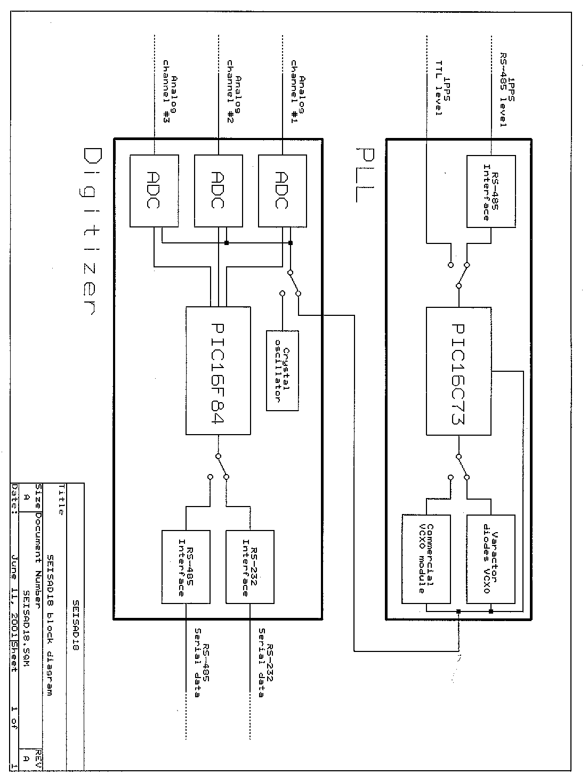
Figure 1.- Block diagram of SEISAD18 and PLL circuit.
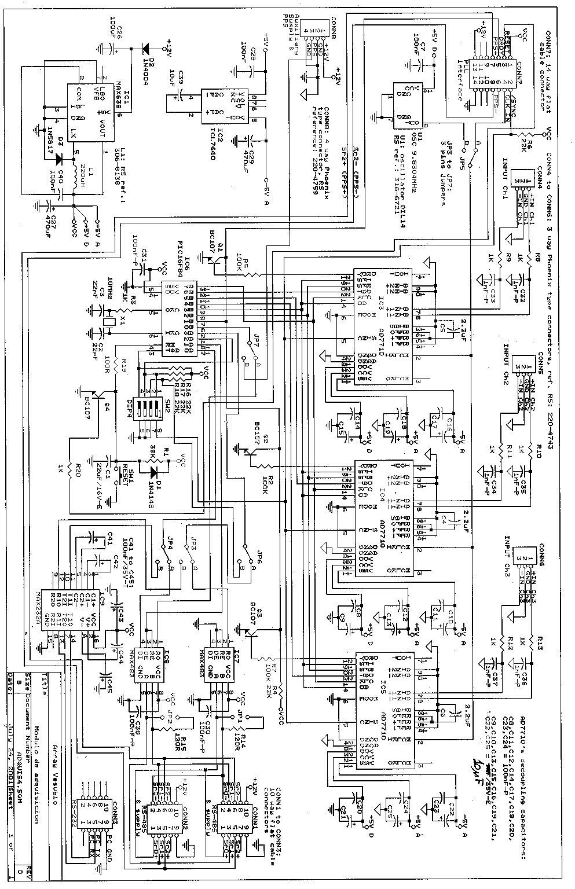
Figure 2.- Electric scheme of SEISAD18 digitizer.
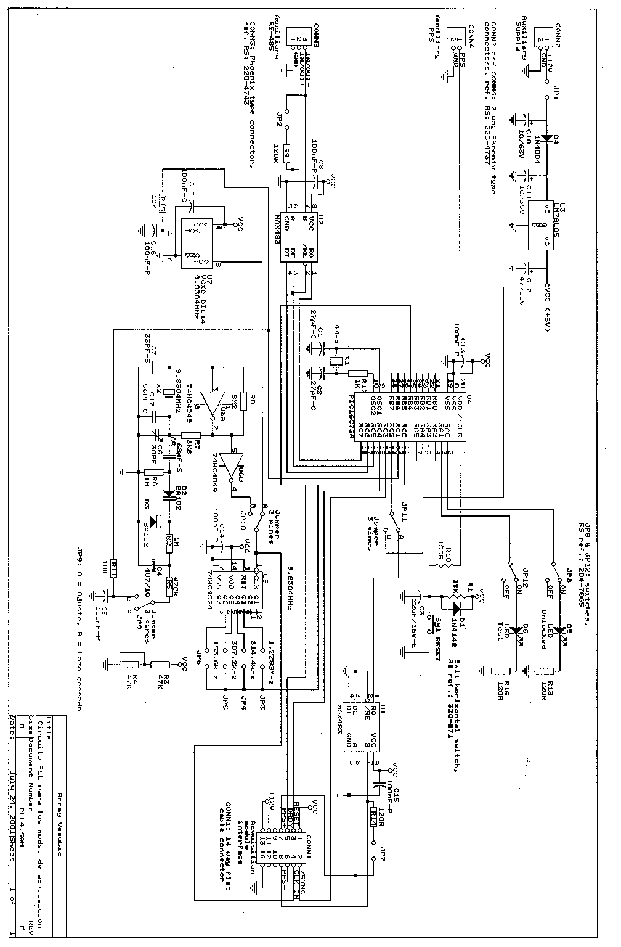

Figure 3.- Electric scheme of the PLL circuit.

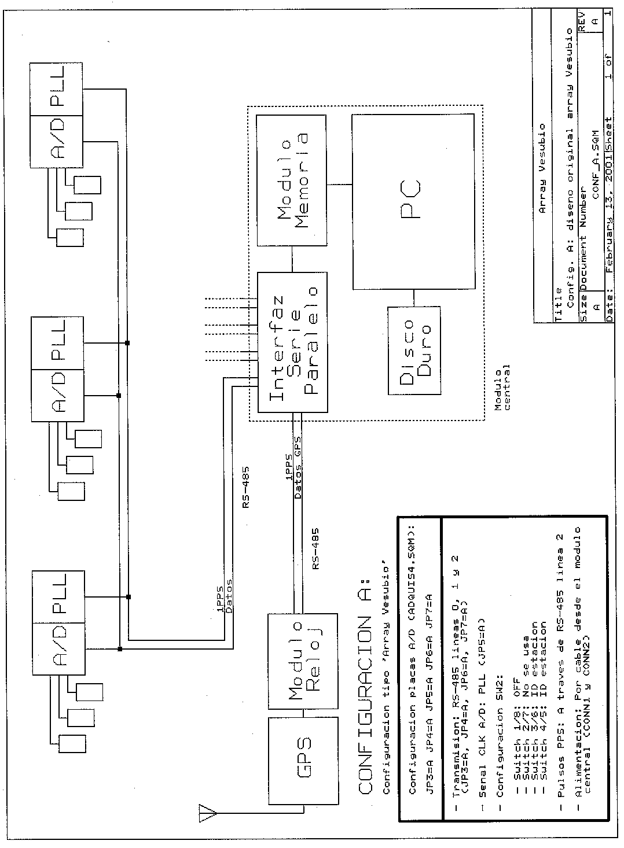
Figure 4.- Mt. Vesuvius array configuration.

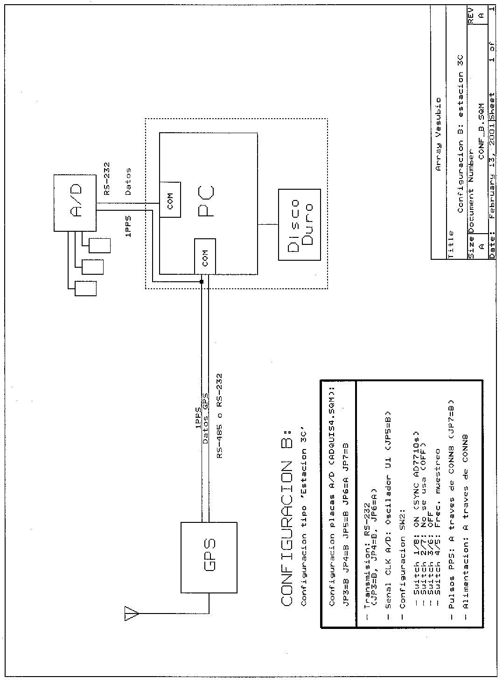
Figure 5.- Three channel station configuration.

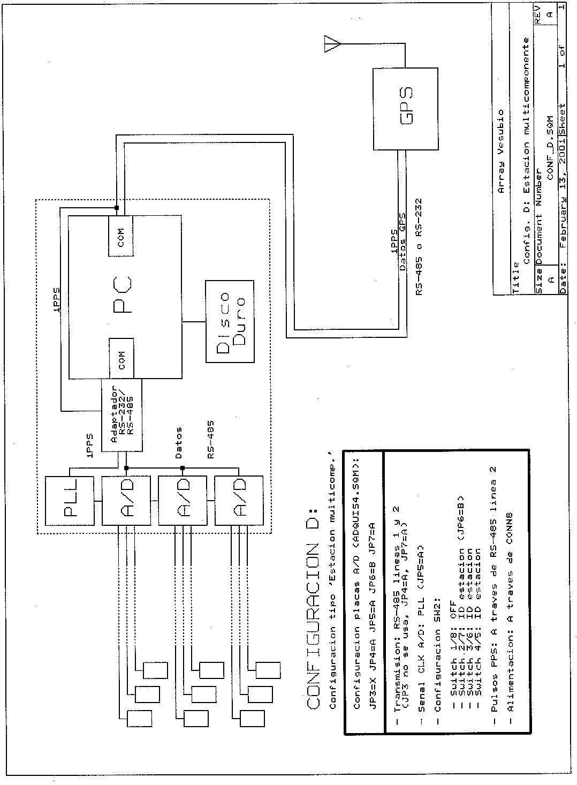
Figure 6.- Multichannel station configuration.

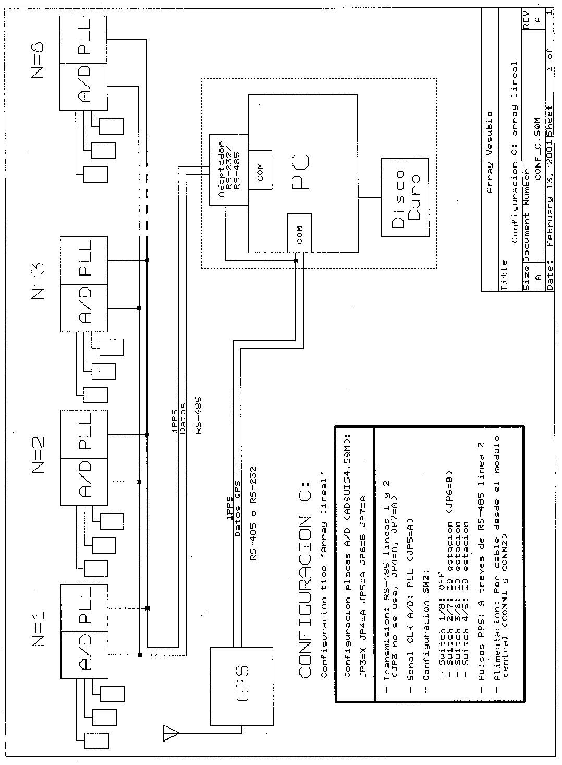
Figure 7.- Lineal array configuration.

