Norwegian National Seismic Network

Technical Report No. 28

Revision of station coordinates

by

Maren Kjos Veim

Department of Earth Science, University of Bergen

August, 2015

The final goal of this project was to improve the accuracy and reliability of the Norwegian National Seismic Network. This was done by gathering the coordinates of each station from different sources, plotting them onto maps, looking for discrepancies and ultimately deciding on the correct location. By increasing the accuracy of the station-locations we possibly obtain a lower error-margin when processing seismic events.

The coordinates for each station was gathered from the Seisan database, the NNSNs Seisview webpage, the ISCs database, from on-site reports located in the Seisview database and from the people who have visited or is stationed at the site pointing out the location on a map. The resulting database contains 3-5 coordinates for each station, for some stations these coordinates were all the same, but most of them had a small discrepancy between all or some of the obtained coordinates. The most reliable coordinates would normally come from GPS based measurements. However, mistakes can be made also when the coordinates are entered into the system. When the sampled coordinates seemed erroneous, new coordinates were chosen by NNSN staff at a meeting 22.06.2015, attended by Lars Ottomöller, Ole Meyer, Marte L. Strømme, Mareile Andersson, Stig Monsen, Øyvind Natvik, Mathilde Sørensen and Maren K. Veim. The sites were marked on a finn-map and re-marked until approved by all, the site was placed usually in reference to nearby buildings, infrastructure and/or terrain. The database was then plotted in google maps using a google fusion table and in a Finn-map by plotting events one by one. While it is attractive and fast to make the comparison with aerial photographs, it should be noted that there can be an error of tens of meters in the positioning of the pictures on the geographic coordinate system.

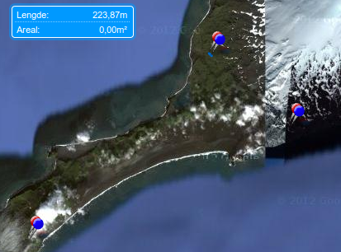  Img. 1, Jan Mayen overview | 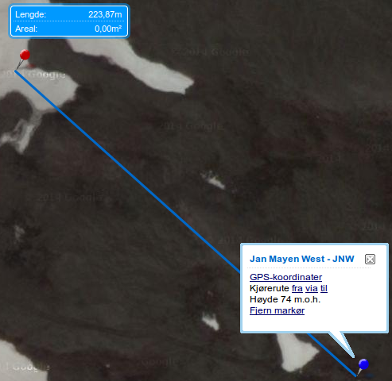  Img 2. ,Close up movement JNW

Coordinates for most stations shifted some distance in location, from a few meters to a few
hundred meters, with great help from Ole I found possible explanations for some of the outliers. The location change for some stations might be explained by measurements being performed in different datums. This is particularly visible at Jan Mayen where all three stations have “moved” about 219 meters in the same south-east direction, see link or photos above. It is difficult to identify if other stations have been affected by this since the “movement” of the remaining stations are not consistent in direction or in distance. The ISC location of TBLU is severely off (20.6 km),the error is most likely due to a conversion-error between degrees using decimals and degree using degree-minutes, this might also explain some of the other errors, for instance the ISC coordinates belonging to MOR8, located in a lake 1.8 km from the original site and the ISC coordinates belonging to DOMB, located 4.2 km from the original site. Some sites are known to have changed location, such as MOR8 (2011) and KBS (1993), unfortunately not all databases were necessarily updated when a stations is moved, for instance; the seidat-database was updated when the MOR8 station moved in 2011, but not the Seisan-database, producing an unfortunate error of 250 meters when doing calculations for the new location. Ideally, the SEISAN station file should allow to record changes in location under the same station code. The GPS devices used to estimate the position are not 100 % accurate, they usually have some margin of error, depending on the satellite coverage at the moment of measurement and the signal strength in the area. Selective availability (degraded GPS-accuracy), imposed by US-army during the 1990s might have affected measurements obtained during this time-period, use of selective availability ended early 2000’s. Pre-GPS the accuracy was affected by the quality of the map and the thickness of the pencil.

In this work, we wanted to check and document the change in earthquake location due to the corrections in station coordinates when relocating the NNSN database. Before we could update the database with the new station coordinates, the database needed to be checked for errors to ensure that all location changes at the end of this project is due to modifications in station coordinates. We checked for errors by relocating all events with no changes applied. Assuming the database is correct, this should in theory produce little to no changes in the hypocenter-locations. During this first relocation of the seismic database, we looked for any changes in hypocenter location more than 5 km in horizontal or vertical movement or changes resulting in a RMS larger than 0.2. This resulted in 3-50 reported changes in local events and 3-25 changes in teleseismic events per year between 2000 and 2014, the difference in number of local and teleseismic changes is proportional to the number of registered events, between 0.2% and 1.5% of the total number of events. This increases to an average of 272 (10.46%) local changes/year through the 90’s, reaching the maximum in 1990 with 372 events (22.44%). The total number of seismic events remains stable averaging at about 4000 events/year between 2014 and 1993 before decreasing towards a couple of hundred events/year around 1980. The total number of events to be checked was 3655.

To revise the changes Marte went through all the events that were flagged to have changed significantly. She then decided upon which of the two locations for each event was the most accurate, original or relocated. Where the original showed the most accurate location, she marked the event not to be located. After all the events were revised by Marte about 40% of the events were left to be relocated.

The final step is to update the Seisan database as well as the google-drive/ Seisview and send in a report with all the updated coordinates to ISC. After updating the Seisan database we will relocate the same seismic events and observe the resulting changes in location. Any changes observed will be due to the coordinate changes and will give an indication of the impact improving the coordinates made.

To relocate the seismic events and compare them to the original locations, a new directory was made. The station-files STATION.HYP and STATIONJ.HYP was imported and updated with the new coordinates and depths. The new hypocenter locations were computed using the hyp-program and saved to an output-file. The output-file was then moved to a new directory and compared to the original output-file using the hyp-comp program. With the same input-values as earlier, ( 5 km distance, 5 km depth and 0.2 RMS) a total of 1085 events were found. This constitutes 1.05% of all 102944 events in the time period,1975-2014. These events show a similar distribution to the original database, with some increase near Jan Mayen and south-western Norway. The increase near Jan Mayen is due to the collective shift of 220 meters of all three stations at Jan Mayen, while the increase in events in south-western Norway might be caused by the 882.5 meter change of ASK, the largest change made in the Seisan-database.

Events producing changes exceeding 25 km distance, 15 km depth and 0.5 rms will be studied further. Applying these values I find 325 seismic events, equal to 0.32% of all local events in the time period, generating a more manageable workload than looking into all 1085 events. These events mostly accumulate near Jan Mayen and south-western Norway, validating the tendency observed earlier as well as indicating that the area showing the highest amount of events changing also shows the largest amount of change per event, but this might be a consequence of probability(law of big numbers).
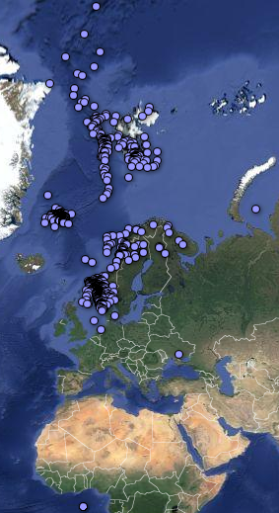 | Img. 3  Events using input values  5km, 5km, rms 0.2 | 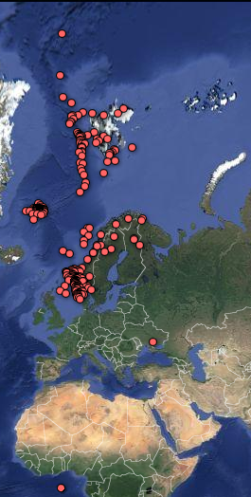 | Img. 4  Events using input values  25km, 15km, rms 0.5

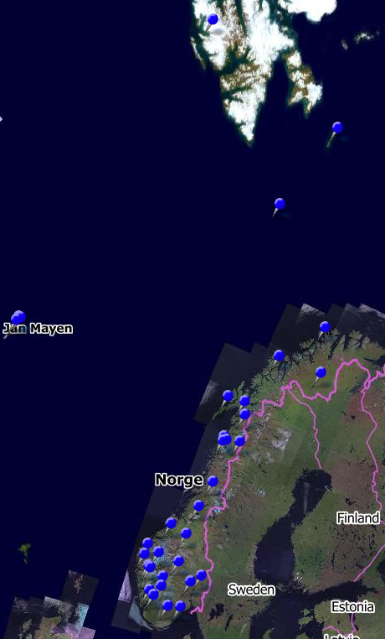
Img.5 Station overview using Finn-map

Appendix 1: Station overview

Station | Latitude | Longitude | Elevation
BER | 60.38444 | 5.32951 | 22
ASK | 60.47540 | 5.19964 | 58
BJO1 | 74.50363 | 19.00377 | 18
BLS5 | 59.42308 | 6.45758 | 540
TBLU | 63.42040 | 10.43038 | 117
DOMB | 62.07320 | 9.11220 | 660
FAUS | 67.38204 | 15.28777 | 94
FOO | 61.59740 | 5.04270 | 10
FLOS | 66.33630 | 13.36300 | 18
HAMF | 70.64234 | 23.68423 | 99
HOMB | 58.27011 | 8.50520 | 25
HOPEN | 76.50840 | 25.01085 | 25
HYA | 61.16333 | 6.18546 | 22
JMI | 70.92683 | -8.72668 | 211
JNE | 70.98841 | -8.29255 | 57
JNW | 71.02734 | -8.42362 | 95
KMY | 59.21079 | 5.24527 | 58
KTK1 | 69.01174 | 23.23660 | 340
KBS | 78.91530 | 11.93840 | 40
KONO | 59.64910 | 9.59822 | 216
KONS | 66.49918 | 13.11764 | 28
LOF | 68.13251 | 13.53987 | 75
MOR8 | 66.28297 | 14.73088 | 411
MOL | 62.56995 | 7.54675 | 90
NSS | 64.53031 | 11.96583 | 102
ODD1 | 59.91080 | 6.62625 | 676
OSL | 59.93729 | 10.72181 | 70
SKAR | 60.68077 | 8.30440 | 799
SNART | 58.33870 | 7.20970 | 160
STAV | 58.93439 | 5.70349 | 39
STEI | 67.93000 | 15.24200 | 21
STOK | 66.33300 | 13.01770 | 18
SUE | 61.05703 | 4.75952 | 10
TRO | 69.63495 | 18.91100 | 27

Station: Bergen (BER)
Coordinates: 60.3844N 5.32951E Elevation: 22 m
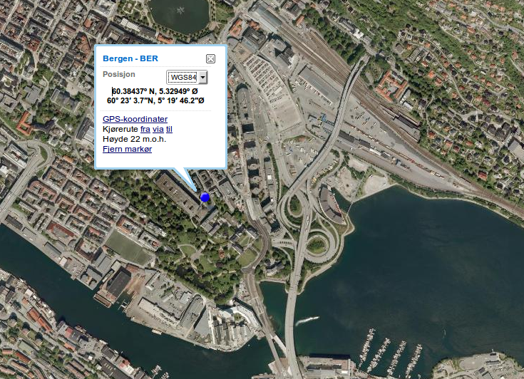
Link to: finn-map

The final location were chosen based on knowledge of the seismographs location within the building, construction-maps of the building and comparing them to a finn-map.
The new location is located 299.3-303.8 meters away from the old coordinates. The change is most likely due to a shift in datum.

station | source | latitude | longitude | elevation (m) | distance from final location (m)
BER | CORRECT | 60.38444 | 5.32951 | 22
BER | SEISDAT | 60.38370 | 5.33480 | 21 | 302.1
BER | SEISAN | 60.38380 | 5.33480 | 21 | 299.3
BER | ISC | 60.38381 | 5.33389 | 50 | 303.8
BER | MAP GUESS | 60.38444 | 5.32951 | 22 | 0
BER | GPS MEASURED

Station: Askøy (ASK)
Coordinates: 60.47540N 5.19964E Elevation: 58m
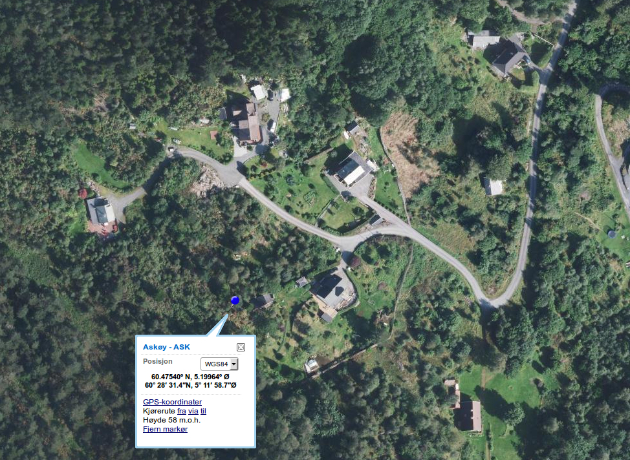
Link to: finn-map

This seismometer was formerly part of an array. The new coordinates are based on a picture of a GPS-device, taken during a site visit, and is 882.5 m away from the original site.

station | source | latitude | longitude | elevation(m) | distance from final location (m)
ASK | CORRECT | 60.47540 | 5.19964 | 58
ASK | SEISDAT | 60.48300 | 5.19500 | 50 | 882.5
ASK | SEISAN | 60.48300 | 5.19500 | 50 | 882.5
ASK | ISC | 60.48300 | 5.19500 | 50 | 882.5
ASK | MAP GUESS | 60.47541 | 5.19967 | 58 | 2.0
ASK | GPS MEASURED | 60.47540 | 5.19964 |  | 0.0

Station: Bjørnøya (BJO1)
Coordinates: 74.50363N 18.99880E Elevation: 18 m
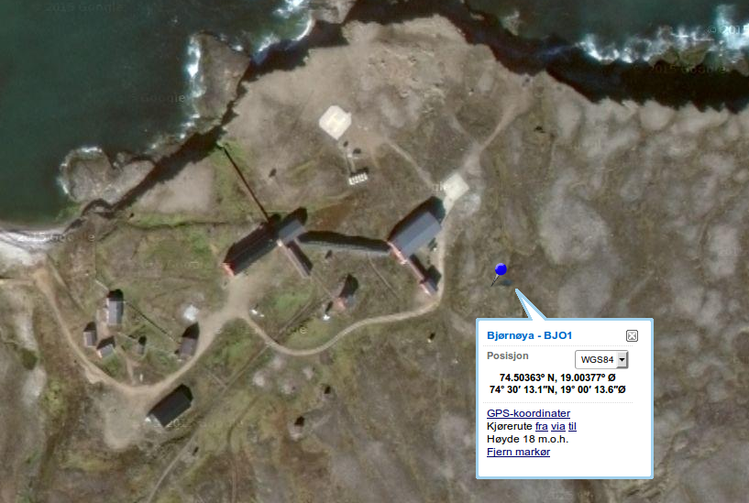

Link to: finn-map

Coordinates obtained from site-technician, measured by handheld device. Copy of email available at google-drive.

station | source | latitude | longitude | elevation(m) | distance from final location (m)
BJO1 | CORRECT | 74.50363 | 19.00377 | 18
BJO1 | SEISDAT | 74.50230 | 18.99880 | 18 | 209.0
BJO1 | SEISAN | 74.50230 | 18.99880 | 18 | 209.0
BJO1 | ISC | 74.50200 | 18.99900 | 18 | 230.1
BJO1 | MAP GUESS | 74.50376 | 19.00387 |  | 13.7
BJO1 | GPS MEASURED | 74.50363 | 19.00377 | 18 | 0.0

Station: Blussuvoll, Trondheim (TBLU)
Coordinates: 63.42040N 10.43038E Elevation: 117 m
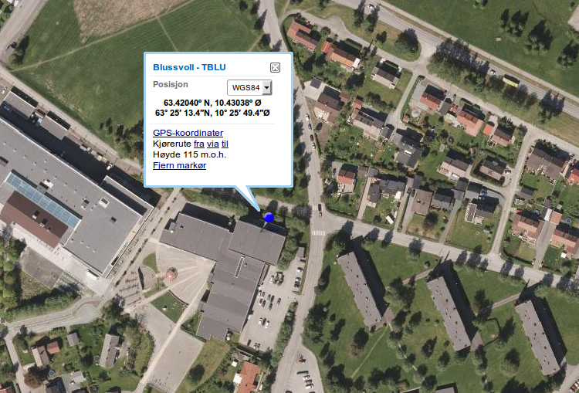

Link to: finn-map

The coordinates chosen for this location was reported by maintenance personnel that visited TBLU on 10 March 2015. The coordinates registred by ISC is probably due to an error that occurred when converting between degrees and minutes.

station | source | latitude | longitude | elevation(m) | distance from final location (m)
TBLU | CORRECT | 63.42040 | 10.43038 | 117
TBLU | SEISDAT | 63.41960 | 10.43450 | 230 | 223.5
TBLU | SEISAN | 63.41970 | 10.43450 | 232 | 219.3
TBLU | ISC | 63.25180 | 10.26070 | 232 | 20570.0
TBLU | MAP GUESS | 63.42034 | 10.43055 | 115 | 10.8
TBLU | REPORT, MAINTENANCE | 63.42040 | 10.43038 | 117 | 0.0

Station: Blåsjø (BLS5)
Coordinates: 59.42308N 6.45758E Elevation: 540 m
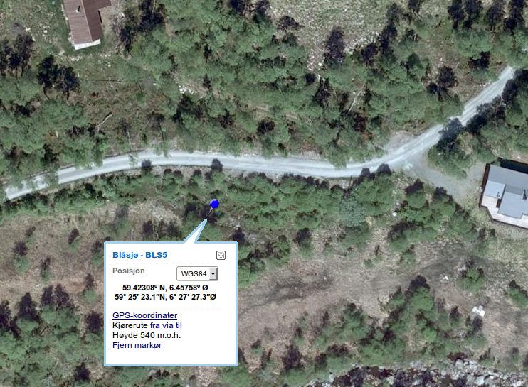
Link to: Finn-map

Location determined by Lars Ottemöller and Terje Utheim based on Finn-map.

station | source | latitude | longitude | elevation(m) | distance from final location (m)
BLS5 | CORRECT | 59.42308 | 6.45758 | 540
BLS5 | SEISDAT | 59.42290 | 6.45600 | 540 | 91.6
BLS5 | SEISAN | 59.42280 | 6.45600 | 540 | 94.6
BLS5 | ISC | 59.42290 | 6.45600 | 540 | 91.6
BLS5 | MAP GUESS | 59.42308 | 6.45758 | 540
BLS5 | REPORT, MAINTENANCE | 59.42300 | 6.45600 | 540 | 89.8

Station: Dombås (DOMB)
Coordinates: 62.07320N 9.11220E Elevation: 660 m
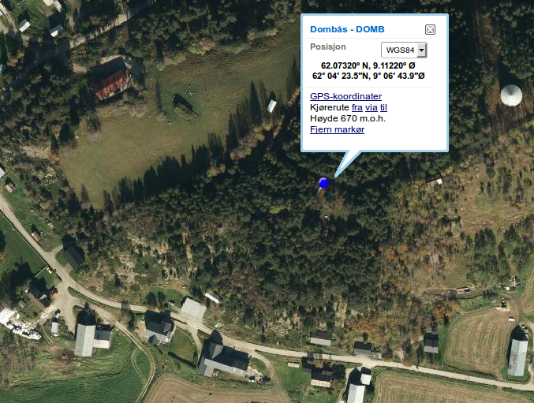
Link to: Finn-map

Seisan determined as correct location by Øyvind Natvik and Terje Utheim.

station | source | latitude | longitude | elevation(m) | distance from final location (m)
DOMB | CORRECT | 62.07320 | 9.11220 | 660
DOMB | SEISDAT | 62.07310 | 9.11210 | 660 | 12.3
DOMB | SEISAN | 62.07320 | 9.11220 | 660 | 0.0
DOMB | ISC | 62.04239 | 9.06419 | 660 | 4242.0
DOMB | MAP GUESS
DOMB | GPS MEASURED | 62.07330 | 9.11700 | 660 | 250.0

Station: Fauske (FAUS)
Coordinates: 67.38204N 15.28777E Elevation: 94 m
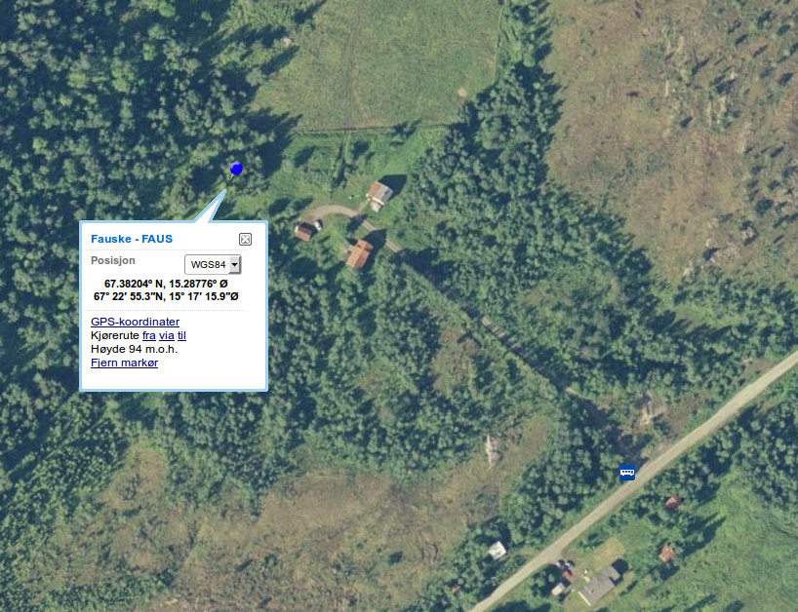
Link to: Finn-map

The difference between Seisdat and Seisan is due to a rounding error ( Seisan operates with only 4 decimals while Seisdat operates with 5). The small change with the map-guess is negligible considering it was created by an approximation on a map.

station | source | latitude | longitude | elevation (m) | distance from final location (m)
FAUS | CORRECT | 67.38204 | 15.28777 | 94
FAUS | SEISDAT | 67.38204 | 15.28777 | 97 | 0.0
FAUS | SEISAN | 67.38200 | 15.28770 | 95 | 5.4
FAUS | ISC
FAUS | MAP GUESS | 67.38206 | 15.28765 | 94 | 5.6
FAUS | GPS MEASURED

Station: Florø (FOO)
Coordinates: 61.59740N 5.04270E Elevation: 10 m
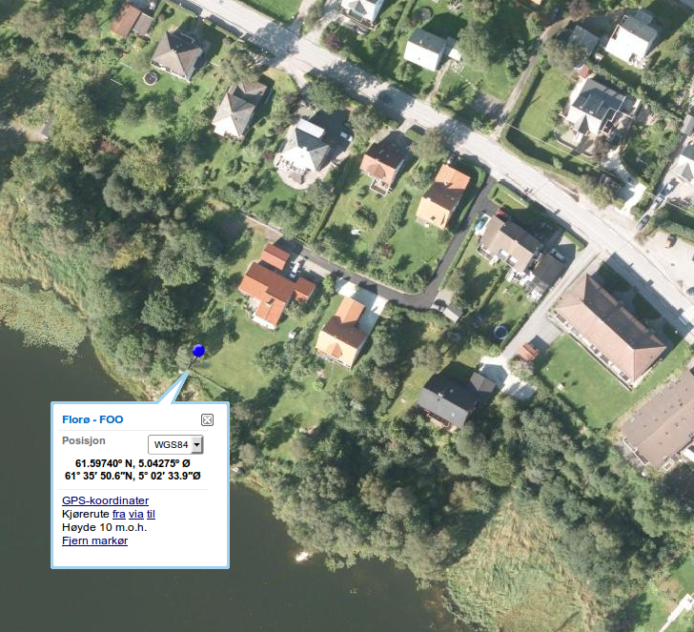
Link to: Finn-map

At this site the sensorbox is visible from satellite/airplane photos, determining the location from a map was thus a simple task performed by Ole.

station | source | latitude | longitude | elevation (m) | distance from final location (m)
FOO | CORRECT | 61.59750 | 5.04220 | 10
FOO | SEISDAT | 61.59750 | 5.04220 | 15 | 28.7
FOO | SEISAN | 61.59750 | 5.04220 | 15 | 28.7
FOO | ISC | 61.59800 | 5.04400 | 10 | 95.8
FOO | MAP GUESS | 61.59740 | 5.04270 | 10 | 0.0
FOO | GPS MEASURED | 61.59739 | 5.04276 |  | 3.6

Station: Flostrand(FLOS)
Coordinates: 66.33630N 13.36300E Elevation: 18 m
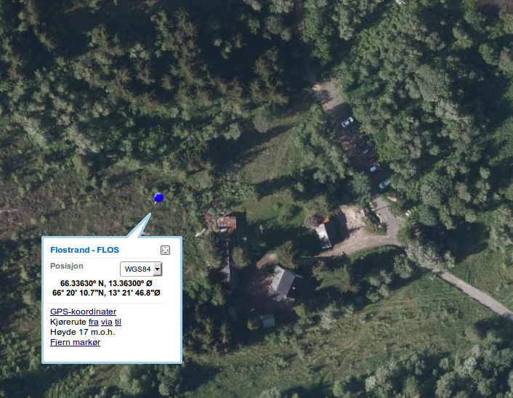
Link to: Finn-map

These coordinates measured while visiting the station 11.06.2007, these are the same as registred in Seisan and at Seisdat and were confirmed correct at the meeting 22.06.2015.

station | source | latitude | longitude | elevation (m) | distance from final location (m)
FLOS | CORRECT | 66.33630 | 13.36300 | 18
FLOS | SEISDAT | 66.33630 | 13.36300 | 18 | 0.0
FLOS | SEISAN | 66.33630 | 13.36300 | 18 | 0.0
FLOS | ISC | 66.33650 | 13.36470 | 20 | 79.1
FLOS | MAP GUESS
FLOS | GPS MEASURED | 66.33630 | 13.36300 | 18 | 0.0

Station: Hammerfest(HAMF)
Coordinates: 70.64234N 23.68423E Elevation: 99 m
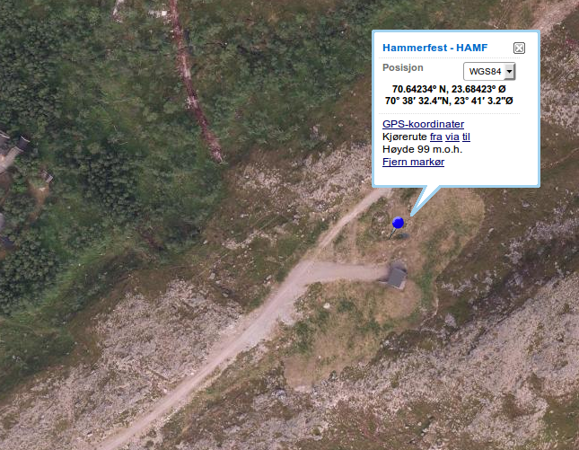
Link to: Finn-map

These coordinates are estimated based on the report from the station-installation. They are estimated by trilateration of the distance between the sensor-box and the different corners of the building nearby.

station | source | latitude | longitude | elevation (m) | distance from final location (m)
HAMF | CORRECT | 70.64234 | 23.68423 | 99
HAMF | SEISDAT | 70.64239 | 23.68431 | 105 | 6.3
HAMF | SEISAN | 70.64250 | 23.68420 | 105 | 17.8
HAMF | ISC | 70.64240 | 23.68430 | 105 | 7.2
HAMF | MAP OF SITE | 70.64234 | 23.68423 | 99 | 0.0
HAMF | GPS MEASURED | 70.64239 | 23.68431 | 105 | 6.3

Station: Homborsund(HOMB)
Coordinates: 58.27011N 8.50520E Elevation: 25 m
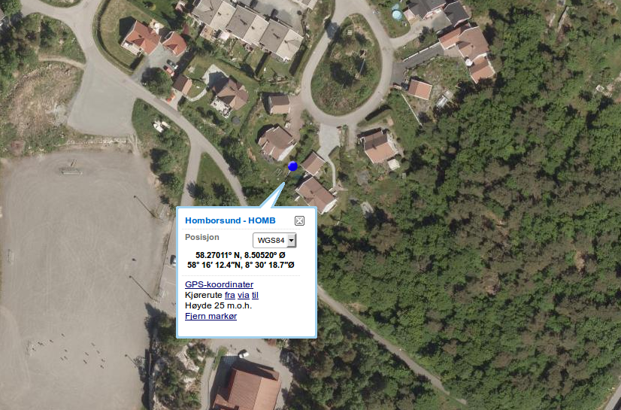
Link to: Finn-map

These coordinates was determined at the meeting 22.06.15 by pointing out the location on a map, the coordinates was later confirmed by Stig Monsen who has visited the station.

station | source | latitude | longitude | elevation(m) | distance from final location (m)
HOMB | CORRECT | 58.27011 | 8.50520 | 25
HOMB | SEISDAT | 58.27020 | 8.50520 | 21 | 10.0
HOMB | SEISAN | 58.27020 | 8.50520 | 21 | 10.0
HOMB | ISC | 58.27020 | 8.50520 | 21 | 10.0
HOMB | MAP GUESS | 58.27011 | 8.50520 | 25 | 0.0
HOMB | GPS MEASURED

Station: Hopen(HOPEN)
Coordinates: 76.50840N 25.01085E Elevation: 25 m
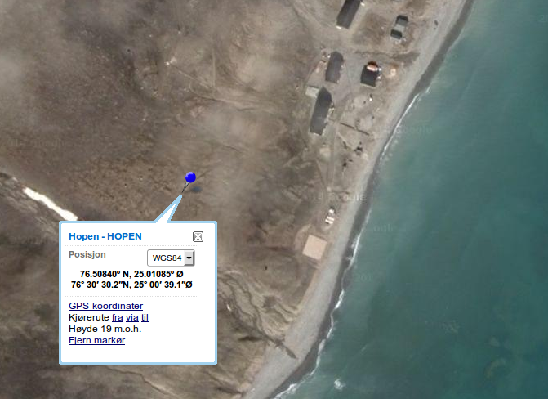

Link to: Finn-map

These coordinates were measured and reported at a visit 27.09.2004, they were confirmed correct at the review meeting 26.06.2015.

station | source | latitude | longitude | elevation(m) | distance from final location (m)
HOPEN | CORRECT | 76.50840 | 25.01085 | 25
HOPEN | SEISDAT | 76.50840 | 25.01090 | 25 | 1.3
HOPEN | SEISAN | 76.50830 | 25.01080 | 25 | 11.2
HOPEN | ISC | 76.51000 | 25.01000 | 25 | 179.3
HOPEN | MAP GUESS
HOPEN | GPS MEASURED | 76.50840 | 25.01085 | 29 | 0.0

Station: Høyanger(HYA)
Coordinates: 61.16333N 6.18546E Elevation: 22 m
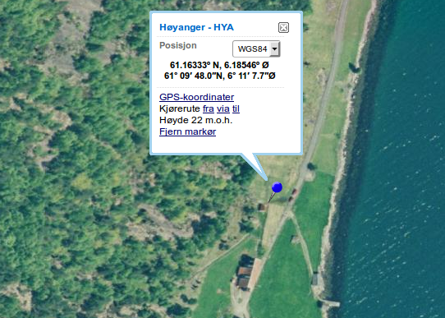

Link to: Finn-map

Location determined by Lars Ottemöller from Finn-map.

station | source | latitude | longitude | elevation(m) | distance from final location (m)
HYA | CORRECT | 61.16333 | 6.18546 | 22
HYA | SEISDAT | 61.16520 | 6.18170 | 30 | 289.7
HYA | SEISAN | 61.16520 | 6.18170 | 30 | 289.7
HYA | ISC | 61.16600 | 6.18700 | 30 | 308.2
HYA | MAP GUESS | 61.16333 | 6.18546 | 22
HYA | GPS MEASURED | 61.16600 | 6.18700 | 30 | 308.2

Station: Jan Mayen / Trolldalen (JMI)
Coordinates: 70.92683N -8.72668E Elevation: 211 m
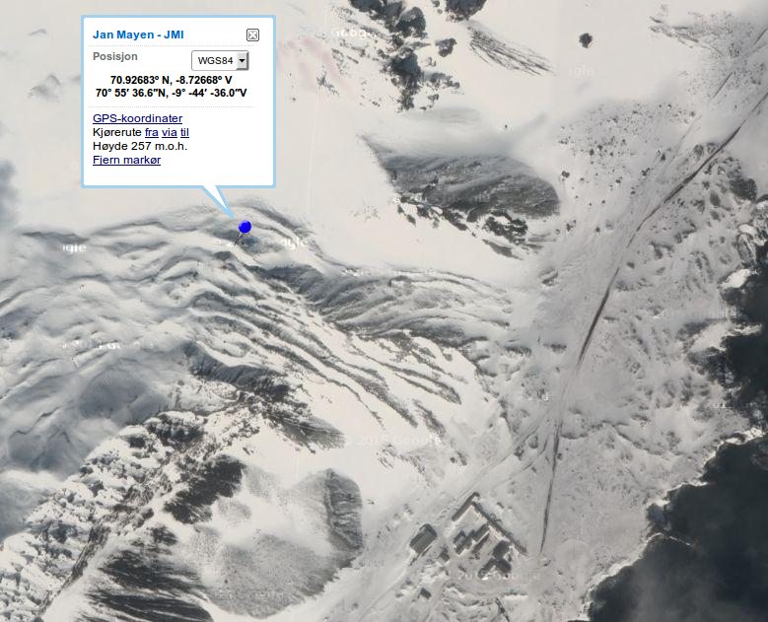
Link to: Finn-map

These coordinates were obtained from a project report, 21.03.2014, by Ole Meyer and confirmed at the review-meeting.

station | source | latitude | longitude | elevation(m) | distance from final location (m)
JMI | CORRECT | 70.92683 | -8.72668 | 211
JMI | SEISDAT | 70.92830 | -8.73080 | 211 | 221.6
JMI | SEISAN | 70.92830 | -8.73080 | 211 | 221.6
JMI | ISC | 70.92830 | -8.73081 | 50 | 158.9
JMI | MAP GUESS
JMI | GPS MEASURED | 70.92683 | -8.72668 |  | 0.0

Station: Jan Mayen East / Ulla (JNE)
Coordinates: 70.98841N -8.29255E Elevation: 57 m
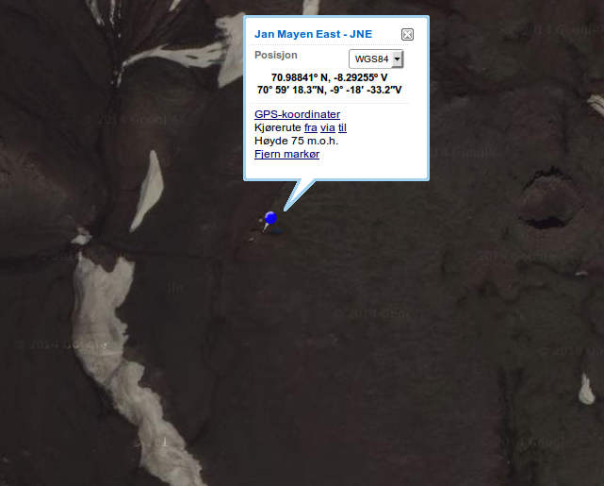
Link to: Finn-map

These coordinates were obtained from a picture on-site of a GPS-device, the photo was taken during an inspection made in August 2012 by Ole Meyer.

station | source | latitude | longitude | elevation (m) | distance from final location (m)
JNE | CORRECT | 70.98841 | -8.29255 | 57
JNE | SEISDAT | 70.98980 | -8.29680 | 57 | 218.1
JNE | SEISAN | 70.98980 | -8.29680 | 57 | 218.1
JNE | ISC | 70.99000 | -8.29700 | 57 | 239.2
JNE | MAP GUESS
JNE | GPS MEASURED | 70.98841 | -8.29255 |  | 0.0

Station: Jan Mayen West / Liberg (JNW)
Coordinates: 71.02734N -8.42362E Elevation: 95 m
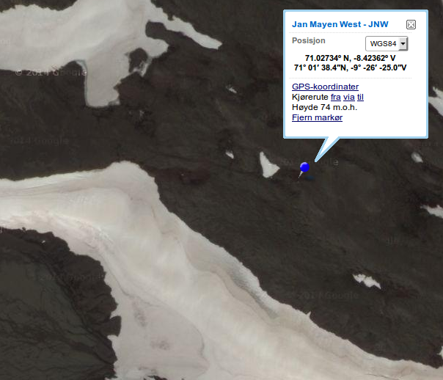
Link to: Finn-map

These coordinates were also obtained from a picture on-site of a GPS-device, the photo was taken during the same inspection 2012-08 by Ole Meyer. Confirmed at review-meeting.

station | source | latitude | longitude | elevation (m) | distance from final location (m)
JNW | CORRECT | 71.02734 | -8.42362 | 95
JNW | SEISDAT | 71.02870 | -8.42820 | 95 | 224.2
JNW | SEISAN | 71.02870 | -8.42820 | 95 | 224.2
JNW | ISC | 71.02900 | -8.42800 | 95 | 243.2
JNW | MAP GUESS
JNW | GPS MEASURED | 71.02734 | -8.42362 |  | 0.0

Station: Karmøy (KMY)
Coordinates: 59.21079N 5.24527E Elevation: 58 m
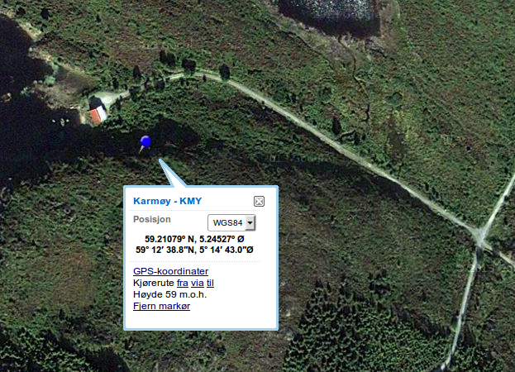
Link to: Finn-map

These coordinates were obtained from a report on the site visit 17.-19. January 2012 and confirmed by Ole Meyer at the review meeting 26.06.2015.

station | source | latitude | longitude | elevation (m) | distance from final location (m)
KMY | CORRECT | 59.21079 | 5.24527 | 58
KMY | SEISDAT | 59.21082 | 5.24527 | 58 | 3.3
KMY | SEISAN | 59.20230 | 5.24070 | 58 | 979.2
KMY | ISC | 59.21200 | 5.24700 | 58 | 166.7
KMY | MAP GUESS
KMY | GPS MEASURED | 59.21079 | 5.24527 |  | 0.0

Station: Kautokeino (KTK1)
Coordinates: 69.01170N 23.23720E Elevation: 340 m
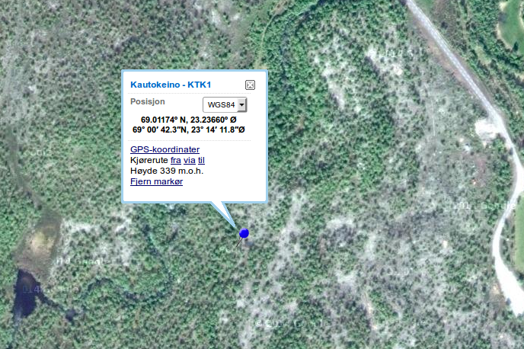
Link to: Finn-map

These coordinates were determined by Ole Meyer by comparing a map of the original array to a finn-map and estimating the position, the position has since been confirmed by Marte L. Strømme.

station | source | latitude | longitude | elevation (m) | distance from final location (m)
KTK1 | CORRECT | 69.01174 | 23.23660 | 340
KTK1 | SEISDAT | 69.01170 | 23.23720 | 340 | 0.0
KTK1 | SEISAN | 69.01170 | 23.23720 | 340 | 0.0
KTK1 | ISC | 69.01170 | 23.23710 | 340 | 4.0
KTK1 | map from google drive | 69.01174 | 23.23660 | 339 | 24.3
KTK1 | GPS MEASURED | 69.01170 | 23.23710 | 340 | 4.0

Station: Kings Bay (KBS)
Coordinates: 78.91530N 11.93840E Elevation: 40 m
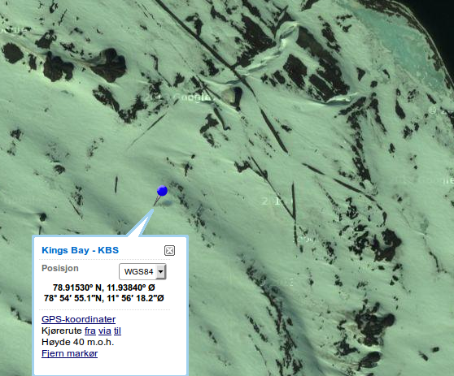
Link to: Finn-map

These coordinates are based on old maps of the site, the sensor is located on a large concrete construction visible on maps.

station | source | latitude | longitude | elevation(m) | distance from final location (m)
KBS | CORRECT | 78.91530 | 11.93840 | 40
KBS | SEISDAT | 78.91680 | 11.91730 | 46 | 480.9
KBS | SEISAN | 78.91680 | 11.91730 | 46 | 480.9
KBS | ISC | 78.92561 | 11.94169 | 74 | 1149.0
KBS | MAP GUESS | 78.91530 | 11.93840 | 40 | 0.0
KBS | GPS MEASURED | 78.92560 | 11.91730 | 74 | 1231.0

Station: Kongsberg (KONO)
Coordinates: 59.64910N 9.59822E Elevation: 216 m
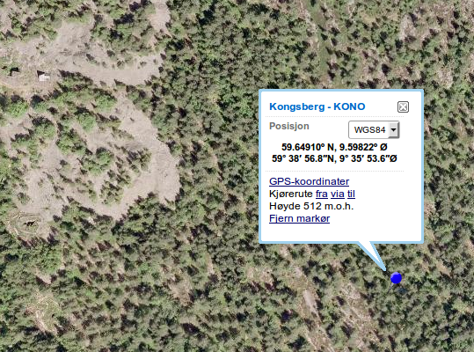

Link to: Finn-map

During the review-meeting 26.06.2015 the coordinates gathered from ISC was determined to be accurate. The station is within the silver mine, thus below the surface and 216m is assumed to be correct.

station | source | latitude | longitude | elevation (m) | distance from final location (m)
KONO | CORRECT | 59.64910 | 9.59822 | 216
KONO | SEISDAT | 59.64910 | 9.59820 | 216 | 1.1
KONO | SEISAN | 59.64920 | 9.59820 | 216 | 11.2
KONO | ISC | 59.64910 | 9.59822 | 216 | 0.0
KONO | MAP GUESS
KONO | GPS MEASURED | 59.64900 | 9.59820 | 216 | 11.2

Station: Konsvik (KONS)
Coordinates: 66.49918N 13.11764E Elevation: 28 m
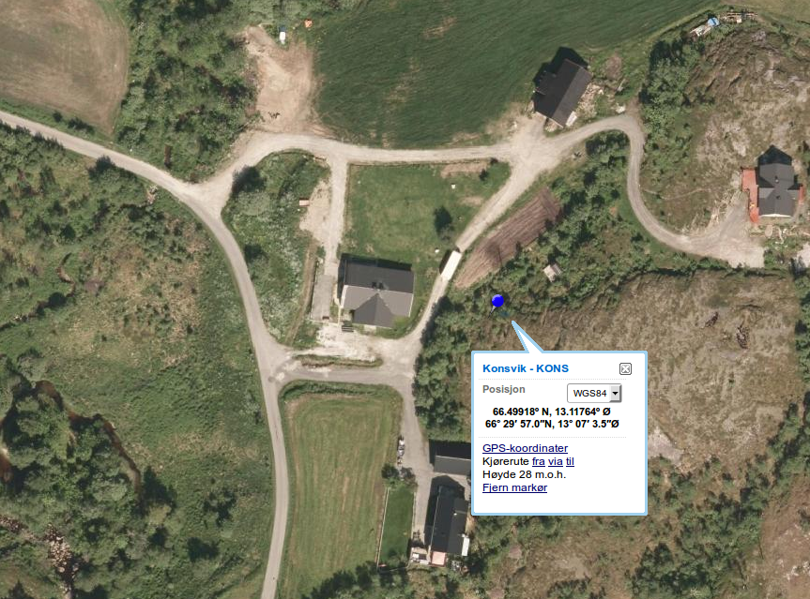
Link to: Finn-map

These coordinates were determined during the review-meeting 26.06.2015, they were obtained by visitors of the site agreeing upon a location on a finn-map.

station | source | latitude | longitude | elevation (m) | distance from final location (m)
KONS | CORRECT | 66.49918 | 13.11764 | 28
KONS | SEISDAT | 66.49902 | 13.11758 | 23 | 18.0
KONS | SEISAN | 66.49900 | 13.11770 | 23 | 20.2
KONS | ISC | 66.49920 | 13.11930 | 36 | 73.6
KONS | MAP GUESS | 66.49918 | 13.11764 | 28
KONS | GPS MEASURED | 66.49902 | 13.11758 | 23 | 18.0

Station: Lofoten (LOF)
Coordinates: 68.13251N 13.53987E Elevation: 75 m
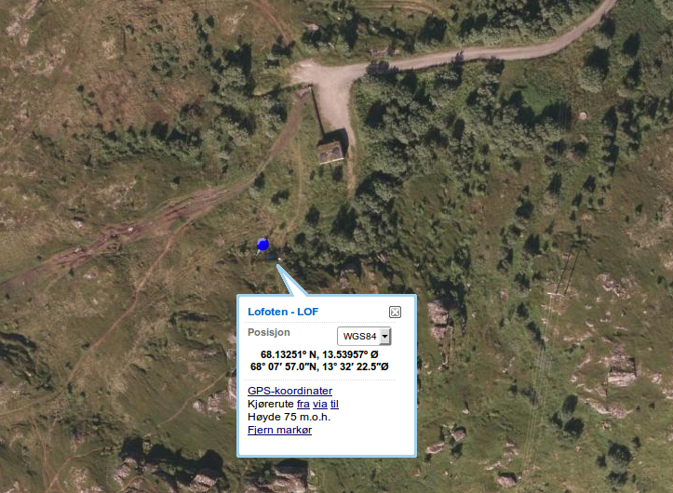
Link to: Finn-map

These coordinates were determined by Ole Meyer, based on visits to the site.

station | source of coordinates | latitude | longitude | elevation (m) | distance from final location (m)
LOF | CORRECT | 68.13251 | 13.53987 | 75
LOF | SEISDAT | 68.13250 | 13.54100 | 80 | 46.8
LOF | SEISAN | 68.13250 | 13.54100 | 80 | 46.8
LOF | ISC | 68.13100 | 13.54200 | 80 | 189.7
LOF | MAP GUESS | 68.13251 | 13.53987 | 75 | 0.0
LOF | GPS MEASURED | 68.13100 | 13.54200 | 80 | 189.7

Station: Mo i Rana (MOR8)
Coordinates: 66.28297N 14.73088E Elevation: 411 m
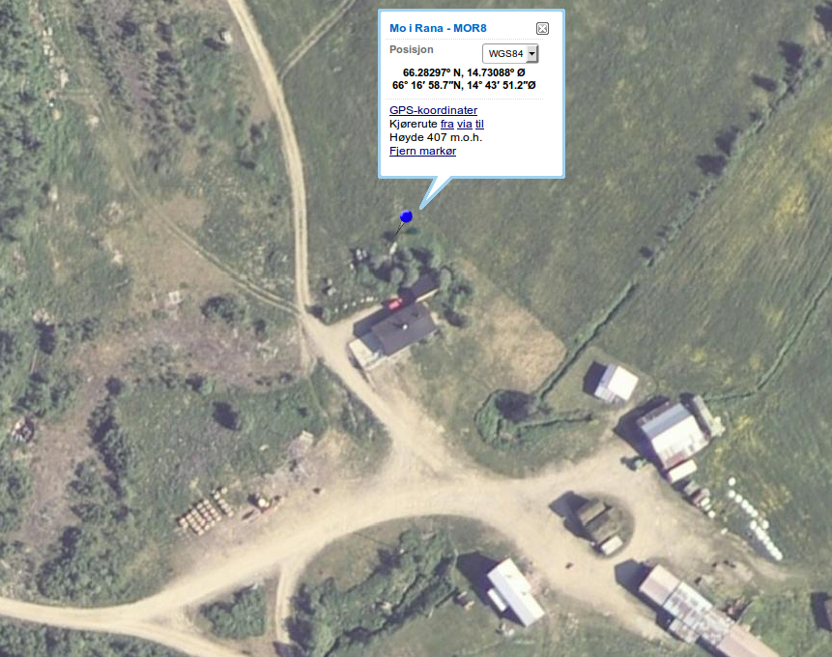
Link to: Finn-map

These coordinates were obtained from Seisdat and confirmed accurate at the review-meeting 26.06.2015. This station was moved approx. 250 meters 26.10.2011, the coordinates registred in Seisan belong to the old location, the coordinates found at ISC might be due to the same conversion error made at TBLU.

station | source | latitude | longitude | elevation (m) | distance from final location (m)
MOR8 | CORRECT | 66.28297 | 14.73088 | 411
MOR8 | SEISDAT | 66.28297 | 14.73088 | 411 | 0.0
MOR8 | SEISAN | 66.28520 | 14.73170 | 445 | 250.7
MOR8 | ISC | 66.17130 | 14.44110 | 445 | 17970.0
MOR8 | MAP GUESS
MOR8 | GPS MEASURED

Station: Molde (MOL)
Coordinates: 62.56995N 7.54675E Elevation: 90 m
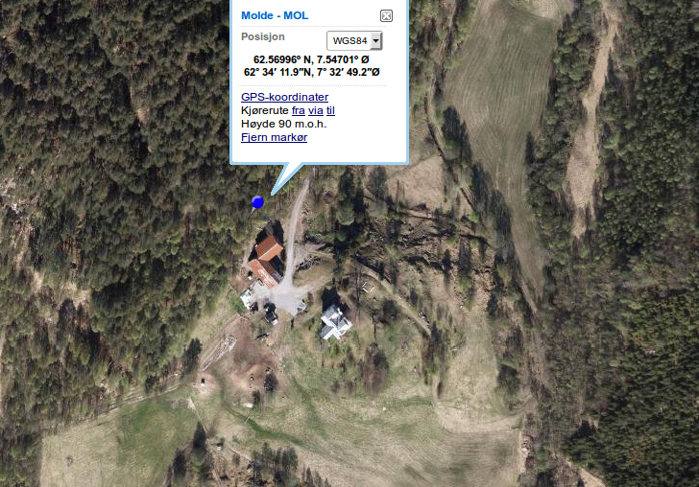
Link to: Finn-map

These coordinates were obtained from a picture taken at site of a GPS-device. The location was confirmed by visitors of the site at the review-meeting 26.06.2015.

station | source | latitude | longitude | elevation (m) | distance from final location (m)
MOL | CORRECT | 62.56995 | 7.54675 | 90
MOL | SEISDAT | 62.56990 | 7.54700 | 98 | 14.0
MOL | SEISAN | 62.56980 | 7.54700 | 98 | 21.0
MOL | ISC | 62.57000 | 7.54800 | 98 | 64.3
MOL | MAP GUESS
MOL | GPS MEASURED | 62.56995 | 7.54675 | 90 | 0.0

Station: Namsos(NSS)
Coordinates: 64.53031N 11.96583E Elevation: 102 m
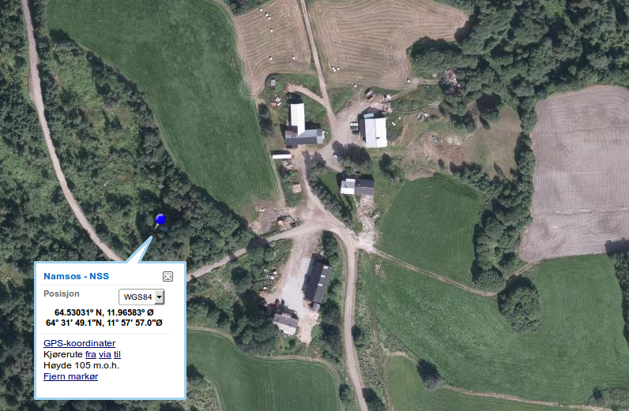
Link to: Finn-map

The coordinates obtained from Seisdat correlate with coordinates noted on a map as part of a report on a site-visit. These coordinates were confirmed at the review-meeting 26.06.2015.

station | source | longitude | latitude | elevation (m) | distance from final location (m)
NSS | CORRECT | 64.53031 | 11.96583 | 102
NSS | SEISDAT | 64.53031 | 11.96583 | 102 | 0.0
NSS | SEISAN | 64.53070 | 11.96730 | 102 | 82.6
NSS | ISC | 64.53000 | 11.96700 | 102 | 65.7
NSS | MAP GUESS
NSS | GPS MEASURED | 64.53000 | 11.96700 | 102 | 65.7

Station: Odda (ODD1)
Coordinates: 59.91080N 6.62625E Elevation: 676 m
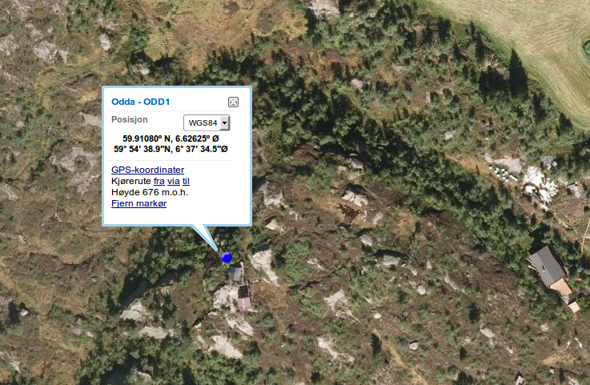
Link to: Finn-map

Location determined by Marte.

station | source | latitude | longitude | elevation | distance from final location (m)
ODD1 | CORRECT | 59.91080 | 6.62625 | 676
ODD1 | SEISDAT | 59.91100 | 6.62720 | 684 | 57.4
ODD1 | SEISAN | 59.91100 | 6.62720 | 684 | 57.4
ODD1 | ISC | 59.91200 | 6.62800 | 684 | 165.3
ODD1 | MAP GUESS | 59.91080 | 6.62625 | 676 | 0.0
ODD1 | GPS MEASURED | 59.91200 | 6.62800 | 684 | 165.3

Station: Oslo (OSL)
Coordinates: 59.93729N 6.62625E Elevation: 70 m
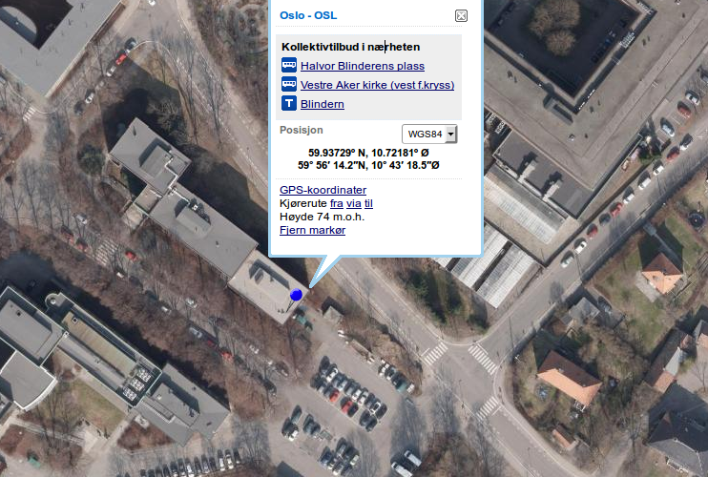
Link to: Finn-map

Location determined by Lars Ottemöller, Seismometer located within the University of Oslo, Geology-building.

station | source | latitude | longitude | elevation(m) | distance from final location (m)
OSL | CORRECT | 59.93729 | 10.72181 | 70
OSL | SEISDAT | 59.93720 | 10.72270 | 70 | 50.6
OSL | SEISAN | 59.93720 | 10.72270 | 70 | 50.6
OSL | ISC | 59.93717 | 10.72267 | 70 | 49.7
OSL | MAP GUESS | 59.93729 | 10.72181 | 70
OSL | GPS MEASURED

Station: Skarslia (SKAR)
Coordinates: 60.68077N 8.30440E Elevation: 799 m
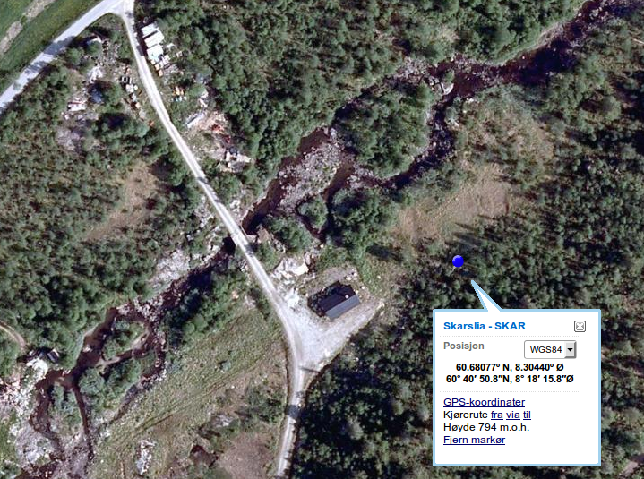
Link to: Finn-map

Seisdat determined correct at review-meeting.

station | source | latitude | longitude | elevation(m) | distance from final location (m)
SKAR | CORRECT | 60.68077 | 8.30440 | 799
SKAR | SEISDAT | 60.68077 | 8.30440 | 799 | 0.0
SKAR | SEISAN | 60.68070 | 8.30430 | 799 | 9.5
SKAR | ISC | 60.68080 | 8.30440 | 799 | 3.3
SKAR | MAP GUESS | 60.68084 | 8.30422 | 792 | 12.5
SKAR | GPS MEASURED

Station: Snartemo (SNART)
Coordinates: 58.33870N 7.20970E Elevation: 160 m
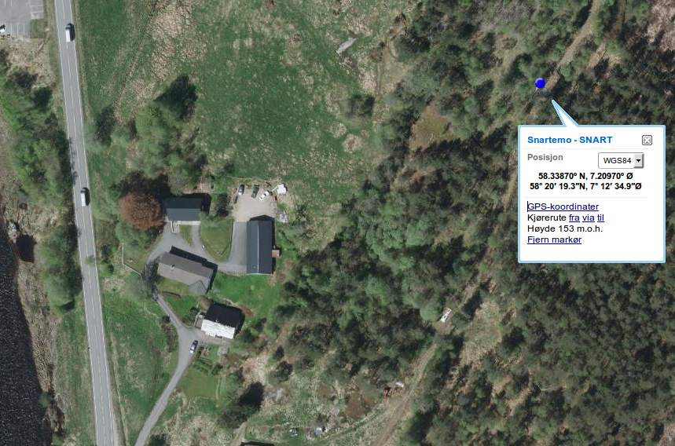
Link to: Finn-map

Seisview coordinates confirmed to be ok by Stig Monsen.

station | source | latitude | longitude | elevation(m) | distance from final location (m)
SNART | CORRECT | 58.33870 | 7.20970 | 160
SNART | SEISDAT | 58.33870 | 7.20970 | 160 | 0.0
SNART | SEISAN | 58.33870 | 7.20970 | 160 | 0.0
SNART | ISC | 58.33870 | 7.20970 | 160 | 0.0
SNART | MAP GUESS
SNART | GPS MEASURED

Station: Stavanger (STAV)
Coordinates: 58.93439N 5.70349E Elevation: 39 m
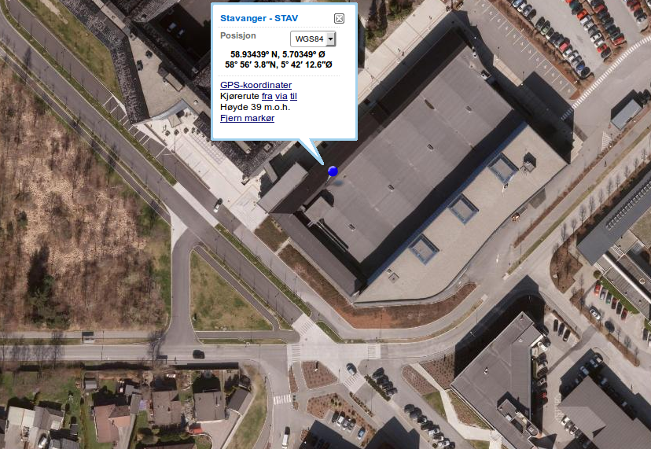
Link to: Finn-map

Location determined at review-meeting 26.06.2015, Helge.

station | source | latitude | longitude | elevation (m) | distance from final location (m)
STAV | CORRECT | 58.93439 | 5.70349 | 39
STAV | SEISDAT | 58.93480 | 5.70220 | 28 | 86.9
STAV | SEISAN | 58.93480 | 5.70220 | 28 | 86.9
STAV | ISC | 58.93483 | 5.70217 | 28 | 90.2
STAV | MAP GUESS | 58.93439 | 5.70349 | 39 | 0.0
STAV | GPS MEASURED

Station: Steigen (STEI)
Coordinates: 67.93000N 15.24200E Elevation: 21 m
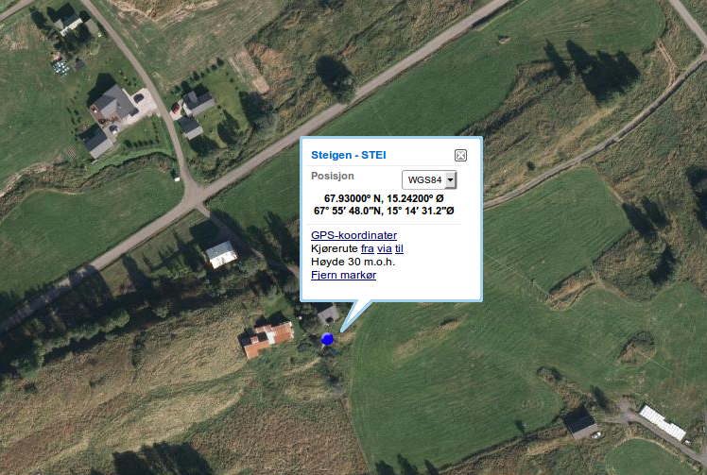
Link to: Finn-map

All sources correlate, location confirmed at review-meeting 26.06.2015

station | source | latitude | longitude | elevation (m) | distance from final location (m)
STEI | CORRECT | 67.93000 | 15.24200 | 21
STEI | SEISDAT | 67.93000 | 15.24200 | 21 | 0.0
STEI | SEISAN | 67.93000 | 15.24200 | 21 | 0.0
STEI | ISC | 67.93000 | 15.24200 | 21 | 0.0
STEI | MAP GUESS
STEI | GPS MEASURED | 67.93000 | 15.24200 | 21 | 0.0

Station: Stokkvågen (STOK)
Coordinates: 66.33300N 13.01770E Elevation: 18 m
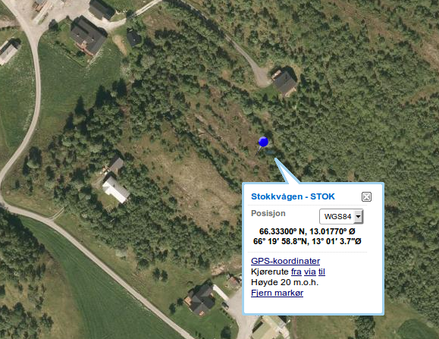
Link to: Finn-map

All sources correlate, location confirmed at review-meeting

station | source | latitude | longitude | elevation | distance from final location (m)
STOK | CORRECT | 66.33300 | 13.01770 | 18
STOK | SEISDAT | 66.33300 | 13.01770 | 18 | 0.0
STOK | SEISAN | 66.33300 | 13.01770 | 18 | 0.0
STOK | ISC | 66.33300 | 13.01770 | 18 | 0.0
STOK | MAP GUESS
STOK | GPS MEASURED

Station: Sulen (SUE)
Coordinates: 61.05703N 4.75952E Elevation: 10 m
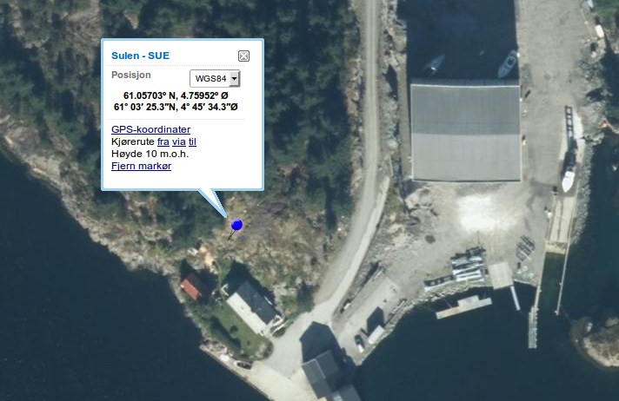
Link to: Finn-map

Location determined at review-meeting, confirmed by Marte L. Strømme.

station | source | latitude | longitude | elevation (m) | distance from final location (m)
SUE | CORRECT | 61.05703 | 4.75952 | 10
SUE | SEISDAT | 61.05700 | 4.76100 | 10 | 79.7
SUE | SEISAN | 61.05700 | 4.76100 | 10 | 79.7
SUE | ISC | 61.05700 | 4.76100 | 10 | 79.7
SUE | MAP GUESS | 61.05703 | 4.75952 | 10 | 5.8
SUE | GPS MEASURED

Station: Tromsø (TRO)
Coordinates: 69.63495N 18.91100E Elevation: 27 m
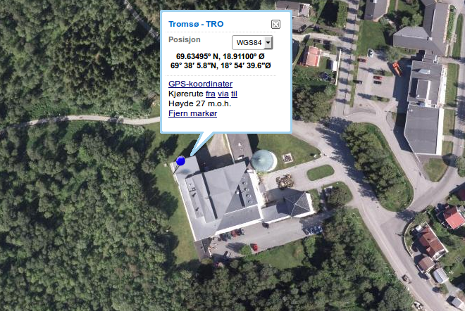
Link to: Finn-map

Location determined by Mathilde Sørensen.

station | source | latitude | longitude | elevation (m) | distance from final location (m)
TRO | CORRECT | 69.63495 | 18.91100 | 27
TRO | SEISDAT | 69.63450 | 18.90770 | 15 | 137.2
TRO | SEISAN | 69.63450 | 18.90770 | 15 | 137.2
TRO | ISC | 69.63250 | 18.92810 | 15 | 715.6
TRO | MAP GUESS | 69.63495 | 18.91100 | 27 | 0
TRO | GPS MEASURED | 69.63250 | 18.92810 | 15 | 715.6

Appendix 2
Events producing changes exceeding 25 km horizontal, 15 km depth, 0.5 RMS, 1975-2014
1983 417 2033 33.1 L 62.016 2.251 15.0 BER 3 0.2 1.5CBER 1.6LIGS
1983 417 2033 33.2 L 62.196 2.273 31.0 BER 3 0.1 1.5CBER 1.6LIGS
change epicentre,depth,rms: 20.0 16.0 -0.1
1983 5 4 2007 32.0 L 59.153 7.215 23.0 BER 8 1.0 1.1CBER
1983 5 4 2007 29.2 L 60.190 5.701 15.0 BER 8 1.7 1.1CBER
change epicentre,depth,rms: 143.0 8.0 0.7
1983 526 1500 39.5 L 66.822 27.204 23.0 BER 7 1.5 2.6CBER
1983 526 1500 36.7 L 69.358 20.562 15.0 BER 7 1.2 2.5CBER
change epicentre,depth,rms: 393.2 8.0 -0.3
1985 110 0524 55.5JL 70.850 -8.153 3.1 BER 3 0.8 3.6CBER
1985 110 0524 55.2JL 70.891 -7.593 25.4 BER 3 0.4 3.6CBER
change epicentre,depth,rms: 20.9 22.3 -0.4
1985 222 1002 18.6 L 60.580 5.635 15.0 BER 5 1.0 0.9CBER
1985 222 1002 20.9 L 60.350 5.353 9.4 BER 5 1.2 0.9CBER
change epicentre,depth,rms: 29.8 5.6 0.2
1985 311 1523 29.9 L 60.231 5.240 4.3 BER 5 0.7 0.9CBER
1985 311 1523 26.6 L 60.609 5.700 15.1 BER 5 2.1 0.9CBER
change epicentre,depth,rms: 49.0 10.8 1.4
1985 419 0754 49.9 L 59.295 7.028 15.0 BER 7 1.4 2.2LBER 2.0CBER
1985 419 0754 48.5 L 59.326 7.122 0.0 BER 7 1.1 2.2LBER 2.0CBER
change epicentre,depth,rms: 6.3 15.0 -0.3
1985 712 1102 48.8 LE 59.144 7.311 0.0F BER 6 1.8 1.5CBER
1985 712 1102 41.9 LE 60.624 4.943 0.0F BER 6 1.9 1.5CBER
change epicentre,depth,rms: 210.7 0.0 0.1
1985 9 2 1310 42.2 L 57.939 5.937 31.0 BER 4 0.5 1.4CBER
1985 9 2 1310 42.2 L 58.026 5.913 15.0 BER 4 0.6 1.3CBER
change epicentre,depth,rms: 9.8 16.0 0.1
1985 9 4 1339 54.7 L 61.210 7.914 15.0 BER 4 0.8 1.4CBER
1985 9 4 1339 55.0 L 61.138 7.710 0.0 BER 4 0.5 1.4CBER
change epicentre,depth,rms: 13.5 15.0 -0.3
1985 917 1407 19.9 L 60.181 5.660 0.0 BER 4 1.6 1.7CBER
1985 917 1407 18.4 L 60.415 4.784 15.0 BER 4 2.9 1.7CBER
change epicentre,depth,rms: 54.8 15.0 1.3
1985 11 9 1820 40.6 L 61.781 5.800 15.0 BER 3 1.3 1.9CBER
1985 11 9 1820 40.5 L 62.446 6.507 0.0 BER 3 1.0 1.9CBER
change epicentre,depth,rms: 82.5 15.0 -0.3
1986 6 3 1114 28.9 L 58.119 5.498 15.0 BER 4 0.1 1.6CBER
1986 6 3 1114 29.1 L 58.043 5.450 37.8 BER 4 0.0 1.6CBER
change epicentre,depth,rms: 8.9 22.8 -0.1
1986 924 0536 24.7 L 60.554 4.862 15.4 BER 4 1.0 1.0CBER
1986 924 0536 25.2 L 60.613 4.777 31.0 BER 4 1.0 1.0CBER
change epicentre,depth,rms: 8.0 15.6 0.0
1986 11 8 1406 41.2 L 60.733 5.453 15.0 BER 8 2.2 1.0LBER 0.8CBER
1986 11 8 1406 40.4 L 60.702 5.609 0.0 BER 8 2.1 1.0LBER 0.8CBER
change epicentre,depth,rms: 9.1 15.0 -0.1
1986 12 2 1409 32.8 L 61.355 4.242 15.0 BER 3 0.5 1.3CBER
1986 12 2 1409 33.0 L 61.787 4.607 50.8 BER 3 0.0 1.3CBER
change epicentre,depth,rms: 51.7 35.8 -0.5
1987 7 9 1316 36.5 L 58.067 6.043 15.0 BER 6 0.6 1.9CBER
1987 7 9 1316 36.6 L 57.982 6.012 31.0 BER 6 0.7 1.9CBER
change epicentre,depth,rms: 9.6 16.0 0.1
1987 718 0938 5.3 L 62.692 6.284 15.0 BER 3 0.8 2.0CBER
1987 718 0938 12.0 L 61.469 5.785 15.0 BER 3 1.3 2.0CBER
change epicentre,depth,rms: 138.2 0.0 0.5
1988 131 2009 56.5 L 68.416 11.983 15.0 BER 317.4 2.6CBER
1988 131 2010 16.2 L 67.198 8.497 30.7 BER 3 2.1 2.5CBER
change epicentre,depth,rms: 199.0 15.7 -15.3
1988 526 1156 54.5 L 61.282 10.276 9.3 BER 3 0.8 1.8CBER
1988 526 1156 55.1 L 61.357 10.454 31.0 BER 3 0.8 1.8CBER
change epicentre,depth,rms: 12.6 21.7 0.0
1988 527 1859 55.6 L 62.170 4.903 99.6 BER 3 0.7 1.9CBER
1988 527 1859 55.7 L 62.202 4.822 12.7 BER 3 1.1 1.9CBER
change epicentre,depth,rms: 5.5 86.9 0.4
1988 619 1321 19.1 L 60.583 4.630 15.0 BER 4 1.2 1.7CBER
1988 619 1321 20.6 L 60.625 4.901 0.0 BER 4 0.8 1.7CBER
change epicentre,depth,rms: 15.5 15.0 -0.4
1988 621 2028 39.5 L 60.734 5.491 15.0 BER 7 1.1 1.3CBER
1988 621 2028 38.9 L 60.713 5.613 0.0 BER 7 0.9 1.3CBER
change epicentre,depth,rms: 7.0 15.0 -0.2
1988 812 1301 32.4 L 60.386 5.124 15.0 BER 6 0.9 1.6CBER
1988 812 1301 32.6 L 60.376 5.322 0.0 BER 6 0.9 1.6CBER
change epicentre,depth,rms: 10.9 15.0 0.0
1988 1011 1438 47.7 L 59.106 5.884 15.0 BER 6 0.9 1.7CBER
1988 1011 1438 47.9 L 59.164 5.885 0.0 BER 6 0.8 1.7CBER
change epicentre,depth,rms: 6.4 15.0 -0.1
1989 929 1116 42.1 L 58.201 6.339 0.2 BER 3 0.6 1.3CBER
1989 929 1116 42.3 L 58.036 6.316 31.7 BER 3 0.9 1.3CBER
change epicentre,depth,rms: 18.4 31.5 0.3
1989 1117 1129 38.8 L 60.630 6.212 15.0 BER 8 1.0 1.0CBER
1989 1117 1129 37.6 L 60.624 6.316 0.0 BER 8 0.7 1.0CBER
change epicentre,depth,rms: 5.7 15.0 -0.3
1989 1212 1416 23.0 L 58.100 6.307 30.9 BER 3 0.8 1.1CBER
1989 1212 1416 23.5 L 58.288 6.326 0.1 BER 3 0.3 1.1CBER
change epicentre,depth,rms: 20.9 30.8 -0.5
1990 2 1 2359 59.9 L 62.136 2.401 32.1 BER 4 0.6 1.8CBER
1990 2 1 2359 59.9 L 62.110 2.596 15.0 BER 4 0.7 1.8CBER
change epicentre,depth,rms: 10.5 17.1 0.1
1990 5 2 1415 8.7 L 57.621 5.950 15.0 BER 3 1.3 1.2CBER
1990 5 2 1415 7.8 L 57.673 6.003 0.0 BER 3 1.2 1.2CBER
change epicentre,depth,rms: 6.6 15.0 -0.1
1990 821 1229 2.8 L 58.061 5.971 30.6 BER 3 0.7 1.1CBER
1990 821 1229 3.3 L 58.241 6.046 0.0 BER 3 0.4 1.1CBER
change epicentre,depth,rms: 20.5 30.6 -0.3
1990 1112 1444 58.6 L 63.081 8.009 15.0 BER 3 1.4 1.7CBER
1990 1112 1444 59.8 L 62.995 7.726 0.0 BER 3 0.7 1.7CBER
change epicentre,depth,rms: 17.1 15.0 -0.7
1991 421 1749 10.4 L 61.955 4.429 31.1 BER 8 0.9 2.1CBER
1991 421 1749 8.0 L 61.954 4.275 15.0 BER 8 1.0 2.1CBER
change epicentre,depth,rms: 8.0 16.1 0.1
1991 8 6 1019 10.7 L 62.065 2.254 15.0 BER 4 0.2 1.3CBER
1991 8 6 1019 10.7 L 62.107 2.086 31.0 BER 4 0.2 1.3CBER
change epicentre,depth,rms: 9.9 16.0 0.0
1991 10 8 0118 12.4 L 58.917 4.749 3.5 BER 3 0.2 0.8CBER
1991 10 8 0118 12.4 L 58.846 5.378 10.3 BER 3 0.2 0.8CBER
change epicentre,depth,rms: 36.9 6.8 0.0
1991 1110 2133 24.6 L 62.032 2.227 15.0 BER 5 0.6 1.3CBER
1991 1110 2133 24.6 L 62.076 2.061 30.9 BER 5 0.5 1.3CBER
change epicentre,depth,rms: 9.9 15.9 -0.1
1992 312 1508 17.3 L 60.621 8.417 0.1 BER 3 0.4 1.2CBER
1992 312 1508 14.4 L 60.546 8.161140.2 BER 3 0.1 1.2CBER
change epicentre,depth,rms: 16.3140.1 -0.3
1992 625 1247 32.2 L 60.551 8.369 15.0 BER 3 0.2 1.4CBER
1992 625 1247 33.3 L 60.580 8.414 31.0 BER 3 0.2 1.4CBER
change epicentre,depth,rms: 4.0 16.0 0.0
1992 720 2027 44.7 L 80.299 23.468 31.0 BER 2 0.4 2.9CBER 2.8LNAO
1992 720 2027 44.9 L 80.197 23.142 15.0 BER 2 0.4 2.8CBER 2.8LNAO
change epicentre,depth,rms: 12.9 16.0 0.0
1992 923 1311 24.8 L 58.311 6.574 15.0 BER 7 0.5 2.3CBER
1992 923 1311 23.9 L 58.360 6.526 0.0 BER 7 0.5 2.3CBER
change epicentre,depth,rms: 6.1 15.0 0.0
1992 923 1344 15.1 L 60.551 5.057 15.0 BER 4 0.7 0.6CBER
1992 923 1344 15.6 L 60.546 4.973 0.0 BER 4 0.6 0.6CBER
change epicentre,depth,rms: 4.6 15.0 -0.1
1993 322 0239 19.7 L 59.442 5.867 15.2 BER 5 0.6 1.6CBER
1993 322 0239 18.6 L 59.429 5.846 0.0 BER 5 0.4 1.6CBER
change epicentre,depth,rms: 1.9 15.2 -0.2
1993 323 2008 59.9 L 60.757 2.434 31.5 BER 3 0.3 1.9CBER
1993 323 2008 59.9 L 60.690 2.710 7.0 BER 3 0.3 1.9CBER
change epicentre,depth,rms: 16.7 24.5 0.0
1993 331 0337 49.9 L 80.010 7.588 15.0 BER 3 0.4 2.3CBER
1993 331 0337 49.9 L 79.948 8.081 0.0 BER 3 0.4 2.3CBER
change epicentre,depth,rms: 11.7 15.0 0.0
1993 610 1630 2.2 L 61.228 7.049 0.0 BER 6 0.6 1.4CBER
1993 610 1630 3.6 L 61.256 6.986 15.0 BER 6 0.6 1.4CBER
change epicentre,depth,rms: 4.6 15.0 0.0
1993 721 1703 27.6 L 62.173 7.144 15.5 BER 2 0.7 1.3CBER
1993 721 1703 27.2 L 62.593 3.765 13.0 BER 2 0.7 1.3CBER
change epicentre,depth,rms: 180.0 2.5 0.0
1993 731 0339 7.6JL 71.126 -8.432 23.7 BER 3 0.0 1.8CBER
1993 731 0339 9.2JL 70.940 -8.063 3.0 BER 3 0.5 1.8CBER
change epicentre,depth,rms: 24.6 20.7 0.5
1993 912 0128 7.7 L 62.540 3.993 15.0 BER 5 0.7 1.6CBER
1993 912 0128 7.1 L 62.543 4.178 0.0 BER 5 0.6 1.6CBER
change epicentre,depth,rms: 9.5 15.0 -0.1
1993 1023 0007 54.7 L 61.379 6.376 15.4 BER 3 0.2 1.2CBER
1993 1023 0007 54.6 L 61.292 3.786 15.3 BER 3 0.1 1.2CBER
change epicentre,depth,rms: 138.3 0.1 -0.1
1993 11 1 1417 45.0 L 61.205 3.806 7.4 BER 3 0.3 1.2CBER
1993 11 1 1417 45.0 L 61.283 6.376 6.6 BER 3 0.3 1.2CBER
change epicentre,depth,rms: 137.5 0.8 0.0
1993 1113 1737 1.5 L 61.401 3.686 15.0F BER 3 0.3 1.4CBER
1993 1113 1737 1.5 L 61.487 6.442 15.0F BER 3 0.4 1.4CBER
change epicentre,depth,rms: 146.6 0.0 0.1
1993 1115 1601 39.4 L 60.814 4.264 31.0 BER 3 0.0 0.7CBER 1.0LNAO
1993 1115 1601 39.4 L 60.813 4.253 15.0 BER 3 0.2 0.7CBER 1.0LNAO
change epicentre,depth,rms: 0.6 16.0 0.2
1993 12 6 0926 23.0JL 71.232 -8.752 3.0 BER 3 0.2 2.5CBER
1993 12 6 0926 23.4JL 71.156 -8.468 24.2 BER 3 0.1 2.5CBER
change epicentre,depth,rms: 13.2 21.2 -0.1
1993 1225 1237 55.9 L 61.330 3.227 18.8 BER 3 0.1 1.5CBER
1993 1225 1237 55.9 L 61.446 6.914 18.8 BER 3 0.1 1.5CBER
change epicentre,depth,rms: 196.4 0.0 0.0
1994 127 1349 29.3 L 60.703 5.636 0.0 BER 3 0.1 0.5CBER
1994 127 1349 29.5 L 60.685 5.560 15.0 BER 3 0.2 0.5CBER
change epicentre,depth,rms: 4.6 15.0 0.1
1994 5 4 1018 27.8JL 71.261 -9.064 29.4 BER 3 0.0 1.9LBER 1.9CBER
1994 5 4 1018 27.8JL 71.281 -9.125 3.0 BER 3 0.2 1.8LBER 1.9CBER
change epicentre,depth,rms: 3.1 26.4 0.2
1994 513 1906 26.1JL 71.297 -9.080 3.0 BER 3 0.3 2.2CBER
1994 513 1906 26.1JL 71.223 -8.872 39.5 BER 3 0.0 2.2CBER
change epicentre,depth,rms: 11.1 36.5 -0.3
1994 922 0417 11.2 L 61.029 6.155 7.1 BER 3 0.0 1.2CBER
1994 922 0417 12.4 L 61.063 5.813 54.2 BER 3 0.4 1.3CBER
change epicentre,depth,rms: 18.8 47.1 0.4
1994 928 0638 6.1JL 71.147 -8.064 21.9 BER 3 0.0 2.5LBER 1.9CBER
1994 928 0638 5.3JL 70.839 -7.662 3.0 BER 3 0.4 2.5LBER 1.9CBER
change epicentre,depth,rms: 37.1 18.9 0.4
1994 12 3 1918 6.9 L 59.775 6.382 15.0 BER 4 0.3 0.5CBER
1994 12 3 1918 7.3 L 59.775 6.301 0.0 BER 4 0.2 0.5CBER
change epicentre,depth,rms: 4.5 15.0 -0.1
1995 120 1647 34.9 L 60.953 4.239 19.8 BER 3 0.2 0.7CBER
1995 120 1647 34.7 L 61.152 5.132 31.1 BER 3 0.2 0.7CBER
change epicentre,depth,rms: 52.8 11.3 0.0
1995 324 1414 29.1 L 58.231 6.253 15.0 BER 5 1.1 1.4LBER 1.4CBER
1995 324 1414 30.2 L 58.359 6.342 0.0 BER 5 0.9 1.4LBER 1.4CBER
change epicentre,depth,rms: 15.1 15.0 -0.2
1995 413 2034 24.4 L 58.711 -0.541 30.4 BER 3 0.0 2.1CBER
1995 413 2034 24.4 L 58.733 -0.375 15.0 BER 3 0.0 2.1CBER
change epicentre,depth,rms: 9.9 15.4 0.0
1995 7 7 1605 19.1 L 62.298 7.147 15.0 BER 4 0.4 1.0CBER 1.3LNAO
1995 7 7 1605 18.1 L 62.260 7.103 0.0 BER 4 0.3 1.0CBER 1.3LNAO
change epicentre,depth,rms: 4.8 15.0 -0.1
1995 8 8 2203 56.5JL 70.786 -6.728 3.0 BER 3 0.2 2.3LBER 2.0CBER
1995 8 8 2203 56.4JL 70.929 -6.402 18.0 BER 3 0.0 2.4LBER 2.0CBER
change epicentre,depth,rms: 19.8 15.0 -0.2
1995 9 8 0949 16.6 L* 61.999 3.834 11.0F BER 16 1.9 2.7LBER 2.6CBER 2.6LNAO
1995 9 8 0949 23.9 L* 61.626 4.335 11.0F BER 16 2.0 2.6LBER 2.6CBER 2.6LNAO
change epicentre,depth,rms: 49.0 0.0 0.1
1995 9 9 1214 47.9 L 61.861 4.221 0.0 BER 7 0.6 2.0LBER 1.9CBER
1995 9 9 1214 49.2 L 61.849 4.242 15.0 BER 7 0.6 2.0LBER 1.9CBER
change epicentre,depth,rms: 1.7 15.0 0.0
1996 1 9 1803 18.1 L 60.970 5.214 0.0 BER 3 0.2 0.7CBER
1996 1 9 1803 18.3 L 60.943 5.065 15.0 BER 3 0.3 0.7CBER
change epicentre,depth,rms: 8.6 15.0 0.1
1996 125 2028 48.0 L 61.559 2.273 31.1 BER 3 0.1 1.6LBER 1.3CBER
1996 125 2028 48.0 L BER 1.3CBER
change epicentre,depth,rms: 999.0 31.1 *****
1996 416 0911 47.9JL 71.242 -7.024 11.6 BER 3 0.0 2.5LBER
1996 416 0911 47.6JL 71.018 -6.811 2.9 BER 3 0.3 2.5LBER
change epicentre,depth,rms: 26.0 8.7 0.3
1996 731 0847 25.4 L 60.996 6.421 0.0 BER 4 0.4 1.5LBER 1.2CBER
1996 731 0847 25.9 L 61.148 5.815 0.1 BER 4 0.4 1.5LBER 1.2CBER
change epicentre,depth,rms: 36.7 0.1 0.0
1996 1210 0344 51.3JL 71.225 -8.760 37.5 BER 3 0.1 2.9LBER 2.6CBER
1996 1210 0344 51.3JL 71.293 -8.979 3.0 BER 3 0.3 2.8LBER 2.6CBER
change epicentre,depth,rms: 10.9 34.5 0.2
1996 1225 1112 6.7 L 62.543 8.048 26.7 BER 3 0.2 1.5CBER
1996 1225 1112 6.7 L 62.325 1.824 23.3 BER 3 0.2 1.5CBER
change epicentre,depth,rms: 320.6 3.4 0.0
1997 1 5 0057 51.3JL 71.161 -8.574 23.2 BER 3 0.0 1.8LBER 1.9CBER
1997 1 5 0057 51.0JL 71.220 -8.801 3.0 BER 3 0.2 1.7LBER 1.9CBER
change epicentre,depth,rms: 10.4 20.2 0.2
1997 111 0957 13.4JL 71.624 -10.141 18.0 BER 3 0.2 2.2LBER 2.4CBER
1997 111 0957 13.3JL 71.446 -9.749 74.4 BER 3 0.1 2.3LBER 2.4CBER
change epicentre,depth,rms: 24.1 56.4 -0.1
1997 430 2124 29.7 L 73.259 5.843115.5 BER 3 0.8 2.7LBER 2.9CBER
1997 430 2124 29.6 L 73.229 7.022235.0 BER 3 1.2 2.7LBER 2.9CBER
change epicentre,depth,rms: 37.9119.5 0.4
1997 515 1416 14.3 L 77.744 12.942 15.0 BER 2 0.3 2.6LBER 2.0CBER 1.7LNAO
1997 515 1416 15.4 L 77.745 12.848 40.1 BER 2 0.3 2.6LBER 2.0CBER 1.7LNAO
change epicentre,depth,rms: 2.2 25.1 0.0
1997 615 1334 29.9JL 71.148 -8.649 18.6 BER 3 0.1 1.5LBER 1.6CBER
1997 615 1334 29.9JL 71.187 -8.746 3.0 BER 3 0.2 1.5LBER 1.6CBER
change epicentre,depth,rms: 5.6 15.6 0.1
1997 10 7 1018 31.7JL 71.585 -7.615 17.8 BER 3 0.3 2.2LBER 2.1CBER
1997 10 7 1018 32.0JL 71.260 -6.968 48.2 BER 3 0.3 2.3LBER 2.1CBER
change epicentre,depth,rms: 42.7 30.4 0.0
1997 1213 0805 55.9JL 71.282 -7.256 1.6 BER 3 3.0 2.0LBER 1.7CBER
1997 1213 0806 0.5JL 70.949 -8.852 0.1 BER 3 0.0 1.4LBER 1.7CBER
change epicentre,depth,rms: 68.2 1.5 -3.0
1998 1213 2044 30.7 L 62.472 4.545 0.0 BER 5 0.8 2.1LBER 1.4CBER
1998 1213 2044 31.7 L 62.497 4.511 15.0 BER 5 0.9 2.1LBER 1.4CBER
change epicentre,depth,rms: 3.3 15.0 0.1
1999 417 1248 14.5 L 58.557 8.148 8.4 BER 3 0.8 1.1LBER 1.0CBER
1999 417 1248 14.1 L 58.667 8.143119.5 BER 3 0.4 1.2LBER 1.0CBER
change epicentre,depth,rms: 12.2111.1 -0.4
1999 5 3 2326 16.5 LP 67.881 20.258 0.0F BER 3 0.5 1.6LBER
1999 5 3 2326 19.3 LP 66.587 8.509 0.0F BER 3 1.7 1.9LBER
change epicentre,depth,rms: 523.8 0.0 1.2
1999 6 4 2234 24.6 L 61.309 4.806 15.6 BER 3 0.1 0.4CBER
1999 6 4 2234 24.6 L 61.323 5.335 15.7 BER 3 0.1 0.4CBER
change epicentre,depth,rms: 28.2 0.1 0.0
1999 918 0426 6.3JL 70.877 -7.873 3.0 BER 3 0.5 1.5LBER 1.5CBER
1999 918 0426 6.3JL 71.022 -8.058 24.4 BER 3 0.3 1.6LBER 1.5CBER
change epicentre,depth,rms: 17.4 21.4 -0.2
1999 923 1401 51.8 L 60.698 5.585 0.0 BER 6 1.0 0.9LBER 1.1CBER
1999 923 1401 52.6 L 60.679 5.400 15.0 BER 6 1.1 0.9LBER 1.1CBER
change epicentre,depth,rms: 10.3 15.0 0.1
1999 11 8 1246 3.8JL 71.201 -8.683 26.4 BER 3 0.0 1.9LBER 2.1CBER
1999 11 8 1246 4.2JL 71.217 -8.802 3.0 BER 3 0.1 1.8LBER 2.1CBER
change epicentre,depth,rms: 4.6 23.4 0.1
2000 213 1054 4.5JL 71.220 -8.784 26.6 BER 3 0.1 2.3LBER 1.7CBER
2000 213 1054 4.5JL 71.251 -8.905 3.0 BER 3 0.2 2.3LBER 1.7CBER
change epicentre,depth,rms: 5.5 23.6 0.1
2000 322 1058 58.3 L 65.366 3.799 15.0 BER 2 2.1 2.7CBER
2000 322 1058 58.3 L 65.170 3.222 28.1 BER 2 2.1 2.7CBER
change epicentre,depth,rms: 34.5 13.1 0.0
2000 323 1510 35.3 L 59.511 4.697 8.6 BER 3 0.4 0.8LBER 0.9CBER
2000 323 1510 35.0 L 59.460 5.840 24.4 BER 3 0.2 0.9LBER 0.9CBER
change epicentre,depth,rms: 64.7 15.8 -0.2
2000 521 2027 44.2JL 71.121 -8.386 21.7 BER 3 0.1 1.7LBER 1.6CBER
2000 521 2027 43.8JL 71.208 -8.656 3.0 BER 3 0.3 1.7LBER 1.6CBER
change epicentre,depth,rms: 13.7 18.7 0.2
2000 521 2140 22.1JL 71.279 -8.945 3.0 BER 3 0.4 1.9LBER 2.1CBER
2000 521 2140 22.1JL 71.268 -8.862 22.8 BER 3 0.4 1.9LBER 2.1CBER
change epicentre,depth,rms: 3.2 19.8 0.0
2000 522 0809 7.4JL 71.116 -8.438 21.3 BER 3 0.0 1.8LBER 1.5CBER
2000 522 0809 9.1JL 70.950 -8.110 3.0 BER 3 0.5 1.6LBER 1.5CBER
change epicentre,depth,rms: 21.9 18.3 0.5
2000 6 2 0424 57.8JL 71.235 -8.930 18.0 BER 3 0.1 2.1LBER 2.3CBER
2000 6 2 0424 57.9JL 71.246 -8.979 3.0 BER 3 0.2 2.1LBER 2.3CBER
change epicentre,depth,rms: 2.1 15.0 0.1
2000 7 9 0218 51.4JL 70.944 -8.842 10.0F BER 20 0.0 3.5LBER 4.1CBER
2000 7 9 0218 51.4JL 10.0F BER 4.1CBER
change epicentre,depth,rms: 999.0 0.0 *****
2000 710 1340 11.3 L 61.533 2.349 15.0 BER 11 0.6 1.8LBER 2.2CBER 2.6LNAO
2000 710 1340 11.5 L 61.568 2.190 31.0 BER 11 0.6 1.8LBER 2.2CBER 2.6LNAO
change epicentre,depth,rms: 9.3 16.0 0.0
2000 717 2203 27.1JL 69.581 -10.484 10.0F BER 25 0.2 3.7LBER 4.3CBER
2000 717 2203 27.4JL 71.129 -13.164 10.0F BER 25 0.1 3.8LBER 4.3CBER
change epicentre,depth,rms: 198.7 0.0 -0.1
2000 812 1448 18.0 LQ 59.744 5.441 15.0 BER 4 0.1 0.5LBER
2000 812 1448 18.1 LQ 59.749 5.458 0.0 BER 4 0.1 0.5LBER
change epicentre,depth,rms: 1.1 15.0 0.0
2000 812 2058 25.8 LQ 59.743 5.441 15.0 BER 4 0.1 1.0CBER
2000 812 2058 25.9 LQ 59.748 5.465 0.0 BER 4 0.1 1.0CBER
change epicentre,depth,rms: 1.5 15.0 0.0
2000 11 8 2317 42.9 L 62.642 5.083 0.0 BER 4 0.8 1.4LBER 1.8CBER
2000 11 8 2317 42.1 L 62.804 4.803 23.4 BER 4 1.2 1.4LBER 1.8CBER
change epicentre,depth,rms: 22.9 23.4 0.4
2000 1212 0128 20.0 L 80.580 5.203 14.9 BER 2 0.5 2.1LBER 2.8LNAO
2000 1212 0128 20.3 L 80.510 3.866 31.1 BER 2 0.3 2.1LBER 2.8LNAO
change epicentre,depth,rms: 25.6 16.2 -0.2
2000 1224 1152 17.3 L 61.416 5.408 14.2 BER 3 0.0 0.2CBER
2000 1224 1152 17.3 L 61.387 4.738 12.9 BER 3 0.0 0.2CBER
change epicentre,depth,rms: 35.8 1.3 0.0
2000 1229 0526 59.9 L 59.692 1.402 15.0 BER 3 0.6 1.8CBER
2000 1229 0526 60.0 L 59.687 1.231 31.7 BER 3 0.5 1.8CBER
change epicentre,depth,rms: 9.6 16.7 -0.1
2001 1 6 1101 14.6JL 71.117 -12.125 18.1 BER 3 0.3 2.7LBER 2.4CBER
2001 1 6 1101 14.6JL 71.107 -11.761 2.9 BER 3 0.3 2.7LBER 2.4CBER
change epicentre,depth,rms: 13.1 15.2 0.0
2001 228 0829 59.7JL 71.122 -8.738 23.2 BER 3 0.0 1.9LBER 2.0CBER
2001 228 0829 59.6JL 71.177 -8.864 3.0 BER 3 0.3 1.8LBER 2.0CBER
change epicentre,depth,rms: 7.6 20.2 0.3
2001 313 2106 58.6 L 62.578 5.204 0.0 BER 4 0.9 0.9CBER
2001 313 2106 57.0 L 62.694 4.941 15.0 BER 4 1.1 0.9CBER
change epicentre,depth,rms: 18.6 15.0 0.2
2001 329 1358 59.9 L 59.888 5.065 15.0 BER 4 0.2 0.6CBER
2001 329 1359 0.2 L 59.883 5.097 0.0 BER 4 0.2 0.6CBER
change epicentre,depth,rms: 1.9 15.0 0.0
2001 4 1 0952 2.8 LP 67.964 19.308 0.0F BER 3 1.3 1.5CBER
2001 4 1 0952 2.4 LP 67.774 19.665 0.0F BER 3 1.4 1.5CBER
change epicentre,depth,rms: 25.8 0.0 0.1
2001 427 0655 51.0 L 78.540 6.530 15.0 BER 2 0.4 2.1LBER 2.1LNAO
2001 427 0655 51.0 L 78.536 6.066 31.0 BER 2 0.4 2.1LBER 2.1LNAO
change epicentre,depth,rms: 10.2 16.0 0.0
2001 612 1704 6.0 L 59.699 5.907 15.0 BER 2 0.3 0.7CBER
2001 612 1704 6.2 L 59.707 5.893 0.0 BER 2 0.3 0.7CBER
change epicentre,depth,rms: 1.2 15.0 0.0
2001 617 1029 56.3 L 61.282 2.904 15.0 BER 9 0.8 1.6LBER 1.9CBER
2001 617 1029 55.1 L 61.253 2.916 0.0 BER 9 0.7 1.6LBER 1.9CBER
change epicentre,depth,rms: 3.3 15.0 -0.1
2001 626 1131 24.2 L 60.436 5.322 15.0 BER 5 1.0 1.4LBER 0.9CBER
2001 626 1131 25.4 L 60.452 5.410 0.0 BER 5 0.3 1.2LBER 0.9CBER
change epicentre,depth,rms: 5.1 15.0 -0.7
2001 719 1849 28.3JL 71.131 -8.040 19.0 BER 3 0.0 2.3LBER 2.0CBER
2001 719 1849 27.6JL 70.869 -7.668 3.0 BER 3 0.4 2.3LBER 2.0CBER
change epicentre,depth,rms: 32.0 16.0 0.4
2002 119 0549 15.3JL 71.040 -7.736 18.0 BER 3 0.1 2.0LBER 1.9CBER
2002 119 0549 14.9JL 71.044 -7.561 3.0 BER 3 0.2 2.0LBER 1.9CBER
change epicentre,depth,rms: 6.3 15.0 0.1
2002 219 1401 1.7 L 59.599 5.306 15.0 BER 5 0.8 1.0LBER 0.9CBER
2002 219 1401 0.3 L 59.490 5.269 51.8 BER 5 0.8 1.1LBER 0.9CBER
change epicentre,depth,rms: 12.3 36.8 0.0
2002 5 6 2351 44.0 L 57.515 7.582 21.7 BER 2 0.3 1.9CBER
2002 5 6 2351 39.4 L 59.196 5.271292.1 BER 2 0.3 1.9CBER
change epicentre,depth,rms: 230.1270.4 0.0
2002 511 1031 45.2 L 61.352 5.851 0.0 BER 3 0.3 0.7LBER 1.2CBER
2002 511 1031 44.7 L 61.476 5.211 15.0 BER 3 0.7 0.8LBER 1.2CBER
change epicentre,depth,rms: 36.7 15.0 0.4
2002 6 4 0824 4.6 L 57.356 6.667 15.0 BER 2 0.8 1.5CBER
2002 6 4 0824 5.0 L 57.486 6.595 0.0 BER 2 0.8 1.5CBER
change epicentre,depth,rms: 15.1 15.0 0.0
2002 611 1348 56.6 L 60.671 5.188 15.0 BER 3 1.3 0.4CBER
2002 611 1348 57.5 L 60.600 5.046 0.0 BER 3 0.1 0.4CBER
change epicentre,depth,rms: 11.0 15.0 -1.2
2002 714 1811 15.1 L 59.236 1.435 0.0 BER 4 0.3 1.3LBER 1.7CBER
2002 714 1811 15.6 L 59.464 9.155 0.0 BER 4 0.2 1.3LBER 1.7CBER
change epicentre,depth,rms: 437.5 0.0 -0.1
2003 120 1458 8.7 L 59.952 5.868 15.0 BER 2 0.3 0.9LBER 0.8CBER
2003 120 1458 6.2 L 59.986 5.910 60.5 BER 2 0.0 1.0LBER 0.8CBER
change epicentre,depth,rms: 4.4 45.5 -0.3
2003 3 4 0631 17.0 L 57.113 6.938 15.0 BER 3 1.0 1.6LBER 2.0CBER
2003 3 4 0631 17.0 L 57.541 6.006211.9 BER 3 0.2 1.7LBER 2.0CBER
change epicentre,depth,rms: 73.4196.9 -0.8
2003 528 2058 23.5JL 70.894 -7.524 3.0 BER 3 0.3 2.3LBER 2.4CBER
2003 528 2058 24.0JL 71.117 -7.741 18.0 BER 3 0.1 2.3LBER 2.4CBER
change epicentre,depth,rms: 26.0 15.0 -0.2
2004 118 0037 18.9 L 70.104 24.449 0.0 BER 4 1.1 1.5LBER 2.4CBER
2004 118 0037 18.1 L 70.197 24.981 23.0 BER 4 1.2 1.5LBER 2.4CBER
change epicentre,depth,rms: 22.6 23.0 0.1
2004 3 1 1511 57.7 L 59.268 10.392 15.0 BER 3 1.5 1.6LBER
2004 3 1 1511 57.6 L 59.273 10.201 0.0 BER 3 1.1 1.5LBER
change epicentre,depth,rms: 10.9 15.0 -0.4
2004 324 1240 24.7JL 71.009 -7.636 0.0 BER 9 2.0 3.0LBER 3.5CBER 2.8WBER
2004 324 1240 24.5JL 71.253 -8.185 0.1 BER 9 1.9 3.0LBER 3.5CBER 2.8WBER
change epicentre,depth,rms: 33.5 0.1 -0.1
2004 330 0911 11.8 L 59.869 6.530 15.0 BER 3 1.4 0.1CBER
2004 330 0911 12.8 L 59.876 6.427 0.0 BER 3 1.3 0.1CBER
change epicentre,depth,rms: 5.8 15.0 -0.1
2004 415 0100 4.9JL 71.117 -7.808 24.9 BER 3 0.1 2.2LBER
2004 415 0100 4.3JL 70.849 -7.553 3.0 BER 3 0.3 2.1LBER
change epicentre,depth,rms: 31.1 21.9 0.2
2004 415 0712 56.5JL 71.115 -7.518 18.2 BER 4 0.2 2.4LBER
2004 415 0712 56.5JL 70.968 -7.413 3.0 BER 4 0.3 2.3LBER
change epicentre,depth,rms: 16.7 15.2 0.1
2004 415 1011 1.9JL 71.133 -7.590 19.4 BER 4 0.2 2.5LBER 2.4CBER
2004 415 1011 1.9JL 70.988 -7.587 0.0 BER 4 0.3 2.4LBER 2.4CBER
change epicentre,depth,rms: 16.1 19.4 0.1
2004 415 1354 33.2JL 71.022 -7.642 0.0 BER 4 0.2 2.7LBER 2.4CBER
2004 415 1354 32.7JL 71.301 -8.014 3.0 BER 4 0.3 2.8LBER 2.4CBER
change epicentre,depth,rms: 33.7 3.0 0.1
2004 415 1932 28.1JL 70.715 -8.858 1.6 BER 3 0.1 1.6CBER
2004 415 1932 28.1JL 71.183 -7.560 0.1 BER 3 0.1 1.6CBER
change epicentre,depth,rms: 70.1 1.5 0.0
2004 417 1101 8.7JL 70.955 -7.377 0.0 BER 4 0.3 2.8LBER 2.0CBER
2004 417 1101 8.7JL 71.301 -7.681 3.0 BER 4 0.4 2.8LBER 2.0CBER
change epicentre,depth,rms: 39.9 3.0 0.1
2004 426 0653 25.7JL 71.494 -7.922 3.0 BER 3 0.2 1.9LBER 1.8CBER
2004 426 0653 26.0JL 71.346 -7.303 11.2 BER 3 0.0 1.9LBER 1.8CBER
change epicentre,depth,rms: 27.4 8.2 -0.2
2004 427 1003 0.2JL 71.301 -7.909 0.0 BER 3 0.3 2.0LBER
2004 427 1002 59.6JL 71.103 -7.197 3.0 BER 3 0.4 2.1LBER
change epicentre,depth,rms: 33.6 3.0 0.1
2004 5 9 2056 35.6JL 71.209 -7.067 18.1 BER 3 0.1 2.1LBER
2004 5 9 2056 35.2JL 70.982 -6.967 3.0 BER 3 0.3 2.1LBER
change epicentre,depth,rms: 25.4 15.1 0.2
2004 510 1155 43.9JL 70.789 -7.053 3.0 BER 7 0.4 3.4LBER 3.2CBER 3.1WBER
2004 510 1155 45.0JL 71.402 -8.027 3.0 BER 7 0.3 3.4LBER 3.2CBER 3.1WBER
change epicentre,depth,rms: 76.5 0.0 -0.1
2004 618 0631 1.6 L 77.930 14.095 15.0 BER 3 0.2 1.7LBER 2.1CBER 2.3LNAO
2004 618 0631 0.7 L 77.910 13.948 0.0 BER 3 0.1 1.7LBER 2.1CBER 2.3LNAO
change epicentre,depth,rms: 4.1 15.0 -0.1
2004 625 1549 13.7 L 86.081 -5.984 29.9 BER 4 0.6 4.3bBER
2004 625 1549 13.7 L 86.129 -7.807 66.2 BER 4 0.6 4.3bBER
change epicentre,depth,rms: 14.7 36.3 0.0
2004 8 3 0625 27.7JL 10.0F BER 3.4CBER 3.4WBER
2004 8 3 0625 26.4JL 71.712 -7.753 10.0F BER 6 0.4 3.2LBER 3.4CBER 3.1WBER
change epicentre,depth,rms: 999.0 0.0 999.4
2005 226 0938 24.3 L 59.994 6.051 15.0 BER 6 0.6 0.6CBER
2005 226 0938 24.5 L 59.982 6.017 0.0 BER 6 0.5 0.6CBER
change epicentre,depth,rms: 2.3 15.0 -0.1
2005 612 2013 15.9JL 70.900 -7.554 3.0 BER 3 0.3 2.2LBER 2.3CBER
2005 612 2013 16.8JL 71.128 -7.886 17.0 BER 3 0.0 2.2LBER 2.3CBER
change epicentre,depth,rms: 28.0 14.0 -0.3
2005 613 0230 39.1 L 57.274 6.711 0.0 BER 3 0.6 1.3LBER 1.7CBER
2005 613 0230 39.0 L 57.106 6.934 30.5 BER 3 0.6 1.4LBER 1.7CBER
change epicentre,depth,rms: 23.0 30.5 0.0
2005 725 1602 6.3JL 70.974 -7.322 3.0 BER 5 0.2 4.3LBER 4.7CBER 5.5LNAO
2005 725 1602 6.1JL 71.328 -8.333 0.0 BER 5 0.4 4.3LBER 4.7CBER 5.5LNAO
change epicentre,depth,rms: 53.5 3.0 0.2
2005 725 1613 25.5JL 70.986 -7.500 10.0F BER 10 0.2 3.5LBER 3.1CBER 3.8WBER
2005 725 1613 24.9JL 71.312 -8.093 10.0F BER 10 0.5 3.5LBER 3.1CBER 3.9WBER
change epicentre,depth,rms: 42.0 0.0 0.3
2005 727 1348 53.6JL 70.980 -7.433 3.0 BER 3 0.3 1.8LBER
2005 727 1348 54.0JL 71.115 -7.600 18.0 BER 3 0.1 1.9LBER
change epicentre,depth,rms: 16.1 15.0 -0.2
2005 728 0721 28.6JL 71.043 -7.495 3.0 BER 4 0.1 2.0LBER
2005 728 0721 27.9JL 71.302 -8.299 0.0 BER 4 0.3 2.0LBER
change epicentre,depth,rms: 40.7 3.0 0.2
2005 731 2339 28.6JL 71.067 -7.468 3.0 BER 4 0.1 2.0LBER
2005 731 2339 27.9JL 71.312 -8.288 0.0 BER 4 0.4 2.0LBER
change epicentre,depth,rms: 40.0 3.0 0.3
2005 817 0648 5.7JL 70.984 -7.479 10.0F BER 4 0.3 2.8LBER 2.7CBER 2.6WBER
2005 817 0648 6.2JL 71.276 -8.186 10.0F BER 4 0.5 2.8LBER 2.7CBER 2.6WBER
change epicentre,depth,rms: 41.2 0.0 0.2
2005 821 0438 34.0JL 71.128 -8.543 19.7 BER 4 0.1 2.2LBER 1.8CBER
2005 821 0438 33.5JL 71.212 -8.523 3.3 BER 4 0.4 2.2LBER 1.8CBER
change epicentre,depth,rms: 9.4 16.4 0.3
2005 11 1 0142 49.5JL 71.030 -6.991 18.0 BER 3 0.1 2.4LBER 2.2CBER
2005 11 1 0142 49.5JL 70.873 -7.107 3.0 BER 3 0.3 2.4LBER 2.2CBER
change epicentre,depth,rms: 17.9 15.0 0.2
2005 1213 2002 11.1 LP 65.811 32.299 0.0F BER 4 9.2
2005 1213 2002 29.6 LP 66.456 29.087 0.0F BER 4 9.3
change epicentre,depth,rms: 161.0 0.0 0.1
2005 1217 0114 59.2 L 83.897 2.335 0.0 BER 5 0.8 3.5LBER 3.0CBER
2005 1217 0114 58.6 L 83.935 0.214 15.0 BER 5 0.8 3.5LBER 3.0CBER
change epicentre,depth,rms: 25.3 15.0 0.0
2006 222 2357 41.3JL 71.132 -5.985 10.0F BER 5 0.3 3.0LBER 3.0CBER 2.9WBER
2006 222 2357 41.8JL 71.520 -6.640 10.0F BER 5 0.3 3.0LBER 3.0CBER 2.9WBER
change epicentre,depth,rms: 48.9 0.0 0.0
2006 3 6 1849 13.3 L 82.052 0.821 0.0 BER 5 0.8 2.5CBER 2.2LNAO
2006 3 6 1849 12.9 L 82.083 -0.371 15.0 BER 5 0.8 2.5CBER 2.2LNAO
change epicentre,depth,rms: 18.6 15.0 0.0
2006 4 8 2301 39.6JL 70.895 -6.451 0.0 BER 4 0.5 2.6LBER 2.4CBER
2006 4 8 2301 39.6JL 71.227 -6.352 6.1 BER 4 0.4 2.6LBER 2.4CBER
change epicentre,depth,rms: 37.0 6.1 -0.1
2006 5 3 0918 0.8JL 70.364 -8.673 10.0F BER 4 0.6 3.0LBER 3.0CBER 3.0WBER
2006 5 3 0918 0.3JL 71.399 -10.067 10.0F BER 4 0.2 3.1LBER 3.0CBER 3.2WBER
change epicentre,depth,rms: 125.5 0.0 -0.4
2006 5 9 0302 16.0JL 71.135 -7.329 10.0F BER 4 0.1 3.0LBER 3.1CBER 2.9WBER
2006 5 9 0302 14.5JL 71.451 -8.157 10.0F BER 4 0.3 3.1LBER 3.1CBER 3.1WBER
change epicentre,depth,rms: 45.8 0.0 0.2
2006 518 0520 28.9JL 71.531 -6.893 3.3 BER 4 0.1 2.3LBER 2.4CBER
2006 518 0520 28.4JL 71.325 -6.192 8.4 BER 4 0.2 2.2LBER 2.4CBER
change epicentre,depth,rms: 33.7 5.1 0.1
2006 519 0744 45.0JL 71.120 -8.798 0.0 BER 4 0.2 1.9LBER 1.9CBER
2006 519 0744 44.7JL 71.140 -8.697 21.5 BER 4 0.2 2.1LBER 1.9CBER
change epicentre,depth,rms: 4.3 21.5 0.0
2006 520 0624 9.5JL 71.728 -6.717 10.0F BER 16 0.8 3.1LBER 3.6CBER 3.2WBER
2006 520 0624 8.8JL 71.964 -8.511 10.0F BER 16 0.8 3.1LBER 3.6CBER 3.1WBER
change epicentre,depth,rms: 67.3 0.0 0.0
2006 521 0522 33.3JL 70.859 -7.859 10.0F BER 4 0.5 1.6LBER 1.1CBER
2006 521 0522 33.1JL 71.228 -8.429 10.0F BER 4 0.6 1.8LBER 1.1CBER
change epicentre,depth,rms: 45.8 0.0 0.1
2006 6 4 1140 41.3JL 70.666 -7.965 10.0F BER 4 0.7 2.3LBER 2.7CBER 2.5WBER
2006 6 4 1140 41.2JL 71.286 -9.089 10.0F BER 4 0.4 2.5LBER 2.7CBER 2.6WBER
change epicentre,depth,rms: 79.9 0.0 -0.3
2006 6 8 2251 57.0JL 71.051 -7.440 3.0 BER 4 0.1 1.8LBER
2006 6 8 2251 56.2JL 71.323 -8.326 0.0 BER 4 0.4 1.8LBER
change epicentre,depth,rms: 43.8 3.0 0.3
2006 6 9 1230 9.3 L 58.773 5.655 8.8 BER 3 0.1 0.6LBER 0.4CBER
2006 6 9 1230 9.3 L 58.792 5.572 26.6 BER 3 0.2 0.6LBER 0.4CBER
change epicentre,depth,rms: 5.2 17.8 0.1
2006 7 2 2323 22.6 L 58.548 1.819 0.1 BER 3 0.3 1.3LBER 1.9CBER
2006 7 2 2323 22.6 L 58.305 1.650 77.7 BER 3 0.1 1.4LBER 1.9CBER
change epicentre,depth,rms: 28.7 77.6 -0.2
2006 718 1026 42.6 L 59.562 10.055 15.0 BER 7 0.9 1.8LBER 1.6CBER
2006 718 1026 41.7 L 59.637 9.969 0.0 BER 7 0.9 1.8LBER 1.6CBER
change epicentre,depth,rms: 9.6 15.0 0.0
2006 727 1922 59.4JL 71.251 -8.961 18.2 BER 3 0.0 1.8LBER 1.9CBER
2006 727 1922 59.4JL 71.263 -8.995 3.0 BER 3 0.2 1.7LBER 1.9CBER
change epicentre,depth,rms: 1.8 15.2 0.2
2006 815 1324 38.4 L 59.265 6.171 15.0 BER 6 1.4 0.9LBER 1.6CBER
2006 815 1324 39.1 L 59.316 6.101 0.0 BER 6 1.1 0.9LBER 1.6CBER
change epicentre,depth,rms: 6.9 15.0 -0.3
2006 1117 1213 27.2 L 59.272 6.205 15.0 BER 4 0.5 2.1CBER
2006 1117 1213 28.0 L 59.359 6.088 0.0 BER 4 0.4 2.1CBER
change epicentre,depth,rms: 11.7 15.0 -0.1
2006 1121 1849 0.3JL 71.056 -6.779 3.0 BER 3 0.3 2.6LBER 2.1CBER
2006 1121 1849 0.5JL 71.248 -6.798 18.2 BER 3 0.1 2.6LBER 2.1CBER
change epicentre,depth,rms: 21.3 15.2 -0.2
2007 112 0639 46.5 L 67.830 14.950 0.0 BER 6 0.6 1.6LBER 1.7CBER
2007 112 0639 48.1 L 68.003 14.683 50.0 BER 6 1.4 1.7LBER 1.7CBER
change epicentre,depth,rms: 22.2 50.0 0.8
2007 130 1659 34.3 L 65.390 12.039 16.7 BER 3 0.5 0.8LBER 1.7CBER
2007 130 1659 32.9 L 65.362 11.844 79.3 BER 3 0.2 0.9LBER 1.7CBER
change epicentre,depth,rms: 9.5 62.6 -0.3
2007 212 1516 24.2 L 64.110 10.126 15.0 BER 3 0.9 2.1CBER
2007 212 1516 25.7 L 64.329 9.786 31.1 BER 3 2.8 2.1CBER
change epicentre,depth,rms: 29.3 16.1 1.9
2007 227 0851 47.5 L 77.699 8.618 15.0 BER 3 0.2 2.0LBER 1.3CBER 2.9LNAO
2007 227 0851 49.4 L 77.682 8.927 31.0 BER 3 0.2 2.0LBER 1.3CBER 2.9LNAO
change epicentre,depth,rms: 7.5 16.0 0.0
2007 315 1531 42.3 L 65.852 18.822 15.0 BER 4 0.8 1.3LBER 1.9CBER
2007 315 1531 42.3 L 65.878 18.567 0.0 BER 4 0.8 1.3LBER 1.9CBER
change epicentre,depth,rms: 11.9 15.0 0.0
2007 4 5 0742 17.8JL 71.211 -6.812 18.1 BER 3 0.1 2.3LBER 1.7CBER
2007 4 5 0742 17.4JL 71.519 -7.938 3.0 BER 3 0.4 2.2LBER 1.6CBER
change epicentre,depth,rms: 52.6 15.1 0.3
2007 928 1046 44.3 L 66.199 13.272 11.0 BER 3 0.2 1.0LBER 1.0CBER
2007 928 1046 43.9 L 66.507 13.295 7.9 BER 3 0.1 1.1LBER 1.0CBER
change epicentre,depth,rms: 34.2 3.1 -0.1
2007 10 8 2006 32.6 L 68.827 10.055 15.0 BER 4 0.5 1.1LBER 1.7CBER
2007 10 8 2006 32.6 L 68.888 9.873 31.2 BER 4 0.5 1.2LBER 1.7CBER
change epicentre,depth,rms: 9.9 16.2 0.0
2007 1130 0840 6.1 L 68.379 8.771 15.0 BER 4 0.7 1.4LBER 1.8CBER
2007 1130 0840 6.2 L 68.419 8.548 31.2 BER 4 0.6 1.5LBER 1.8CBER
change epicentre,depth,rms: 10.1 16.2 -0.1
2008 1 3 1701 57.9 L 65.363 12.471 0.1 BER 4 0.9 1.1LBER 1.6CBER
2008 1 3 1701 59.0 L 65.384 12.014 30.9 BER 4 0.8 1.2LBER 1.6CBER
change epicentre,depth,rms: 21.3 30.8 -0.1
2008 127 0917 36.1JL 71.154 -8.752 3.0 BER 3 0.3 2.0LBER 1.5CBER
2008 127 0917 36.1JL 71.096 -8.614 19.5 BER 3 0.0 2.0LBER 1.5CBER
change epicentre,depth,rms: 8.1 16.5 -0.3
2008 2 8 1227 20.3 L 61.131 3.555 15.0 BER 6 1.0 1.3LBER 1.1CBER
2008 2 8 1227 19.6 L 61.106 3.562 0.0 BER 6 0.9 1.3LBER 1.1CBER
change epicentre,depth,rms: 2.8 15.0 -0.1
2008 214 1623 59.9 L 62.689 6.475 15.0 BER 3 0.8 1.0CBER
2008 214 1624 0.3 L 62.565 6.472 0.0 BER 3 0.6 1.0CBER
change epicentre,depth,rms: 13.8 15.0 -0.2
2008 221 1021 32.9 L 77.253 19.804 15.0 BER 3 0.8 2.6LBER 2.1CBER
2008 221 1021 30.7 L 77.259 19.772 0.0 BER 3 0.3 2.6LBER 2.1CBER
change epicentre,depth,rms: 1.0 15.0 -0.5
2008 221 1231 53.5JL 71.193 -8.288 3.0 BER 3 0.2 2.2LBER 1.4CBER
2008 221 1231 53.4JL 71.128 -8.335 19.8 BER 3 0.0 2.2LBER 1.4CBER
change epicentre,depth,rms: 7.4 16.8 -0.2
2008 314 1730 26.6 L 58.283 7.768 0.0 BER 7 1.0 1.5LBER 1.8CBER
2008 314 1730 26.2 L 58.136 7.726 15.0 BER 7 1.2 1.6LBER 1.8CBER
change epicentre,depth,rms: 16.5 15.0 0.2
2008 318 2142 34.5 L 76.070 16.482 20.5 BER 3 1.6 2.7LBER 2.5CBER 2.2LNAO
2008 318 2142 25.2 L 75.171 15.990 49.8 BER 3 3.4 2.9LBER 2.5CBER 2.2LNAO
change epicentre,depth,rms: 100.7 29.3 1.8
2008 322 1814 20.1 L 77.016 19.216 15.0 BER 5 0.5 2.8LBER 2.3CBER 2.6LNAO
2008 322 1814 23.7 L 77.143 20.088 79.9 BER 5 1.5 2.9LBER 2.3CBER 2.6LNAO
change epicentre,depth,rms: 25.8 64.9 1.0
2008 430 0907 17.8 L 65.745 16.958 15.0 BER 3 0.8 1.1LBER 1.5CBER
2008 430 0907 17.8 L 65.496 16.315 0.0 BER 3 0.6 1.1LBER 1.5CBER
change epicentre,depth,rms: 40.4 15.0 -0.2
2008 814 1804 29.4 L 65.706 0.831 15.0 BER 3 1.3 2.2LBER
2008 814 1804 29.4 L 65.702 0.579 34.5 BER 3 1.3 2.2LBER
change epicentre,depth,rms: 11.5 19.5 0.0
2008 9 3 0245 36.3JL 71.207 -8.750 3.0 BER 3 0.2 1.7LBER 1.2CBER
2008 9 3 0245 36.6JL 71.133 -8.489 22.3 BER 3 0.0 1.7LBER 1.2CBER
change epicentre,depth,rms: 12.4 19.3 -0.2
2008 918 1614 42.1 L 58.221 8.279 0.0 BER 4 0.4 1.6CBER
2008 918 1614 42.5 L 58.149 8.296 15.0 BER 4 0.9 1.6CBER
change epicentre,depth,rms: 8.1 15.0 0.5
2008 1014 2038 0.8 L 79.865 20.634 15.0 BER 2 0.1 2.0LNAO
2008 1014 2037 58.2 L 79.904 21.076 0.0 BER 2 0.1 2.0LNAO
change epicentre,depth,rms: 9.6 15.0 0.0
2009 622 1918 55.1 L 76.168 7.530 15.0 BER 3 0.8 2.8LBER 2.1CBER
2009 622 1918 55.8 L 76.142 6.976 50.0 BER 3 0.7 2.8LBER 2.1CBER
change epicentre,depth,rms: 15.0 35.0 -0.1
2009 712 1826 7.9JL 71.320 -8.530 10.0F BER 3 0.4 1.9LBER 1.8CBER
2009 712 1826 7.9JL 70.696 -8.698 10.0F BER 3 0.6 2.0LBER 1.8CBER
change epicentre,depth,rms: 69.5 0.0 0.2
2009 720 0250 34.2JL 71.196 -8.823 3.0 BER 3 0.3 1.5LBER 1.6CBER
2009 720 0250 34.8JL 71.051 -8.343 25.3 BER 3 0.0 1.5LBER 1.6CBER
change epicentre,depth,rms: 23.6 22.3 -0.3
2009 826 0234 22.6JL 71.120 -8.037 0.0 BER 3 0.2 1.6LBER 1.7CBER
2009 826 0234 21.8JL 70.840 -7.972 0.0 BER 3 0.3 1.8LBER 1.8CBER
change epicentre,depth,rms: 31.2 0.0 0.1
2009 826 0700 1.4JL 71.181 -7.887 26.7 BER 3 0.2 2.8CBER
2009 826 0700 1.8JL 71.263 -8.239 3.0 BER 3 0.3 2.8CBER
change epicentre,depth,rms: 15.5 23.7 0.1
2009 10 1 0113 49.2 LP 66.055 14.883 0.0F BER 4 0.8 1.3LBER 1.9CBER
2009 10 1 0113 50.6 LP 66.458 14.906 0.0F BER 4 0.6 1.2LBER 1.9CBER
change epicentre,depth,rms: 44.7 0.0 -0.2
2009 1013 1635 36.3JL 71.183 -8.210 3.0 BER 3 0.2 2.3LBER 1.5CBER
2009 1013 1635 36.3JL 71.122 -8.262 18.3 BER 3 0.0 2.3LBER 1.5CBER
change epicentre,depth,rms: 7.0 15.3 -0.2
2009 11 7 0643 54.8JL 71.136 -8.376 18.8 BER 3 0.0 1.8LBER 0.8CBER
2009 11 7 0643 54.6JL 71.211 -8.497 3.0 BER 3 0.2 1.8LBER 0.8CBER
change epicentre,depth,rms: 9.4 15.8 0.2
2009 1218 1108 6.2 L 60.367 5.190 0.0 BER 5 0.8 0.6LBER 0.6CBER
2009 1218 1108 5.4 L 60.448 5.221 15.0 BER 5 1.5 0.8LBER 0.6CBER
change epicentre,depth,rms: 9.2 15.0 0.7
2010 228 0115 50.8JL 71.134 -8.348 19.7 BER 3 0.0 2.1LBER 1.1CBER
2010 228 0115 50.8JL 71.198 -8.293 3.0 BER 3 0.2 2.1LBER 1.1CBER
change epicentre,depth,rms: 7.4 16.7 0.2
2010 228 1806 2.3 L 76.847 17.960 15.0 BER 3 0.9 1.4LBER 2.1CBER
2010 228 1806 0.7 L 76.885 18.061 0.0 BER 3 0.9 1.4LBER 2.1CBER
change epicentre,depth,rms: 4.9 15.0 0.0
2010 331 0404 2.8JL 71.207 -8.941 0.6 BER 4 0.1 2.8CBER
2010 331 0403 58.2JL 71.428 -9.313 0.1 BER 4 0.1 2.8CBER
change epicentre,depth,rms: 27.9 0.5 0.0
2010 430 0746 42.6 L 66.425 12.770 5.0F BER 3 0.0-0.1LBER-0.2CBER
2010 430 0746 41.4 L 66.344 13.467 5.0F BER 3 0.3-0.2LBER-0.2CBER
change epicentre,depth,rms: 32.3 0.0 0.3
2010 619 0041 45.2JL 71.186 -8.602 10.0F BER 9 0.1 3.5LBER 2.9CBER 3.1LNAO
2010 619 0041 45.6JL 70.897 -7.991 10.0F BER 9 0.4 3.5LBER 2.9CBER 3.1LNAO
change epicentre,depth,rms: 38.9 0.0 0.3
2010 620 0058 46.5JL 71.015 -8.072 3.0 BER 3 0.5 1.4LBER
2010 620 0058 44.8JL 71.141 -8.347 18.2 BER 3 0.0 1.6LBER
change epicentre,depth,rms: 17.1 15.2 -0.5
2010 7 4 2142 11.3 L 76.865 18.172 15.0 BER 3 0.5 1.4LBER 1.5CBER
2010 7 4 2142 11.5 L 76.726 18.104 31.1 BER 3 0.5 1.4LBER 1.5CBER
change epicentre,depth,rms: 15.5 16.1 0.0
2010 829 1738 36.0 L 78.198 8.890 7.0 BER 3 0.8 1.6LBER 2.0CBER
2010 829 1738 33.6 L 78.278 7.546 75.5 BER 3 1.3 1.7LBER 2.0CBER
change epicentre,depth,rms: 31.7 68.5 0.5
2010 1118 0355 49.6JL 71.161 -8.430 20.7 BER 3 0.0 2.5LBER 1.8CBER
2010 1118 0355 49.3JL 71.225 -8.656 3.0 BER 3 0.2 2.5LBER 1.8CBER
change epicentre,depth,rms: 10.8 17.7 0.2
2011 129 0658 52.5JL 70.727 -7.684 0.0 BER 3 0.3 2.7LBER
2011 129 0658 52.5JL 71.093 -7.323 0.0 BER 3 0.4 2.7LBER
change epicentre,depth,rms: 42.7 0.0 0.1
2011 130 1106 14.8 L 78.031 8.879 10.0F BER 3 0.4 0.9LBER 2.1CBER
2011 130 1106 14.8 L 79.724 15.756 10.0F BER 3 0.4 1.0LBER 2.1CBER
change epicentre,depth,rms: 238.3 0.0 0.0
2011 215 2303 39.8 L 78.229 7.633 15.0 BER 3 1.2 0.5LBER 2.1CBER
2011 215 2303 40.3 L 78.219 7.009 31.0 BER 3 0.9 0.6LBER 2.1CBER
change epicentre,depth,rms: 14.2 16.0 -0.3
2011 320 1306 38.5JL 71.281 -7.947 18.1 BER 4 0.3 2.8LBER
2011 320 1306 38.7JL 71.297 -8.035 3.0 BER 4 0.4 2.7LBER
change epicentre,depth,rms: 3.6 15.1 0.1
2011 5 6 0605 42.2 L 78.336 10.574 13.6 BER 3 0.6 1.7LBER 2.0CBER
2011 5 6 0605 41.7 L 78.376 9.959 31.2 BER 3 0.7 1.8LBER 2.0CBER
change epicentre,depth,rms: 14.5 17.6 0.1
2011 510 1915 2.4JL 70.996 -8.784 0.3 BER 3 0.3 1.8LBER 1.2CBER
2011 510 1915 1.8JL 71.077 -8.642 21.7 BER 3 0.1 2.0LBER 1.2CBER
change epicentre,depth,rms: 10.3 21.4 -0.2
2011 522 0059 57.3JL 71.180 -8.254 3.0 BER 3 0.3 1.7LBER 1.5CBER
2011 522 0059 57.3JL 71.105 -8.312 19.6 BER 3 0.1 1.7LBER 1.5CBER
change epicentre,depth,rms: 8.6 16.6 -0.2
2011 617 1244 35.3JL 71.382 -7.307 1.5 BER 3 0.4 1.9LBER 2.3CBER
2011 617 1244 35.0JL 70.577 -7.469 1.0 BER 3 0.5 1.9LBER 2.3CBER
change epicentre,depth,rms: 89.5 0.5 0.1
2011 625 1322 33.3JL 71.044 -7.537 0.0 BER 3 0.2 1.4LBER 2.1CBER
2011 625 1322 34.0JL 70.770 -8.141 0.0 BER 3 0.3 1.4LBER 2.0CBER
change epicentre,depth,rms: 37.5 0.0 0.1
2011 7 2 1212 52.7JL 71.161 -8.423 18.8 BER 3 0.1 1.5LBER 1.7CBER
2011 7 2 1212 52.7JL 71.215 -8.386 3.0 BER 3 0.2 1.5LBER 1.7CBER
change epicentre,depth,rms: 6.1 15.8 0.1
2011 717 2330 42.5JL 71.204 -8.223 3.0 BER 3 0.2 1.1LBER 0.6CBER
2011 717 2330 42.5JL 71.149 -8.260 18.6 BER 3 0.1 1.2LBER 0.6CBER
change epicentre,depth,rms: 6.2 15.6 -0.1
2011 8 4 2017 44.9 L 70.865 -7.363 10.0F BER 10 0.5 3.7LBER 3.8LNAO
2011 8 4 2017 36.3 L 70.696 -10.600 10.0F BER 10 1.6 3.9LBER 3.8LNAO
change epicentre,depth,rms: 119.7 0.0 1.1
2011 8 9 1503 43.0 L 78.561 12.381 15.0 BER 2 0.1 0.8LBER
2011 8 9 1503 43.1 L 78.550 12.473 0.0 BER 2 0.1 0.8LBER
change epicentre,depth,rms: 2.4 15.0 0.0
2011 826 0102 8.1JL 71.202 -8.709 3.0 BER 3 0.1 0.8CBER
2011 826 0102 8.0JL 71.144 -8.672 22.3 BER 3 0.0 0.8CBER
change epicentre,depth,rms: 6.6 19.3 -0.1
2011 10 3 2124 24.5JL 70.978 -7.443 3.0 BER 4 0.3 2.4LBER
2011 10 3 2124 24.5JL 71.113 -7.554 18.1 BER 4 0.2 2.4LBER
change epicentre,depth,rms: 15.5 15.1 -0.1
2011 1120 0156 10.4JL 71.091 -7.740 0.0 BER 3 0.3 1.5LBER
2011 1120 0156 11.1JL 70.998 -7.838 26.9 BER 3 0.0 1.7LBER
change epicentre,depth,rms: 10.9 26.9 -0.3
2011 1121 0239 34.5 L 77.449 26.870 31.1 BER 3 1.3 2.1LBER 1.6CBER
2011 1121 0239 33.2 L 77.423 26.498 15.0 BER 3 1.7 2.0LBER 1.6CBER
change epicentre,depth,rms: 9.4 16.1 0.4
2011 1125 1435 45.0JL 70.945 -6.500 3.0 BER 3 0.3 2.5LBER 2.1CBER
2011 1125 1435 45.0JL 70.711 -6.717 3.0 BER 3 0.3 2.5LBER 2.1CBER
change epicentre,depth,rms: 27.1 0.0 0.0
2012 122 1248 16.6JL 71.114 -8.373 22.6 BER 3 0.0 1.9LBER
2012 122 1248 16.2JL 71.216 -8.616 3.0 BER 3 0.2 1.9LBER
change epicentre,depth,rms: 14.3 19.6 0.2
2012 126 0657 34.4 L 76.919 18.652 15.0 BER 4 0.7 1.6LBER
2012 126 0657 33.1 L 77.000 18.891 0.0 BER 4 0.6 1.6LBER
change epicentre,depth,rms: 10.8 15.0 -0.1
2012 2 3 0917 8.8 L 60.722 5.484 15.0 BER 10 1.1 1.3LBER
2012 2 3 0917 8.1 L 60.712 5.629 0.0 BER 10 0.8 1.3LBER
change epicentre,depth,rms: 8.0 15.0 -0.3
2012 3 8 1340 27.2 L 58.802 7.776 15.0 BER 7 0.4 1.2LBER
2012 3 8 1340 26.6 L 58.832 7.776 0.0 BER 7 0.3 1.2LBER
change epicentre,depth,rms: 3.3 15.0 -0.1
2012 4 8 0111 26.7 L 76.012 19.832103.3 BER 3 3.6 1.2LBER
2012 4 8 0111 31.3 L 76.243 20.154 36.3 BER 3 2.6 1.2LBER
change epicentre,depth,rms: 27.0 67.0 -1.0
2012 420 1252 31.9 L 76.934 18.445 0.0 BER 7 0.3 2.0LBER 2.6LNAO
2012 420 1252 33.8 L 76.943 18.313 15.0 BER 7 0.4 2.0LBER 2.6LNAO
change epicentre,depth,rms: 3.5 15.0 0.1
2012 5 8 0056 18.2 L 77.533 8.032 15.0 BER 3 1.0 1.0LBER
2012 5 8 0056 18.5 L 77.495 7.667 31.2 BER 3 0.9 1.0LBER
change epicentre,depth,rms: 9.7 16.2 -0.1
2012 522 0501 42.9JL 71.134 -7.546 18.1 BER 4 0.2 2.3LBER
2012 522 0501 42.9JL 71.002 -7.413 3.0 BER 4 0.3 2.2LBER
change epicentre,depth,rms: 15.4 15.1 0.1
2012 528 0838 24.3 L 80.752 0.914 16.0 BER 5 0.6 2.0LBER 3.0LNAO
2012 528 0838 23.8 L 80.857 0.599 31.0 BER 5 0.7 2.0LBER 3.0LNAO
change epicentre,depth,rms: 12.9 15.0 0.1
2012 531 2326 52.8 L 78.219 8.168 0.0 BER 3 0.8 1.1LBER
2012 531 2326 52.7 L 78.281 7.680 15.0 BER 3 1.0 1.1LBER
change epicentre,depth,rms: 13.0 15.0 0.2
2012 6 1 1011 1.5 L 78.200 8.223 0.0 BER 3 0.9 0.6LBER
2012 6 1 1011 1.2 L 78.235 7.193 32.0 BER 3 0.9 0.6LBER
change epicentre,depth,rms: 23.7 32.0 0.0
2012 6 1 2130 22.6 L 78.286 7.304 15.0 BER 3 0.9 1.4LBER
2012 6 1 2130 23.0 L 78.282 6.646 31.1 BER 3 0.7 1.4LBER
change epicentre,depth,rms: 14.8 16.1 -0.2
2012 613 1232 23.6JL 71.286 -9.671 3.0 BER 4 0.2 1.8LBER
2012 613 1232 23.6JL 71.274 -9.819 18.0 BER 4 0.1 1.9LBER
change epicentre,depth,rms: 5.4 15.0 -0.1
2012 614 1556 48.7JL 71.380 -9.264 3.0 BER 4 0.3 1.8LBER
2012 614 1556 48.8JL 71.286 -9.118 48.7 BER 4 0.2 1.9LBER
change epicentre,depth,rms: 11.6 45.7 -0.1
2012 616 0327 4.5 L 79.653 4.367 15.0 BER 3 0.6 1.2LBER
2012 616 0327 4.5 L 79.747 4.084 37.2 BER 3 0.6 1.2LBER
change epicentre,depth,rms: 11.8 22.2 0.0
2012 7 6 1550 13.1JL 71.177 -8.756 3.0 BER 4 0.1 1.7LBER
2012 7 6 1550 13.1JL 71.130 -8.638 18.5 BER 4 0.1 1.8LBER
change epicentre,depth,rms: 6.7 15.5 0.0
2012 726 0908 43.4 L 75.069 8.556 23.2 BER 3 0.6 1.3LBER
2012 726 0908 43.0 L 74.958 8.576 51.0 BER 3 0.6 1.4LBER
change epicentre,depth,rms: 12.3 27.8 0.0
2012 728 1126 1.5JL 71.509 -9.047 3.0 BER 4 0.2 2.1LBER
2012 728 1126 1.6JL 71.287 -8.213 68.2 BER 4 0.1 2.2LBER
change epicentre,depth,rms: 38.5 65.2 -0.1
2012 8 3 0316 35.1 L 77.068 7.966 15.0 BER 3 0.4 1.0LBER
2012 8 3 0316 35.4 L 77.031 7.646 31.3 BER 3 0.3 1.0LBER
change epicentre,depth,rms: 9.0 16.3 -0.1
2012 8 6 1213 59.2 L 77.443 7.951 15.0 BER 3 1.0 0.6LBER
2012 8 6 1213 59.7 L 77.385 7.406 31.1 BER 3 0.8 0.7LBER
change epicentre,depth,rms: 14.7 16.1 -0.2
2012 817 0735 18.4JL 70.847 -7.859 0.0 BER 4 0.6 1.7LBER
2012 817 0735 18.1JL 71.239 -8.698 0.0 BER 4 0.2 1.7LBER
change epicentre,depth,rms: 53.0 0.0 -0.4
2012 828 0350 25.2 L 67.872 10.708 15.0 BER 4 0.5 1.0LBER
2012 828 0350 25.2 L 67.938 10.295 31.1 BER 4 0.4 1.1LBER
change epicentre,depth,rms: 18.7 16.1 -0.1
2012 828 1001 47.2 L 78.010 13.267 0.0 BER 3 0.1 0.6LBER
2012 828 1001 48.1 L 78.034 13.404 15.0 BER 3 0.3 0.6LBER
change epicentre,depth,rms: 4.1 15.0 0.2
2012 830 1412 35.1JL 71.259 -8.983 3.0 BER 4 0.1 2.4LBER
2012 830 1412 35.1JL 71.199 -8.913 29.9 BER 4 0.0 2.4LBER
change epicentre,depth,rms: 7.1 26.9 -0.1
2012 830 1506 54.1JL 71.267 -9.249 28.3 BER 4 0.0 2.2LBER
2012 830 1506 54.0JL 71.289 -9.277 3.0 BER 4 0.1 2.1LBER
change epicentre,depth,rms: 2.6 25.3 0.1
2012 830 1529 30.1JL 71.239 -9.272 3.0 BER 4 0.2 2.8LBER
2012 830 1529 30.2JL 71.143 -9.076 38.8 BER 4 0.2 2.8LBER
change epicentre,depth,rms: 12.8 35.8 0.0
2012 830 1543 53.6JL 70.657 -7.683 3.0 BER 3 0.1 2.1LBER
2012 830 1543 54.0JL 71.083 -8.962 53.7 BER 3 0.0 2.1LBER
change epicentre,depth,rms: 66.3 50.7 -0.1
2012 830 2158 17.1JL 71.266 -8.996 3.0 BER 4 0.2 1.8LBER
2012 830 2158 17.2JL 71.124 -8.583 40.5 BER 4 0.0 1.8LBER
change epicentre,depth,rms: 21.6 37.5 -0.2
2012 831 0058 47.8JL 70.867 -8.505 0.0 BER 4 0.3 1.5LBER
2012 831 0058 47.6JL 71.048 -8.993 5.7 BER 4 0.1 1.6LBER
change epicentre,depth,rms: 26.8 5.7 -0.2
2012 831 0119 6.2JL 71.155 -9.418 3.0 BER 4 0.3 1.8LBER
2012 831 0119 6.4JL 70.700 -8.354 0.0 BER 4 0.5 1.8LBER
change epicentre,depth,rms: 63.6 3.0 0.2
2012 831 0120 28.8JL 71.319 -9.606 3.0 BER 4 0.2 2.4LBER
2012 831 0120 28.9JL 71.324 -9.720 18.0 BER 4 0.1 2.4LBER
change epicentre,depth,rms: 4.1 15.0 -0.1
2012 831 0411 20.8JL 70.823 -8.522 3.0 BER 3 0.1 1.5LBER
2012 831 0411 21.1JL 71.007 -8.987 3.4 BER 3 0.1 1.4LBER
change epicentre,depth,rms: 26.5 0.4 0.0
2012 831 0507 26.1JL 71.309 -9.111 3.0 BER 3 0.2 1.7LBER
2012 831 0507 26.0JL 71.122 -9.032 46.1 BER 3 0.0 1.8LBER
change epicentre,depth,rms: 20.9 43.1 -0.2
2012 831 0612 8.6JL 71.302 -9.505 1.6 BER 4 0.1 1.9LBER
2012 831 0612 8.6JL 71.258 -9.507 43.5 BER 4 0.1 2.0LBER
change epicentre,depth,rms: 4.9 41.9 0.0
2012 9 1 0253 0.4JL 71.231 -9.151 3.0 BER 4 0.1 2.1LBER
2012 9 1 0253 0.4JL 71.210 -9.113 21.5 BER 4 0.0 2.1LBER
change epicentre,depth,rms: 2.7 18.5 -0.1
2012 9 6 1513 35.0 L 79.606 4.028 15.0 BER 3 0.6 1.3LBER
2012 9 6 1513 34.9 L 79.701 3.713 37.8 BER 3 0.6 1.3LBER
change epicentre,depth,rms: 12.3 22.8 0.0
2012 911 0226 44.0JL 71.286 -9.153 3.0 BER 4 0.1 1.9LBER
2012 911 0226 44.1JL 71.258 -9.079 29.6 BER 4 0.0 2.0LBER
change epicentre,depth,rms: 4.1 26.6 -0.1
2012 916 0401 43.9JL 71.378 -9.284 3.0 BER 4 0.3 1.5LBER
2012 916 0401 44.1JL 70.968 -8.257 63.9 BER 4 0.1 1.6LBER
change epicentre,depth,rms: 58.5 60.9 -0.2
2012 916 0545 54.9JL 70.970 -7.833 3.0 BER 3 0.0 1.2LBER
2012 916 0545 55.0JL 71.158 -8.477 0.0 BER 3 0.1 1.1LBER
change epicentre,depth,rms: 31.2 3.0 0.1
2012 921 2031 43.3JL 71.320 -9.146 3.0 BER 4 0.2 1.6LBER
2012 921 2031 43.5JL 71.161 -8.772 48.5 BER 4 0.0 1.7LBER
change epicentre,depth,rms: 22.1 45.5 -0.2
2012 924 1622 46.9 L 78.096 17.449 15.0 BER 3 0.8
2012 924 1622 47.2 L 78.066 17.084 0.0 BER 3 0.2
change epicentre,depth,rms: 9.0 15.0 -0.6
2012 925 1812 55.1 L 79.423 4.809 15.0 BER 3 0.4 1.5LBER
2012 925 1812 55.0 L 79.488 4.426 35.7 BER 3 0.4 1.5LBER
change epicentre,depth,rms: 10.6 20.7 0.0
2012 1010 2135 34.5JL 71.179 -8.239 3.0 BER 3 0.2 1.3LBER
2012 1010 2135 33.8JL 71.075 -8.324 28.4 BER 3 0.0 1.4LBER
change epicentre,depth,rms: 11.9 25.4 -0.2
2012 1030 1305 6.1 L 69.971 29.917 0.0 BER 4 0.5-0.2LBER
2012 1030 1305 5.9 L 70.146 30.268 28.7 BER 4 1.1-0.1LBER
change epicentre,depth,rms: 23.5 28.7 0.6
2012 11 3 0727 18.6 L 77.088 7.244 15.0 BER 3 0.8 1.3LBER
2012 11 3 0727 18.1 L 77.008 6.780 31.1 BER 3 0.7 1.4LBER
change epicentre,depth,rms: 14.6 16.1 -0.1
2012 12 4 0425 26.8 L 77.805 7.566 15.0 BER 3 1.7 1.3LBER
2012 12 4 0425 27.5 L 77.773 7.019 31.1 BER 3 1.5 1.4LBER
change epicentre,depth,rms: 13.3 16.1 -0.2
2013 1 7 1549 32.7 LQ 77.089 7.704 15.0 BER 3 0.5 1.2LBER
2013 1 7 1549 33.1 LQ 77.034 7.184 31.1 BER 3 0.3 1.3LBER
change epicentre,depth,rms: 14.3 16.1 -0.2
2013 113 0504 12.8 LQ 78.385 7.133 15.0 BER 3 1.2 1.9LBER
2013 113 0504 13.1 LQ 78.388 6.467 31.0 BER 3 1.0 2.0LBER
change epicentre,depth,rms: 14.9 16.0 -0.2
2013 119 1134 3.8 L 60.292 5.264 15.0 BER 6 1.1 1.1LBER
2013 119 1134 4.3 L 60.285 5.322 0.0 BER 6 0.5 1.0LBER
change epicentre,depth,rms: 3.3 15.0 -0.6
2013 212 0411 22.5 LQ 73.946 9.127 15.0 BER 3 0.3 1.6LBER
2013 212 0411 22.8 LQ 73.779 8.926 80.7 BER 3 0.2 1.7LBER
change epicentre,depth,rms: 19.5 65.7 -0.1
2013 317 1634 45.7 LQ 75.406 7.888 15.0 BER 4 0.6 1.5LBER
2013 317 1634 45.9 LQ 75.335 7.730 31.1 BER 4 0.5 1.5LBER
change epicentre,depth,rms: 9.0 16.1 -0.1
2013 328 1303 59.5JLQ 71.364 -9.150 17.9 BER 4 0.1 2.3LBER
2013 328 1303 59.5JLQ 71.332 -9.096 34.2 BER 4 0.1 2.3LBER
change epicentre,depth,rms: 4.0 16.3 0.0
2013 4 6 0255 46.8 L 75.665 7.804 15.0 BER 4 0.6 1.8LBER
2013 4 6 0255 46.8 L 75.598 7.510 33.6 BER 4 0.5 1.8LBER
change epicentre,depth,rms: 11.0 18.6 -0.1
2013 4 8 0323 52.6 L 77.330 7.196 31.1 BER 3 0.6 1.0LBER
2013 4 8 0323 51.8 L 77.405 7.584 15.0 BER 3 0.7 1.0LBER
change epicentre,depth,rms: 12.6 16.1 0.1
2013 426 1029 20.0 LP 0.0F BER
2013 426 1025 13.5 LP 47.540 34.061 0.0F BER 4 0.4
change epicentre,depth,rms: 999.0 0.0 999.4
2013 427 2231 16.5 L 75.918 7.573 31.0 BER 3 0.5 1.5LBER
2013 427 2231 16.4 L 76.021 7.944 15.0 BER 3 0.6 1.5LBER
change epicentre,depth,rms: 15.2 16.0 0.1
2013 6 8 2317 14.5 LQ 78.012 7.523 15.0 BER 3 0.9 1.5LBER
2013 6 8 2317 15.1 LQ 77.969 6.985 31.0 BER 3 0.7 1.6LBER
change epicentre,depth,rms: 13.3 16.0 -0.2
2013 629 1611 56.0JL 71.201 -8.297 3.0 BER 3 0.1 1.7LBER
2013 629 1611 54.8JL 70.778 -8.323 0.0 BER 3 0.5 1.7LBER
change epicentre,depth,rms: 47.0 3.0 0.4
2013 7 4 1015 50.9JL 71.014 -7.618 0.0 BER 3 0.2 1.2LBER
2013 7 4 1015 51.4JL 71.237 -8.175 0.0 BER 3 0.3 1.2LBER
change epicentre,depth,rms: 31.8 0.0 0.1
2013 715 0835 10.6JLQ 70.716 -7.944 0.0 BER 4 0.5 2.3LBER
2013 715 0835 10.3JLQ 71.255 -9.111 0.0 BER 4 0.1 2.4LBER
change epicentre,depth,rms: 73.2 0.0 -0.4
2013 715 0904 42.8JL 71.103 -8.359 20.4 BER 4 0.2 1.4LBER
2013 715 0904 43.0JL 70.912 -8.117 0.0 BER 4 0.4 1.2LBER
change epicentre,depth,rms: 22.9 20.4 0.2
2013 819 2242 47.7JL 71.140 -8.413 22.4 BER 3 0.0 1.6LBER
2013 819 2242 47.5JL 70.905 -7.850 3.1 BER 3 0.1 1.6LBER
change epicentre,depth,rms: 33.1 19.3 0.1
2013 921 0014 0.5 L 76.009 17.697 15.0F BER 3 4.9
2013 921 0014 4.7 L 76.207 17.130 15.0F BER 3 4.9
change epicentre,depth,rms: 26.7 0.0 0.0
2013 1023 1356 54.3 L 77.153 8.143 15.0 BER 3 0.5 1.2LBER
2013 1023 1356 54.6 L 77.077 7.622 31.1 BER 3 0.3 1.2LBER
change epicentre,depth,rms: 15.4 16.1 -0.2
2013 1119 1545 39.4 L 77.881 6.516 31.0 BER 3 0.4
2013 1119 1545 38.8 L 77.909 7.049 15.0 BER 3 0.6
change epicentre,depth,rms: 12.8 16.0 0.2
2013 1121 1522 30.8 L 58.801 11.176 31.0 BER 7 0.9 1.7LBER
2013 1121 1522 30.8 L 58.942 11.094 15.0 BER 7 0.9 1.6LBER
change epicentre,depth,rms: 16.3 16.0 0.0
2013 1124 1757 50.5JL 71.339 -9.220 3.0 BER 4 0.2 2.3LBER
2013 1124 1757 50.3JL 71.318 -9.220 34.8 BER 4 0.1 2.4LBER
change epicentre,depth,rms: 2.3 31.8 -0.1
2014 120 1408 54.7JL 71.187 -9.295 3.0 BER 4 0.2 2.1LBER
2014 120 1408 54.8JL 71.121 -9.207 30.1 BER 4 0.1 2.2LBER
change epicentre,depth,rms: 8.0 27.1 -0.1
2014 120 1409 47.3JL 70.834 -7.791 3.1 BER 3 0.1 1.8LBER
2014 120 1409 47.6JL 71.142 -8.488 32.0 BER 3 0.0 1.9LBER
change epicentre,depth,rms: 42.5 28.9 -0.1
2014 219 1453 11.4 L 79.102 3.603 15.0 BER 3 0.5 1.9LBER
2014 219 1453 11.4 L 79.165 3.195 39.0 BER 3 0.5 1.9LBER
change epicentre,depth,rms: 11.0 24.0 0.0
2014 220 0202 40.6JL 70.777 -11.700 0.6 BER 4 0.2 2.2LBER
2014 220 0202 40.6JL 70.063 -10.118 0.6 BER 4 0.2 2.2LBER
change epicentre,depth,rms: 98.7 0.0 0.0
2014 224 1428 36.7 L 78.272 7.924 0.0 BER 4 0.7 1.5LBER
2014 224 1428 36.5 L 78.338 6.908 36.7 BER 4 0.7 1.5LBER
change epicentre,depth,rms: 24.0 36.7 0.0
2014 227 1000 46.0 L 67.443 27.017 15.0 BER 4 0.6 1.3LBER
2014 227 1000 46.1 L 67.311 27.181 31.1 BER 4 0.6 1.3LBER
change epicentre,depth,rms: 16.2 16.1 0.0
2014 4 5 0955 45.0 L 79.825 5.794 15.0 BER 3 0.5 1.3LBER
2014 4 5 0955 45.7 L 79.752 6.485 0.0 BER 3 0.5 1.2LBER
change epicentre,depth,rms: 15.8 15.0 0.0
2014 411 0602 34.3 L 68.847 10.516 33.3 BER 18 0.7 1.6LBER
2014 411 0602 34.5 L 68.854 10.568 59.5 BER 18 0.7 1.7LBER
change epicentre,depth,rms: 2.2 26.2 0.0
2014 422 1221 38.2 L 70.140 30.207 27.6 BER 4 0.8
2014 422 1221 38.2 L 69.949 29.912 0.5 BER 4 0.5
change epicentre,depth,rms: 24.0 27.1 -0.3
2014 426 1105 55.1 L 79.247 3.811 15.0 BER 3 0.5 1.3LBER
2014 426 1105 55.1 L 79.284 3.389 30.9 BER 3 0.5 1.3LBER
change epicentre,depth,rms: 9.6 15.9 0.0
2014 610 1601 27.4JL 70.828 -8.087 0.0 BER 4 0.5 1.1LBER
2014 610 1601 27.1JL 71.219 -8.880 2.9 BER 4 0.1 1.2LBER
change epicentre,depth,rms: 52.0 2.9 -0.4
2014 613 1500 25.6 L 67.553 26.975 15.0 BER 4 0.4 1.4LBER
2014 613 1500 25.7 L 67.483 27.102 30.0 BER 4 0.4 1.5LBER
change epicentre,depth,rms: 9.5 15.0 0.0
2014 616 0633 10.6 L 77.443 8.174 15.0 BER 5 0.6 1.3LBER
2014 616 0633 11.0 L 77.385 7.624 31.1 BER 5 0.4 1.4LBER
change epicentre,depth,rms: 14.8 16.1 -0.2
2014 617 2105 25.3JL 71.214 -9.012 3.0 BER 4 0.1 1.7LBER
2014 617 2105 25.4JL 71.182 -8.916 23.1 BER 4 0.1 1.8LBER
change epicentre,depth,rms: 4.9 20.1 0.0
2014 623 0708 12.8 L 79.880 12.428 19.7 BER 3 0.8 1.1LBER
2014 623 0708 12.7 L 79.883 11.758 66.5 BER 3 0.8 1.2LBER
change epicentre,depth,rms: 13.1 46.8 0.0
2014 711 2256 15.5 L 76.749 8.111 15.0 BER 3 0.5 1.5LBER
2014 711 2256 15.6 L 76.684 7.850 31.2 BER 3 0.4 1.5LBER
change epicentre,depth,rms: 9.8 16.2 -0.1
2014 712 2343 23.5 L 78.323 7.571 0.0 BER 3 0.4 1.1LBER
2014 712 2343 23.4 L 78.414 6.595 30.9 BER 3 0.4 1.1LBER
change epicentre,depth,rms: 24.1 30.9 0.0
2014 719 0610 52.9 L 79.251 4.262 15.0 BER 4 0.3 1.8LBER
2014 719 0610 52.8 L 79.292 3.845 30.1 BER 4 0.4 1.8LBER
change epicentre,depth,rms: 9.7 15.1 0.1
2014 726 0823 21.0 L 74.365 9.273 15.0 BER 4 0.5 2.3LBER
2014 726 0823 21.1 L 74.242 8.981 63.7 BER 4 0.4 2.3LBER
change epicentre,depth,rms: 16.2 48.7 -0.1
2014 728 2137 20.9JL 71.534 -7.254 3.1 BER 4 0.1 1.5LBER
2014 728 2137 20.9JL 71.217 -6.592 1.9 BER 4 0.1 1.5LBER
change epicentre,depth,rms: 42.3 1.2 0.0
2014 8 6 1705 16.4 L 78.105 14.488 15.0 BER 3 0.5 1.2LBER
2014 8 6 1705 15.6 L 78.248 15.936 54.9 BER 3 0.5 1.3LBER
change epicentre,depth,rms: 36.5 39.9 0.0
2014 827 1753 49.5 L 77.691 7.074 31.0 BER 3 0.4 1.3LBER
2014 827 1753 48.9 L 77.709 7.635 15.0 BER 3 0.6 1.3LBER
change epicentre,depth,rms: 13.4 16.0 0.2
2014 9 5 1944 21.8JL 71.458 -8.918 2.0 BER 4 0.8 2.1LBER
2014 9 5 1944 22.0JL 70.954 -7.499 59.6 BER 4 0.8 2.2LBER
change epicentre,depth,rms: 75.5 57.6 0.0
2014 922 2007 18.7 L 76.801 18.352 31.1 BER 3 0.4 1.5LBER
2014 922 2007 18.0 L 76.908 18.454 15.0 BER 3 0.5 1.4LBER
change epicentre,depth,rms: 12.1 16.1 0.1
2014 929 1735 35.3JL 71.106 -8.464 24.5 BER 3 0.0 1.7LBER
2014 929 1735 35.7JL 71.187 -8.412 3.0 BER 3 0.2 1.6LBER
change epicentre,depth,rms: 9.2 21.5 0.2
2014 10 9 0332 24.7 L 78.028 7.919 15.0 BER 4 0.5 1.4LBER
2014 10 9 0332 24.7 L 77.960 7.284 31.1 BER 4 0.5 1.5LBER
change epicentre,depth,rms: 16.5 16.1 0.0
2014 1031 0034 18.1JLQ 71.154 -8.480 0.1 BER 4 0.1 1.2LBER
2014 1031 0034 18.1JLQ 70.959 -7.975 0.6 BER 4 0.1 1.3LBER
change epicentre,depth,rms: 28.3 0.5 0.0
2014 1226 0932 33.0 LQ 77.463 7.621 15.0 BER 3 0.9 1.4LBER
2014 1226 0932 33.5 LQ 77.425 7.365 31.3 BER 3 0.8 1.4LBER
change epicentre,depth,rms: 7.5 16.3 -0.1

