Technical report # 2 for the AFAD project of magnitude calibration

Mehmet Ozyazicioglu and Jens Havskov

14-24 January 2013

Introduction

This report covers activities during visit of J. Havskov and Mehmet Ozyazicioglu to AFAD, January 2013.
The purpose of the visit was to prepare a data set to be used for the magnitude calibration: Waveform data and corresponding hypocenter files, calibration files and station files. In addition SEISAN should be installed and interfaced to the AFAD data base in order to compare results with the in-house analysis system EA, check response files, select further events as well as being able to do more advanced analysis.

SEISAN installation at AFAD

SEISAN was installed on a Linux system in a disk common to both the old Linux server and the new Linux server. The main reason to use a Linux system was to be able to make the archive day files as well as making it easier for safe access for other users. SEISAN was also installed on the same disk available to Windows users and both Windows and Linux users read the data from the same place (two Windows PC`s in operation room are configured to run SEISAN from windows server for fast location and any advanced analysis using the SeisComp data buffer).

Problems Windows –Linux: An ASCII file written on Windows have an extra character ^M at the end of the line. An ASCII file written on Linux is missing this character so when the file is seen in an editor on Windows, all lines might be seen as one line. It seems that most programs work ok on both systems but this has not been systematically tested. It is particularly S-files and parameter files that can be affected. It is recommended always to update parameters files on one system to have consistent file types. If an event cannot be edited on Windows it can be rewritten e.g. by updating the event.

SEISAN data base and software

Windows SEISAN installation on new Windows server: \\10.15.0.12\seismo-windows, mounted in /seisan-DB, equivalent to w: this is given in the path of the individual PC.
Windows data path: x:\seismo = SEISAN_TOP set in each PC
Linux software in /home/seisan_DB/seismo/PRO =SEISAN_TOP
Linux data in /home/seismo/seisan_DB/seismo = SEISAN_TOP

The SEISAN archive (wave form archive) was mounted in:
Linux: /home/seismo/usag-data/archive
Windows: z:\archive
The location of the archive is defined in SEISAN.DEF under Linux which is also used under Windows. But the name is different under Windows so the user must have a local SEISAN.DEF in the work directory to point to the correct place in the Windows structure.

SeisComp archive in SeisComp3: /seiscomp-data/archive on new server. If using the SeisComp archive, a separate SEISAN.DEF must be used. It is recommended to put the two archives together.

NOTE: On Linux, two users should not work in the same directory with the same account since this might mix the events and data can be lost.
The Linux systems were very slow. Despite having a large memory, processes often stopped due to too little memory. For most of the time, it was faster to work under Windows. It seems that the setup of the system should be checked.

Data set of 1090 events

All channels of all 1090 events (250 Gb) were converted to miniseed using “gcf2msd” (software by Guralp) and all files placed in one directory (about 450 000) files and filenr.lis files was constructed with files in chronological order. SEISEI was run which took about 2 days on Linux! The first files checked appeared OK, but later files were found to be incomplete, although the number of channels in file name was given correctly (bug in SEISEI) or the number of channels were not correct due to overlap of different events in time as well as many channels having mismatching start times (up to 60 min). Since each event was in a separate directory, it was possible to do the processing per event, but not for 1090 events! All events larger than 4.5 (this is AFAD magnitude) were therefore selected (68) to create a limited but complete data set, the bug in SEISEI fixed and the process of conversion one by one was started. Not all events could be converted and merged, due to too many gaps. A total of 63 events were finally assembled, see Figure 1. The work was done under Windows, which was much faster than Linux, seems to be related to the use VNC for connection. These events will give a good distance ranges for Ml and be large enough for the Q inversion. The files were not cut and have the original 1 hr size. The data together with a local data base is located in WOR/BIG.

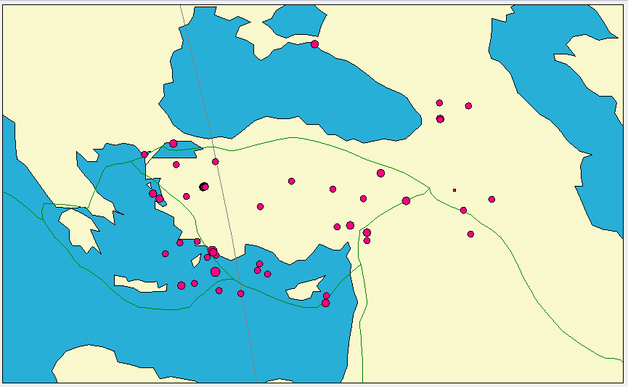

Figure 1 Epicenters of the large events (63) data set.

From the map, it is seen that more events are needed along and to the north of the North Anatolian Fault and in Eastern Anatolia.

Continuous data base

As a test, day files were made for January 2012 using first “gcf2msd_many” (a new program that reads from the AFAD gcf file structure) and then by “msrouter”. This process is rather time consuming since each day contains about 50 000 15 min files. The conversion had to be done under Windows since “gcf2msd” only convert one file at a time on Linux. The process seems to work ok, but no detailed check was made if all data was converted. However, the size of the archive indicates that all were put in.
The corresponding readings were put in using the HINOR program and processing started on the largest events (amplitude for Ml). This data set was also used to calculate magnitudes mb, MS and Ms for a teleseismic event in order to check calibrations, see below.

Plotting from archive

Since the S-files have no reference a waveform file name, a default parameter must be set to tell MULPLT to look in the archive. There are several possibilities:

- Setting parameter ARC_BY_DEFAULT=2 in SEISAN.DEF : This means that, when using command po, in MULPLT, only stations with readings will be plotted. So plotting is quite fast. Only works from EEV. If an additional station is wanted, just add station name to S-file without readings.
- Setting parameter ARC_BY_DEFAULT=1 in SEISAN.DEF : This means that all channels will be plotted.
- Setting parameter ARC_BY_DEFAULT= 0 in SEISAN.DEF : This means that no channels will be plotted from EEV. An arc reference can now be made from EEV. Use command arc in EEV and an ARC line is inserted in S-file with default start time, duration and use of all channels (indicated by a *). The arc line can be edited with arc commend to plot another duration or use readings as reference (indicated by P).

For more details, see latest SEISAN manual in the AFAD installation. The manual on the Bergen Website is not updated.

How to plot an individual event together with data from the archive

- When using command p in EEV, all available waveform sources are shown and the waveform file(s) are also shown.
- Select the desired sources (continuous channels and/or waveform files).

In order to find all channels, both channels marked with HH and BH had to be defined in SEISAN.DEF. This slowed down plotting and a new option was put into SEISAN.DEF making it possible to set a time window of validity for a channel.
Conversion for more months of data was attempted and one month of data was converted at a time. Using that much data, it seems that “msrouter” failed. In addition it was found that some 15 min files did not have the correct channel names so the data could not be found when trying to plot it. Most work was initially done on the old Linux server but problems with many files (like command “ls” ) meant that work had to be done on the new server. The reason for the failure of “msrouter” was not investigated and only data for January 2012 was used.

Data base of readings and hypocenters

Kenan made an output from EA in Nordic format with all the parameters in the EA data base including fault plane solutions. All data available form 2007 to January 2013 were put in, ready to be used if more continuous data are made. Searching in this data base using the S-files was very slow so the corresponding CAT files were made with command UPD. See SEISAN manual for more detail .

Acceleration records

Acceleration records were available for 1160 events for 2011 and 2012. They were converted to miniseed format (new program AFADSEI) and put into the SEISAN data base in WAV. Corresponding S-files were made from the hypocenter and origin time information in the input files and put in the ADD data base and the response files (also made by AFADSEI) put into CAL. The S-files are now duplicates in the data base and should WERE merged with the existing events ASSOCI with a time difference of 2 s. This might have resulted in some other events also being merged. The unit in the files are micrometer/s*s. The epicenters of the events are seen in Figure 2.

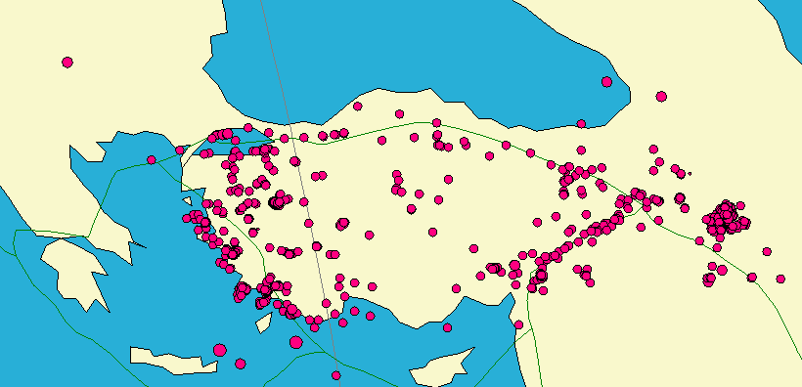

Figure 2. Epicenters of earthquakes with acceleration records for 2011 and 2012.

Magnitudes

Teleseismic event

One large teleseismic event (Sumatra on 2012 01 10) was located and magnitudes determined as part of instrument response information checking.

Following eqarthquake info is obtained for his event by SEISAN (for location, AFAD’s earlier phase readings from EA are used):

10 January 2012 18:36 48 2.080N 94.716E 0.2 km Ms=7.0 MS=7.1 Mb=6.7 MB=7.9

Event info by various agencies are as follows:

Agency
 | ML | Mw | Ms | MS | mb | mB | MLv
PDE-W |  | 7.2
IDC |  |  |  |  | 5.9
IDC |  |  |  | 6.8
IDC | 5.7
CSEM |  | 7.6
DJA
DJA |  |  |  |  | 6.6
DJA |  |  |  |  |  | 7.1
DJA |  |  |  |  |  |  | 7.3
DJA |  | 6.7
GCMT |  | 7.2
MOS |  |  |  | 7.1
BKK |  |  |  |  | 6.5
BKK |  |  |  |  |  | 7.1
BKK |  |  |  |  |  |  | 7.3
AUST |  | 7.2
BJI |  |  | 7.2
BGS |  | 7.3
BGS |  | 7.7
Average | 5.7 | 7.3 | 7.2 | 7.0 | 6.3 | 7.1 | 7.3

The AFAD magnitudes comply with those reported with international agencies. Especially the broadband surface wave magnitude reported by MOS is exactly the same as computed by SEISAN using AFAD network. The slight difference in location should be attributed to AFAD stations being compressed to one particular area and some reading mistakes. From this test there is no indication of significant calibration errors.

Local Events

Amplitudes were read for 180 events for January 2012, partly to get training in using software and partly to compare old and new magnitudes. The average difference between the old AFAD magnitudes and the new Ml (using California scale) is 0.8, see Figure 3.
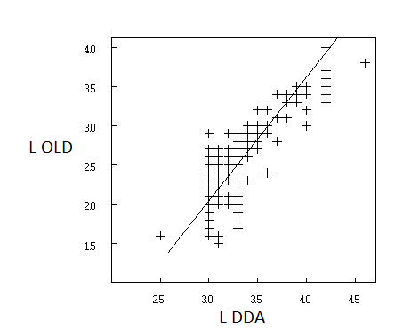

Figure 3 Comparison between old ADAD local magnitudes (OLD) and new magnitudes (DDA).

However looking at the larger events, the difference seems smaller. A test was made with event 2013 0113 08:55. The following magnitudes were calculated:

Ml (DDA) = 4.5 (SEISAN, California Scale)
Mw (spectrum) = 4.8 (SEISAN)
Mw (Isola) = 4.6
Mw (Swift) = 4.6
Mw (Dreger in SEISAN) =4.5

which can be compared to

Ml (Kandilli) = 5.0
M (EMSC) =4.9
Ml (old DDA) =5.0
Mw (GFZ) = 4.7

There is a consistency within all magnitudes calculated by DDA, but other magnitudes are larger. Since the teleseismic test seem to indicate that calibrations are OK, some scales outside DDA and inside DDA do not seem consistent. Obviously some magnitude calibrations will have to be made somewhere.

Procedures

Procedure for adding data to the test data set using gcf files

- Put all gcf file in one directory for one event
- Run conversion: gcf2msd *.gcf /net:TU /sys
- Run SEISEI with options (1) Merge, output in miniseed format, enter for default base name NSN and enter time lag long enough to cover different start times for all individual files; make sure time window is large enough (3800 s generally covers all cases) to include all traces.
- Get S-file from SEISAN data base, DDA. If a new event, get it from Kenan.
- Add waveform file name of the merged file into the S-file.
- Put S-file and waveform file in directory of large events, WOR/BIG

Procedure for adding data to the test data set from SEISAN data base

- Select event from SEISAN data base
- Plot all relevant traces desired for output file in time window desired
- Copy out file with Out command
- Copy out S-file from eev with c-command
- Put waveform file name in S-file
- Copy all to directory of large events

Procedure for adding data to the test data set directly from archive

- Open time window desired in MULPLOT, option arc
- Plot all channels, if many windows, use option N to plot all on one window
- Select nearest station, option S. Stations with distance defined in SEISAN.DEF are now selected.
- Plot selected stations
- A new radius in degrees can be selected with option R
- Use option Regis (P) to make an S-file and cut out waveform file. Make S-file in local directory.
- Put data to WOR/BIG directory
- After the workshop in Anakara: >180 new big events (M > 4.5 with AFAD magnitudes) were selected from the period 2007-2011, and S-files were placed in BIG folder. Now in BIG folder there are 63 events with readings and wave form data and 180 events without wave data. The events with good geographical distribution should be selected for processing.

Tasks to be completed by AFAD team until next meeting (tentative time April)

- Add more data to the data set of large events to get more uniform coverage, about 20 more.
- Finalize reading WA amplitudes on all vertical channels for the (63) large events and any new event added to the data set. All amplitudes must be checked when locating in order to make sure there is not too large a magnitude difference between the individual stations pointing to potential calibration or reading problems. All events must also be checked for location accuracy.
- Investigate the problem with “msrouter” and put in more data in the archive.
- Read amplitudes on more events using the archive. If amplitude readings are put into EA, fix the interface to SEISAN so correct amplitude notation is used. Check locations and magnitude consistency.
- Kenan is to extract 1 hr gcf files for each station for each of new 180 events (he is informed to do so) and to store them in separate folders in windows. Tugbay is to convert 1 hr station files to mseed using Guralp’s “gcf2msd /net:TU /sys” and combine them a multi-station multi-channel single mseed file using “SEISEI” with parameters
  - merge,
  - mseed
  - enter for default agency (NSN)
  - 3800 for merging time tolerance
- Some young people separately read ML amplitudes of BIG events from all possible channels.

