TECHNICAL REPORT # 3
THE AFAD PROJECT OF MAGNITUDE CALIBRATION

Mehmet Ozyazicioglu, Tugbay Kilic, Kenan Yanik, Jens Havskov and Lars Ottemöller

April 2013

Introduction

This report covers activities during visit of J. Havskov and Mehmet Ozyazicioglu to AFAD, April 2013.

The purpose of this visit was to continue the preparation of a data set to be used for the magnitude calibration: Waveform data and corresponding hypocenter files, calibration files and station files.
With this data set a first attempt will be made to invert for the Ml scale as well as testing suitable Q-values for the spectral Mw.

Status at arrival

The original 63 large events had been reprocessed. However, the processing was incomplete:

- Many events had very few S readings
- Not all traces with signals were read
- Many traces only had readings of amplitude and could therefore not be used since no distance can be calculated.

New processing:

- All events were processed again for both readings and amplitudes, so considerably more data is now available.
- All events were checked with the Wadati plot to check the quality of the readings.
- Events were relocated using only the nearest stations (XNEAR and XFAR 150 and 450 km, respectively).

By doing the Ml inversion, it was discovered that 3 stations had wrong calibration:

YURE: Was BB instead of SP
EKAR: Missing
ECAT: Missing

Calibration curves were fixed and tested, however the amplitude readings were not corrected.

There often seem to be missing stations (are data missing from stations where there should be data?). These are mostly ‘ghost’ stations being generated when there are transmission problems. A name could e.g. be ANA03. However, 3 missing stations were found and included.
Further Data Addition

Events from 2013 were added to the data set (10 more). These events had already been processed by extracting events out of the SeisComp ring buffer. Since only vertical channels were used (SeisComp only receives vertical channels, or only these were extracted?), the waveform files only have vertical channels, maybe the complete files should be extracted to make the data set useful for other purposes.
37 events between the years 2008 to 2011 were also added, and were processed.
The large Van earthquake of October 2011 (WHRV=7.1) and an aftershock (WHRV=5.4) plus
2 events from Caucasus (Black Sea coast) which had Harvard CMT solutions were added to get a better geographical distribution of events. (I think events far outside the network should not be included).
The total data set now consists of 112 events, see Figure 1.

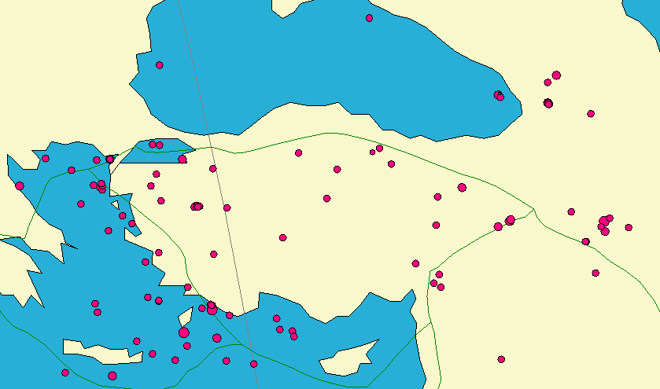
Figure 1 The test data set of 112 events.

Inversion for a new Ml scale

The 64 reprocessed events were used for the Ml inversion. The ray-path distribution is quite good, see Figure 2.
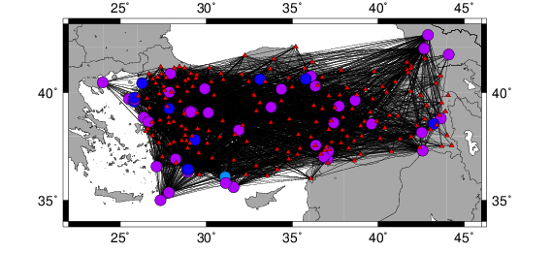
Figure 2. Ray-Path coverage of the 64 events in the data set. The circles give the event locations and the triangles indicate station locations. In total, 3949 observations are used from 64 events. The depth distribution of the events is seen in Figure 3, a check should be made to see if depths below 30 km are reliable.

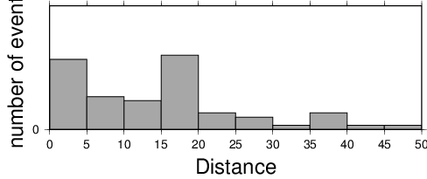

Figure 3. Depth distribution of events.

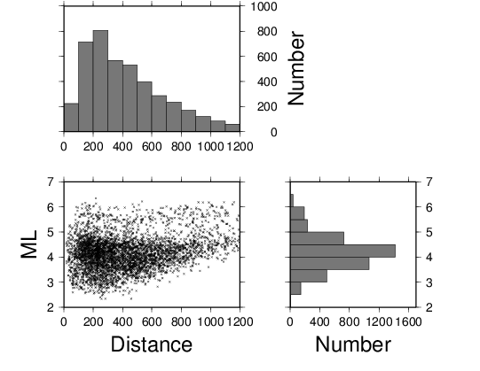

Figure 4 Distribution of data with magnitude and distance.

The new Ml scale is given by

Ml = log A + 1.15 * log R + 0.00141 * R – 2.12 + S

where R is hypocentral distance (km). The distance correction term (-log A0 ) is slightly lower than that of Hutton and Boore (1987), see Figure 5. However, it is intermediate between Joyner and Bakun (1984) and the intra-plate scales for Norway (Alsaker, 1991) and the northeastern US (Kim, 1998). It seems that compared to California, the attenuation in Turkey is a bit smaller so Ml magnitude will decrease compared to using the California scale.

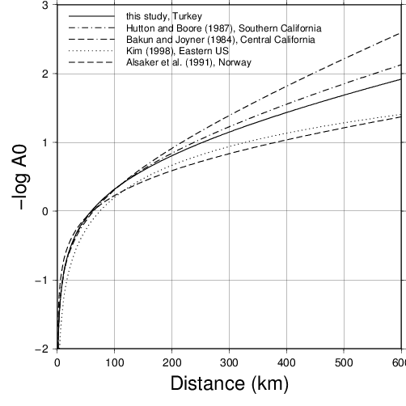
Figure 5 Comparison of Ml correction term -log A0 with other scales.

Compared to the Hutton and Boore scale (1987) without station corrections, the overall variance reduction is 29 %. This improvement is shown in Figure 6. The figure also shows the reduction of distance dependence, although this partly remains with the new scale.

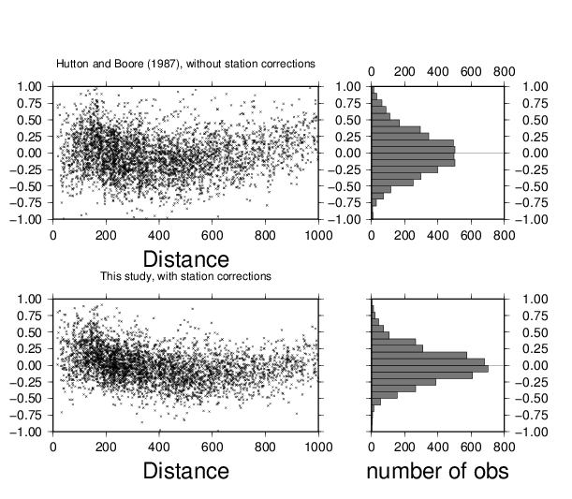
Figure 6. Left: Individual magnitude residuals as function of distance is compared to the event averages for the Hutton and Boore scale (1987) without station corrections and the magnitude scale derived here. Right: Histogram version of the data.

We can conclude preliminarily that the Ml scale for Turkey will be quite similar to the scale for California by Hutton and Boore (1987), but significantly different from Richter (1935) or Bakun and Joyner (1984); the data will also be investigated for regional variations.

Attenuation for spectral Mw

Some initial tests were made to get an idea of the proper values for Q, until the final inversion will be made with the Qlg method.

The Q-correction was made with the following attenuation function:

where A(f, t) is the amplitude as a function if distance, A0 is the initial amplitude, κ is the near surface attenuation and Q(f) is the frequency dependent attenuation, which usually is expressed as

An example is shown in Figure 7.

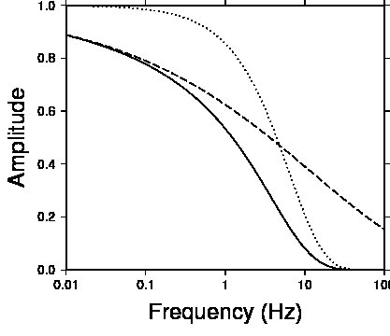

Figure 7. Illustration showing the functions (dotted) and (dashed) and the product of the two (solid). In this example we use Q(f)=200*f^{0.7}, κ=0.05 and t=30s.

The Brune model predicts the following source displacement spectrum S(f)

where M₀ (Nm) is the seismic moment, ρ is the density (kg/m³), v is the velocity (m/s) at the source (P or S-velocity depending on spectrum) and f₀ is the corner frequency. This expression does not include the effect of radiation pattern (see Chapter 7). The shape of the log-log spectrum is seen in Figure 8.
At low frequencies, the spectrum is flat with a level proportional to M₀ while at high frequencies, the spectral level decays linearly with a slope of -2. At the corner frequency (f=f₀), the spectral amplitude is half of the amplitude of the flat level.
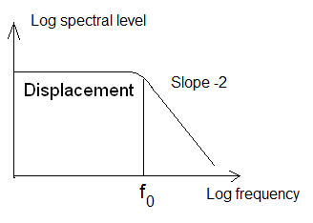
Figure 8 Shape of the seismic source displacement spectrum.

After, correcting the spectra for Q, we should therefore get the spectral shape as seen in Figure 8. SEISAN has the facility for doing a search for the best spectral level and f₀ (e.g. used in MULPLT for the spectral analysis). In this study, an S-velocity of 3.6 km/s and a density of 3.0 g/cm**3 was used.

A new program, called AUTOMAG, can do a grid search using different Q₀, α, and κ to find the values best fitting the Brune spectral shapes.

The test can be made with many traces from many events; up to 4000 spectra were used for each attenuation combination in the grid search. Only S-waves were used.

Q₀ and α will play off each other, therefore a comparable fit might be obtained with a low Q₀ and high α as with a high Q₀ and low α. (QLg measures Q for various frequencies, so it is not an issue)
However, the lower Q₀ will generally give a higher spectral level and therefore a higher magnitude. Similarly, κ also plays off with Q₀, but to a lesser degree.
Hence, for any given Q₀ and α, there was generally a best κ which was in the range 0.03 to 0.05. In order to limit number of parameters, a value of κ= 0.04 was selected.

For the α parameter, the best fits were obtained for α in the range between 0.5 to 0.7 and the value is fixed to 0.6.

For Q₀, the values with a good fit were in the range 100-300, depending on α. On fixing κ and α, the range was reduced to 150 to 250. A good fit to the Brune spectrum does not entail automatically a correct Q₀, since the spectrum could have another shape, but at least it gives an indication of possible values.

At this stage, only Q₀ should be selected and new grid search was made with events with known reliable Mw. The events with known Mw were selected from CMT solutions in order to get a uniform Mw, see Figure 9. For the selected 12 events, the Q₀ giving the closest average Mw to CMT Mw magnitude was 150, however there was some significant scatter, see Figure 10, thus other Q₀’s were also tested, see Table 1.

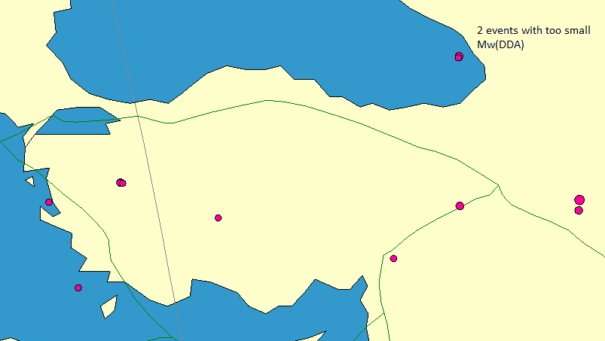

Figure 9 Epicenters of events with CMT solutions.

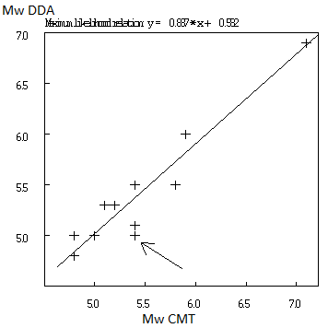

Figure 10 Comparison of Mw CMT and Mw DDA (explained) (Q₀=150). The arrow indicates the most deviating DDA magnitude, see Figure 12.

Using a Q₀ = 150, Mw were calculated for the 73 events and compared to the new Ml (Table 1). The average Ml is 3.99 and Mw is 4.56, so Mw is significantly higher than Ml while we ideally would expect them to be equal.
Tests were made with higher Q₀’s to see if this could lower the Mw sufficiently (Table 1). The tests with higher Q₀ did not solve the problem, although Ml and Mw got closer to each other. However, there is a reasonably linear relationship between Mw and Ml, see Figure 11.

Table 1 A comparison of average magnitudes using different Q₀
 | Q₀=150 | Q₀=200 | Q₀=300 | Q₀=600 | Average Mw CMT | Average Ml DDA
12 CMT vents | 5.37 | 5.31 | 5.28 | 5.22 | 5.39
73 events | 4.56 | 4.49 | 4.38 | 4.33 |  | 3.99

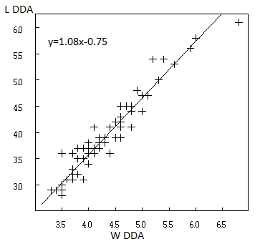
Figure 11 Ml (DDA) vs Mw(DDA), Q0=300.

Tests made with individual events in different areas showed significant distance bias in some cases, both positive and negative, so it might be difficult to use a single attenuation function for the whole area.
Figure 12 shows an example of the most deviating event. There is clearly a distance bias, most clearly seen when Q₀=300. Since the moment decreases with distance and Mw is too low, a lower Q₀ might be needed. Alternatively a different geometrical spreading could be used. This event and one more is located in the Black Sea (Figure 9). The first has a magnitude 0.4 smaller than the CMT magnitude and the other 0.3 smaller, clearly an indication of a regional bias. Disregarding these 2 events, a Q₀=200 gives the best agreement between CMT and DDA magnitudes.

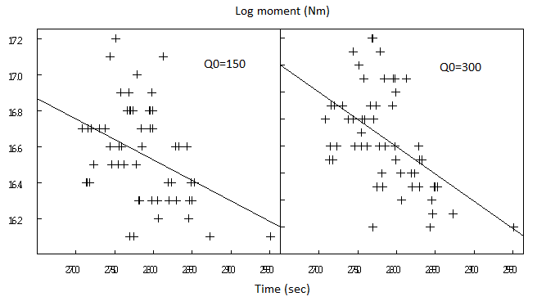
Figure 12 Log moment vs start time of spectral window for two different Q₀. Each point represent one station. The event is 2012 1225 22:44, Mw (DDA) = 4.9 for Q₀=400, Mw(DDA)=5.0 for Q₀=150, Mw(CMT)=5.4. (why not show the difference from average as function of distance for several events?)

Current ML practice in DDA

AFAD still uses the old procedure for calculating Ml: Take the maximum P-wave amplitude within 3 seconds on the Z-channel raw trace, correct for instrument with one frequency only, apply a fudge factor to give a ‘correct’ magnitude and calculate Ml using the original Richter Ml scale.
Old AFAD Ml is compared to the new Ml and Mw (Q₀=200) in Figure 13.
It is clear from the scatter of the data that several of the old Ml’s are completely off. The average Mw is 4.5, Ml(old) = 4.7 and Ml(NEW) = 4.0.
So the old Ml is probably a bit too large but still closer to Mw than the new Ml. (Is that because it was made to be close to MW, fudge factor?)

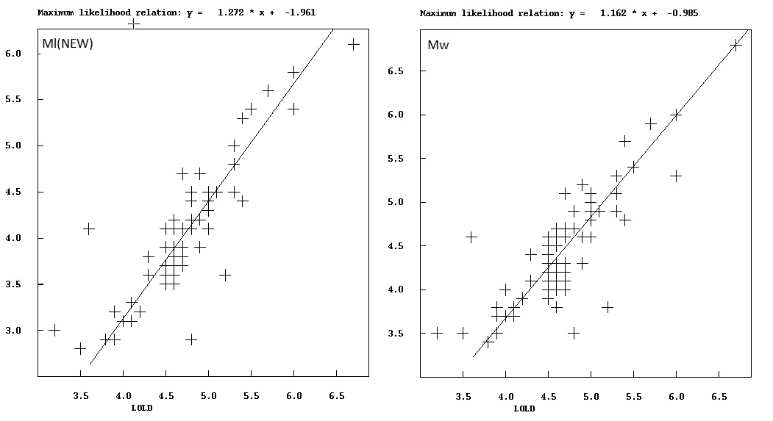
Figure 13 Comparison of old Ml to new Ml and Mw, Q₀=200.

Discussion

The new Ml scale seems reasonable compared to other scales; a slightly lower attenuation in Turkey as compared to California does not sound unreasonable. The significant difference between Ml and Mw for the larger data set seems a bit problematic; still it does not seem to be a question only about using a higher attenuation. The potential source of the difference can be several of the following:

- The geometrical spreading is not correct
- S-velocity and/or density is wrong
- The automatic fitting of the spectra has a systematic error
- The Ml scale is not correct.

These topics will be investigated with the complete data set and after the independent determination of Q with the Qlg inversion. For now, it seems that using a Q=200 f^0.6 is the best choice.

Tasks to be completed by the AFAD team (until next meeting)

- Finish processing the data set.
  - MT inversion on all data set (112 events) (above magnitude 4?)
  - Put HRV Mw in s-files of all 112 events

- Add more data which have GCMT solutions to have a better data base for comparison.
- Check all events for location accuracy; particularly the depths should be checked against other sources.
- Prepare another data set of 50 small events (2.0 < M < 3.1) for further Ml testing
- Is data set for Q inversion ready?

Technical comments

Velocities and Q is set in MULPLT.DEF. Q for P and S are therefore the same and velocities and density do not vary t with depth. It is possible to use a model for both P and S which can be set up in SEISAN.DEF, see new manual.

