TECHNICAL REPORT # 4
THE AFAD PROJECT OF MAGNITUDE CALIBRATION

Mehmet Ozyazicioglu, Jens Havskov, Lars Ottemöller, Tugbay Kilic, Kenan Yanik
September 2013

Introduction

This report covers activities during visit of Mehmet Ozyazicioglu, Tugbay Kilic, Kenan Yanik
to UiB in 26-30 August 2013.

The purpose of this visit was to finalize the calibration for Ml magnitude, testing the scale as well as Q determination by QLg method using the data set prepared. We will also compare derived Ml scale magnitudes to Mw calculated by spectral method, and two Mw magnitudes (by moment tensor inversion (Dreger) and spectrum method using average Q, alpha and kappa estimated for whole country).

Status at arrival

The original 112 large events (3.5 < M) had been reprocessed with
- p-phase and WA amplitude readings on all triggered channels and some s-phase readings,
- rms < 2 for all except 2 events.
- All corrupt wave form files had been replaced.
- Some new events had been added to the data set, making the total number of events 164.
- All large events were given magnitude information from external sources (ISK, PDE, MSCE, HRV, GFZ).
- All events were provided with a report file containing
  - Tavel time
  - Wadati diagram
  - Distance ordered waveform plots.
- A new small earthquakes (M < 3.0) data set, well distributed over the country has been added (83 events)

Further checking the data set:

- All events were checked with the Wadati and travel time plots
- Locations of 30 suspicious events were compared to MSCE or PDE locations and phase picks were corrected.
- 4 events which either duplicates or fall too far from the network coverage area and do not locate well were deleted, leaving 160 events in the data set.
- 3 stations missing in the station list were added to STATION0.HYP file.

Epicenters of the old, new and small test data set is seen in Figure 1.
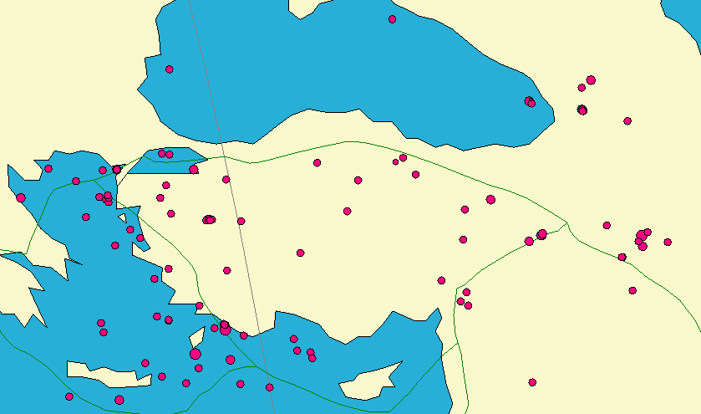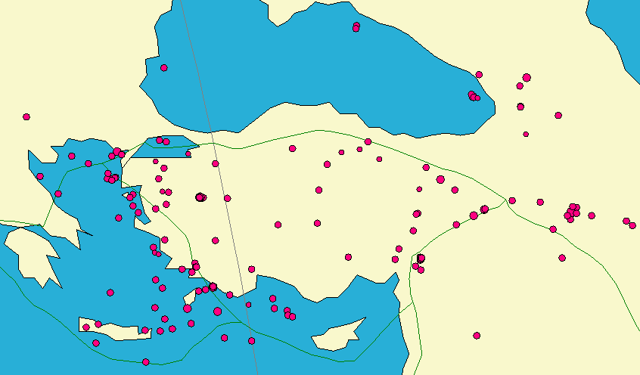
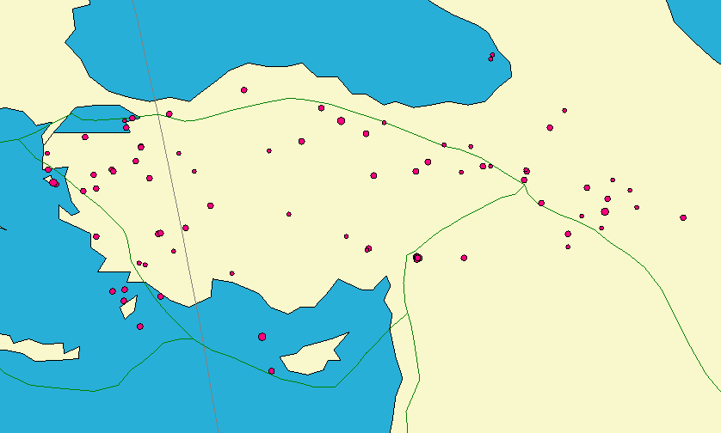
Figure 1. Top left: The earlier test data set of 112 events. Top right: The new test data set of 160 events. Bottom: The new test data set of small events (83 events).

Inversion for a new Ml scale

The 160 reprocessed events were used for the Ml inversion. The ray-path distribution is quite good, see Figure 2.

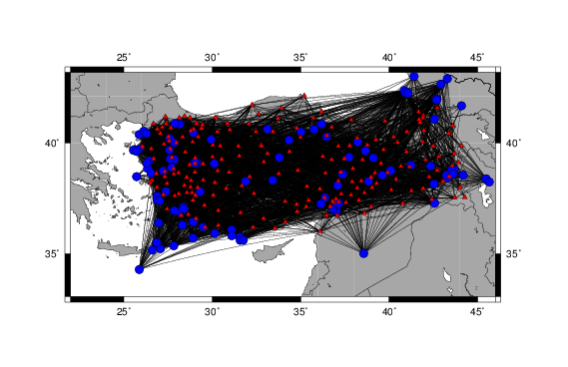
Figure 2. Left: Ray-Path coverage of the 112 events in the old data set. The circles give the event locations and the triangles indicate station locations. Right: The same for the new test data set of 160 events

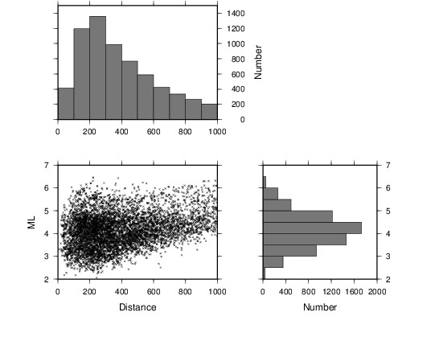
Figure 3. Distribution of data with magnitude and distance.

The Ml scale from the previous inversion of 112 evens was

Ml = log A + 1.15 * log R + 0.00141 * R – 2.12 + S

and the new inversion with 160 events

Whole Country:

Ml = log A + 1.12 * log R + 0.00162 * R – 2.09 + S

When the inversion is done for west and east Turkey separately, the scales come out as:

West:

Ml = log A + 0.83 * log R + 0.00237 * R – 1.59 + S

East:

Ml = log A + 1.11 * log R + 0.00165 * R – 2.07 + S
where R is hypocentral distance (km), A is ground displacement amplitude in (nm). It is seen that using the larger data set (160 events) makes almost no difference as compared to the old data set of 112 events. The scales of east and west Turkey are also very similar (see Figure 4). As with the previous data set, the distance correction term (-log A0 ) is slightly lower than that of Hutton and Boore (1987), see Figure 4. The new scale is intermediate between Joyner and Bakun (1984) and the intra-plate scales for Norway (Alsaker, 1991) and the northeastern US (Kim, 1998). It seems that compared to California, the attenuation in Turkey must be slightly smaller leading to Ml magnitude to decrease compared to using the California scale.

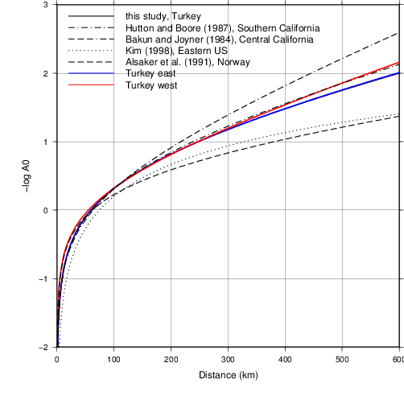
Figure 4. Comparison of Ml correction term -log A0 with other scales. This figure includes the inversion of east and west Turkey.

Compared to the Hutton and Boore scale (1987) without station corrections, the overall variance reduction is xx %. This improvement is shown in Figure 5. The figure also shows the reduction of distance dependence, although this partly remains with the new scale.

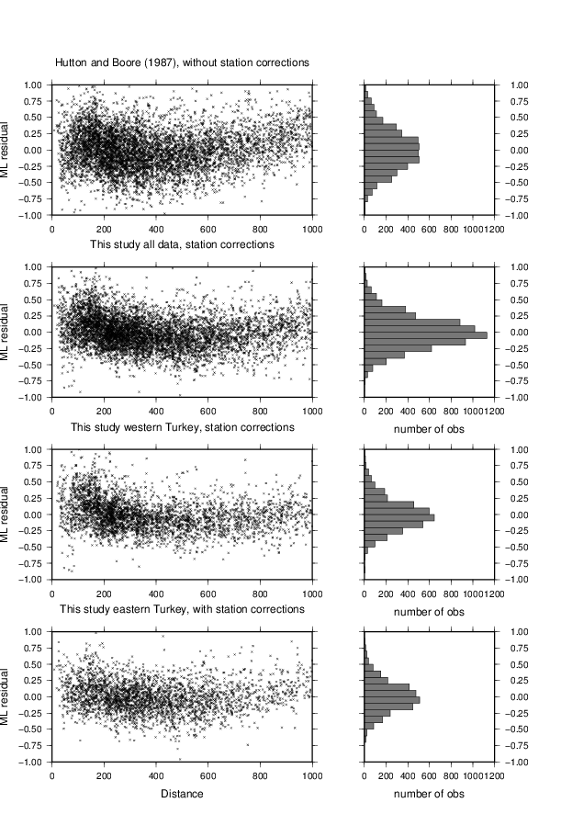
Figure 5. Left: Individual magnitude residuals as function of distance are compared to the event averages for the Hutton and Boore scale (1987) without station corrections and the magnitude scale derived here. Right: Histogram version of the data. The results are shown for all data and eastern Turkey and western Turkey, respectively.

We can conclude preliminarily that the Ml scale for Turkey will be quite similar to the scale for California by Hutton and Boore (1987), but significantly different from Richter (1935) or Bakun and Joyner (1984). The east and west Turkey scale are so similar that there does not seem to be any reason to use 2 different scales (Figure 4).

Table 1. Average Standart Deviation of with Different Ml Scales
Model | Av. STD
Bakun and Joyner (1984) | 0.3334
Hutton and Boore (1987) | 0.2786
This Study (whole country) | 0.2758

As seen in table 1, average standard deviation of station magnitudes is minimum with the model obtained in this study, indicating better inversion for current data available.

Horizontal vs Vertical Seismogram Amplitudes in Ml

Testing a few events indicate that Ml will increase by about 0.2 if horizontal component are used. This must be studied in more detail and, if confirmed, the Ml scale can be adjusted accordingly.

Comparison of Dreger moment tensor inversion Mw and spectral Mw

Moment tensor inversion using the Dreger method had been completed at AFAD on 20 events in the test data set. Since the magnitudes determined by the spectral method still has some uncertainty due to attenuation being uncertain, the spectral Mw was calculated using those 20 events and then compared to the Dreger Mw. Since the moment tensor Mw is determined at low frequencies ( <0.05 Hz), it is assumed to represent the ‘correct’ Mw. For the spectral Mw, the following parameters are used:
Vp=6.2 km/s, Vs=3.6 km/s,
density=3.0 g/cm³,
Q=200f^{0.6}
κ=0.4.
Time window = 30 s .
These are the values found most suitable, see technical report #3. Figure 6 shows the comparison.

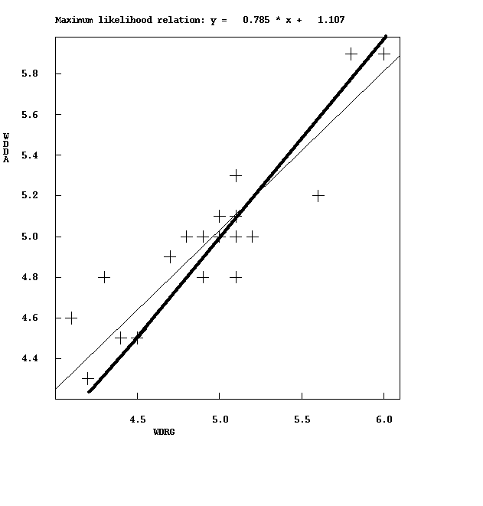
Figure 6. Comparison of spectral Mw (DDA) and Mw from the Dreger inversion (DRG). The thick line is the 1:1 relationship.

On average the two magnitudes were the same but there is scatter in the data. However the comparison shows that on average the magnitudes obtained with Dreger moment tensor solutions are correct.
In report #3 it was shown that comparing Mw from CMT tensor solutions, using larger events, also agreed very well with the Mw from the spectra. So in the magnitude range M = 4-7, the spectral method seems to work reliably and the preliminary Q-values seem reasonable.

Comparing Mw to Ml using the latest Ml scale

For the test data set, Mw was recalculated with the parameters used above and the resultant Mw compared to the new Ml, see Figure 7.
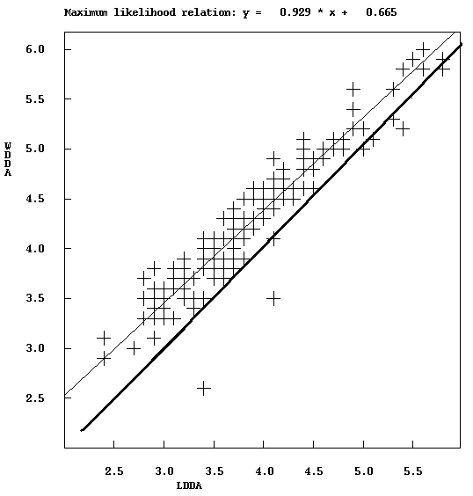
Figure 7. Local magnitude (LDDA) vs. spectral Mw for large earthquakes (160 events). The thick line is the 1 :1 relationship. No station corrections used.

The average Ml and Mw were 3.9 and 4.3, respectively, a difference in magnitude of 0.4. I is seen that the difference decreases with magnitude and at magnitude 5, the difference is only 0.2. If a correction factor of 0.2 is used due to the horizontal vs vertical amplitude difference magnitudes would then be on average the same for magnitudes above 5 and Ml only 0.2 less than Mw at magnitude 3.

Tests werer also made wıth the small event data set. For these events the same spectral parameters were used as for the large events except that the tıme wındow was 20 s. Using events with magnitude 1.5 to 3.0 the averages for Mw and Ml are 2.87 and 2.24, respectively, a difference of 0.6 (see Figure 8). This is larger than the 0.4 we got for the larger magnitudes
And the correct of 0.2 will not bring the two magnitudes together.

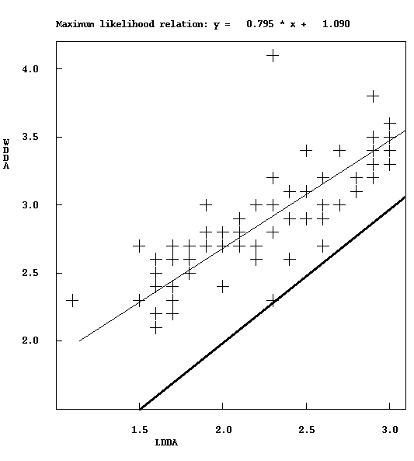
Figure 8. Local magnitude (LDDA) vs. spectral Mw for small earthquakes (83 events). The thick line is the 1:1 relationship. No station corrections used.

Discussion

The new Ml scale made with a larger data set is very similar to the scale found for the smaller data set. The scale seems reasonable compared to other scales; a slightly lower attenuation in Turkey as compared to California does not sound unreasonable. There is still a significant difference between Ml and Mw, particularly for the smaller events in the test data set. This cannot be explained by anchoring the scale at 100 km instead of the ideally more correct 17 km since the shape of the attenuation curve for Turkey virtually identical to most other scales in the distance range 0-100 km. Thus anchoring at 17 km would not change the magnitude values. The old Ml seem to be more in agreement with Mw than the new Ml (see technıcal report 3) . We consider the Mw from spectra correct on average since they compare well with the Mw determined by moment tenor inversion. The reason for the difference from Mw could then be

- Significant difference of amplitudes on vertical and horizontal components
- Non normal sources in the region (source spectra different)
- The old Ml scale is not a standard Ml scale (see technical report #3)

If we use the correction 0.2 for the vertical/horizontal amplitude difference, the difference is at most 0.2 magnitude units in the magnitude range 3-6. This can be considered acceptable.
It is often observed that for larger events Mw=Ml and this is also what is expected theoretically (Deichman, 2006). For events smaller than about magnitude 3 (region dependent), it is observed that Mw ~0.7 Ml and Ml is underestimated relatively to Mw (Deichmann, 2006). In our study the factor ıs 0.8 for small events and 0.9 for the large eventsç This discrepancy could be attributed to various parameters, however it seems that the main cause is the attenuation and scattering between the source and receiver (Bethmann et al, 2011). This can be explained by the higher frequency content of smaller events relative to larger events at shorter distances and therefore higher attenuation than envisaged in the standard Ml relation using larger events. Ideally therefore the Ml scales should have a magnitude dependent term. In practice, this is rarely done. In the current large event data set we have few events smaller then 3.5. However as expected, the magnitude difference will increased more for the smaller events.

If AFAD wants to use a standard Ml, calibrated for Turkey, it must be accepted that Ml will be smaller them Mw, particularly for smaller events. This is due to the limitation in the Ml scale. If other agencies report an Ml larger than the Ml given by the new scale, it is like that they do not use a correct Ml scale calibrated for Turkey. We have e.g. found the SeisComp3 system use a non standard scale which seem to overestimate the Ml values by 0.4 at 300 km distance (reference SeisComp3 manual). On the other hand if AFAD wants to report magnitudes with similar values as the old Ml, the spectral Mw scale can be used. It is strongly advised to discontinue the use of the old Ml scale since it has little scientific justification, the amplitude readings are non standard and consequently the magnitudes cannot be related to any known standard.

Tasks to be completed by the AFAD team (until next meeting)

- Check systematically for the differences between reading on horizontal and vertical component by reading amplitudes on 10 events on both horizontal components.
- Check for amplitude outliers
- Put in missing OLD Ml (LOLD) values in test data set

References

Bethmann, F., N. Deichmann and P. M. Mai (2011). Scaling Relations of Local Magnitude versus Moment Magnitude for Sequences of Similar Earthquakes in Switzerland. Bull. Seism. Soc. Am. 101, 515-534.

Deichman, N. (2006). Local magnitude, a moment revisited. Bull. Seism. Soc. Am. 96, 1267-1277.

Appendix

Station correction terms to be applied
Code Correction Latitude Longitude
Station # 1 BOZC 0.193 +/- 0.1679 39.842 26.053
Station # 2 KMR 0.346 +/- 0.2251 40.418 27.069
Station # 3 SART 0.156 +/- 0.1467 40.688 27.178
Station # 4 NEV 0.352 +/- 0.2598 39.954 27.263
Station # 5 YNK -0.119 +/- 0.1881 40.826 27.397
Station # 6 ATI 0.102 +/- 0.1319 40.083 27.563
Station # 7 BALY 0.069 +/- 0.1396 39.740 27.619
Station # 8 SLV -0.163 +/- 0.1758 41.073 28.140
Station # 9 BAG -0.241 +/- 0.1766 38.655 26.852
Station # 10 CAM -0.069 +/- 0.1951 38.748 27.313
Station # 11 ELBA 0.373 +/- 0.1855 41.147 28.431
Station # 12 AKHS 0.344 +/- 0.1331 38.879 27.814
Station # 13 DURS 0.050 +/- 0.1353 39.601 28.474
Station # 14 YAK 0.214 +/- 0.3562 38.515 27.323
Station # 15 BLN 0.072 +/- 0.1571 38.635 27.822
Station # 16 ESK -0.300 +/- 0.1844 40.607 28.945
Station # 17 KTT 0.032 +/- 0.5797 38.688 28.093
Station # 18 DGB 0.104 +/- 0.1444 38.052 26.882
Station # 19 DUV 0.001 +/- 0.3361 38.220 27.449
Station # 20 IGD 0.178 +/- 0.1813 40.264 29.201
Station # 21 DEMI 0.139 +/- 0.1450 39.043 28.716
Station # 22 GCAM 0.205 +/- 0.1628 37.714 27.242
Station # 23 KRB -0.175 +/- 0.3360 38.134 28.423
Station # 24 HAR 0.155 +/- 0.2204 38.341 28.799
Station # 25 AYDN 0.021 +/- 0.1309 37.661 27.879
Station # 26 SUL -0.041 +/- 0.1535 38.054 28.768
Station # 27 KHAL 0.309 +/- 0.1557 38.370 29.492
Station # 28 BBD -0.020 +/- 0.1469 37.802 28.853
Station # 29 UZP 0.090 +/- 0.3036 38.031 29.175
Station # 30 DNZL 0.102 +/- 0.1987 37.689 29.046
Station # 31 GOLH -0.047 +/- 0.1434 37.236 29.559
Station # 32 BOLV 0.074 +/- 0.1257 38.718 30.950
Station # 33 KORT 0.149 +/- 0.1342 37.001 30.350
Station # 34 AKAS 0.231 +/- 0.1442 36.233 29.605
Station # 35 KDHN 0.275 +/- 0.1298 38.521 32.114
Station # 36 BBAL 0.093 +/- 0.1192 39.543 33.123
Station # 37 ELDT -0.035 +/- 0.1280 40.489 33.427
Station # 38 GAZI 0.042 +/- 0.1463 36.235 32.316
Station # 39 ERMK 0.016 +/- 0.1311 36.641 32.911
Station # 40 GULE -0.060 +/- 0.1647 37.284 34.777
Station # 41 ERBA 0.343 +/- 0.1375 40.681 36.755
Station # 42 PINB 0.081 +/- 0.3359 38.677 36.403
Station # 43 ANDN -0.049 +/- 0.1379 37.580 36.345
Station # 44 URLA 0.177 +/- 0.1490 38.360 26.596
Station # 45 CVD -0.148 +/- 0.1515 37.752 28.107
Station # 46 YNC -0.281 +/- 0.1787 37.814 28.573
Station # 47 TURN 0.062 +/- 0.1471 36.775 28.244
Station # 48 GDZ 0.463 +/- 0.1725 39.088 29.481
Station # 49 CMH -0.244 +/- 0.1687 40.012 27.970
Station # 50 KNL -0.038 +/- 0.1623 40.271 27.526
Station # 51 KRC -0.068 +/- 0.1709 40.265 28.332
Station # 52 KVK 0.101 +/- 0.1844 40.604 26.888
Station # 53 MADM 0.242 +/- 0.2150 40.654 27.665
Station # 54 BOZ -0.083 +/- 0.2916 40.535 28.782
Station # 55 KKZ -0.186 +/- 0.1884 41.127 27.345
Station # 56 KLC -0.332 +/- 0.1682 40.633 29.398
Station # 57 GBZ 0.034 +/- 0.1510 40.787 29.450
Station # 58 ALT -0.147 +/- 0.1495 41.088 28.740
Station # 59 KIZK -0.029 +/- 0.1507 36.480 34.144
Station # 60 CDAG 0.112 +/- 0.1194 39.624 34.372
Station # 61 ILGA 0.006 +/- 0.1477 41.052 33.716
Station # 62 CAY -0.296 +/- 0.2149 37.172 35.318
Station # 63 HAVZ -0.081 +/- 0.1248 41.074 35.718
Station # 64 AKCD -0.442 +/- 0.1355 38.296 37.922
Station # 65 DBOC 0.020 +/- 0.2036 41.345 41.667
Station # 66 ARTV 0.334 +/- 0.2158 41.185 41.928
Station # 67 DAGI 0.011 +/- 0.2032 41.078 41.914
Station # 68 DDEM 0.033 +/- 0.1959 40.892 41.754
Station # 69 DIGO 0.331 +/- 0.2177 40.415 43.374
Station # 70 OLTU 0.024 +/- 0.4106 40.545 41.973
Station # 71 HOMI -0.271 +/- 0.1777 40.045 41.905
Station # 72 DYDN 0.069 +/- 0.1752 39.544 43.689
Station # 73 TUTA 0.009 +/- 0.2077 39.402 42.814
Station # 74 KOPT -0.051 +/- 0.1770 40.018 40.497
Station # 75 KELT 0.029 +/- 0.1515 40.149 39.256
Station # 76 TATV -0.004 +/- 0.3367 38.508 42.267
Station # 77 GEVA -0.103 +/- 0.1859 38.312 43.057
Station # 78 SUSE 0.029 +/- 0.1623 40.209 38.202
Station # 79 KEMA 0.454 +/- 0.1426 39.269 38.493
Station # 80 FRT -0.035 +/- 0.1919 38.684 39.198
Station # 81 HAKT -0.094 +/- 0.2072 37.558 43.707
Station # 82 SIRN -0.430 +/- 0.2207 37.496 42.413
Station # 83 ELZG -0.011 +/- 0.1522 38.497 38.985
Station # 84 SCER 0.027 +/- 0.1563 39.861 37.129
Station # 85 GER -0.119 +/- 0.2106 38.032 39.035
Station # 86 MARD -0.423 +/- 0.1525 37.313 40.778
Station # 87 KAH -0.417 +/- 0.3036 37.805 38.610
Station # 88 CLH 0.002 +/- 0.2253 38.016 38.207
Station # 89 ATAB -0.098 +/- 0.1610 37.470 38.295
Station # 90 KHM -0.033 +/- 0.2208 37.523 36.991
Station # 91 NAR -0.086 +/- 0.2315 37.392 37.157
Station # 92 KUZU -0.234 +/- 0.1273 36.773 37.075
Station # 93 YAYL -0.223 +/- 0.1815 36.034 36.107
Station # 94 DED 0.103 +/- 0.2250 36.961 34.799
Station # 95 BDRM 0.124 +/- 0.1580 37.065 27.444
Station # 96 MANT 0.009 +/- 0.1483 38.491 28.558
Station # 97 HAS -0.392 +/- 0.5818 36.772 36.465
Station # 98 BORA 0.275 +/- 0.1260 39.880 30.453
Station # 99 KAMA 0.065 +/- 0.1798 37.186 36.668
Station # 100 HCB 0.093 +/- 0.2253 37.344 36.908
Station # 101 BTAS -0.165 +/- 0.1235 40.571 31.000
Station # 102 BCAM 0.024 +/- 0.1241 40.816 32.066
Station # 103 BES -0.337 +/- 0.1947 37.700 37.855
Station # 104 KAST 0.112 +/- 0.1664 41.490 33.929
Station # 105 DIYA -0.223 +/- 0.1524 37.924 40.121
Station # 106 EUZM 0.316 +/- 0.1691 39.708 39.698
Station # 107 EKAR -0.050 +/- 0.2798 39.256 42.064
Station # 108 MACK -0.024 +/- 0.1882 40.943 39.769
Station # 109 DBAD -0.014 +/- 0.2167 41.018 41.695
Station # 110 TVAN 0.104 +/- 0.2323 38.524 43.404
Station # 111 TOKA 0.049 +/- 0.1510 40.323 36.478
Station # 112 EAK -0.347 +/- 0.2033 40.736 43.607
Station # 113 DAD -0.059 +/- 0.2897 39.908 32.753
Station # 114 EATA 0.051 +/- 0.2322 39.862 42.492
Station # 115 CNG 0.059 +/- 0.4144 38.215 39.299
Station # 116 MLTY 0.093 +/- 0.4489 38.326 38.425
Station # 117 CGC -0.190 +/- 0.3360 37.747 37.296
Station # 118 AYK -0.133 +/- 0.3356 37.415 36.807
Station # 119 AKO 0.110 +/- 0.1875 37.461 35.446
Station # 120 ZEY -0.171 +/- 0.1818 38.239 26.503
Station # 121 BAGO 0.334 +/- 0.1305 37.991 30.789
Station # 122 ERE -0.310 +/- 0.1761 40.045 28.891
Station # 123 AUKUT -0.068 +/- 0.7084 39.396 30.021
Station # 124 AUKIR -0.067 +/- 0.3822 39.287 30.531
Station # 125 AUMIH -0.100 +/- 0.3040 39.868 31.483
Station # 126 AUSIV 0.232 +/- 0.3810 39.440 31.539
Station # 127 CUSAR 0.001 +/- 0.1349 39.418 36.244
Station # 128 CUALT -0.072 +/- 0.1306 39.273 36.753
Station # 129 CUGUR -0.455 +/- 0.1309 38.724 37.272
Station # 130 CUKAN 0.008 +/- 0.1316 39.316 37.467
Station # 131 CUZAR -0.536 +/- 0.1568 39.888 37.771
Station # 132 KESN -0.022 +/- 0.1474 40.826 26.680
Station # 133 AYVA -0.078 +/- 0.1362 39.308 26.690
Station # 134 ECAT 0.532 +/- 0.2706 39.606 40.974
Station # 135 EPOS 0.251 +/- 0.2171 41.504 42.728
Station # 136 VMUR -0.022 +/- 0.2385 38.989 43.572
Station # 137 BNGL -0.134 +/- 0.2613 38.952 41.150
Station # 138 TNCL -0.120 +/- 0.1878 39.115 39.542
Station # 139 ORDU -0.039 +/- 0.1875 40.991 37.857
Station # 140 PAL -0.107 +/- 0.7099 38.699 39.918
Station # 141 BTMN -0.447 +/- 0.1545 37.891 41.270
Station # 142 SAMS -0.234 +/- 0.1940 41.361 36.187
Station # 143 SURC -0.351 +/- 0.1947 36.879 38.613
Station # 144 COAL 0.009 +/- 0.1315 40.255 34.986
Station # 145 AVNS -0.074 +/- 0.1325 38.806 34.847
Station # 146 KERG 0.164 +/- 0.1434 37.415 34.125
Station # 147 BGOL 0.173 +/- 0.2158 38.988 40.671
Station # 148 REFA 0.125 +/- 0.1791 39.906 38.765
Station # 149 KKUL -0.037 +/- 0.1405 39.171 32.917
Station # 150 KAND -0.147 +/- 0.1453 41.094 30.192
Station # 151 SAHE -0.072 +/- 0.1509 40.853 30.854
Station # 152 BTIN -0.036 +/- 0.1731 41.636 32.250
Station # 153 KMER 0.219 +/- 0.1684 37.769 32.368
Station # 154 AKSY 0.143 +/- 0.1495 38.650 33.761
Station # 155 AUBOZ -0.008 +/- 0.4531 39.911 30.032
Station # 156 BUY -0.151 +/- 0.2685 40.853 29.118
Station # 157 KEPZ 0.197 +/- 0.1737 36.902 31.604
Station # 158 YAHY 0.121 +/- 0.1663 38.095 35.363
Station # 159 CTAK 0.035 +/- 0.1904 40.648 34.791
Station # 160 BASK 0.127 +/- 0.2627 38.047 44.011
Station # 161 CMDR -0.160 +/- 0.1602 40.494 32.475
Station # 162 ADCV 0.024 +/- 0.2634 38.808 42.725
Station # 163 YOVA 0.048 +/- 0.4546 37.587 44.290
Station # 164 SRTM -0.214 +/- 0.2696 37.991 41.922
Station # 165 HANI -0.077 +/- 0.1895 38.415 40.400
Station # 166 ISPR 0.282 +/- 0.5810 40.489 41.008
Station # 167 ELBS -0.364 +/- 0.1679 38.324 37.133
Station # 168 SAIM -0.043 +/- 0.1764 37.977 36.082
Station # 169 BAYC 0.045 +/- 0.1453 39.741 26.547
Station # 170 TAVA 0.206 +/- 0.1723 37.466 28.913
Station # 171 KZIL 0.212 +/- 0.1580 38.257 30.141
Station # 172 BRDR 0.072 +/- 0.1558 37.696 30.061
Station # 173 DOGA 0.201 +/- 0.1566 38.106 31.668
Station # 174 SINO -0.150 +/- 0.2515 42.018 35.202
Station # 175 ODTU 0.098 +/- 0.1815 39.868 32.793
Station # 176 STEP -0.274 +/- 0.1680 39.377 27.718
Station # 177 GEYV -0.186 +/- 0.1765 40.484 30.296
Station # 178 HEKM -0.223 +/- 0.1638 38.879 37.959
Station # 179 BAYB -0.086 +/- 0.2223 40.258 40.257
Station # 180 IGDI 0.258 +/- 0.3590 39.868 44.078
Station # 181 GULN 0.095 +/- 0.2253 36.184 33.543
Station # 182 SANL -0.231 +/- 0.2324 37.171 38.989
Station # 183 SMV1 -0.091 +/- 0.3177 39.340 29.024
Station # 184 SIMV 0.242 +/- 0.4486 39.109 29.024
Station # 185 GZT -0.207 +/- 0.5031 37.355 37.561
Station # 186 DALY -0.104 +/- 1.0111 36.816 28.653
Station # 187 FETY 0.383 +/- 1.0102 36.635 29.083
Station # 188 KBUK 0.098 +/- 0.5846 41.236 32.627
Station # 189 CLDR 0.361 +/- 1.0600 39.144 43.917
Station # 190 USAK 0.117 +/- 0.3635 38.714 29.018
Station # 191 AKUM 0.144 +/- 0.4170 36.323 30.343
Station # 192 AFYO -0.098 +/- 0.3858 38.787 30.299

