GMT SCRIPT EXAMPLES

The following examples are working scripts that support the GMT version 5.2 and has been tested on Linux Ubuntu 18.04.1 LTS 64 bit version.

The scripts are basic recipes that the user may use as they are or modify to fit specific needs.
The input files, position of seismic stations, epi-centers etc. must follow the format as shown in the examples unless the user modify the scripts.

EX01 Map of Japan with epi-centers.

Input file: quakes.ngdc

Historical Tsunami Earthquakes from the NGDC Database

Year Mo Da Lat+N Long+E Dep Mag
1987 01 04 49.77 149.29 489 4.1
1987 01 09 39.90 141.68 067 6.8
1987 01 09 39.82 141.64 084 4.0
1987 01 14 42.56 142.85 102 6.5
1987 01 16 42.79 145.10 054 5.1
1987 01 17 39.82 141.67 083 4.0
1987 01 20 38.63 141.97 066 4.0
1987 01 22 43.16 146.48 065 4.6
1987 01 27 41.96 142.65 068 4.1
1987 01 27 35.48 140.82 061 4.1
1987 02 06 36.99 141.79 035 6.1

Input file: quakes.cpt (depth color model)

# color palette for seismicity
#z0 red green blue z1 red green blue
0 255 0 0 100 255 0 0
100 0 255 0 300 0 255 0
300 0 0 255 100000 0 0 255

The bash script:

#!/bin/bash

file=Map.ps

grdfile=../DATA/newbathy.grd
#grdfile=../DATA/Bathymetry_GEBCO_30s_world.grd

# Japan
xmin=130
xmax=150
ymin=35
ymax=50

midlon=`gmt gmtmath -Q $xmin $xmax ADD 2 DIV =`
midlat=`gmt gmtmath -Q $ymin $ymax ADD 2 DIV =`

R="-R$xmin/$xmax/$ymin/$ymax"

J="-JM$midlon/$midlat/16c"

# Make a 1-degree grid
#B="-B1a1f1g1"

# Make a 5-degree grid
B="-B5g5"

gmt grdcut $grdfile $R -Gtmpf.grd

gmt grdinfo tmpf.grd

gmt makecpt -Cglobe -T-8500/8500/50 -Z > cptfile2.cpt

# Create map with top title
gmt psbasemap $B -B+t"Japan" $J $R -K -P > $file

gmt grdgradient tmpf.grd -Nt1 -A225 -Gtmpgrd.grd

gmt grdimage $J $R tmpf.grd -Itmpgrd.grd -O -K -Ccptfile2.cpt >> $file

gmt pscoast $J -B $R -Dh -N1/1.00p,- -K -O -W >> $file

# Add text on a longitude/latitude on map
gmt pstext -R -J -N -K -O -V -F+f25,1,blue+j << EOF >> $file
141.0 49.0 BR Some Earthquakes
EOF

# Add text on a longitude/latitude as sub-title outside map
gmt pstext -R -J -N -K -O -V -F+f15,1,black+j << EOF >> $file
143.0 33.0 BR Japanese Earthquakes
EOF

# Mark all event locations, magnitude and depths (acording to input files quakes.ngdc and quakes.cpt
gmt psxy -R -J -O quakes.ngdc -Wfaint -i4,3,5,6s0.1 -h3 -Scc -Cquakes.cpt >> $file

outeps=`echo $file | sed 's/ps/eps/g'`

eps2eps $file $outeps

gmt psconvert $outeps -Tj -P

gv $file

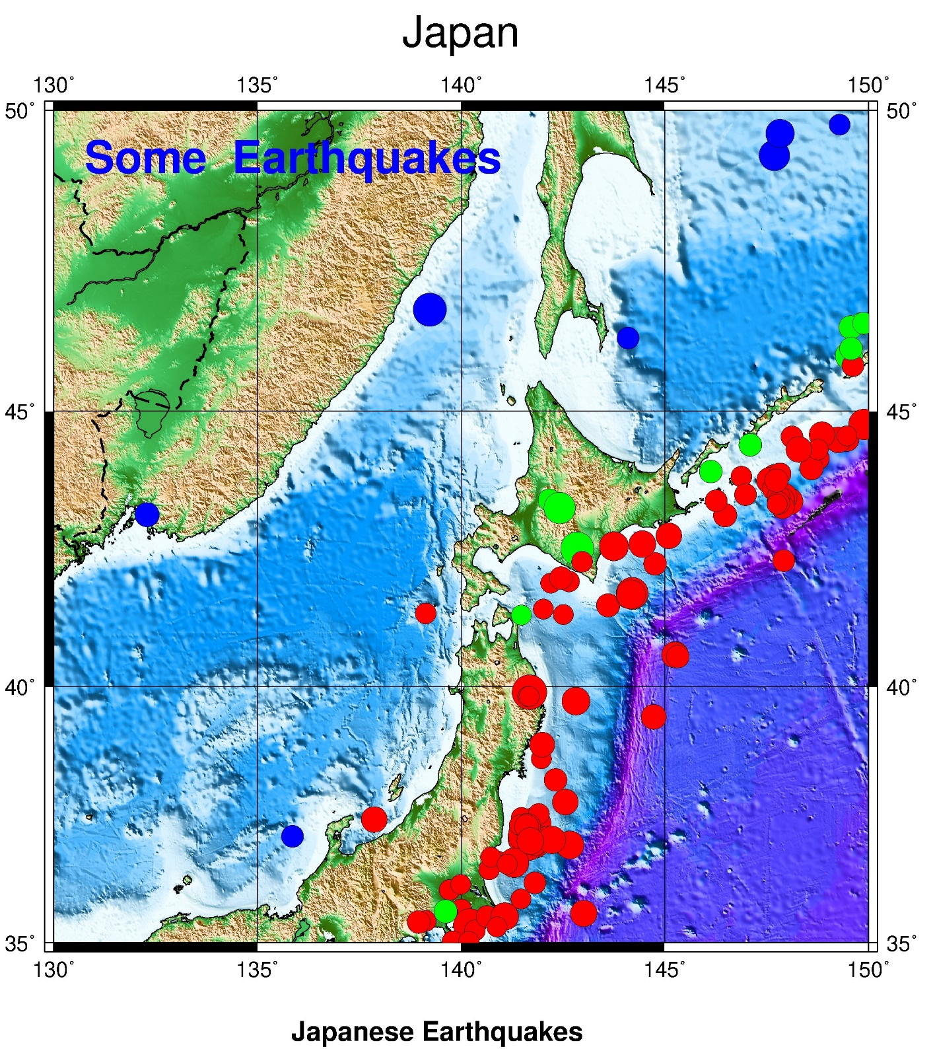

EX02 Map of southern Norway

Input file quakes.ex

Examples events Southern Norway to show magnitude and depth

Year Mo Da Lat+N Long+E Dep Mag
1987 01 04 60.00 8.00 030 4.0
1987 01 09 59.50 7.50 150 5.0
1987 01 09 59.00 7.00 350 6.0
1987 01 14 58.50 6.50 500 7.0

Input file: quakes.cpt (depth color model)

# color palette for seismicity
#z0 red green blue z1 red green blue
0 255 0 0 100 255 0 0
100 0 255 0 300 0 255 0
300 0 0 255 100000 0 0 255

The bash script:

#!/bin/bash

file=Map.ps

grdfile=../DATA/newbathy.grd
#grdfile=../DATA/Bathymetry_GEBCO_30s_world.grd

# South Norway

xmin=4.5
xmax=10
ymin=58
ymax=62

midlon=`gmt gmtmath -Q $xmin $xmax ADD 2 DIV =`
midlat=`gmt gmtmath -Q $ymin $ymax ADD 2 DIV =`

R="-R$xmin/$xmax/$ymin/$ymax"

J="-JM$midlon/$midlat/16c"

# Make a 1-degree grid
B="-B1a1f1g1"

gmt grdcut $grdfile $R -Gtmpf.grd

gmt grdinfo tmpf.grd

gmt makecpt -Cglobe -T-8500/8500/50 -Z > cptfile2.cpt

gmt psbasemap $B -B+t"Southern Norway" $J $R -K -P > $file

gmt grdgradient tmpf.grd -Nt1 -A225 -Gtmpgrd.grd

gmt grdimage $J $R tmpf.grd -Itmpgrd.grd -O -K -Ccptfile2.cpt >> $file

gmt pscoast $J -B $R -Dh -N1/1.00p,- -K -O -W >> $file

#deep_point=760

#gmt makecpt -Crainbow -T0./$deep_point/10 -I -Z > cptfile.cpt

gmt psxy -R -J -O quakes.ex -Wfaint -i4,3,5,6s0.2 -h3 -Scc -Cquakes.cpt >> $file

outeps=`echo $file | sed 's/ps/eps/g'`

eps2eps $file $outeps

gmt psconvert $outeps -Tj -P

gv $file

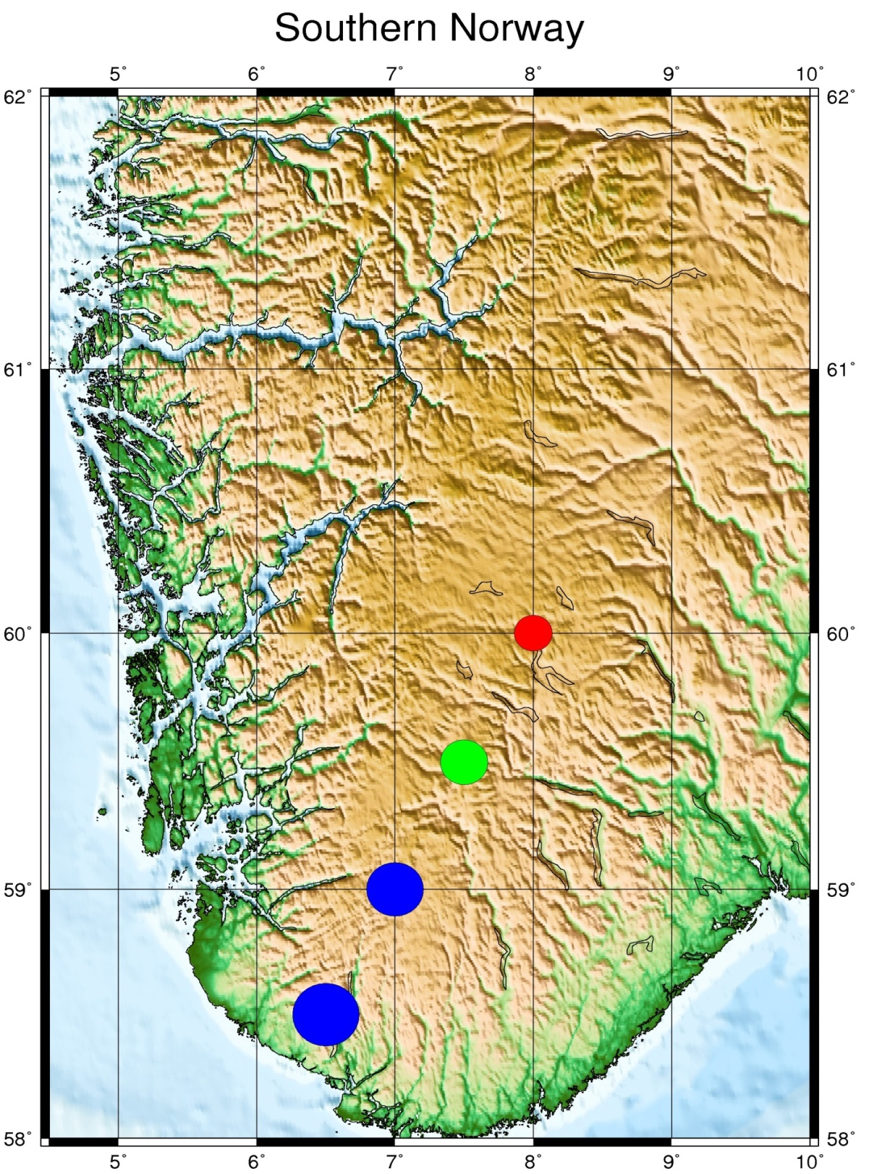

EX03 Map of Turkey with some demo events and depths

Input file: turkey.demo

Some demo events in Turkey

Year Mo Da Lat+N Long+E Dep Mag
1987 01 04 40.00 30.00 489 4.1
1987 01 09 41.00 29.00 030 6.8
1987 01 09 39.00 28.00 034 7.5

Input file: quakes.cpt (depth color model)

# color palette for seismicity
#z0 red green blue z1 red green blue
0 255 0 0 100 255 0 0
100 0 255 0 300 0 255 0
300 0 0 255 100000 0 0 255

The bash script:

#!/bin/bash

file=Map.ps

grdfile=../DATA/newbathy.grd
#grdfile=../DATA/Bathymetry_GEBCO_30s_world.grd

# Turkey map
xmin=20
xmax=40
ymin=34
ymax=43

midlon=`gmt gmtmath -Q $xmin $xmax ADD 2 DIV =`
midlat=`gmt gmtmath -Q $ymin $ymax ADD 2 DIV =`

R="-R$xmin/$xmax/$ymin/$ymax"

J="-JM$midlon/$midlat/16c"

# Make a 1-degree grid
#B="-B1a1f1g1"

# Make a 5-degree grid
B="-B5g5"

gmt grdcut $grdfile $R -Gtmpf.grd

gmt grdinfo tmpf.grd

gmt makecpt -Cglobe -T-8500/8500/50 -Z > cptfile2.cpt

# Create map with top title
gmt psbasemap $B -B+t"Turkey" $J $R -K -P > $file

gmt grdgradient tmpf.grd -Nt1 -A225 -Gtmpgrd.grd

gmt grdimage $J $R tmpf.grd -Itmpgrd.grd -O -K -Ccptfile2.cpt >> $file

gmt pscoast $J -B $R -Dh -N1/1.00p,- -K -O -W >> $file

gmt psxy -R -J -O turkey.demo -Wfaint -i4,3,5,6s0.1 -h3 -Scc -Cquakes.cpt >> $file

outeps=`echo $file | sed 's/ps/eps/g'`

eps2eps $file $outeps

gmt psconvert $outeps -Tj -P

gv $file

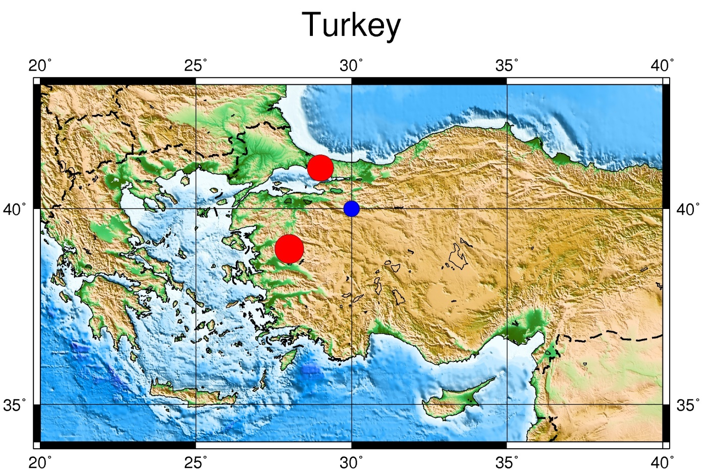

EX04 World Map with locations.

Inputfile: gmtxy.out (all with same depth -> same color on map and different format !!)

Latitud Longitud Depth M

-83.650 10.130 150 0.05400
158.040 52.360 150 0.05600
71.150 36.740 150 0.05300
78.710 22.770 150 0.05500
145.610 18.780 150 0.05600
40.170 39.300 150 0.03000
30.560 39.830 150 0.02000
80.740 29.930 150 0.05700
28.910 36.340 150 0.02500
23.580 39.020 150 0.03200
53.830 -35.270 150 0.05300

Input file: quakes.cpt (depth color model)

# color palette for seismicity
#z0 red green blue z1 red green blue
0 255 0 0 100 255 0 0
100 0 255 0 300 0 255 0
300 0 0 255 100000 0 0 255

The bash script:

#!/bin/bash

file=Map.ps

rm -f $file

grdfile=../DATA/ETOPO10_Bed_c_gdal.grd

R="-R0/360/-90/90"

J="-JKs0/9i"

B="-B30g30"

gmt makecpt -Cglobe -T-10000/10000/200 -Z > cptfile2.cpt

gmt psbasemap $B -B+t"World Wide" $J $R -K > $file

gmt grdgradient $grdfile -Nt1 -A225 -Gtmpgrd.grd

gmt grdimage $J -R-180/180/-90/90 $grdfile -Itmpgrd.grd -O -K -Ccptfile2.cpt >> $file

gmt psxy $R $J $B -O gmtxy.out -Wfaint -i0,1,2,3s5.1 -h1 -Scc -Cquakes.cpt >> $file

outeps=`echo $file | sed 's/ps/eps/g'`

eps2eps $file $outeps

gmt psconvert $outeps -Tj -P

gv $outeps

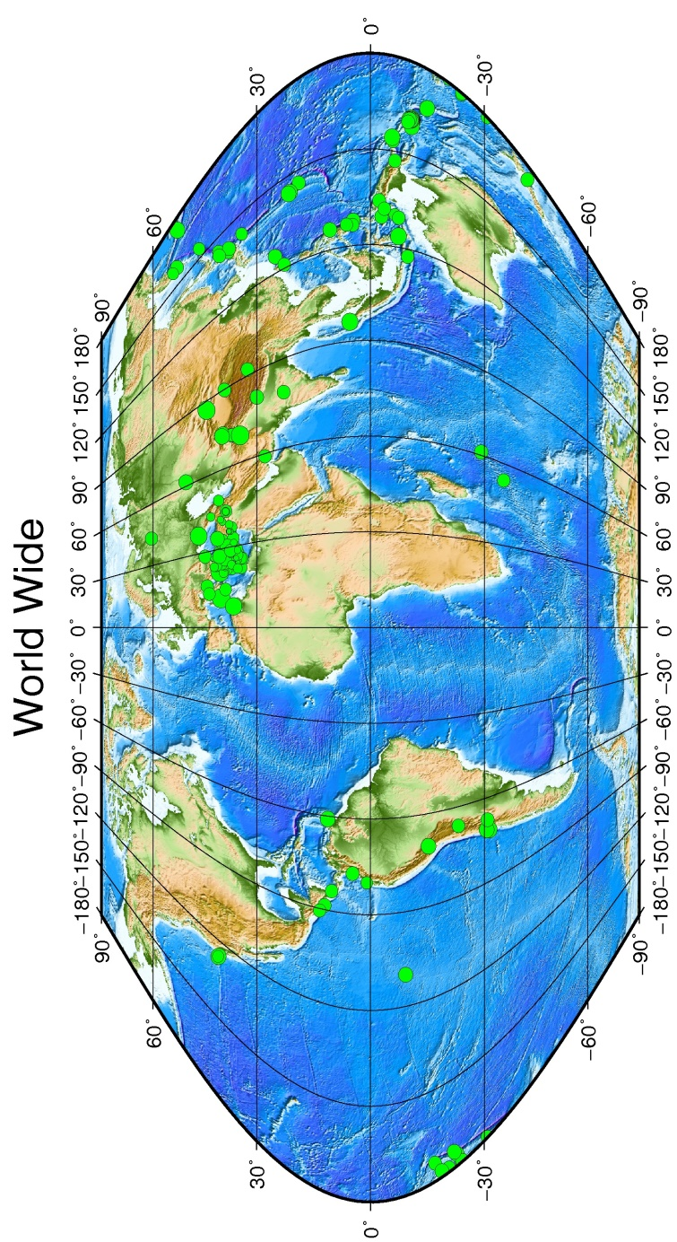

EX05 Dominican Republic with locations and stations

Input file: stations

-71.0591 18.1555 t cyan 4 LOBA1
-71.4209 18.4826 t cyan 4 LONE1
-71.7462 18.0328 t cyan 4 LOPE1
-67.1112 18.4675 t cyan 4 AGPR
-70.3582 18.3923 t cyan 4 BANI
-67.1398 18.2117 t cyan 4 MPR
-69.9170 18.4672 t cyan 4 SDD
-71.2878 18.9822 t cyan 4 SDDR
-69.8561 19.3541 t cyan 4 NADR
-70.7243 19.8053 t cyan 4 PPDR
-70.4000 18.9400 t cyan 4 BON1
-70.7277 19.4272 t cyan 4 SC01
-71.2189 18.8030 t cyan 4 SJM1
-72.6058 18.5110 t cyan 4 LGNH
-68.7169 18.5920 t cyan 4 HIGY1
-75.1108 19.9268 t cyan 4 GTBY

Inputfile: seismicity.dr

2012 11 03 06 04 32.60 -70.523 18.689 20 2.5
2012 11 03 10 03 31.40 -71.461 19.885 20 2.5
2012 11 03 13 22 42.80 -70.296 20.385 20 2.5
2012 11 04 05 47 52.70 -70.935 18.521 20 2.5
2012 11 05 07 25 48.30 -69.716 17.959 20 2.5
2012 11 06 03 06 59.90 -69.775 18.195 20 2.5
2012 11 07 16 35 41.60 -99.316 15.761 20 2.5
2012 11 07 19 07 07.80 -70.694 18.966 20 2.5
2012 11 11 20 36 29.60 -70.879 18.612 20 2.5
2012 11 15 00 20 25.80 -70.756 18.664 20 2.5
2012 11 19 06 55 16.40 -71.165 19.909 20 2.5
2012 11 25 01 27 14.10 -71.252 17.990 20 2.5
2012 11 25 11 06 08.90 -68.702 17.635 20 2.5
2012 11 28 00 20 49.30 -68.635 18.722 20 2.5
2012 12 02 00 31 06.30 -68.785 18.617 20 2.5
2012 12 02 07 53 50.90 -68.834 20.779 20 2.5
2012 12 06 15 11 58.30 -70.761 18.777 20 2.5
2012 12 07 00 13 31.70 -69.251 17.791 20 2.5
2012 12 07 10 00 48.40 -70.016 17.685 20 2.5
2012 12 08 22 59 37.90 -69.296 17.921 20 2.5

Input file: quakes.cpt (depth color model)

# color palette for seismicity
#z0 red green blue z1 red green blue
0 255 0 0 100 255 0 0
100 0 255 0 300 0 255 0
300 0 0 255 100000 0 0 255

The bash script:

#!/bin/bash
file=Map.ps
rm -f *.grd

grdfile=../DATA/newbathy.grd
#grdfile=../DATA/Bathymetry_GEBCO_30s_world.grd

# Rep. Dom.
xmin=-75
xmax=-66
ymin=16
ymax=22

midlon=`gmt gmtmath -Q $xmin $xmax ADD 2 DIV =`
midlat=`gmt gmtmath -Q $ymin $ymax ADD 2 DIV =`

R="-R$xmin/$xmax/$ymin/$ymax"

J="-JM$midlon/$midlat/16c"

# Make a 1-degree grid
B="-B1a1f1g1"

gmt grdcut $grdfile $R -Gtmpf.grd

gmt grdinfo tmpf.grd

gmt makecpt -Cglobe -T-8500/8500/50 -Z > cptfile2.cpt

# Create map with top title
gmt psbasemap $B -B+t"Dominican Republic" $J $R -K -P > $file

gmt grdgradient tmpf.grd -Nt1 -A225 -Gtmpgrd.grd

gmt grdimage $J $R tmpf.grd -Itmpgrd.grd -O -K -Ccptfile2.cpt >> $file

gmt pscoast $J -B $R -Dh -N1/1.00p,- -K -O -W >> $file

sizecoef=.2

# Variable used inside loop to adjust position of text-label
adjust=-0.5

while read line
do
lon=`echo $line | gawk '{print $1}' `
lat=`echo $line | gawk '{print $2}'`
sym=`echo $line | gawk '{print $3}' `
col=`echo $line | gawk '{print $4}' `
cof=`echo $line | gawk -v var=$sizecoef '{print $5*var}' `
stn=`echo $line | gawk '{print $6}' `
#echo $lon $lat $sym $col $cof

echo $lon $lat $sym$cof | gmt psxy $J $R -O -K -S -W -G$col >> $file

# Compute new longitude for text-label
lon2=$(echo "$lon + $adjust"|bc)

echo $lon2 $lat $stn | gmt pstext $J $R -O -F+f12p,Helvetica-Bold+jRB -K >> $file

done < "stations"

gmt psxy $R $J $B -O seismicity.dr -Wfaint -i6,7,8,9s0.1 -h1 -Scc -Cquakes.cpt >> $file

outeps=`echo $file | sed 's/ps/eps/g'`

eps2eps $file $outeps

gmt psconvert $outeps -Tj -P

gv $file
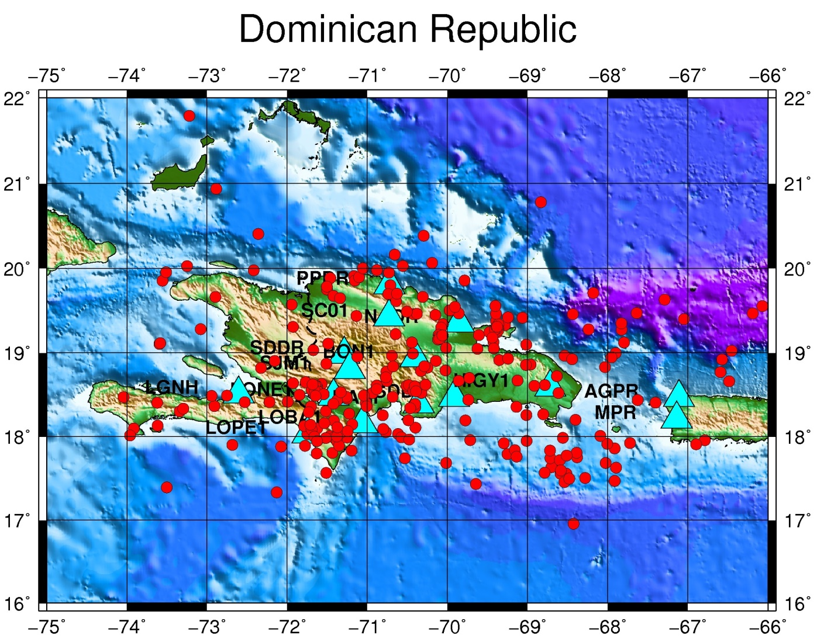

EX06 Turkey: a) all same depth, shallow. b) all same depth, deep. c) different depths

gmtxy_a.out

Latitud Longitud Depth M

-83.650 10.130 020 0.05400
158.040 52.360 020 0.05600
71.150 36.740 020 0.05300
78.710 22.770 020 0.05500
145.610 18.780 020 0.05600
40.170 39.300 020 0.03000
30.560 39.830 020 0.02000
80.740 29.930 020 0.05700
28.910 36.340 020 0.02500
23.580 39.020 020 0.03200
53.830 -35.270 020 0.05300
-70.530 -15.220 020 0.06300
33.860 36.310 020 0.03300

ex06a.sh

#!/bin/bash
file=Map.ps
rm -f *.grd

grdfile=$HOME/GEBCO/newbathy.grd
#grdfile=$HOME/GEBCO/Bathymetry_GEBCO_30s_world.grd

# Turkey
xmin=20
xmax=40
ymin=33
ymax=45

midlon=`gmt gmtmath -Q $xmin $xmax ADD 2 DIV =`
midlat=`gmt gmtmath -Q $ymin $ymax ADD 2 DIV =`

R="-R$xmin/$xmax/$ymin/$ymax"

J="-JM$midlon/$midlat/16c"

# Make a 1-degree grid
#B="-B1a1f1g1"

# Make a 5-degree grid
B="-B5g5"

gmt grdcut $grdfile $R -Gtmpf.grd

gmt grdinfo tmpf.grd

gmt makecpt -Cglobe -T-8500/8500/50 -Z > cptfile2.cpt

#gmt psbasemap -B1a1f1g1 $J $R -K -P > $file
#gmt psbasemap -B5g5 $J $R -K -P > $file

# Create map with top title
gmt psbasemap $B -B+t"Turkey - all events same depth, shallow" $J $R -K -P > $file

gmt grdgradient tmpf.grd -Nt1 -A225 -Gtmpgrd.grd

gmt grdimage $J $R tmpf.grd -Itmpgrd.grd -O -K -Ccptfile2.cpt >> $file

gmt pscoast $J -B $R -Dh -N1/1.00p,- -K -O -W >> $file

gmt psxy -R -J -O gmtxy_a.out -Wfaint -i0,1,2,3s10.1 -h1 -Scc -Cquakes.cpt >> $file

gv $file

outeps=`echo $file | sed 's/ps/eps/g'`

eps2eps $file $outeps

gmt psconvert $outeps -Tj -P

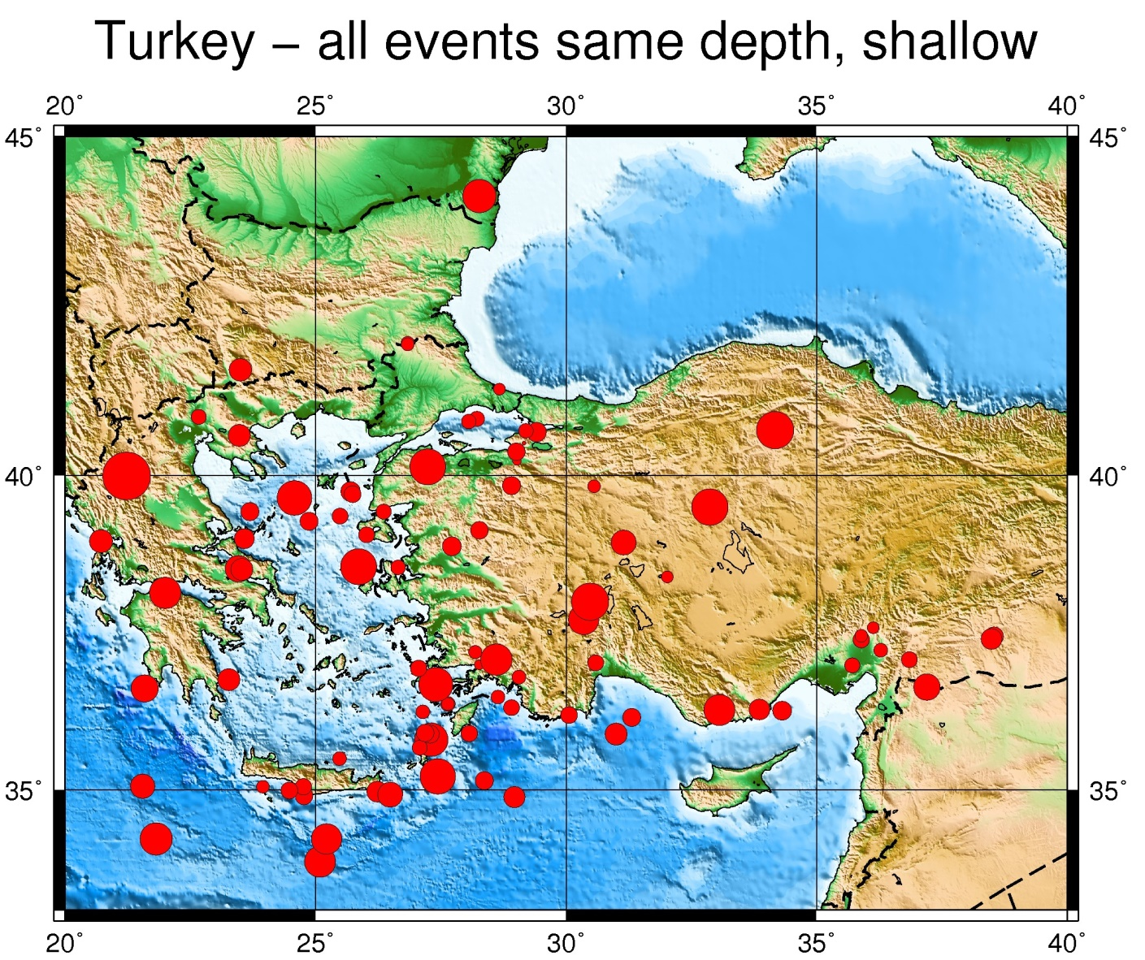
gmtxy_b.out

Latitud Longitud Depth M

-83.650 10.130 200 0.05400
158.040 52.360 200 0.05600
71.150 36.740 200 0.05300
78.710 22.770 200 0.05500
145.610 18.780 200 0.05600
40.170 39.300 200 0.03000
30.560 39.830 200 0.02000
80.740 29.930 200 0.05700
28.910 36.340 200 0.02500
23.580 39.020 200 0.03200
53.830 -35.270 200 0.05300
-70.530 -15.220 200 0.06300
33.860 36.310 200 0.03300

ex06b.sh

#!/bin/bash
file=Map.ps
rm -f *.grd

grdfile=$HOME/GEBCO/newbathy.grd
#grdfile=$HOME/GEBCO/Bathymetry_GEBCO_30s_world.grd

# Turkey
xmin=20
xmax=40
ymin=33
ymax=45

midlon=`gmt gmtmath -Q $xmin $xmax ADD 2 DIV =`
midlat=`gmt gmtmath -Q $ymin $ymax ADD 2 DIV =`

R="-R$xmin/$xmax/$ymin/$ymax"

J="-JM$midlon/$midlat/16c"

# Make a 1-degree grid
#B="-B1a1f1g1"

# Make a 5-degree grid
B="-B5g5"

gmt grdcut $grdfile $R -Gtmpf.grd

gmt grdinfo tmpf.grd

gmt makecpt -Cglobe -T-8500/8500/50 -Z > cptfile2.cpt

#gmt psbasemap -B1a1f1g1 $J $R -K -P > $file
#gmt psbasemap -B5g5 $J $R -K -P > $file

# Create map with top title
gmt psbasemap $B -B+t"Turkey - all events same depth, deep" $J $R -K -P > $file

gmt grdgradient tmpf.grd -Nt1 -A225 -Gtmpgrd.grd

gmt grdimage $J $R tmpf.grd -Itmpgrd.grd -O -K -Ccptfile2.cpt >> $file

gmt pscoast $J -B $R -Dh -N1/1.00p,- -K -O -W >> $file

gmt psxy -R -J -O gmtxy_b.out -Wfaint -i0,1,2,3s10.1 -h1 -Scc -Cquakes.cpt >> $file

gv $file

outeps=`echo $file | sed 's/ps/eps/g'`

eps2eps $file $outeps

gmt psconvert $outeps -Tj -P
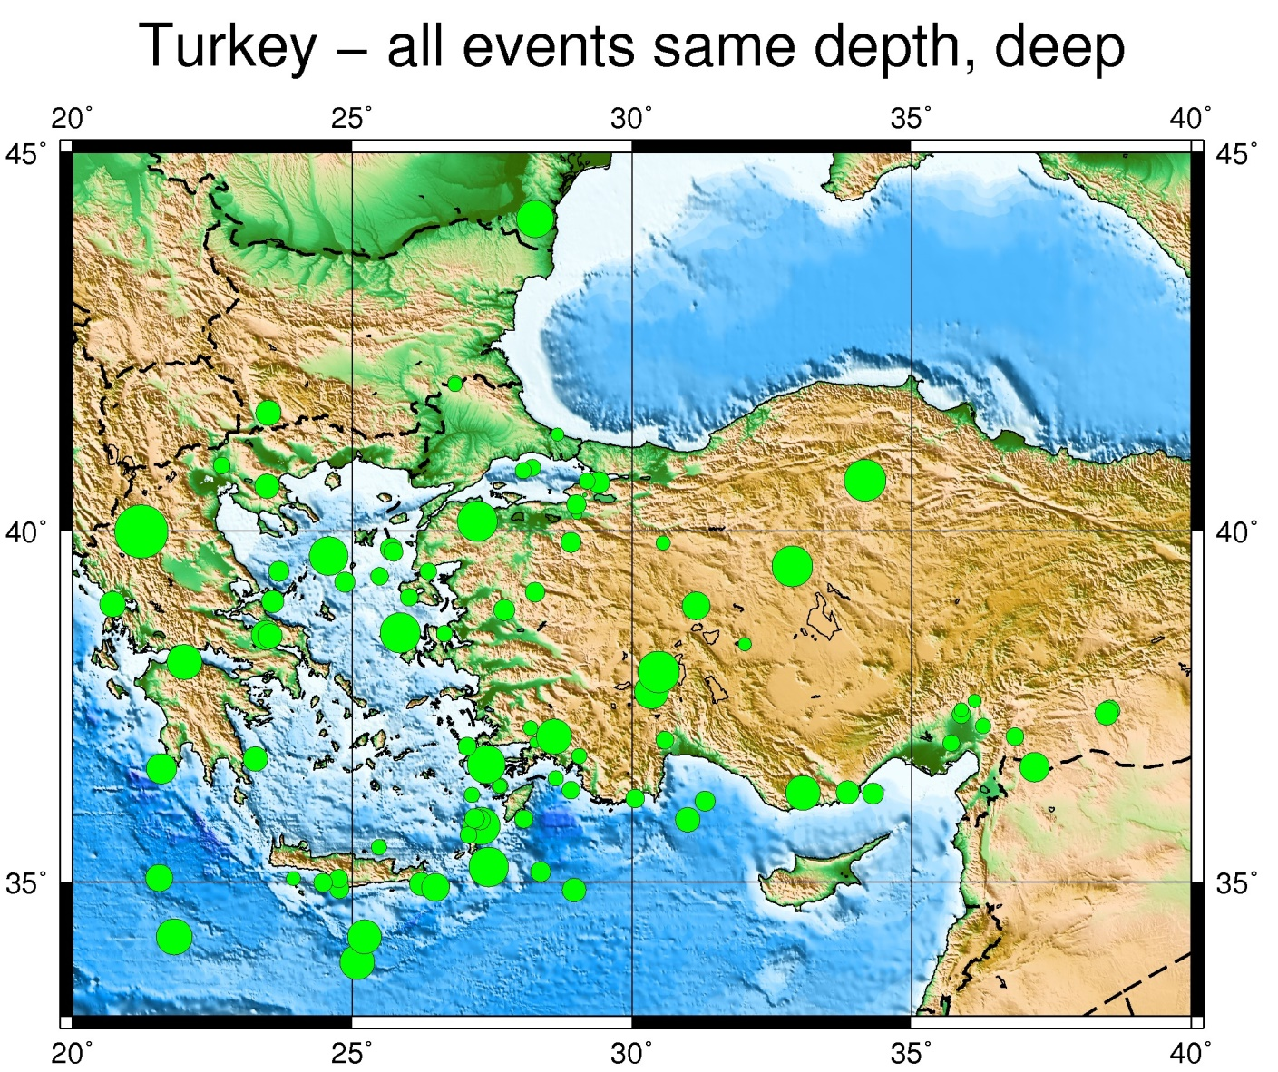

gmtxyz_c.out

Latitud Longitud Depth M

-83.650 10.130 -010.0 0.05400
158.040 52.360 -228.0 0.05600
71.150 36.740 -527.0 0.05300
78.710 22.770 -010.0 0.05500
145.610 18.780 -010.0 0.05600
40.170 39.300 -254.0 0.03000
30.560 39.830 -086.0 0.02000
80.740 29.930 -010.0 0.05700
28.910 36.340 -010.0 0.02500
23.580 39.020 -153.0 0.03200
53.830 -35.270 -200.0 0.05300
-70.530 -15.220 -030.0 0.06300
33.860 36.310 -005.0 0.03300
-178.560 -20.670 -065.0 0.05400
30.060 36.220 -135.0 0.02700
29.410 40.660 -090.0 0.03100

ex06c.sh

#!/bin/bash
file=Map.ps
rm -f *.grd

grdfile=$HOME/GEBCO/newbathy.grd
#grdfile=$HOME/GEBCO/Bathymetry_GEBCO_30s_world.grd

# Turkey
xmin=20
xmax=40
ymin=33
ymax=45

midlon=`gmt gmtmath -Q $xmin $xmax ADD 2 DIV =`
midlat=`gmt gmtmath -Q $ymin $ymax ADD 2 DIV =`

R="-R$xmin/$xmax/$ymin/$ymax"

J="-JM$midlon/$midlat/16c"

# Make a 1-degree grid
#B="-B1a1f1g1"

# Make a 5-degree grid
B="-B5g5"

gmt grdcut $grdfile $R -Gtmpf.grd

gmt grdinfo tmpf.grd

gmt makecpt -Cglobe -T-8500/8500/50 -Z > cptfile2.cpt

# Create map with top title
gmt psbasemap $B -B+t"Turkey - different depths" $J $R -K -P > $file

gmt grdgradient tmpf.grd -Nt1 -A225 -Gtmpgrd.grd

gmt grdimage $J $R tmpf.grd -Itmpgrd.grd -O -K -Ccptfile2.cpt >> $file

gmt pscoast $J -B $R -Dh -N1/1.00p,- -K -O -W >> $file

gmt psxy -R -J -O gmtxyz_c.out -Wfaint -i0,1,2s-1,3s10.1 -h1 -Scc -Cquakes.cpt >> $file

outeps=`echo $file | sed 's/ps/eps/g'`

eps2eps $file $outeps

gmt psconvert $outeps -Tj -P

gv $file

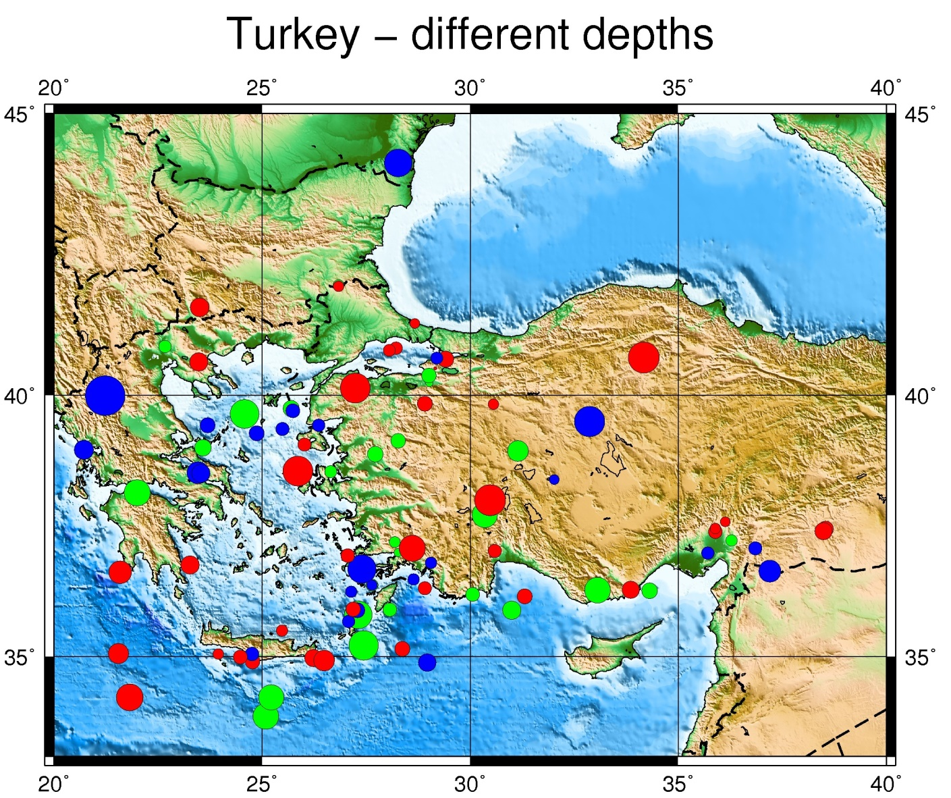

EX07 Nicaragua: events same depth, different magnitudes, stations with two different color and size

Input file: stations

-85.17 11.97 t cyan 4 ACON
-83.77 12.01 t cyan 4 BLUN
-86.70 12.50 t cyan 4 CNGN
-87.03 12.70 t cyan 4 CRIN
-87.56 12.98 t cyan 4 CSGN
-84.30 12.20 t cyan 4 ESPN
-86.37 13.10 t cyan 4 ESTN
-86.01 12.00 t cyan 4 MASN
-85.93 12.93 t cyan 4 MATN
-86.25 12.15 t cyan 4 MGAN
-86.16 13.48 t cyan 4 RCON
-86.83 12.60 t cyan 4 HERN
-86.59 12.18 t orange 2 COPN
-86.30 11.99 t orange 2 CRUN
-86.27 12.14 t orange 2 DECN
-86.82 12.59 t orange 2 HOYN
-85.64 11.54 t orange 2 MORN
-86.76 12.58 t orange 2 PLRN
-86.21 13.53 t orange 2 RCFN
-84.77 13.71 t orange 2 SIUN
-86.84 12.57 t orange 2 TEL3
-86.26 12.14 t orange 2 TISN
-86.35 12.23 t orange 2 APYN
-86.34 12.16 t orange 2 BRAN
-85.62 11.56 t orange 2 CONN
-85.67 11.52 t orange 2 JAPN
-86.54 12.40 t orange 2 MOMN
-86.03 11.74 t orange 2 NADN
-86.81 12.64 t orange 2 POLN
-86.51 13.50 t orange 2 SOMN
-86.83 12.60 t orange 2 TELN
-86.32 12.14 t orange 2 XAVN
-87.65 13.28 t orange 2 AMPH
-88.03 14.15 t orange 2 MCAH
-86.35 16.39 t orange 2 ROTH
-87.12 15.12 t orange 2 YORH
-89.28 13.73 t orange 2 BOQ6
-88.21 13.77 t orange 2 CAHU
-87.83 13.27 t orange 2 CNCH
-89.62 13.83 t orange 2 SBLS
-88.83 13.61 t orange 2 SNVI
-88.27 13.44 t orange 2 VSM

Input file: seismicity.nic

2013 6 18 04 46 21 -88.95 12.86 20 3.5
2013 6 18 15 41 11 -89.04 12.83 20 3.3
2013 6 18 19 09 16 -86.52 11.69 20 3.3
2013 6 19 03 14 35 -87.12 11.60 20 2.4
2013 6 19 12 13 53 -87.02 11.68 20 3.2
2013 6 19 14 25 31 -84.14 14.27 20 3.3
2013 6 20 10 16 14 -87.37 15.81 20 4.7
2013 6 20 12 23 43 -86.94 15.77 20 4.0
2013 6 20 17 05 01 -87.78 16.42 20 4.6
2013 6 20 19 25 28 -86.59 12.02 20 3.1
2013 6 20 21 26 10 -87.56 11.78 20 3.5
2013 6 20 23 17 48 -87.07 12.07 20 3.0
2013 6 21 00 17 24 -87.08 11.76 20 2.9
2013 6 21 02 48 38 -87.88 15.67 20 3.0
2013 6 21 04 46 41 -88.94 12.87 20 3.9
2013 6 21 12 36 39 -85.56 11.60 20 1.4

Input file: quakes.cpt (depth color model)

# color palette for seismicity
#z0 red green blue z1 red green blue
0 255 0 0 100 255 0 0
100 0 255 0 300 0 255 0
300 0 0 255 100000 0 0 255

The bash script:

ex07.sh

#!/bin/bash

file=Map.ps

rm -f *.grd

grdfile=../DATA/newbathy.grd
#grdfile=../DATA/Bathymetry_GEBCO_30s_world.grd

# Nicaragua map
xmin=-89
xmax=-83
ymin=9
ymax=15

midlon=`gmt gmtmath -Q $xmin $xmax ADD 2 DIV =`
midlat=`gmt gmtmath -Q $ymin $ymax ADD 2 DIV =`

R="-R$xmin/$xmax/$ymin/$ymax"

J="-JM$midlon/$midlat/16c"

gmt grdcut $grdfile $R -Gtmpf.grd

gmt grdinfo tmpf.grd

gmt makecpt -Cglobe -T-8500/8500/50 -Z > cptfile2.cpt

gmt psbasemap -B1g1 -B+t"Nicaragua" $J $R -K -P > $file

gmt grdgradient tmpf.grd -Nt1 -A225 -Gtmpgrd.grd

gmt grdimage $J $R tmpf.grd -Itmpgrd.grd -O -K -Ccptfile2.cpt >> $file

gmt pscoast $J -B $R -Dh -N1/1.00p,- -K -O -W >> $file

sizecoef=.2

# Variable used inside loop to adjust position of text-label
adjust=-0.2

while read line
do
lon=`echo $line | gawk '{print $1}' `
lat=`echo $line | gawk '{print $2}'`
sym=`echo $line | gawk '{print $3}' `
col=`echo $line | gawk '{print $4}' `
cof=`echo $line | gawk -v var=$sizecoef '{print $5*var}' `
stn=`echo $line | gawk '{print $6}' `
#echo $lon $lat $sym $col $cof

echo $lon $lat $sym$cof | gmt psxy $J $R -O -K -S -W -G$col >> $file

# Compute new longitude for text-label
lon2=$(echo "$lon + $adjust"|bc)

echo $lon2 $lat $stn | gmt pstext $J $R -O -F+f12p,Helvetica-Bold+jRB -K >> $file

done < "stations"

gmt psxy $R $J $B -O seismicity.nic -Wfaint -i6,7,8,9s0.1 -h1 -Scc -Cquakes.cpt >> $file

outeps=`echo $file | sed 's/ps/eps/g'`

eps2eps $file $outeps

gmt psconvert $outeps -Tj -P

gv $file
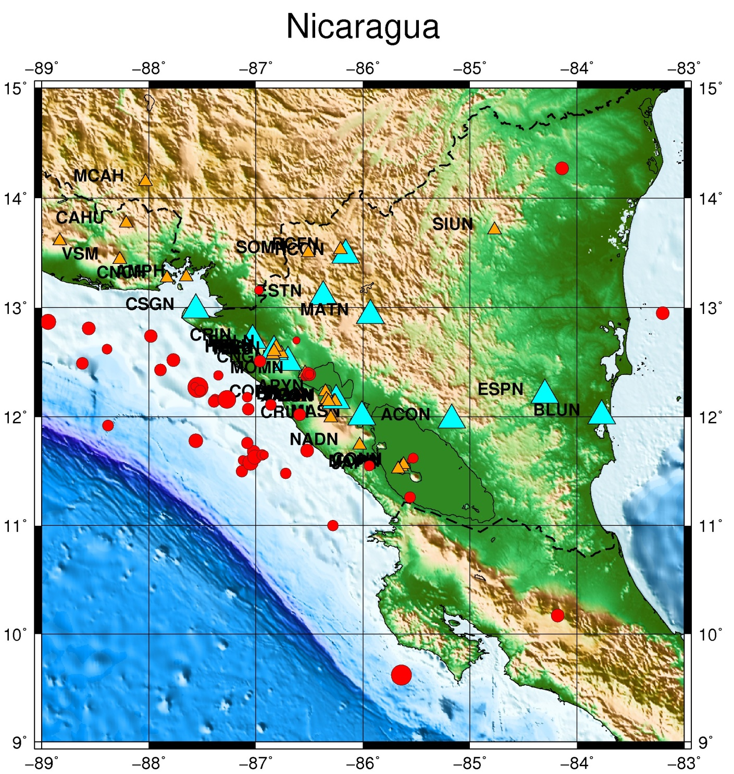

EX08 Artic Conic projection, events and stations

Input file: stations

11.9173 78.9168 t cyan 4 KBS
15.5333 77.0019 t cyan 4 HSPB
25.0108 76.5083 t cyan 4 HOPEN
18.9988 74.5023 t cyan 4 BJO1
-8.4281 71.0286 t cyan 4 JNW
-8.2968 70.9898 t cyan 4 JNE
-8.7308 70.9283 t cyan 4 JMI
23.6843 70.6423 t cyan 4 HAMF
18.9076 69.6345 t cyan 4 TRO
23.2371 69.0116 t cyan 4 KTK1
13.5410 68.1325 t cyan 4 LOF

Input file: seismicity.natl

2013 6 17 12 40 50 -8.021 71.223 20 4.0
2013 6 21 03 00 49 18.337 77.115 20 4.0
2013 6 22 02 09 03 31.684 69.443 20 4.0
2013 6 22 10 48 1 31.289 67.484 20 4.0
2013 6 22 10 51 39 7.752 75.936 20 4.0
2013 6 22 17 34 47 18.882 76.961 20 4.0
2013 6 23 08 43 19 7.260 77.651 20 4.0
2013 6 23 10 58 6 13.908 78.817 20 4.0
2013 6 23 17 50 58 20.673 67.166 20 4.0
2013 6 25 00 11 35 20.356 67.785 20 4.0
2013 6 25 05 30 34 5.519 79.733 20 4.0
2013 6 25 21 18 9 18.750 77.018 20 4.0
2013 6 25 23 31 5 3.255 79.760 20 4.0
2013 6 26 00 18 8 20.464 67.946 20 4.0
2013 6 26 15 05 13 14.790 78.102 20 4.0
2013 6 28 08 06 30 7.270 78.207 20 4.0
2013 6 28 10 35 16 33.876 67.639 20 4.0
2013 7 2 13 54 33 21.205 77.851 20 4.0
2013 7 2 16 18 9 30.591 69.834 20 4.0
2013 7 2 20 42 13 1.137 81.939 20 4.0
2013 7 5 09 23 17 33.761 67.581 20 4.0
2013 7 6 13 38 46 20.389 67.838 20 4.0
2013 7 6 16 47 43 18.066 77.284 20 4.0
2013 7 6 17 14 11 20.598 67.590 20 4.0
2013 7 7 19 39 57 7.600 77.003 20 4.0
2013 7 8 03 16 45 17.020 78.050 20 4.0
2013 7 8 17 48 13 19.085 76.963 20 4.0

Input file: quakes.cpt (depth color model)

# color palette for seismicity
#z0 red green blue z1 red green blue
0 255 0 0 100 255 0 0
100 0 255 0 300 0 255 0
300 0 0 255 100000 0 0 255

The bash script:

ex08.sh

#!/bin/bash

rm -f .gmtdefaults* .gmtcommands* *_tmp.grd output.eps Plot_stn.ps cptfile

file=Map.ps

grdfile=../DATA/newbathy.grd
#grdfile=../DATA/Bathymetry_GEBCO_30s_world.grd

xmin=-30
xmax=30
ymin=68
ymax=82

midlon=`gmt gmtmath -Q $xmin $xmax ADD 2 DIV =`
midlat=`gmt gmtmath -Q $ymin $ymax ADD 2 DIV =`

R="-R$xmin/$xmax/$ymin/$ymax "

J="-JM$midlon/$midlat/16c"

B="-B30g10/5g5"

J="-Js0/90/30c/60"

gmt grdcut $grdfile -Gtmpf.grd $R -V

gmt makecpt -Cglobe -T-8500/8500/50 -Z > cptfile2.cpt

gmt psbasemap $B $J $R -K > $file

gmt grdgradient tmpf.grd -Nt1 -A225 -Gtmpgrd.grd

gmt grdimage $J $R tmpf.grd -Itmpgrd.grd -K -O -Ccptfile2.cpt >> $file

gmt pscoast $J -B+t"Map Title" $R -Dh -N1/1.00p,- -K -O -W >> $file

sizecoef=.2
adjust=-3.0

while read line
do
lon=`echo $line | gawk '{print $1}' `
lat=`echo $line | gawk '{print $2}'`
sym=`echo $line | gawk '{print $3}' `
col=`echo $line | gawk '{print $4}' `
cof=`echo $line | gawk -v var=$sizecoef '{print $5*var}' `
stn=`echo $line | gawk '{print $6}' `
#echo $lon $lat $sym $col $cof

echo $lon $lat $sym$cof | gmt psxy $J $R -O -K -S -W -G$col >> $file

lon2=$(echo "$lon + $adjust"|bc)

echo $lon2 $lat $stn | gmt pstext $J $R -O -F+f12p,Helvetica-Bold+jRB -K >> $file

done < "stations"

gmt psxy $R $J $B -O seismicity.natl -Wfaint -i6,7,8,9s0.1 -h1 -Scc -Cquakes.cpt >> $file

outeps=`echo $file | sed 's/ps/eps/g'`

eps2eps $file $outeps

gmt psconvert $outeps -Tj -P

gv $file

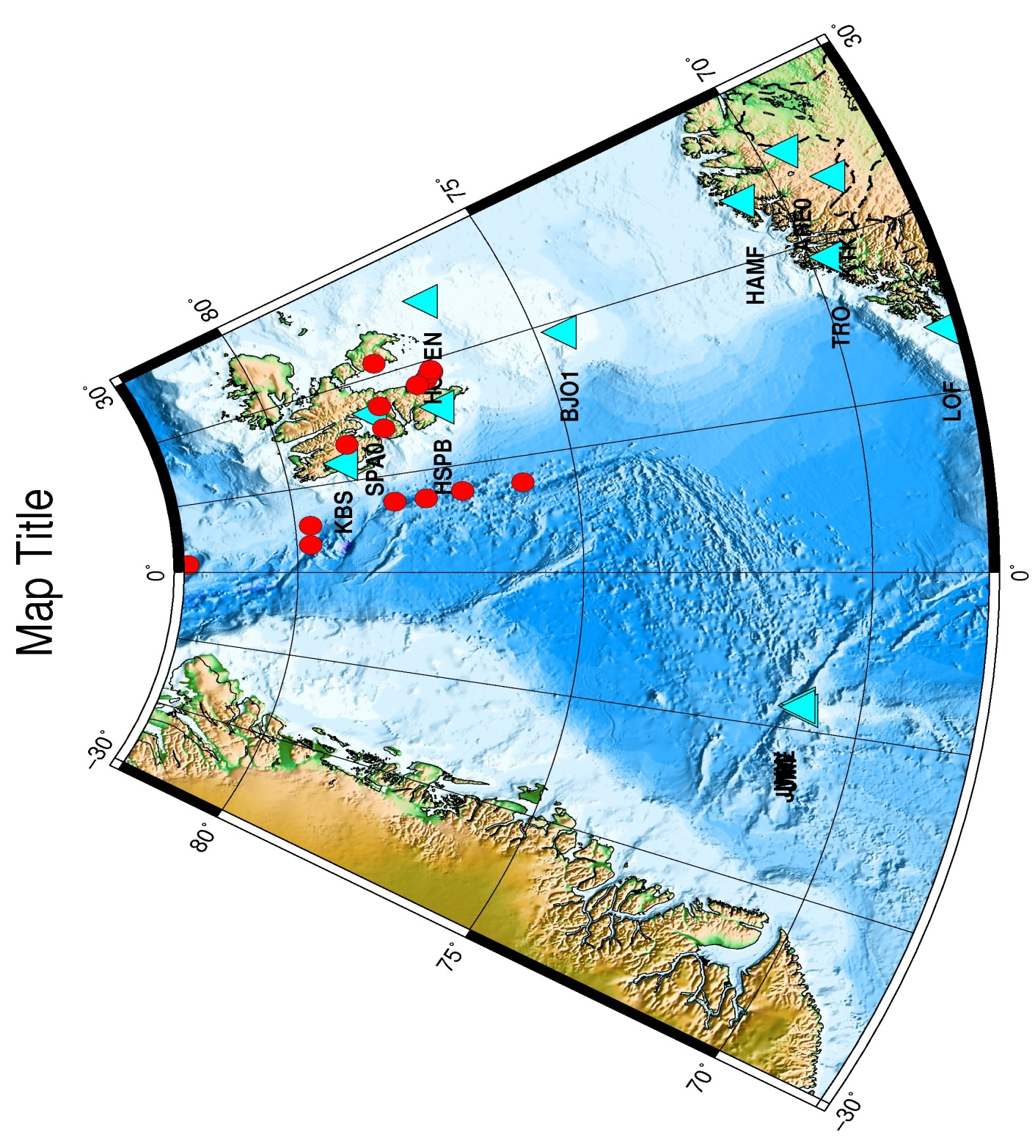

EX09 Artic Conic projection, events and stations and some text labels

Input file: stations

11.9173 78.9168 t cyan 4 KBS
15.5333 77.0019 t cyan 4 HSPB
25.0108 76.5083 t cyan 4 HOPEN
18.9988 74.5023 t cyan 4 BJO1
-8.4281 71.0286 t cyan 4 JNW
-8.2968 70.9898 t cyan 4 JNE
-8.7308 70.9283 t cyan 4 JMI
23.6843 70.6423 t cyan 4 HAMF
18.9076 69.6345 t cyan 4 TRO
23.2371 69.0116 t cyan 4 KTK1
13.5410 68.1325 t cyan 4 LOF

Input file: seismicity.natl

2013 6 17 12 40 50 -8.021 71.223 20 4.0
2013 6 21 03 00 49 18.337 77.115 20 4.0
2013 6 22 02 09 03 31.684 69.443 20 4.0
2013 6 22 10 48 1 31.289 67.484 20 4.0
2013 6 22 10 51 39 7.752 75.936 20 4.0
2013 6 22 17 34 47 18.882 76.961 20 4.0
2013 6 23 08 43 19 7.260 77.651 20 4.0
2013 6 23 10 58 6 13.908 78.817 20 4.0
2013 6 23 17 50 58 20.673 67.166 20 4.0
2013 6 25 00 11 35 20.356 67.785 20 4.0
2013 6 25 05 30 34 5.519 79.733 20 4.0
2013 6 25 21 18 9 18.750 77.018 20 4.0
2013 6 25 23 31 5 3.255 79.760 20 4.0
2013 6 26 00 18 8 20.464 67.946 20 4.0
2013 6 26 15 05 13 14.790 78.102 20 4.0
2013 6 28 08 06 30 7.270 78.207 20 4.0
2013 6 28 10 35 16 33.876 67.639 20 4.0
2013 7 2 13 54 33 21.205 77.851 20 4.0
2013 7 2 16 18 9 30.591 69.834 20 4.0
2013 7 2 20 42 13 1.137 81.939 20 4.0
2013 7 5 09 23 17 33.761 67.581 20 4.0
2013 7 6 13 38 46 20.389 67.838 20 4.0
2013 7 6 16 47 43 18.066 77.284 20 4.0
2013 7 6 17 14 11 20.598 67.590 20 4.0
2013 7 7 19 39 57 7.600 77.003 20 4.0
2013 7 8 03 16 45 17.020 78.050 20 4.0
2013 7 8 17 48 13 19.085 76.963 20 4.0

Input file: quakes.cpt (depth color model)

# color palette for seismicity
#z0 red green blue z1 red green blue
0 255 0 0 100 255 0 0
100 0 255 0 300 0 255 0
300 0 0 255 100000 0 0 255

Input file: strings.txt

-15.0 76.0 LB 1 BERGEN
-15.0 76.5 LB 2 BERGEN
-15.0 77.0 LB 3 BERGEN
-15.0 77.5 LB 4 BERGEN
-15.0 78.0 LB 5 BERGEN
-15.0 78.5 LB 6 BERGEN

The bash script:

ex09.sh

#!/bin/bash

rm -f .gmtdefaults* .gmtcommands* *_tmp.grd output.eps Plot_stn.ps cptfile

file=Map.ps

grdfile=../DATA/newbathy.grd
#grdfile=../DATA/Bathymetry_GEBCO_30s_world.grd

xmin=-30
xmax=30
ymin=68
ymax=82

midlon=`gmt gmtmath -Q $xmin $xmax ADD 2 DIV =`
midlat=`gmt gmtmath -Q $ymin $ymax ADD 2 DIV =`

R="-R$xmin/$xmax/$ymin/$ymax "

J="-JM$midlon/$midlat/16c"

B="-B30g10/5g5"

J="-Js0/90/30c/60"

gmt grdcut $grdfile -Gtmpf.grd $R -V

gmt makecpt -Cglobe -T-8500/8500/50 -Z > cptfile2.cpt

gmt psbasemap $B $J $R -K > $file

gmt grdgradient tmpf.grd -Nt1 -A225 -Gtmpgrd.grd

gmt grdimage $J $R tmpf.grd -Itmpgrd.grd -K -O -Ccptfile2.cpt >> $file

gmt pscoast $J -B+t"Map Title" $R -Dh -N1/1.00p,- -K -O -W >> $file

sizecoef=.2
adjust=-3.0

while read line
do
lon=`echo $line | gawk '{print $1}' `
lat=`echo $line | gawk '{print $2}'`
sym=`echo $line | gawk '{print $3}' `
col=`echo $line | gawk '{print $4}' `
cof=`echo $line | gawk -v var=$sizecoef '{print $5*var}' `
stn=`echo $line | gawk '{print $6}' `
#echo $lon $lat $sym $col $cof

echo $lon $lat $sym$cof | gmt psxy $J $R -O -K -S -W -G$col >> $file

lon2=$(echo "$lon + $adjust"|bc)

echo $lon2 $lat $stn | gmt pstext $J $R -O -F+f12p,Helvetica-Bold+jRB -K >> $file

done < "stations"

# Add text on a longitude/latitude
gmt pstext -R -J -N -K -O -V -F+f15,1,black+j << EOF >> $file
-5.0 75.0 BR BERGEN
EOF

# Add a number of lines with text on longitude/latitude
gmt pstext strings.txt -R -J -N -K -O -V -F+f12,1,darkblue+j >> $file

gmt psxy $R $J $B -O seismicity.natl -Wfaint -i6,7,8,9s0.1 -h1 -Scc -Cquakes.cpt >> $file

outeps=`echo $file | sed 's/ps/eps/g'`

eps2eps $file $outeps

gmt psconvert $outeps -Tj -P

gv $file

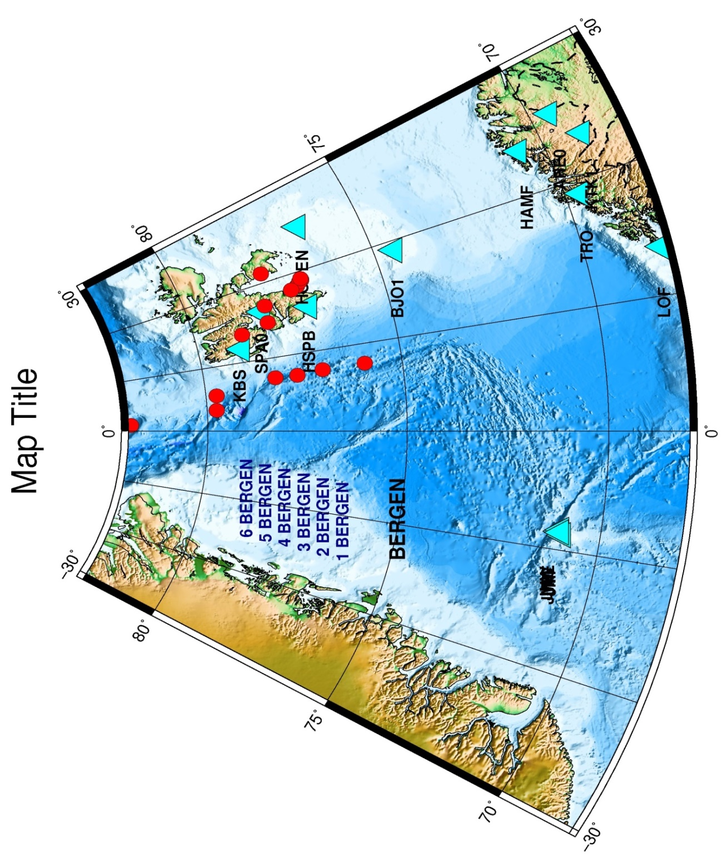

EX10 Northern Chile. Created by RTQUAKE

Input file: stations

-69.48740 -21.04323 t cyan 4 PB01
-69.89603 -21.31973 t cyan 4 PB02
-69.75310 -22.04847 t cyan 4 PB03
-70.14918 -22.33369 t cyan 4 PB04
-70.20235 -22.85283 t cyan 4 PB05
-69.57188 -22.70580 t cyan 4 PB06
-69.88618 -21.72667 t cyan 4 PB07
-69.15340 -20.14112 t cyan 4 PB08
-69.24192 -21.79638 t cyan 4 PB09
-70.55408 -23.51343 t cyan 4 PB10
-69.65582 -19.76096 t cyan 4 PB11
-70.32808 -18.61406 t cyan 4 PB12

Input file: GMT_EPI0.txt

Tamarugal, I RegiÃ³n de TarapacÃ¡, Chile
2017 4 10 13 48 14 -69.08 -20.777 14 2.2 67.1 Provincia del Tamarugal, I RegiÃ³n de TarapacÃ¡, Chile
2017 4 10 14 37 45 -68.84 -20.908 12 2.0 190.7 Provincia del Tamarugal, I RegiÃ³n de TarapacÃ¡, Chile
2017 4 10 14 52 25 -69.90 -20.344 8 1.6 0.0 Provincia del Tamarugal, I RegiÃ³n de TarapacÃ¡, Chile
2017 4 10 14 53 44 -69.91 -20.342 6 1.9 0.0 Provincia del Tamarugal, I RegiÃ³n de TarapacÃ¡, Chile
2017 4 10 14 53 44 29.54 40.86 6 5.0 50.0 Gebze, Kocaeli, Marmara BÃ¶lgesi, TÃ¼rkiye
2017 4 10 17 37 38 -69.50 -20.917 8 2.4 54.3 Provincia del Tamarugal, I RegiÃ³n de TarapacÃ¡, Chile
2017 4 10 17 57 8 -69.14 -22.752 15 1.7 74.9 Provincia de El Loa, II RegiÃ³n de Antofagasta, Chile
2017 4 10 18 46 55 -69.14 -22.250 8 4.7 0.0 Provincia de Tocopilla, II RegiÃ³n de Antofagasta, Chile

Input file: GMT_LAST_LOC.txt

2017 4 10 18 46 55 -69.14 -22.250 8 4.7 -1.0 Provincia de Tocopilla, II RegiÃ³n de Antofagasta, Chile

Input file: quakes.cpt (depth color model)

# color palette for seismicity
#z0 red green blue z1 red green blue
0 255 0 0 100 255 0 0
100 0 255 0 300 0 255 0
300 0 0 255 100000 0 0 255

The bash script:

ex10.sh

#!/bin/bash
file=Map.ps
rm -f *.grd
grdfile=../DATA/newbathy.grd
xmin=-72
xmax=-66
ymax=-19
ymin=-24
midlon=`gmt gmtmath -Q $xmin $xmax ADD 2 DIV =`
midlat=`gmt gmtmath -Q $ymin $ymax ADD 2 DIV =`
R="-R$xmin/$xmax/$ymin/$ymax"
J="-JM$midlon/$midlat/16c"
gmt grdcut $grdfile $R -Gtmpf.grd
gmt grdinfo tmpf.grd
gmt makecpt -Cglobe -T-8500/8500/50 -Z > cptfile2.cpt
top2=`echo echo "Provincia de Tocopilla, II RegiÃ³n de Antofagasta, Chile" | iconv -f utf-8 -t ascii//TRANSLIT`
gmt psbasemap -B1g1 -B+t"Provincia de Tocopilla, II Region de Antofagasta, Chile
" $J $R -K -P > $file
gmt grdgradient tmpf.grd -Nt1 -A225 -Gtmpgrd.grd
gmt grdimage $J $R tmpf.grd -Itmpgrd.grd -O -K -Ccptfile2.cpt >> $file
gmt pscoast $J -B $R -Dh -N1/1.00p,- -K -O -W >> $file
sizecoef=.2
adjust=-0.2
while read line
do
lon=`echo $line | gawk '{print $1}' `
lat=`echo $line | gawk '{print $2}'`
sym=`echo $line | gawk '{print $3}' `
col=`echo $line | gawk '{print $4}' `
cof=`echo $line | gawk -v var=$sizecoef '{print $5*var}' `
stn=`echo $line | gawk '{print $6}' `
echo $lon $lat $sym$cof | gmt psxy $J $R -O -K -S -W -G$col >> $file
lon2=$(echo "$lon + $adjust"|bc)
echo $lon2 $lat $stn | gmt pstext $J $R -O -F+f12p,Helvetica-Bold+jRB -K >> $file
done < "stations"
gmt psxy $R $J $B -O GMT_EPI0.txt -Wfaint -i6,7,10,9s0.2 -h0 -Scc -Cquakes.cpt -K >> $file
gmt psxy $R $J $B -O GMT_LAST_LOC.txt -Wfaint -i6,7,10,9s0.2 -h0 -Sac -Cquakes.cpt >> $file
outeps=`echo $file | sed 's/ps/eps/g'`
eps2eps $file $outeps
gmt psconvert $outeps -Tj -P
gv $file

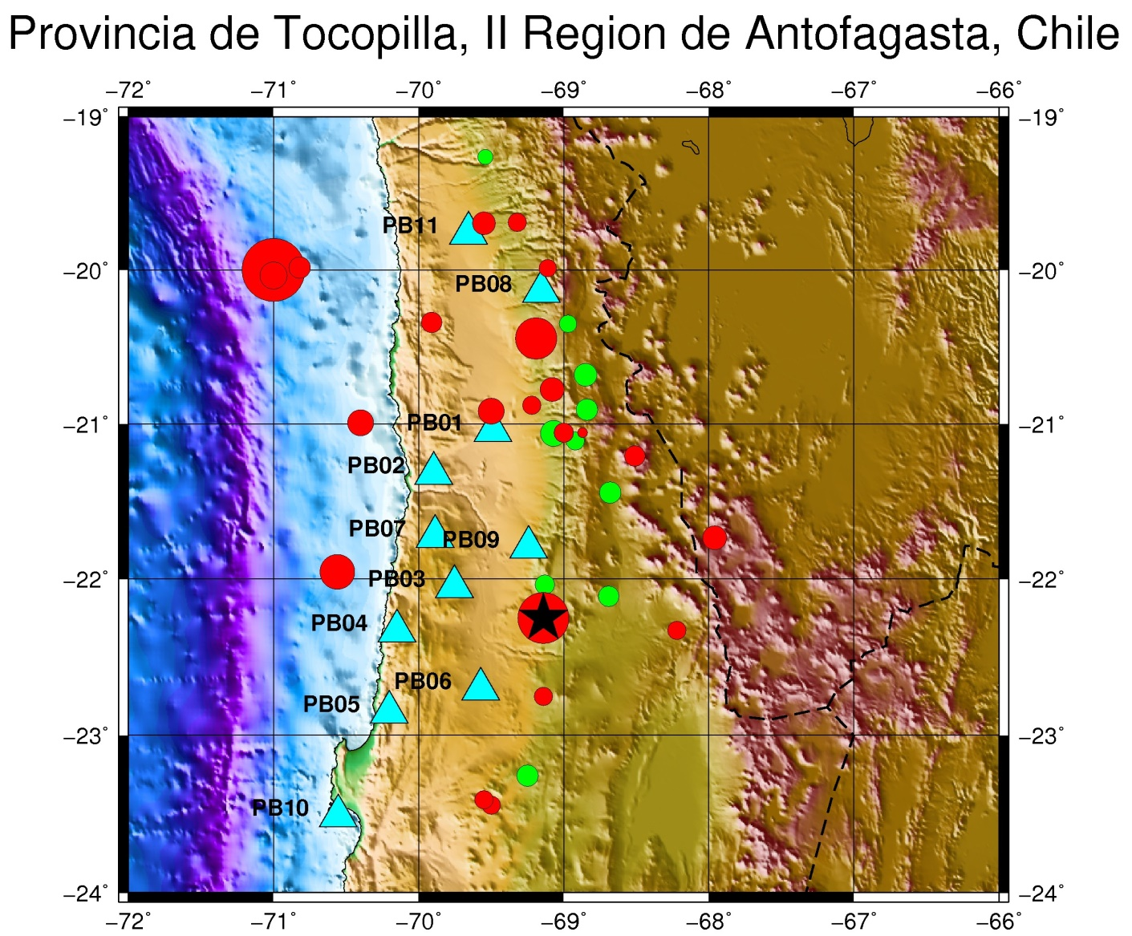

EX11 Draw lines on map from coordinate input-files

Input file example:

SRN.txt

5.019516362346828 65.41524425083982
4.947228430378107 65.36720829328469
4.904097682893287 65.32593417232923
4.878556714672504 65.2882138240668
4.824380699372535 65.24377260252297
4.802761822768773 65.21406810388999
4.801667151659414 65.17773497820853
4.806838219002398 65.12105305535525
4.857731668335463 65.0746558367135
4.897946139060285 65.022550557919
4.88855675205145 64.9729910326444
4.874769688515119 64.91806349464032
4.84394794203488 64.85966707280778
4.819971288828322 64.7991155992818
4.773194646819137 64.73476423445504
4.683304119093872 64.65517215172954
4.586144560610769 64.56229679381194
4.445520451400739 64.47715607995305
4.314051383649639 64.3847102477789
4.160120469418656 64.27280398481616
4.014047774086604 64.1586144509522
3.872250685916772 64.07014749366894
3.710033791764791 63.9750257310155

The bash script:

ex11.sh

#!/bin/bash

file=Map.ps
grdfile=../DATA/newbathy.grd

xmin=-3.0
xmax=11.0
ymin=61.0
ymax=69.0

midlon=`gmt gmtmath -Q $xmin $xmax ADD 2 DIV =`
midlat=`gmt gmtmath -Q $ymin $ymax ADD 2 DIV =`

R="-R$xmin/$xmax/$ymin/$ymax"

J="-JM$midlon/$midlat/16c"

# Make a 1-degree grid
B="-B1a1f1g1"
gmt grdcut $grdfile $R -Gtmpf.grd
gmt grdinfo tmpf.grd
gmt makecpt -Cglobe -T-8500/8500/50 -Z > cptfile2.cpt
gmt psbasemap $B -B+t"Draw lines on map from coordinate input-files" $J $R -K -P > $file
gmt grdgradient tmpf.grd -Nt1 -A225 -Gtmpgrd.grd
gmt grdimage $J $R tmpf.grd -Itmpgrd.grd -O -K -Ccptfile2.cpt >> $file
gmt pscoast $J -B $R -Dh -N1/1.00p,- -K -O -W >> $file

gmt psxy SRN.txt -R -JM -W2,black -O -K >> $file
gmt psxy VG.txt -R -JM -W2,black -O -K >> $file
gmt psxy OL.txt -R -JM -W2,black -O -K >> $file
gmt psxy SRS.txt -R -JM -W2,black -O -K >> $file
gmt psxy KFC.txt -R -JM -W2,black -O -K >> $file
gmt psxy MTG.txt -R -JM -W2,black -O -K >> $file
gmt psxy GGG.txt -R -JM -W2,black -O -K >> $file
gmt psxy MO.txt -R -JM -W2,black -O -K >> $file
gmt psxy JMFZS.txt -R -JM -W2,black -O -K >> $file
gmt psxy JMFZN.txt -R -JM -W2,black -O -K >> $file
gmt psxy FFC.txt -R -JM -W2,black -O -K >> $file
gmt psxy FSE.txt -R -JM -W2,black -O -K >> $file
gmt psxy MG.txt -R -JM -W2,black -O -K >> $file
gmt psxy MMH.txt -R -JM -W2,black -O -K >> $file

# For colors, check with man gmtcolors
gmt psxy TheStoreggaSlide.txt -R -JM -W2,cyan -O -K >> $file
gmt psxy InitiationDeeperSlideLowerHW.txt -R -JM -W2,yellow -O >> $file

outeps=`echo $file | sed 's/ps/eps/g'`

eps2eps $file $outeps

gmt psconvert $outeps -Tj -P

gv $file

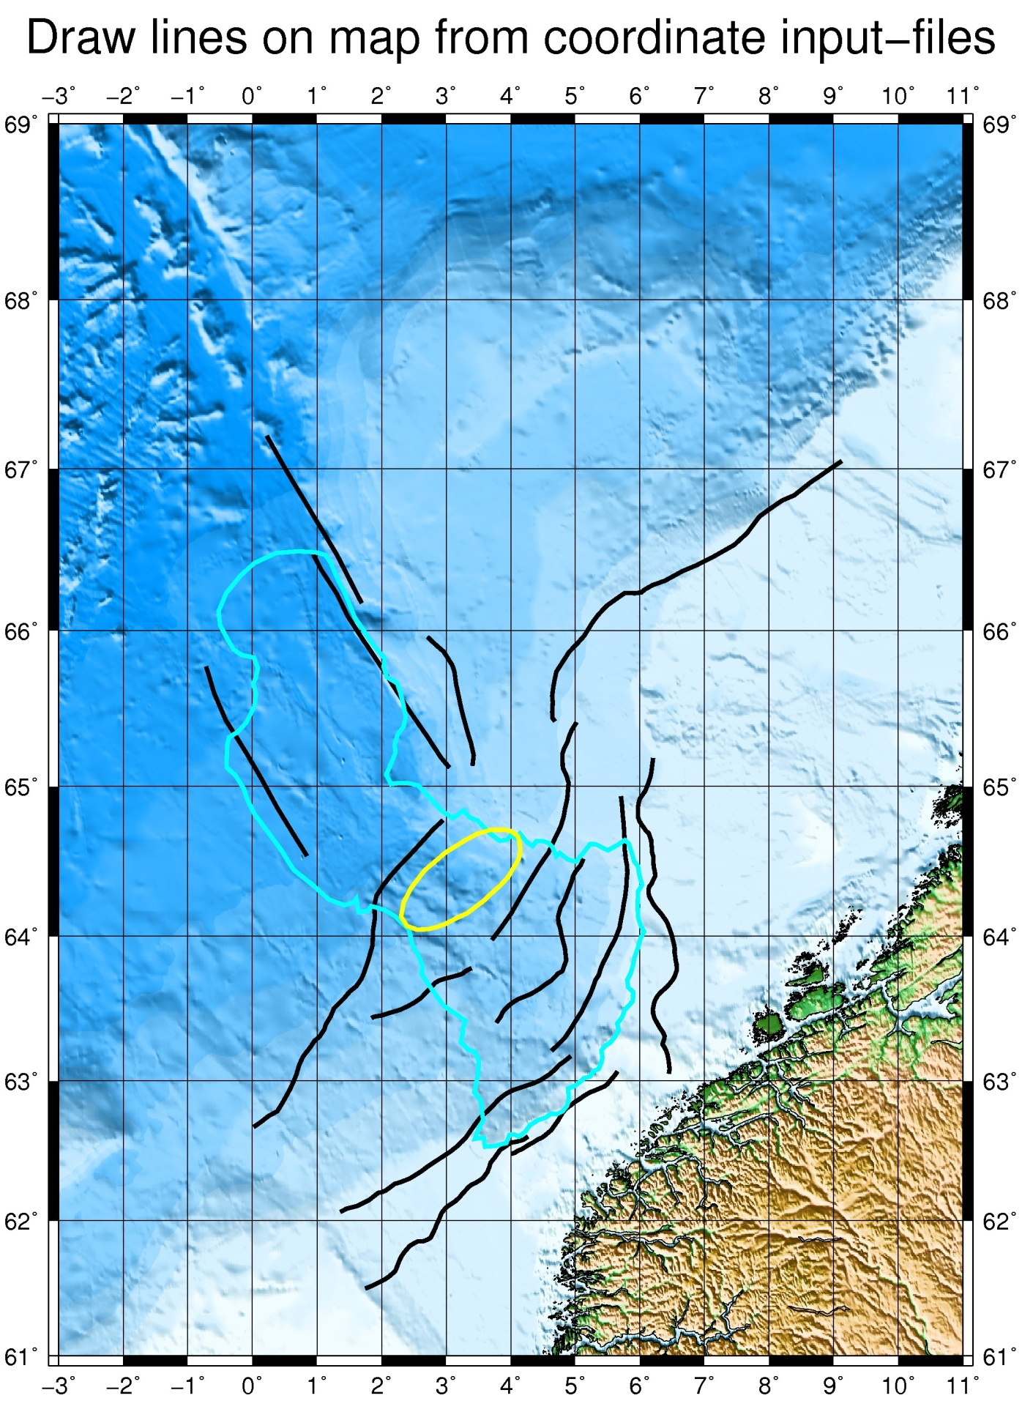

EX12 Plot events from input-file

Input file example:

areanew.out:
2013 6 18 04 46 21 3.000 61.800 20 0.04300
2013 6 18 04 46 21 5.000 61.600 20 0.04500
2013 6 18 04 46 21 10.500 64.700 20 0.04400
2013 6 18 04 46 21 5.000 61.600 20 0.03100
2013 6 18 04 46 21 5.100 61.500 20 0.04500
2013 6 18 04 46 21 6.000 61.900 20 0.04100
2013 6 18 04 46 21 9.500 66.600 20 0.05000
2013 6 18 04 46 21 8.600 66.200 20 0.05300
2013 6 18 04 46 21 4.600 61.400 20 0.03600
2013 6 18 04 46 21 4.600 61.400 20 0.03300
2013 6 18 04 46 21 4.500 61.700 20 0.03300
2013 6 18 04 46 21 5.300 61.800 20 0.03700
2013 6 18 04 46 21 7.300 61.300 20 0.03200
2013 6 18 04 46 21 5.200 61.000 20 0.03600
2013 6 18 04 46 21 4.700 61.600 20 0.03300
2013 6 18 04 46 21 6.300 64.300 20 0.05000
2013 6 18 04 46 21 5.200 61.300 20 0.05200
2013 6 18 04 46 21 6.500 62.100 20 0.03000
2013 6 18 04 46 21 5.000 61.400 20 0.03400
2013 6 18 04 46 21 5.100 61.600 20 0.03900
2013 6 18 04 46 21 5.900 61.500 20 0.04800
2013 6 18 04 46 21 5.300 61.500 20 0.03600
.
.
.
.

The bash script:

ex12.sh

#!/bin/bash

file=Map.ps

rm -f *.grd

grdfile=../DATA/newbathy.grd

# Norway map
xmin=-3
xmax=12
ymin=60
ymax=68

midlon=`gmt gmtmath -Q $xmin $xmax ADD 2 DIV =`
midlat=`gmt gmtmath -Q $ymin $ymax ADD 2 DIV =`

R="-R$xmin/$xmax/$ymin/$ymax"

J="-JM$midlon/$midlat/16c"

gmt grdcut $grdfile $R -Gtmpf.grd

gmt grdinfo tmpf.grd

gmt makecpt -Cglobe -T-8500/8500/50 -Z > cptfile2.cpt

gmt psbasemap -B1g1 -B+t" " $J $R -K -P > $file

gmt grdgradient tmpf.grd -Nt1 -A225 -Gtmpgrd.grd

gmt grdimage $J $R tmpf.grd -Itmpgrd.grd -O -K -Ccptfile2.cpt >> $file

gmt pscoast $J -B $R -Dh -N1/1.00p,- -K -O -W >> $file

# Norway

gmt psxy $R $J $B -O areanew.out -Wfaint -i6,7,8,9s7.0 -h1 -Scc -Cquakes.cpt >> $file

outeps=`echo $file | sed 's/ps/eps/g'`

eps2eps $file $outeps

gmt psconvert $outeps -Tj -P

gv $file

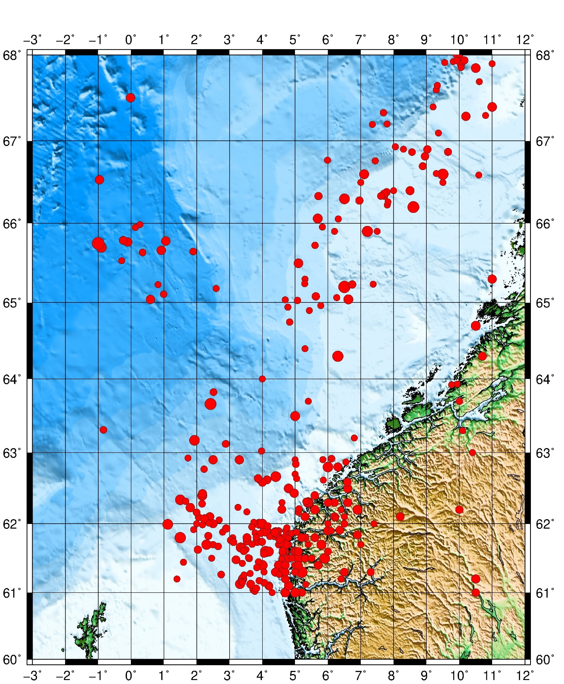

EX13 Plot events from input-file and a depth-scale

Input file example:

seismicity.nsn:

2018 5 1 02 59 36 71.946 37.390 20 4.0
2018 5 1 03 14 53 85.730 44.069 20 4.0
2018 5 1 06 16 0 -5.586 55.872 20 4.0
2018 5 1 06 17 7 7.345 77.454 20 4.0
2018 5 1 06 38 2 18.295 76.908 20 4.0
2018 5 1 10 45 23 8.724 77.910 20 4.0
2018 5 1 15 09 41 4.699 61.850 20 4.0
2018 5 1 19 47 33 -178.6544 17.862- 20 4.0
2018 5 1 22 07 29 8.729 77.984 20 4.0
2018 5 1 23 47 2 122.678 23.833 20 4.0
2018 5 2 03 30 49 -1.436 82.328 20 4.0
2018 5 2 04 08 28 50.534 32.442 20 4.0
2018 5 2 07 56 58 -2.993 80.759 20 4.0
2018 5 2 08 33 38 7.690 78.397 20 4.0
2018 5 2 10 10 16 -52.671 36.200 20 4.0
2018 5 2 11 47 44 5.552 60.702 20 4.0
2018 5 2 14 06 42 13.342 78.084 20 4.0
2018 5 2 14 48 21 7.349 78.505 20 4.0
2018 5 2 15 42 25 20.485 67.579 20 4.0
2018 5 2 16 54 24 13.465 66.673 20 4.0
2018 5 2 18 33 22 6.084 60.040 20 4.0
2018 5 2 21 16 16 27.719 36.798 20 4.0
2018 5 2 22 24 31 17.390 75.489 20 4.0
2018 5 2 22 56 9 71.524 36.940 20 4.0
2018 5 2 22 59 11 -5.227 56.235 20 4.0
2018 5 2 23 15 36 10.552 73.700 20 5.0
2018 5 2 23 17 35 10.678 73.900 200 6.0
2018 5 2 23 22 52 10.647 74.600 400 6.6
2018 5 2 23 41 57 10.000 74.800 600 7.0
2018 5 2 23 59 18 14.642 66.369 20 4.0
2018 5 3 00 14 36 -1.465 80.158 20 4.0
2018 5 3 01 12 35 7.549 62.258 20 4.0
2018 5 3 04 32 40 10.658 60.515 20 4.0
2018 5 3 05 30 34 6.895 62.282 20 4.0
.
.
.

depth.cpt:

# color palette for seismicity
#z0 red green blue z1 red green blue
0 255 0 0 100 255 0 0
100 0 255 0 300 0 255 0
300 0 0 255 500 0 0 255
500 255 255 0 800 255 255 0

The bash script:

ex13.sh

#!/bin/bash

rm -f .gmtdefaults* .gmtcommands* *_tmp.grd output.eps Plot_stn.ps cptfile

file=Map.ps

grdfile=../DATA/newbathy.grd
#grdfile=../DATA/Bathymetry_GEBCO_30s_world.grd

xmin=-30
xmax=30
ymin=68
ymax=82

midlon=`gmt gmtmath -Q $xmin $xmax ADD 2 DIV =`
midlat=`gmt gmtmath -Q $ymin $ymax ADD 2 DIV =`

R="-R$xmin/$xmax/$ymin/$ymax "

J="-JM$midlon/$midlat/16c"

B="-B30g10/5g5"

J="-Js0/90/30c/60"

gmt grdcut $grdfile -Gtmpf.grd $R -V

gmt makecpt -Cglobe -T-8500/8500/50 -Z > cptfile2.cpt

gmt psbasemap $B $J $R -K > $file

gmt grdgradient tmpf.grd -Nt1 -A225 -Gtmpgrd.grd

gmt grdimage $J $R tmpf.grd -Itmpgrd.grd -K -O -Ccptfile2.cpt >> $file

gmt pscoast $J -B+t"Map Title" $R -Dh -N1/1.00p,- -K -O -W >> $file

sizecoef=.2
adjust=-3.0

while read line
do
lon=`echo $line | gawk '{print $1}' `
lat=`echo $line | gawk '{print $2}'`
sym=`echo $line | gawk '{print $3}' `
col=`echo $line | gawk '{print $4}' `
cof=`echo $line | gawk -v var=$sizecoef '{print $5*var}' `
stn=`echo $line | gawk '{print $6}' `
#echo $lon $lat $sym $col $cof

echo $lon $lat $sym$cof | gmt psxy $J $R -O -K -S -W -G$col >> $file

lon2=$(echo "$lon + $adjust"|bc)

echo $lon2 $lat $stn | gmt pstext $J $R -O -F+f12p,Helvetica-Bold+jRB -K >> $file

done < "stations"

gmt psxy $R $J $B -O seismicity.nnsn -Wfaint -i6,7,8,9s0.1 -h1 -Scc -Cdepth.cpt >> $file

gmt psscale -Cdepth.cpt -B+l"Depth" -Dx2.5/-1.5c+w4.5i/0.1i+h -By+lkm -K -P >> $file

outeps=`echo $file | sed 's/ps/eps/g'`

eps2eps $file $outeps

gmt psconvert $outeps -Tj -P

gv $file

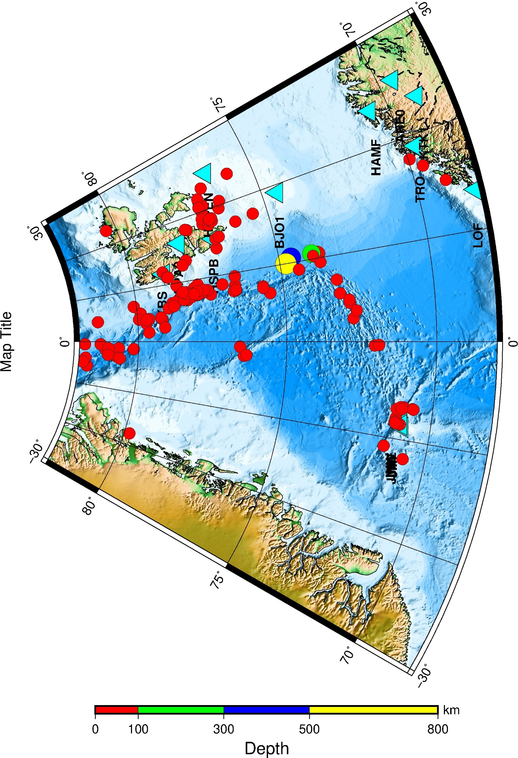

EX14 Plot events and focal mecanisms and a depth-scale

Input file example:

seismicity.natl

2013 6 22 10 48 1 2.0 62.0 500 7.0
2013 6 22 10 48 1 2.457 63.659 50 3.6
2013 6 22 10 48 1 4.741 62.532 110 4.0
2013 6 22 10 48 1 4.427 61.906 50 5.0
2013 6 22 10 48 1 3.888 61.598 150 6.0
2013 6 22 10 48 1 2.634 61.306 50 8.0

depth.cpt

# color palette for seismicity
#z0 red green blue z1 red green blue
0 255 0 0 100 255 0 0
100 0 255 0 300 0 255 0
300 0 0 255 500 0 0 255
500 255 255 0 800 255 255 0

psmeca.out

2.83 60.56 10.00 319.60 84.40 -7.10 2.80 2.83 60.56 20000505
5.33 59.75 18.00 191.90 57.00 114.00 4.50 5.33 59.75 20000812
5.47 60.04 11.00 115.70 36.00 31.20 2.70 5.47 60.04 20001126
6.98 59.85 15.00 159.80 86.50 -7.80 2.70 6.98 59.85 20001129
5.55 60.06 7.00 340.30 44.00 22.10 2.80 5.55 60.06 20001129
4.79 60.13 4.00 112.10 62.20 -48.60 3.80 4.79 60.13 20001208
3.18 56.56 6.00 356.00 85.00 -95.00 4.90 3.18 56.56 20010507
7.35 60.10 15.00 309.70 80.80 -3.60 2.80 7.35 60.10 20010622
-2.09 52.45 15.00 8.00 81.00 -12.00 5.00 -2.09 52.45 20020922
2.05 60.38 12.00 326.91 56.17 -22.76 2.70 2.05 60.38 20030407
-6.53 71.10 10.00 42.86 42.27 -67.37 3.70 -6.53 71.10 20030512
15.80 72.03 7.00 0.00 0.00 0.00 3.60 15.80 72.03 20030618
23.87 76.49 10.00 276.00 46.00 -104.00 5.10 23.87 76.49 20030704
5.69 66.06 15.00 0.00 0.00 0.00 4.40 5.69 66.06 20030804
2.65 61.67 10.00 333.50 68.53 -13.12 3.30 2.65 61.67 20031215
5.13 60.22 14.50 116.32 80.34 -2.61 2.40 5.13 60.22 20040112
-7.47 71.09 10.50 22.00 82.00 -174.00 6.30 -7.47 71.09 20040414
4.91 60.54 12.00 125.00 90.00 30.00 2.80 4.91 60.54 20041101
7.11 57.54 15.00 140.95 30.06 86.00 1.80 7.11 57.54 20050523
13.46 66.48 5.00 200.93 18.36 -39.82 3.50 13.46 66.48 20050624
13.36 66.41 7.10 15.52 37.16 -22.23 2.30 13.36 66.41 20061231
13.30 66.23 4.80 218.00 16.00 63.00 2.40 13.30 66.23 20070115
13.56 66.58 4.00 338.71 44.91 -51.61 2.00 13.56 66.58 20070616
13.38 66.32 6.00 17.00 65.00 -165.00 2.20 13.38 66.32 20080107
13.37 66.32 6.00 297.76 80.73 -67.69 2.20 13.37 66.32 20080107
-0.08 53.90 19.80 91.00 66.00 150.00 5.20 -0.08 53.90 20080227
13.15 66.35 10.10 136.95 18.11 6.13 1.60 13.15 66.35 20080320
12.99 66.23 7.30 218.14 29.03 14.67 2.00 12.99 66.23 20081102
13.33 66.49 6.30 279.16 16.48 13.67 1.50 13.33 66.49 20100328

The bash script:

ex14.sh

#!/bin/bash

file=Map.ps

rm -f *.grd

grdfile=/home/seismo/GMTEXAMPLES/DATA/newbathy.grd

# area map
xmin=-3
xmax=12
ymin=56
ymax=67

midlon=`gmt gmtmath -Q $xmin $xmax ADD 2 DIV =`
midlat=`gmt gmtmath -Q $ymin $ymax ADD 2 DIV =`

R="-R$xmin/$xmax/$ymin/$ymax"

J="-JM$midlon/$midlat/16c"

gmt grdcut $grdfile $R -Gtmpf.grd

gmt grdinfo tmpf.grd

gmt makecpt -Cglobe -T-8500/8500/50 -Z > cptfile2.cpt

gmt psbasemap -B1g1 -B+t"Southern Norway" $J $R -K -P > $file

gmt grdgradient tmpf.grd -Nt1 -A225 -Gtmpgrd.grd

gmt grdimage $J $R tmpf.grd -Itmpgrd.grd -O -K -Ccptfile2.cpt >> $file

gmt pscoast $J -B $R -Dh -N1/1.00p,- -K -O -W >> $file

gmt psxy $R $J $B -O seismicity.natl -Wfaint -i6,7,8,9s0.1 -h1 -Scc -Cdepth.cpt >> $file

gmt psscale -Cdepth.cpt -B+l"Depth" -Dx2.5/-1.5c+w4.5i/0.1i+h -By+lkm -K -P >> $file

gmt psmeca psmeca.out -R -J -V -G0/0/255 -Sa1.0/-1 -P -O >> $file

outeps=`echo $file | sed 's/ps/eps/g'`

eps2eps $file $outeps

gmt psconvert $outeps -Tj -P

gv $file

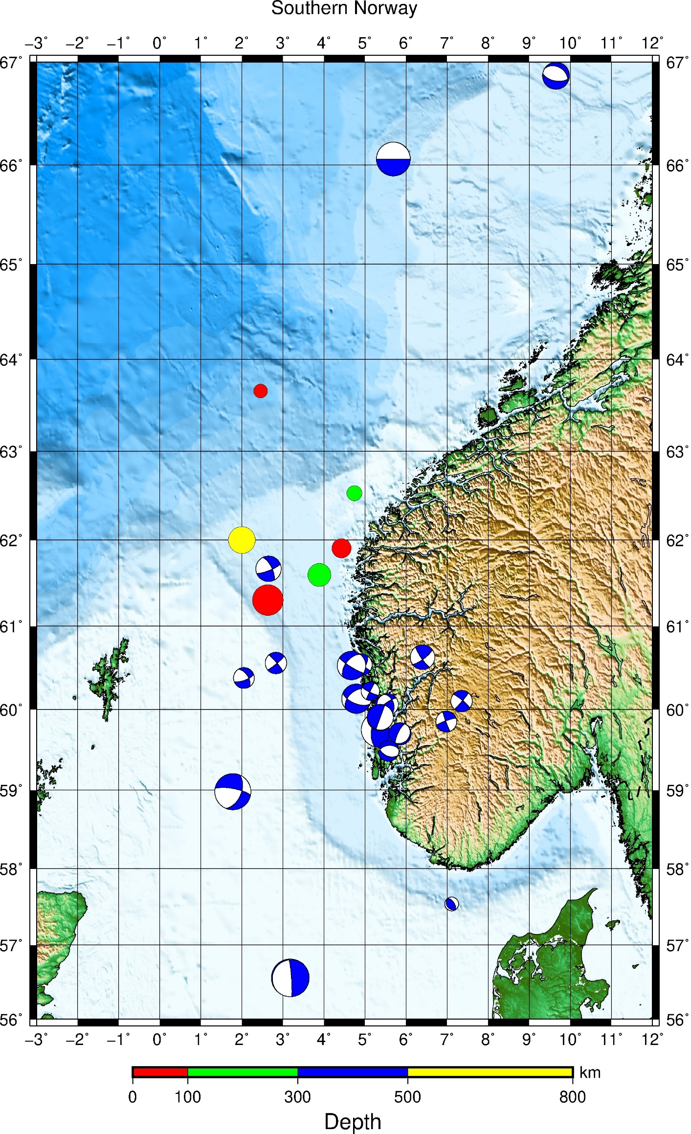

EX15 Plot events, stations and a depth-scale

Input file example:

stations

-85.17 11.97 t cyan 4 ACON
-83.77 12.01 t cyan 4 BLUN
-86.70 12.50 t cyan 4 CNGN
-87.03 12.70 t cyan 4 CRIN
-87.56 12.98 t cyan 4 CSGN
-84.30 12.20 t cyan 4 ESPN
-86.37 13.10 t cyan 4 ESTN
-86.01 12.00 t cyan 4 MASN
-85.93 12.93 t cyan 4 MATN
-86.25 12.15 t cyan 4 MGAN
-86.16 13.48 t cyan 4 RCON
-86.83 12.60 t cyan 4 HERN
-86.59 12.18 t orange 2 COPN
-86.30 11.99 t orange 2 CRUN
-86.27 12.14 t orange 2 DECN
-86.82 12.59 t orange 2 HOYN
-85.64 11.54 t orange 2 MORN
-86.76 12.58 t orange 2 PLRN
-86.21 13.53 t orange 2 RCFN
-84.77 13.71 t orange 2 SIUN
-86.84 12.57 t orange 2 TEL3
-86.26 12.14 t orange 2 TISN
-86.35 12.23 t orange 2 APYN
-86.34 12.16 t orange 2 BRAN
-85.62 11.56 t orange 2 CONN
-85.67 11.52 t orange 2 JAPN
-86.54 12.40 t orange 2 MOMN
-86.03 11.74 t orange 2 NADN
-86.81 12.64 t orange 2 POLN
-86.51 13.50 t orange 2 SOMN
-86.83 12.60 t orange 2 TELN
-86.32 12.14 t orange 2 XAVN
-87.65 13.28 t orange 2 AMPH
-88.03 14.15 t orange 2 MCAH
-86.35 16.39 t orange 2 ROTH
-87.12 15.12 t orange 2 YORH
-89.28 13.73 t orange 2 BOQ6
-88.21 13.77 t orange 2 CAHU
-87.83 13.27 t orange 2 CNCH
-89.62 13.83 t orange 2 SBLS
-88.83 13.61 t orange 2 SNVI
-88.27 13.44 t orange 2 VSM

seismicity.nic

2013 6 18 04 46 21 -88.95 12.86 20 3.5
2013 6 18 15 41 11 -89.04 12.83 20 3.3
2013 6 18 19 09 16 -86.52 11.69 20 3.3
2013 6 19 03 14 35 -87.12 11.60 20 2.4
2013 6 19 12 13 53 -87.02 11.68 20 3.2
2013 6 19 14 25 31 -84.14 14.27 20 3.3
2013 6 20 10 16 14 -87.37 15.81 20 4.7
2013 6 20 12 23 43 -86.94 15.77 20 4.0
2013 6 20 17 05 01 -87.78 16.42 20 4.6
2013 6 20 19 25 28 -86.59 12.02 20 3.1
2013 6 20 21 26 10 -87.56 11.78 20 3.5
2013 6 20 23 17 48 -87.07 12.07 20 3.0
2013 6 21 00 17 24 -87.08 11.76 20 2.9
2013 6 21 02 48 38 -87.88 15.67 20 3.0
2013 6 21 04 46 41 -88.94 12.87 20 3.9
2013 6 21 12 36 39 -85.56 11.60 150 1.4
2013 6 22 19 56 32 -87.38 12.16 250 2.6
2013 6 22 21 03 31 -88.39 12.62 300 2.5
2013 6 22 21 23 30 -87.25 12.16 20 3.2
2013 6 22 22 41 25 -87.35 12.38 20 2.4
2013 6 22 01 29 55 -83.20 12.95 20 3.3
2013 6 22 11 35 31 -90.10 14.26 20 4.9
2013 6 23 19 16 41 -87.39 12.14 20 2.9
2013 6 23 14 00 32 -85.64 9.62 20 5.1
2013 6 24 18 01 45 -87.75 15.98 20 3.5
2013 6 24 18 10 35 -87.62 15.95 20 3.3
2013 6 24 23 32 39 -85.53 11.62 20 2.5
2013 6 24 00 24 48 -85.94 11.55 20 2.6
2013 6 24 09 43 07 -84.18 10.17 20 3.3
2013 6 24 12 41 12 -87.13 11.50 20 2.9
2013 6 25 23 15 48 -86.86 12.11 20 2.8
2013 6 25 01 32 29 -86.72 11.48 20 2.7
2013 6 26 20 29 37 -87.54 12.27 20 5.1
2013 6 26 21 37 07 -89.03 12.79 20 3.9
2013 6 26 21 58 22 -88.56 12.81 20 3.3
2013 6 26 03 32 01 -87.05 11.58 20 3.9
2013 6 26 03 43 21 -86.96 12.51 20 3.0
2013 6 26 09 04 03 -86.28 11.00 20 2.7
2013 6 26 09 11 31 -87.27 12.16 20 4.5
2013 6 26 09 33 47 -87.01 11.63 20 3.6
2013 6 27 23 14 21 -87.89 12.43 20 3.0
2013 6 27 03 42 45 -87.57 12.28 20 2.0
2013 6 28 00 53 07 -86.62 12.70 20 1.8
2013 6 28 08 10 15 -87.08 12.18 20 2.5
2013 6 29 06 39 09 -86.49 12.39 20 2.2
2013 6 30 22 37 44 -87.52 12.24 20 2.7
2013 6 30 04 24 23 -86.97 13.16 20 2.2
2013 6 30 14 09 38 -88.38 11.92 20 2.8
2013 7 01 20 05 20 -87.77 12.52 20 3.3
2013 7 01 21 22 54 -87.98 12.74 20 3.2
2013 7 01 00 17 58 -86.50 12.39 20 1.5
2013 7 01 00 54 53 -86.54 12.37 20 2.2
2013 7 01 02 15 42 -86.52 12.38 20 2.4
2013 7 02 18 18 43 -86.94 11.65 20 2.7
2013 7 02 19 21 20 -86.92 11.65 20 2.1
2013 7 02 21 34 26 -87.31 16.00 20 3.3
2013 7 02 23 55 05 -88.62 12.49 20 3.0
2013 7 02 00 30 18 -87.48 15.75 20 2.7
2013 7 02 04 29 07 -86.50 12.39 20 3.2
2013 7 02 04 30 22 -86.51 12.40 20 2.9
2013 7 02 04 33 17 -86.50 12.39 20 2.2
2013 7 02 05 53 39 -85.56 11.26 20 2.8

depth.cpt

# color palette for seismicity
#z0 red green blue z1 red green blue
0 255 0 0 100 255 0 0
100 0 255 0 300 0 255 0
300 0 0 255 500 0 0 255
500 255 255 0 800 255 255 0

#!/bin/bash

file=Map.ps

rm -f *.grd

grdfile=../DATA/newbathy.grd
#grdfile=../DATA/Bathymetry_GEBCO_30s_world.grd

# Nicaragua map
xmin=-89
xmax=-83
ymin=9
ymax=15

midlon=`gmt gmtmath -Q $xmin $xmax ADD 2 DIV =`
midlat=`gmt gmtmath -Q $ymin $ymax ADD 2 DIV =`

R="-R$xmin/$xmax/$ymin/$ymax"

J="-JM$midlon/$midlat/16c"

gmt grdcut $grdfile $R -Gtmpf.grd

gmt grdinfo tmpf.grd

gmt makecpt -Cglobe -T-8500/8500/50 -Z > cptfile2.cpt

gmt psbasemap -B1g1 -B+t"Nicaragua" $J $R -K -P > $file

gmt grdgradient tmpf.grd -Nt1 -A225 -Gtmpgrd.grd

gmt grdimage $J $R tmpf.grd -Itmpgrd.grd -O -K -Ccptfile2.cpt >> $file

gmt pscoast $J -B $R -Dh -N1/1.00p,- -K -O -W >> $file

sizecoef=.2

# Variable used inside loop to adjust position of text-label
adjust=-0.2

while read line
do
lon=`echo $line | gawk '{print $1}' `
lat=`echo $line | gawk '{print $2}'`
sym=`echo $line | gawk '{print $3}' `
col=`echo $line | gawk '{print $4}' `
cof=`echo $line | gawk -v var=$sizecoef '{print $5*var}' `
stn=`echo $line | gawk '{print $6}' `
#echo $lon $lat $sym $col $cof

echo $lon $lat $sym$cof | gmt psxy $J $R -O -K -S -W -G$col >> $file

# Compute new longitude for text-label
lon2=$(echo "$lon + $adjust"|bc)

echo $lon2 $lat $stn | gmt pstext $J $R -O -F+f12p,Helvetica-Bold+jRB -K >> $file

done < "stations"

gmt psxy $R $J $B -O seismicity.nic -Wfaint -i6,7,8,9s0.1 -h1 -Scc -Cdepth.cpt >> $file

gmt psscale -Cdepth.cpt -B+l"Depth" -Dx2.5/-1.5c+w4.5i/0.1i+h -By+lkm -K -P >> $file

outeps=`echo $file | sed 's/ps/eps/g'`

eps2eps $file $outeps

gmt psconvert $outeps -Tj -P

gv $file

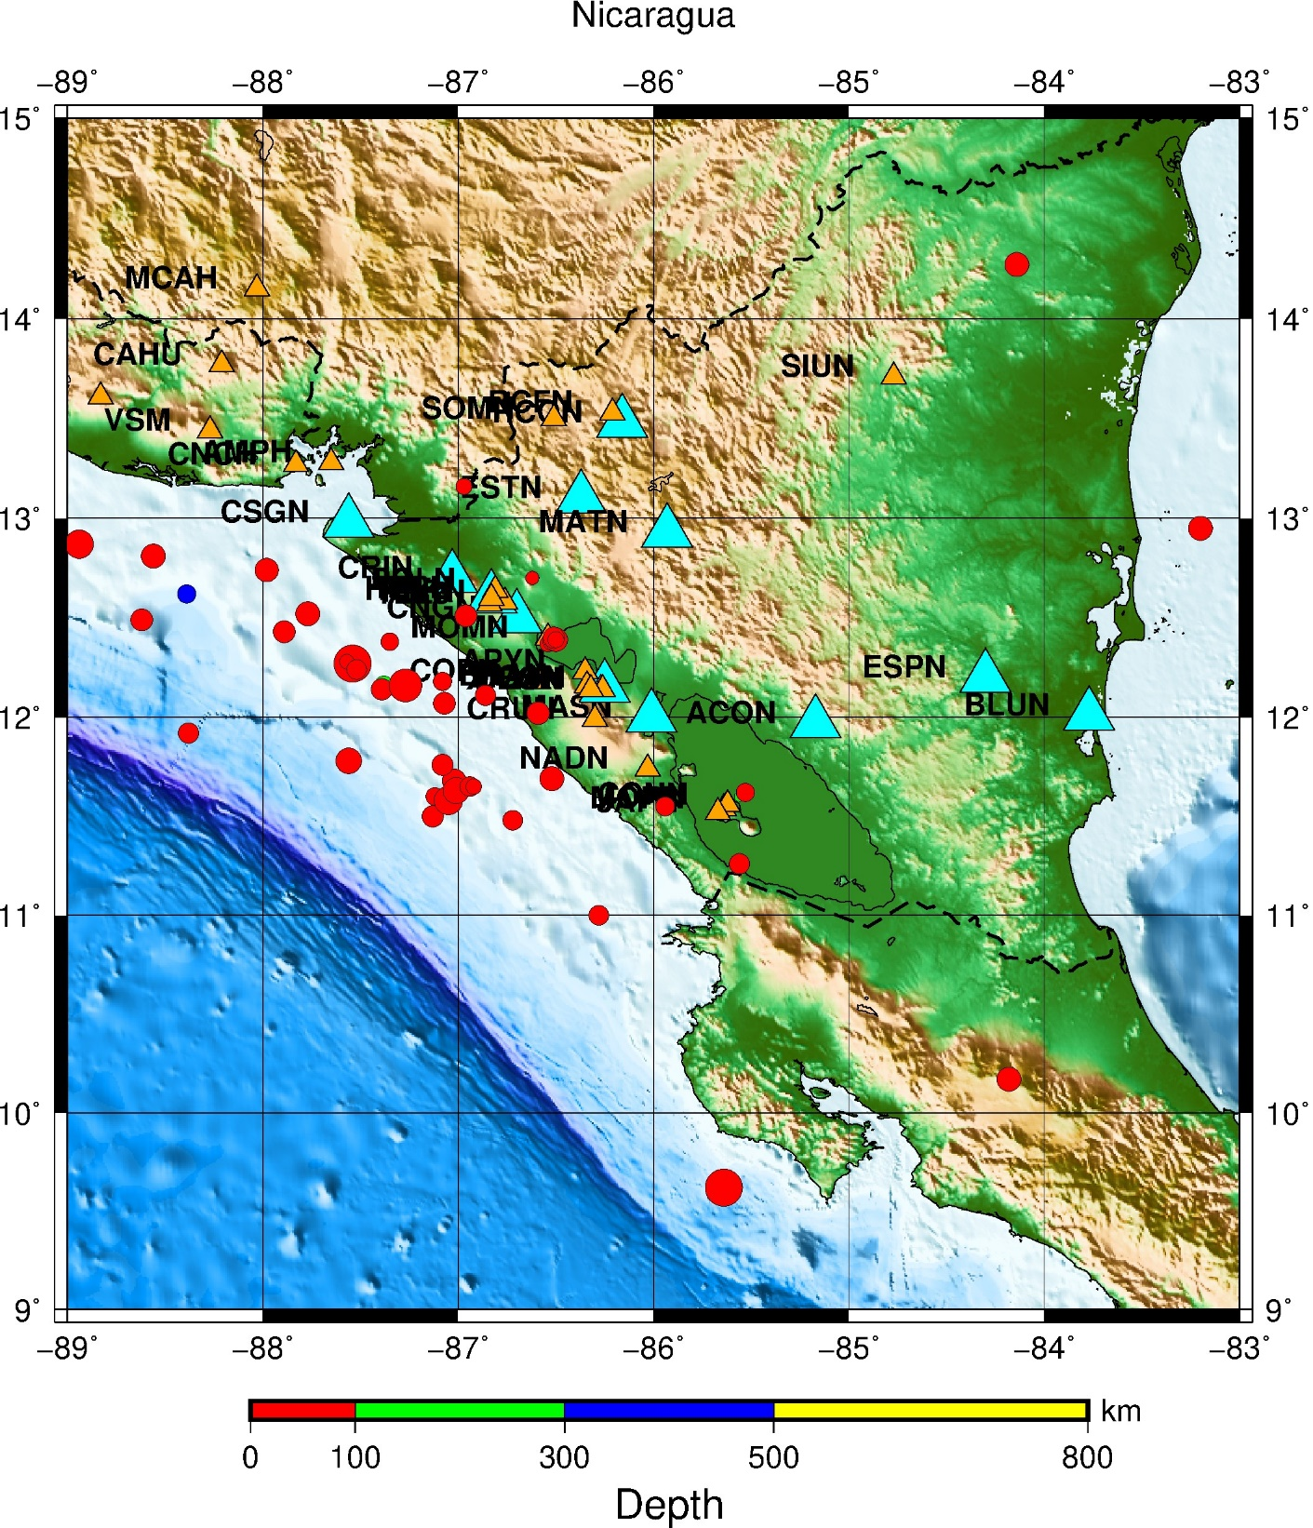

EX16 Plot events and focal mecanisms and a depth-scale

Input file example:

seismicity.natl

2013 6 17 12 40 50 -11.114 71.96 2 3.3
2013 6 21 03 00 49 -11.699 71.78 1 4.1
2013 6 22 02 09 03 -11.171 71.671 600 6.3
2013 6 22 10 48 1 -10.872 71.628 0 3.7
2013 6 17 12 40 50 -10.314 71.86 101 4.3
2013 6 21 03 00 49 -10.599 71.68 200 5.1
2013 6 22 02 09 03 -9.771 71.471 305 7.3
2013 6 22 10 48 1 -9.672 71.328 510 4.7
2013 6 22 02 09 03 -10.754 71.525 10 2.9
2013 6 22 02 09 03 -10.706 71.561 10 3.6
2013 6 22 02 09 03 -9.232 71.325 101 4.6

depth.cpt

# color palette for seismicity
#z0 red green blue z1 red green blue
0 255 0 0 100 255 0 0
100 0 255 0 300 0 255 0
300 0 0 255 500 0 0 255
500 255 255 0 800 255 255 0

psmeca.out

-8.30 71.15 12.00 8.30 41.00 74.70 2.20 -8.30 71.15 19960607
-9.00 71.30 12.00 8.30 41.00 74.70 2.20 -9.00 71.30 19960607
-7.50 71.00 12.00 8.30 41.00 74.70 2.20 -7.50 71.00 19960607

#!/bin/bash

file=Map.ps

rm -f *.grd

grdfile=/home/seismo/GMTEXAMPLES/DATA/newbathy.grd

# Norway map

xmin=-14
xmax=-4
ymin=70
ymax=73

midlon=`gmt gmtmath -Q $xmin $xmax ADD 2 DIV =`
midlat=`gmt gmtmath -Q $ymin $ymax ADD 2 DIV =`

R="-R$xmin/$xmax/$ymin/$ymax"

J="-JM$midlon/$midlat/16c"

gmt grdcut $grdfile $R -Gtmpf.grd

gmt grdinfo tmpf.grd

gmt makecpt -Cglobe -T-8500/8500/50 -Z > cptfile2.cpt

gmt psbasemap -B1g1 -B+t"Jan Mayen" $J $R -K -P > $file

gmt grdgradient tmpf.grd -Nt1 -A225 -Gtmpgrd.grd

gmt grdimage $J $R tmpf.grd -Itmpgrd.grd -O -K -Ccptfile2.cpt >> $file

gmt pscoast $J -B $R -Dh -N1/1.00p,- -K -O -W >> $file

gmt psxy $R $J $B -O seismicity.natl -Wfaint -i6,7,8,9s0.1 -h1 -Scc -Cdepth.cpt >> $file

gmt psscale -Cdepth.cpt -B+l"Depth" -Dx2.5/-1.5c+w4.5i/0.1i+h -By+lkm -K -P >> $file

gmt psmeca psmeca.out -R -J -V -Sa1.5/-1 -P -O >> $file

outeps=`echo $file | sed 's/ps/eps/g'`

eps2eps $file $outeps

gmt psconvert $outeps -Tj -P

gv $file

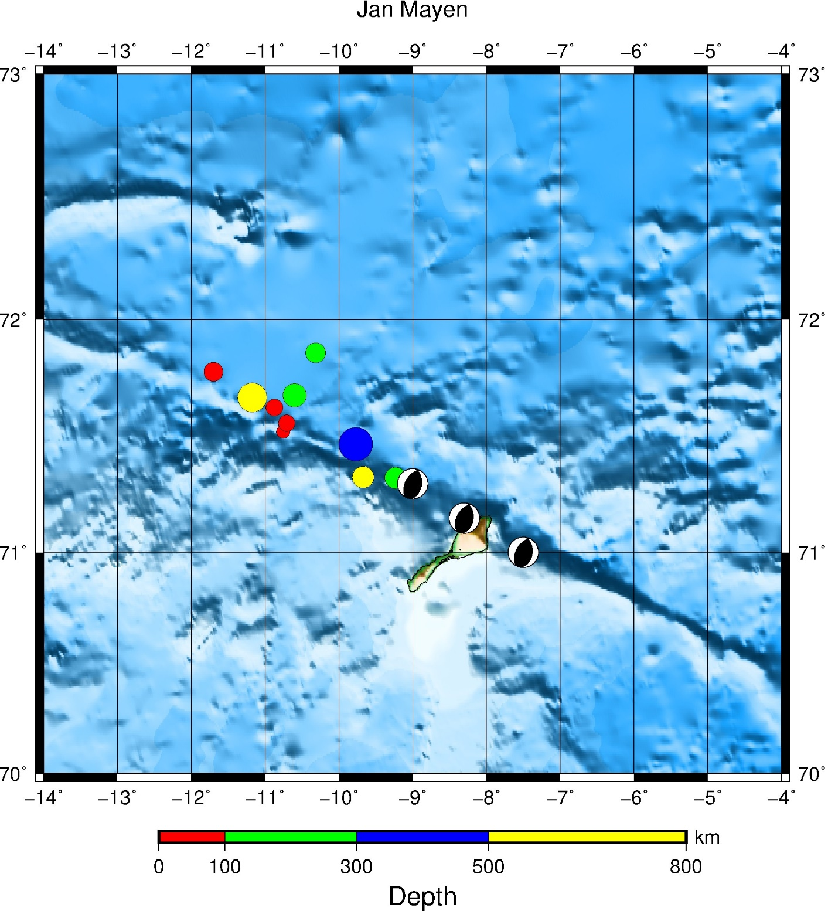

EX17 Plot events and a depth-scale

Input file example:

ALL_EPI.txt

2018/11/06 19:31:46.9 71.182 -8.354 17.1 2.1
2018/11/08 13:47:34.2 70.955 -7.250 10.0 3.4
2018/11/09 01:49:37.2 71.671 -11.171 10.0 6.3
2018/11/09 02:04:37.8 71.495 -11.340 0.0 3.8
2018/11/09 02:10:09.9 71.561 -10.706 0.1 3.6
2018/11/09 02:30:46.4 71.960 -11.114 1.6 3.3
2018/11/09 02:39:00.7 71.540 -11.053 0.0 3.9
2018/11/09 02:44:03.3 71.394 -9.687 0.0 2.4
2018/11/09 02:52:26.0 71.497 -11.056 0.0 3.9
2018/11/09 03:07:03.1 71.026 -11.215 0.0 2.2
2018/11/09 03:48:21.3 71.471 -10.353 3.2 2.7
2018/11/09 04:06:42.8 71.483 -11.049 3.0 3.9
2018/11/09 04:11:37.1 71.513 -11.043 0.0 3.5
2018/11/09 04:18:58.5 71.427 -7.180 0.0 2.2
2018/11/09 04:32:05.6 71.481 -10.723 0.0 2.2
2018/11/09 05:21:24.0 71.519 -10.935 3.0 4.2
2018/11/09 05:36:39.8 71.115 -11.036 1.1 2.1
2018/11/09 05:45:27.5 71.510 -11.799 0.0 4.2
2018/11/09 06:24:18.0 71.378 -10.998 0.0 2.4
2018/11/09 07:35:37.3 71.499 -11.004 1.6 3.0
2018/11/09 08:06:06.8 71.780 -11.699 1.1 4.1
2018/11/09 08:27:38.3 71.328 -10.828 0.0 2.5
2018/11/09 09:20:31.5 71.471 -10.638 10.0 2.5
2018/11/09 10:32:55.4 71.529 -10.475 18.0 2.6
2018/11/09 10:33:52.8 71.478 -9.861 3.2 2.1
2018/11/09 13:20:44.7 71.368 -12.016 0.1 3.6
2018/11/09 14:52:26.7 71.628 -10.872 0.0 3.7
2018/11/11 12:20:19.8 71.525 -10.754 0.0 2.9
2018/11/11 12:28:27.3 70.941 -7.458 0.0 2.5
2018/11/11 17:15:29.5 71.264 -9.320 19.5 2.9
2018/11/11 18:43:02.3 71.325 -9.232 3.0 2.4
2018/11/12 01:30:17.7 70.590 -8.314 10.0 2.1
2018/11/12 01:54:59.1 71.228 -9.511 0.0 4.0
2018/11/12 02:10:39.5 71.278 -9.263 0.0 2.1
2018/11/12 03:33:37.5 71.342 -9.200 3.0 2.3
2018/11/12 03:59:24.8 71.334 -9.269 3.0 2.4
2018/11/12 05:05:46.9 71.440 -10.922 0.0 3.7
2018/11/12 06:49:58.7 71.316 -9.369 10.0 2.4
2018/11/12 07:10:36.7 71.340 -9.345 3.0 2.0
2018/11/12 09:49:13.7 70.992 -8.183 6.9 0.0
2018/11/12 14:22:06.6 71.295 -9.326 0.0 1.9
2018/11/12 14:29:47.2 71.127 -9.397 0.0 3.4
2018/11/12 14:32:31.5 71.358 -9.233 3.0 2.0
2018/11/12 15:51:05.7 71.288 -9.118 0.0 2.1
2018/11/12 18:23:15.0 71.197 -9.410 0.0 1.6
2018/11/12 22:04:22.2 71.211 -9.114 0.0 1.8
2018/11/12 23:52:00.6 71.283 -9.260 0.1 1.8
2018/11/13 03:43:40.9 71.393 -10.006 3.0 1.9
2018/11/13 05:52:35.8 70.648 -7.987 0.0 2.2
2018/11/13 05:59:27.2 71.279 -9.343 0.0 1.7
2018/11/13 08:37:28.3 71.319 -9.181 3.0 1.6
2018/11/13 09:04:05.3 70.649 -8.361 0.0 2.0
2018/11/13 09:06:11.4 71.253 -9.901 0.0 4.5
2018/11/13 10:09:59.1 71.251 -9.241 0.0 1.9
2018/11/13 10:22:18.3 70.620 -8.040 0.0 2.0
2018/11/13 11:06:54.8 71.247 -9.322 0.0 1.8
2018/11/13 12:17:37.1 71.267 -9.251 0.1 2.3
2018/11/13 19:04:03.3 71.278 -9.295 0.0 1.6
2018/11/13 21:19:48.9 71.336 -9.185 2.9 1.3
2018/11/13 21:50:36.0 71.200 -9.467 0.0 1.6
2018/11/14 03:38:34.6 70.649 -8.449 0.0 1.9
2018/11/14 05:28:09.6 71.536 -10.842 1.7 2.9
2018/11/14 05:55:41.0 71.249 -9.215 0.0 1.7
2018/11/14 06:44:20.4 71.332 -9.290 10.0 1.6
2018/11/14 08:06:01.3 71.283 -9.236 0.0 2.2
2018/11/14 10:20:34.3 71.083 -7.772 0.0 2.7
2018/11/14 16:57:10.0 71.344 -9.268 3.0 2.7
2018/11/14 21:12:01.3 71.335 -9.222 10.0 2.0
2018/11/14 21:31:21.3 70.638 -8.455 0.0 1.9
2018/11/14 23:15:33.8 71.099 -7.600 0.0 2.0
2018/11/14 23:59:48.7 71.333 -9.318 3.0 2.1
2018/11/15 00:09:05.6 71.269 -9.845 0.0 4.9
2018/11/15 00:15:57.9 71.242 -9.108 0.0 2.7
2018/11/15 00:37:17.6 71.387 -8.533 3.0 1.6
2018/11/15 00:46:56.0 71.286 -9.142 0.0 2.0
2018/11/15 01:04:48.6 70.891 -6.647 0.0 2.4
2018/11/15 01:14:55.4 71.286 -9.379 1.6 2.1
2018/11/15 01:27:48.4 71.273 -9.207 0.0 2.1
2018/11/15 03:42:05.2 71.220 -9.421 1.6 1.9
2018/11/15 03:57:52.0 71.242 -9.020 0.0 1.4
2018/11/15 04:20:51.5 71.310 -9.273 3.0 1.8
2018/11/15 05:14:21.1 71.413 -8.729 3.0 1.7
2018/11/15 05:35:52.5 71.356 -9.170 3.0 1.8
2018/11/15 07:54:38.2 71.310 -9.355 3.0 2.5
2018/11/15 08:35:28.9 71.321 -9.253 3.0 1.7
2018/11/15 08:47:47.1 71.333 -9.283 3.0 1.8
2018/11/15 09:51:42.3 71.445 -8.567 3.0 1.5
2018/11/15 10:53:54.3 71.158 -9.424 0.0 2.3
2018/11/15 13:38:14.9 71.162 -9.449 0.0 1.8
2018/11/15 14:34:19.4 71.238 -9.795 0.0 2.7
2018/11/15 16:53:19.5 71.242 -9.759 0.0 3.2
2018/11/15 22:06:23.3 71.141 -8.392 20.0 2.2

depth.cpt
# color palette for seismicity
#z0 red green blue z1 red green blue
0 255 0 0 100 255 0 0
100 0 255 0 300 0 255 0
300 0 0 255 500 0 0 255
500 255 255 0 800 255 255 0

#!/bin/bash

file=Map.ps

rm -f *.grd

grdfile=/home/seismo/GMTEXAMPLES/DATA/newbathy.grd
#grdfile=/home/seismo/GMTEXAMPLES/DATA/ETOPO10_Bed_c_gdal.grd
#grdfile=/home/seismo/GMTEXAMPLES/DATA/Bathymetry_GEBCO_30s_world.grd

# area map
xmin=-14
xmax=-4
ymin=70
ymax=73

midlon=`gmt gmtmath -Q $xmin $xmax ADD 2 DIV =`
midlat=`gmt gmtmath -Q $ymin $ymax ADD 2 DIV =`

R="-R$xmin/$xmax/$ymin/$ymax"

J="-JM$midlon/$midlat/16c"

gmt grdcut $grdfile $R -Gtmpf.grd

gmt grdinfo tmpf.grd

gmt makecpt -Cglobe -T-8500/8500/50 -Z > cptfile2.cpt

gmt psbasemap -B1g1 -B+t"Jan Mayen" $J $R -K -P > $file

gmt grdgradient tmpf.grd -Nt1 -A225 -Gtmpgrd.grd

gmt grdimage $J $R tmpf.grd -Itmpgrd.grd -O -K -Ccptfile2.cpt >> $file

gmt pscoast $J -B $R -Dh -N1/1.00p,- -K -O -W >> $file

gmt psxy $R $J $B -O ALL_EPI.txt -Wfaint -i3,2,4,5s0.1 -h1 -Scc -Cdepth.cpt >> $file

gmt psscale -Cdepth.cpt -B+l"Depth" -Dx2.5/-1.5c+w4.5i/0.1i+h -By+lkm -K -P >> $file

outeps=`echo $file | sed 's/ps/eps/g'`

eps2eps $file $outeps

gmt psconvert $outeps -Tj -P

gv $file

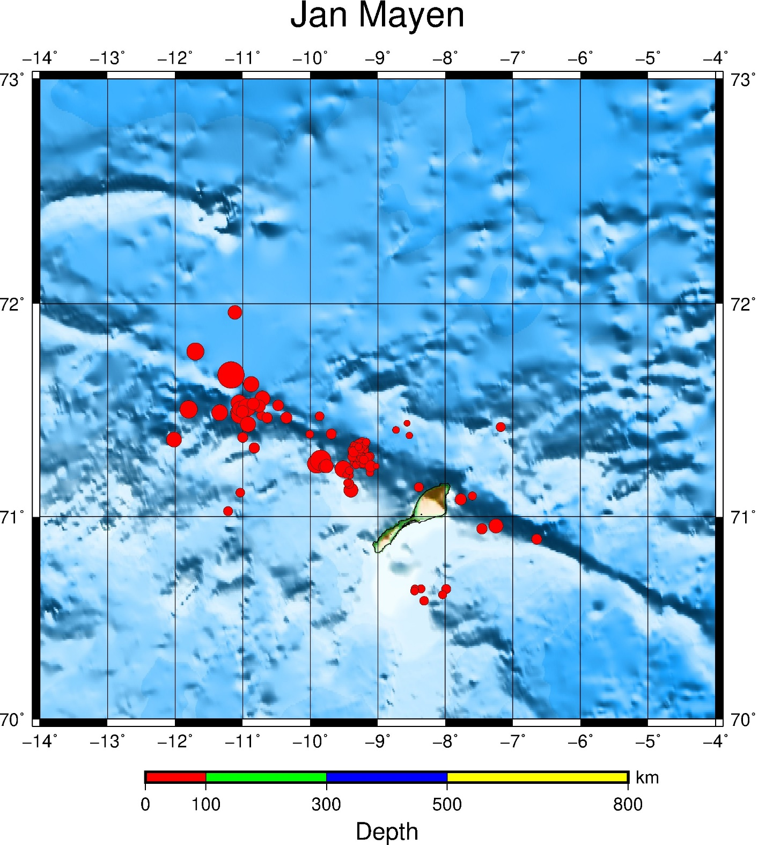

EX18 a) events, focal mecanisms and depth-scale. b) same as a) but with bottom legend

Input file example:

SRN.txt

5.019516362346828 65.41524425083982
4.947228430378107 65.36720829328469
4.904097682893287 65.32593417232923
4.878556714672504 65.2882138240668
4.824380699372535 65.24377260252297
4.802761822768773 65.21406810388999
4.801667151659414 65.17773497820853
4.806838219002398 65.12105305535525
4.857731668335463 65.0746558367135
4.897946139060285 65.022550557919
4.88855675205145 64.9729910326444
4.874769688515119 64.91806349464032
4.84394794203488 64.85966707280778
4.819971288828322 64.7991155992818
4.773194646819137 64.73476423445504
4.683304119093872 64.65517215172954
4.586144560610769 64.56229679381194
4.445520451400739 64.47715607995305
4.314051383649639 64.3847102477789
4.160120469418656 64.27280398481616
4.014047774086604 64.1586144509522
3.872250685916772 64.07014749366894
3.710033791764791 63.9750257310155

gmtxyz.K2

3.000 70.000 200.0 1.0
4.000 70.000 200.0 2.0
5.000 70.000 200.0 3.0
6.000 70.000 200.0 4.0
7.000 70.000 200.0 5.0
8.000 70.000 200.0 6.0
9.000 70.000 200.0 7.0
10.000 70.000 200.0 8.0
6.047 59.384 0.0 1.10000
8.976 58.363 25.8 1.10000
13.047 67.037 21.4 0.90000
5.043 61.832 0.0 1.70000
11.503 61.154 0.0 1.10000
10.954 59.975 0.0 1.20000
11.044 59.115 0.0 1.20000
5.026 60.784 0.0 0.90000
7.833 78.258 13.1 2.50000
6.675 62.482 0.0 1.20000
8.621 77.882 18.3 2.60000
20.966 66.993 0.0 1.90000
11.515 60.482 20.5 0.30000
26.882 67.551 0.0 0.90000
5.035 61.627 0.0 1.10000
8.728 77.994 10.0 2.60000
15.910 68.120 15.0 2.40000
15.558 76.931 2.9 1.70000
7.458 75.478 15.0 3.70000
6.311 59.639 15.0 1.20000
15.079 68.760 15.0 1.40000
20.642 67.927 0.0 1.30000
8.970 58.571 0.0 1.10000
9.169 74.707 16.1 3.50000
8.670 74.667 10.0 3.40000
5.664 59.837 2.1 0.80000
30.440 69.559 0.0 0.70000
4.607 79.693 10.0 2.90000
8.894 77.750 10.0 2.20000
7.713 78.097 10.0 2.40000
5.547 60.710 0.0 1.20000
6.918 58.767 0.0 1.60000
7.544 78.318 10.0 2.20000
13.465 66.613 21.8 1.50000
14.523 67.771 12.1 0.50000
14.757 66.411 0.0 1.10000
19.652 77.427 14.1 1.30000
4.258 61.313 13.6 1.20000
8.014 77.263 3.0 2.30000
26.844 67.600 0.0 1.20000
3.056 79.118 27.0 2.90000
13.665 59.380 0.0 1.80000
30.488 64.737 0.0 1.60000
9.758 59.793 0.0 1.10000
14.901 67.858 0.0 0.80000
13.235 64.730 0.0 1.00000
6.057 59.362 0.0 1.30000
.
.
.

quakes.cpt

# color palette for seismicity
#z0 red green blue z1 red green blue
0 255 0 0 100 255 0 0
100 0 255 0 300 0 255 0
300 0 0 255 100000 0 0 255

depth.cpt

# color palette for seismicity
#z0 red green blue z1 red green blue
0 255 0 0 100 255 0 0
100 0 255 0 300 0 255 0
300 0 0 255 500 0 0 255
500 255 255 0 800 255 255 0

psmeca.out

13.33 66.49 6.30 279.16 16.48 13.67 1.50 13.33 66.49 20100328
13.36 66.40 7.50 23.36 22.76 -14.51 2.30 13.36 66.40 20100802
5.36 59.90 8.00 138.00 57.00 -42.00 3.10 5.36 59.90 20101220
5.36 59.90 8.00 243.40 57.70 -176.00 3.10 5.36 59.90 20101220
5.36 59.90 8.00 50.00 75.00 174.00 3.10 5.36 59.90 20101220
5.36 59.90 8.00 314.80 78.01 -87.96 3.10 5.36 59.90 20101220
5.37 59.90 17.00 60.00 63.00 -167.00 3.40 5.37 59.90 20101220
5.37 59.90 17.00 110.00 5.00 0.00 3.40 5.37 59.90 20101220
6.40 60.63 15.30 58.00 68.00 178.00 3.20 6.40 60.63 20120324
6.40 60.63 15.30 53.10 76.90 170.40 3.20 6.40 60.63 20120324
13.33 66.43 5.00 324.20 46.00 -118.30 2.30 13.33 66.43 20130918
13.33 66.43 5.00 205.00 80.00 -90.00 2.30 13.33 66.43 20130918
9.77 67.48 14.70 14.30 42.30 -79.60 2.30 9.77 67.48 20130918
14.12 67.45 8.00 43.65 57.20 -32.73 2.60 14.12 67.45 20131010
14.12 67.45 8.00 85.11 7.07 44.89 2.60 14.12 67.45 20131010
14.12 67.45 8.00 277.20 44.90 121.60 2.60 14.12 67.45 20131010
13.46 66.68 3.80 108.00 61.00 -82.00 2.50 13.46 66.68 20140124
13.46 66.68 3.80 123.49 55.15 -83.90 2.50 13.46 66.68 20140124
13.46 66.68 3.80 123.00 49.00 -53.00 2.50 13.46 66.68 20140124
13.46 66.68 3.80 265.30 56.00 -108.30 2.50 13.46 66.68 20140124
13.40 66.95 3.50 70.70 8.40 -26.50 2.70 13.40 66.95 20140307
13.40 66.95 3.50 85.00 38.00 -56.00 2.70 13.40 66.95 20140307
13.40 66.95 3.50 63.02 15.79 -71.32 2.70 13.40 66.95 20140307
13.40 66.95 3.50 201.70 63.00 -139.90 2.70 13.40 66.95 20140307
12.36 66.31 12.40 335.10 53.70 96.30 1.80 12.36 66.31 20140421
12.36 66.31 12.40 188.05 65.41 78.99 1.80 12.36 66.31 20140421
12.36 66.31 12.40 336.00 46.30 98.60 1.80 12.36 66.31 20140421
15.19 67.08 6.60 17.10 67.70 -143.00 1.80 15.19 67.08 20140531
15.19 67.08 6.60 249.82 43.96 -60.48 1.80 15.19 67.08 20140531
15.19 67.08 6.60 21.90 62.40 -120.40 1.80 15.19 67.08 20140531
15.19 67.08 6.60 13.00 56.00 -142.00 1.80 15.19 67.08 20140531
11.59 68.37 8.30 82.80 83.60 77.50 2.10 11.59 68.37 20140604
11.59 68.37 8.30 70.00 88.00 54.00 2.10 11.59 68.37 20140604
11.59 68.37 8.30 80.26 85.08 79.96 2.10 11.59 68.37 20140604
11.59 68.37 8.30 265.00 84.20 -90.00 2.10 11.59 68.37 20140604
13.34 66.39 2.60 271.70 32.50 45.10 1.10 13.34 66.39 20140606
9.65 66.87 17.50 28.43 42.06 31.11 3.50 9.65 66.87 20140607
9.65 66.87 17.50 315.90 28.70 -64.40 3.50 9.65 66.87 20140607
9.65 66.87 17.50 106.90 57.40 -102.20 3.50 9.65 66.87 20140607
9.65 66.87 17.50 100.00 58.00 -102.00 3.50 9.65 66.87 20140607
13.42 66.67 7.50 41.55 31.61 -49.26 2.10 13.42 66.67 20140614
13.42 66.67 7.50 36.00 33.00 -62.00 2.10 13.42 66.67 20140614
13.42 66.67 7.50 186.20 72.90 -119.00 2.10 13.42 66.67 20140614
13.42 66.67 7.50 41.55 31.61 -49.26 2.10 13.42 66.67 20140614
13.42 66.67 7.50 38.00 32.00 -62.00 2.10 13.42 66.67 20140614
13.42 66.67 7.50 202.70 88.00 -68.90 2.10 13.42 66.67 20140614
13.42 66.67 7.50 65.40 25.80 -16.50 2.10 13.42 66.67 20140614
13.47 66.67 3.40 350.00 50.00 -90.00 2.20 13.47 66.67 20140623
13.47 66.67 3.40 16.80 68.60 -81.60 2.20 13.47 66.67 20140623
13.47 66.67 3.40 0.00 57.00 -82.00 2.20 13.47 66.67 20140623
13.47 66.67 3.40 154.00 41.00 -93.60 2.20 13.47 66.67 20140623
9.94 68.07 15.00 36.90 75.60 -125.90 1.90 9.94 68.07 20141028
13.41 66.69 4.20 215.00 90.00 85.00 2.50 13.41 66.69 20150219
13.41 66.69 4.20 246.40 29.40 39.10 2.50 13.41 66.69 20150219
13.43 66.65 4.80 41.34 75.06 -84.82 2.80 13.43 66.65 20150411
13.43 66.65 4.80 41.34 75.06 -84.82 2.80 13.43 66.65 20150411
13.43 66.65 4.80 269.89 7.07 -44.89 2.80 13.43 66.65 20150411
13.44 66.65 3.60 40.76 66.76 -74.73 3.30 13.44 66.65 20150424
13.44 66.65 3.60 132.40 45.00 165.00 3.30 13.44 66.65 20150424
13.44 66.65 3.60 31.14 63.94 -24.23 3.30 13.44 66.65 20150424
13.44 66.65 3.60 214.18 50.18 -83.48 3.30 13.44 66.65 20150424
13.44 66.65 3.60 215.00 40.00 -90.00 3.30 13.44 66.65 20150424
5.85 59.70 15.40 75.30 18.30 -33.90 2.90 5.85 59.70 20150723
5.85 59.70 15.40 230.04 71.25 -68.83 2.90 5.85 59.70 20150723
5.85 59.70 15.40 54.00 18.00 -62.00 2.90 5.85 59.70 20150723
24.24 69.35 6.10 133.20 45.40 22.70 1.60 24.24 69.35 20150731
11.35 67.70 20.60 292.62 76.43 64.23 2.10 11.35 67.70 20150803
13.01 66.63 14.30 8.58 30.38 -80.08 3.00 13.01 66.63 20150809
13.01 66.63 14.30 352.70 26.40 -98.80 3.00 13.01 66.63 20150809
13.01 66.63 14.30 10.30 40.80 -79.10 3.00 13.01 66.63 20150809
13.01 66.63 14.30 2.00 32.00 -82.00 3.00 13.01 66.63 20150809
13.01 66.63 14.30 10.00 18.00 -62.00 3.00 13.01 66.63 20150809
13.01 66.63 14.30 27.70 30.20 -47.80 3.00 13.01 66.63 20150809
13.01 66.63 14.30 15.41 56.36 -71.89 3.00 13.01 66.63 20150809
13.01 66.63 14.30 24.60 32.30 -34.50 3.00 13.01 66.63 20150809
5.57 59.49 12.20 115.92 48.65 -65.69 2.70 5.57 59.49 20170625
1.78 58.98 11.30 280.71 75.48 -39.86 4.70 1.78 58.98 20170630
4.67 60.53 12.50 -52.00 90.00 62.00 3.70 4.67 60.53 20171107
4.67 60.53 12.50 337.30 66.10 61.50 3.70 4.67 60.53 20171107
4.67 60.53 12.50 122.14 81.46 -34.07 3.70 4.67 60.53 20171107

#!/bin/bash
file=Map.ps
grdfile=../DATA/newbathy.grd
#grdfile=../DATA/Bathymetry_GEBCO_30s_world.grd
# Norway map
xmin=0
xmax=33
ymin=54
ymax=73
midlon=`gmt gmtmath -Q $xmin $xmax ADD 2 DIV =`
midlat=`gmt gmtmath -Q $ymin $ymax ADD 2 DIV =`
R="-R$xmin/$xmax/$ymin/$ymax"
J="-JM$midlon/$midlat/16c"

#Make a 1-degree grid
#B="-B1a1f1g1"

# Make a 5-degree grid
B="-B5g5"

gmt grdcut $grdfile $R -Gtmpf.grd
gmt grdinfo tmpf.grd
gmt makecpt -Cglobe -T-8500/8500/50 -Z > cptfile2.cpt

#Create map with top title
gmt psbasemap $B -B+t"Norway" $J $R -K -P > $file
gmt grdgradient tmpf.grd -Nt1 -A225 -Gtmpgrd.grd
gmt grdimage $J $R tmpf.grd -Itmpgrd.grd -O -K -Ccptfile2.cpt >> $file
gmt pscoast $J -B $R -Dh -N1/1.00p,- -K -O -W >> $file

# Draw fault-line
gmt psxy SRN.txt -R -JM -W2,black -O -K >> $file

# Add text on a longitude/latitude on map
gmt pstext -R -J -N -K -O -V -F+f25,1,blue+j << EOF >> $file
8.0 65.6 BR Fault line
EOF

# Draw seismic events
gmt psxy -R -J -O gmtxyz.K2 -Wfaint -i0,1,2,3s0.1 -h3 -Scc -Cquakes.cpt >> $file

# Draw depth-scale
gmt psscale -Cdepth.cpt -B+l"Depth" -Dx2.5/-1.5c+w4.5i/0.2i+h -By+lkm -K -P >> $file

# Draw focal mec.
gmt psmeca psmeca.out -R -J -V -Sa1.5/-1 -P -O >> $file

outeps=`echo $file | sed 's/ps/eps/g'`
eps2eps $file $outeps
gmt psconvert $outeps -Tj -P
gv $file

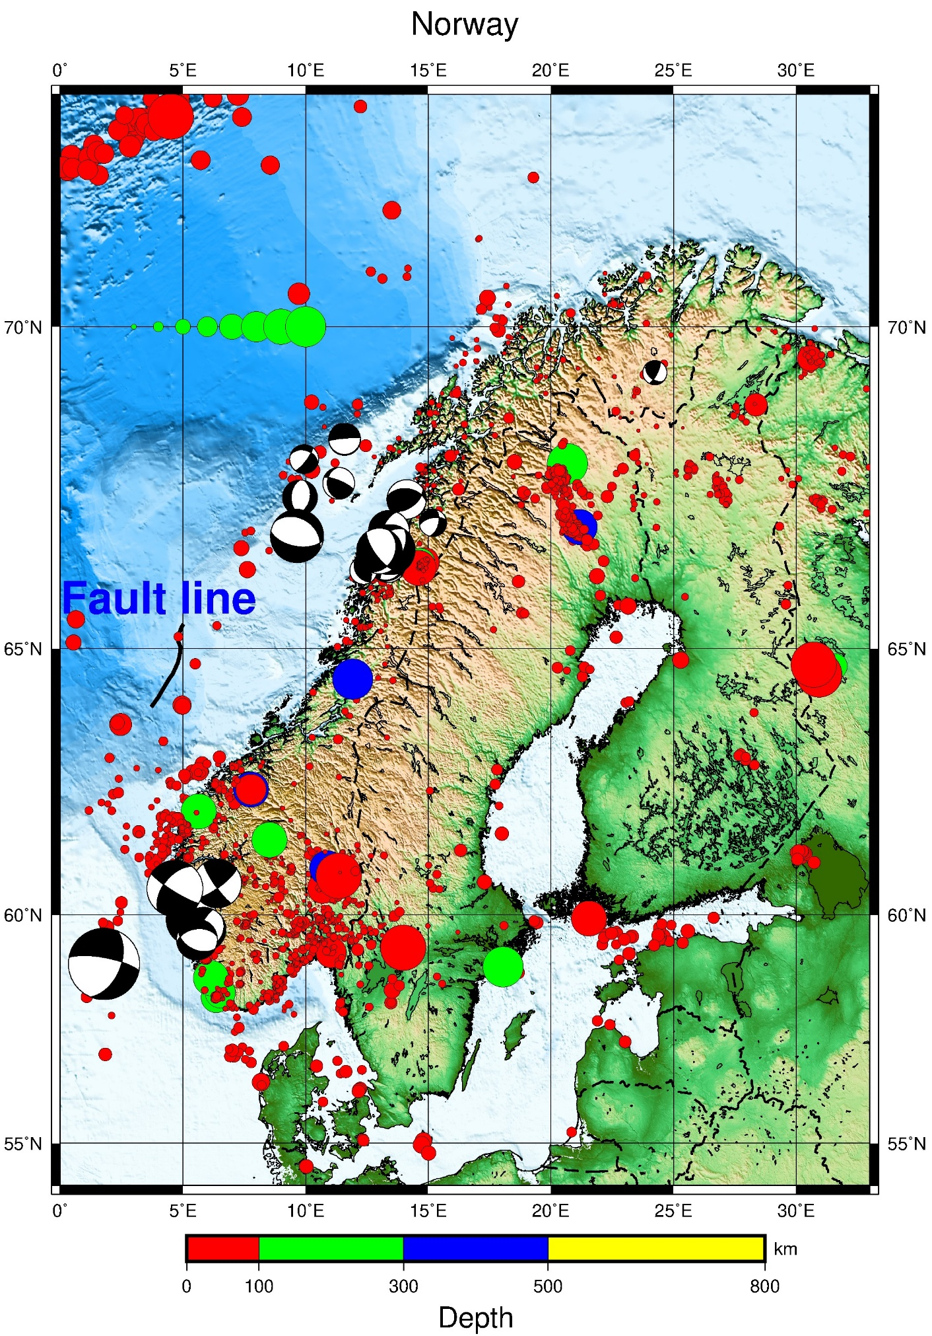

#!/bin/bash
file=Map.ps
grdfile=../DATA/newbathy.grd
#grdfile=../DATA/Bathymetry_GEBCO_30s_world.grd
# Norway map
xmin=0
xmax=33
ymin=54
ymax=73
midlon=`gmt gmtmath -Q $xmin $xmax ADD 2 DIV =`
midlat=`gmt gmtmath -Q $ymin $ymax ADD 2 DIV =`
R="-R$xmin/$xmax/$ymin/$ymax"
J="-JM$midlon/$midlat/16c"

#Make a 1-degree grid
#B="-B1a1f1g1"

# Make a 5-degree grid
B="-B5g5"

gmt grdcut $grdfile $R -Gtmpf.grd
gmt grdinfo tmpf.grd
gmt makecpt -Cglobe -T-8500/8500/50 -Z > cptfile2.cpt

#Create map with top title
gmt psbasemap $B -B+t"Norway" $J $R -K -P > $file
gmt grdgradient tmpf.grd -Nt1 -A225 -Gtmpgrd.grd
gmt grdimage $J $R tmpf.grd -Itmpgrd.grd -O -K -Ccptfile2.cpt >> $file
gmt pscoast $J -B $R -Dh -N1/1.00p,- -K -O -W >> $file

# Draw fault-line
gmt psxy SRN.txt -R -JM -W2,black -O -K >> $file

# Add text on a longitude/latitude on map (f12: size text)
gmt pstext -R -J -N -K -O -V -F+f12,1,blue+j << EOF >> $file
8.0 65.6 BR Fault line
EOF

# Add text on a longitude/latitude as sub-title outside map
gmt pstext -R -J -N -K -O -V -F+f15,1,black+j << EOF >> $file
15.0 50.0 BR ----------------------------------------
EOF

# Draw seismic events (-h3: lines to skip on top)(0.06 size magnitude circles)
gmt psxy -R -J -O gmtxyz.K2 -Wfaint -i0,1,2,3s0.06 -h3 -Scc -Cquakes.cpt -K >> $file

# Draw focal mec. (1.0: size focmec circles)
gmt psmeca psmeca.out -R -J -V -Sa1.0/-1 -P -O -K >> $file

# Create legend input file for NEIS quake plot
# the line: N 1.9i 2.4i 2.0i placement of circles
cat > neis.legend << END
N 1.9i 2.4i 2.0i
#V 0 1p
S 0.1i c 0.1i red 0.25p 0.2i Shallow depth (0-100 km)
S 0.1i c 0.1i green 0.25p 0.2i Intermediate depth (100-300 km)
S 0.1i c 0.1i blue 0.25p 0.2i Very deep (> 300 km)
D 0 1p
V 0 1p
N 7
#V 0 1p
S 0.1i c 0.06i - 0.25p 0.3i M 3
S 0.1i c 0.07i - 0.25p 0.3i M 4
S 0.1i c 0.08i - 0.25p 0.3i M 5
S 0.1i c 0.09i - 0.25p 0.3i M 6
S 0.1i c 0.10i - 0.25p 0.3i M 7
S 0.1i c 0.11i - 0.25p 0.3i M 8
S 0.1i c 0.12i - 0.25p 0.3i M 9
#D 0 1p
#V 0 1p
#N 1
END
# placement and size of legend
gmt pslegend -DJBC+o0/0.3i+w6.3i/0.50i -R -J -O -F+p+glightyellow neis.legend >> $file

outeps=`echo $file | sed 's/ps/eps/g'`
eps2eps $file $outeps
gmt psconvert $outeps -Tj -P
gv $file

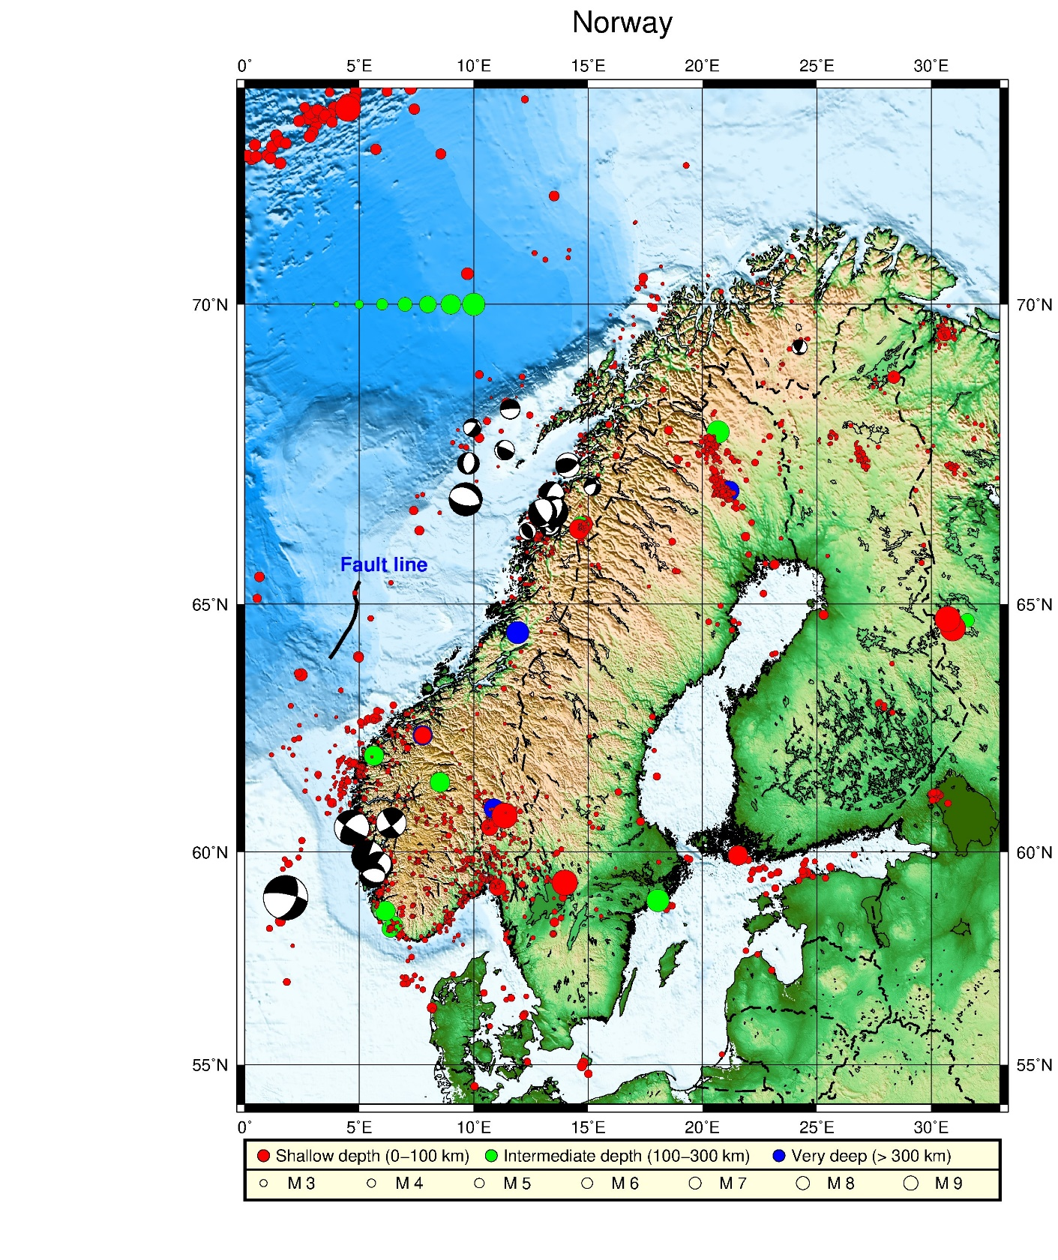

EX19 Plot events and a legend

Input file example:

chilexy.txt

date time latitude longitude depth magnitude magtype
2017/04/02 08:31:20.50 -21.503 -66.564 0.0 2.3 LTES
2017/04/02 08:43:59.50 -20.898 -68.839 92.1 1.8 LTES
2017/04/02 09:00:39.20 -20.753 -69.448 12.1 2.0 LTES
2017/04/02 09:00:28.00 -21.462 -68.762 96.6 2.4 LTES
2017/04/03 14:59:04.50 -23.740 -71.438 0.0 2.1 LTES
2017/04/03 18:51:30.30 -32.546 -80.045 700.0 3.4 CTES
2017/04/03 19:00:13.10 -21.637 -68.410 115.2 2.3 LTES
2017/04/03 19:48:38.30 -22.111 -68.692 116.0 1.9 LTES
2017/04/03 20:25:37.20 -20.446 -69.191 99.1 3.8 LTES
2017/04/04 17:17:25.60 -23.445 -69.497 0.0 1.7 LTES
2017/04/04 17:38:30.50 -20.879 -69.223 0.0 1.7 LTES
2017/04/04 17:51:08.80 -21.110 -68.924 112.5 1.7 LTES
2017/04/04 18:11:19.10 -18.329 -69.195 147.0 2.1 LTES
2017/04/04 18:26:48.00 -19.696 -69.550 13.1 2.1 LTES
2017/04/04 18:32:11.70 -22.241 -69.117 0.1 1.9 LTES
2017/04/04 18:38:20.70 -21.954 -70.560 3.5 3.2 LTES
2017/04/04 19:10:51.70 -19.985 -70.825 0.0 2.0 LTES
2017/04/04 19:42:46.50 -19.263 -69.540 129.0 1.4 CTES
2017/04/04 19:47:53.40 -21.735 -67.965 12.2 2.2 LTES
2017/04/04 19:59:36.20 -21.207 -68.508 23.7 1.9 LTES
2017/04/04 20:03:30.30 -20.037 -70.996 0.1 2.5 LTES
2017/04/04 20:09:10.60 -23.411 -69.548 0.0 1.7 LTES
2017/04/04 20:25:14.30 -22.338 -69.206 0.0 1.6 LTES
2017/04/09 17:45:12.00 -21.057 -69.005 0.0 1.8 LTES
2017/04/10 09:30:35.30 -44.994 167.463 138.7 2.1 LTES
2017/04/10 13:40:14.60 -19.690 -69.315 89.2 1.7 LTES
2017/04/10 13:48:22.10 -20.777 -69.077 67.1 2.2 LTES
2017/04/10 14:37:37.20 -20.908 -68.839 190.7 2.0 LTES
2017/04/10 14:55:10.90 -20.344 -69.896 0.0 1.6 LTES
2017/04/10 14:55:10.80 -20.342 -69.906 0.0 1.9 CTES
2017/04/10 17:38:21.60 -20.917 -69.504 54.3 2.4 LTES
2017/04/10 17:57:43.90 -22.752 -69.136 74.9 1.7 LTES
2017/04/10 18:47:00.40 -22.250 -69.145 0.0 1.7 LTES
2017/04/15 14:31:33.50 -21.778 -67.424 241.9 1.9 LTES
2017/04/15 14:44:30.90 -24.461 -66.978 2.9 1.7 CTES
2017/04/15 14:44:32.70 -24.291 -67.224 201.3 2.4 LTES
2017/04/15 16:10:28.20 -22.586 -69.883 0.0 2.0 LTES
2017/04/15 16:15:06.70 -22.080 -68.355 115.1 2.2 LTES
2017/04/15 16:22:43.90 -26.443 -58.750 0.0 3.4 LTES
2017/04/15 16:33:34.40 -20.559 -68.954 82.2 2.3 LTES
2017/04/15 16:58:51.80 -19.612 -70.338 1.4 2.3 LTES
2017/04/15 17:02:11.30 -21.505 -68.485 121.8 1.7 LTES
2017/04/15 17:35:13.40 -20.829 -69.281 1.3 1.7 LTES
2017/04/16 11:36:10.40 -23.242 -69.590 62.3 3.9 LTES
2017/05/16 17:09:51.10 -17.194 -71.793 0.1 3.6 LTES
2017/05/16 18:05:27.50 -24.205 -66.853 285.3 3.2 LTES
2017/05/16 18:29:44.80 -22.250 -69.095 0.0 2.6 CTES
2017/05/16 18:39:07.40 -22.882 -69.782 0.0 2.1 LTES
2017/05/16 18:55:08.90 -20.966 -69.284 22.0 1.9 LTES
2017/05/16 18:59:40.30 -17.755 -58.941 0.0 3.4 LTES
2017/05/16 19:07:20.50 -19.795 -69.033 100.5 2.1 LTES
2017/05/16 19:07:20.50 -19.747 -69.022 97.7 2.1 LTES
2017/05/17 18:34:35.30 -20.246 -69.356 82.9 2.2 LTES
2017/05/17 18:47:58.90 -22.777 -69.378 0.0 1.8 LTES
2017/05/17 18:54:01.10 -21.187 -70.239 25.4 2.1 LTES
2017/05/17 19:00:06.20 -21.870 -68.421 126.0 1.8 CTES
2017/05/17 19:00:05.80 -21.823 -68.416 132.0 2.5 LTES
2017/05/17 19:41:30.90 -20.203 -69.586 126.2 2.2 LTES
2017/06/04 10:40:45.20 -22.047 -67.500 282.0 2.7 LTES

quakes.cpt

# color palette for seismicity
#z0 red green blue z1 red green blue
0 255 0 0 100 255 0 0
100 0 255 0 300 0 255 0
300 0 0 255 100000 0 0 255

#!/bin/bash
file=Map.ps
grdfile=../DATA/newbathy.grd
#grdfile=../DATA/Bathymetry_GEBCO_30s_world.grd

# Chile
xmin=-80
xmax=-50
ymax=-10
ymin=-35

midlon=`gmt gmtmath -Q $xmin $xmax ADD 2 DIV =`
midlat=`gmt gmtmath -Q $ymin $ymax ADD 2 DIV =`
R="-R$xmin/$xmax/$ymin/$ymax"
J="-JM$midlon/$midlat/16c"

# Make a 5-degree grid
B="-B5g5"

gmt grdcut $grdfile $R -Gtmpf.grd
gmt grdinfo tmpf.grd
gmt makecpt -Cglobe -T-8500/8500/50 -Z > cptfile2.cpt

#Create map with top title
gmt psbasemap $B -B+t"Chile" $J $R -K -P > $file
gmt grdgradient tmpf.grd -Nt1 -A225 -Gtmpgrd.grd
gmt grdimage $J $R tmpf.grd -Itmpgrd.grd -O -K -Ccptfile2.cpt >> $file
gmt pscoast $J -B $R -Dh -N1/1.00p,- -K -O -W >> $file

# Add text on a longitude/latitude on map (f12: size text)
gmt pstext -R -J -N -K -O -V -F+f12,1,blue+j << EOF >> $file
-55.0 -12.0 BR Add some text
EOF

# Add text on a longitude/latitude as sub-title outside map
gmt pstext -R -J -N -K -O -V -F+f15,1,black+j << EOF >> $file
-69.0 -38.8 BR ----------
EOF

# Draw seismic events (-h3: lines to skip on top)(0.06 size magnitude circles)
gmt psxy -R -J -O chilexy.txt -Wfaint -i3,2,4,5s0.1 -h3 -Scc -Cquakes.cpt -K >> $file

# Create legend input file for NEIS quake plot
# the line: N 1.9i 2.4i 2.0i placement of circles
cat > neis.legend << END
N 1.9i 2.4i 2.0i
#V 0 1p
S 0.1i c 0.1i red 0.25p 0.2i Shallow depth (0-100 km)
S 0.1i c 0.1i green 0.25p 0.2i Intermediate depth (100-300 km)
S 0.1i c 0.1i blue 0.25p 0.2i Very deep (> 300 km)
D 0 1p
V 0 1p
N 7
#V 0 1p
S 0.1i c 0.06i - 0.25p 0.3i M 3
S 0.1i c 0.07i - 0.25p 0.3i M 4
S 0.1i c 0.08i - 0.25p 0.3i M 5
S 0.1i c 0.09i - 0.25p 0.3i M 6
S 0.1i c 0.10i - 0.25p 0.3i M 7
S 0.1i c 0.11i - 0.25p 0.3i M 8
S 0.1i c 0.12i - 0.25p 0.3i M 9
#D 0 1p
#V 0 1p
#N 1
END
# placement and size of legend
gmt pslegend -F+glightyellow+p1p,0 -Dx0c/-2.5c+w16.0c/1.5c+l1.2 -C0.2c/0.2c -V -O neis.legend >> $file

outeps=`echo $file | sed 's/ps/eps/g'`
eps2eps $file $outeps
gmt psconvert $outeps -Tj -P
gv $file

